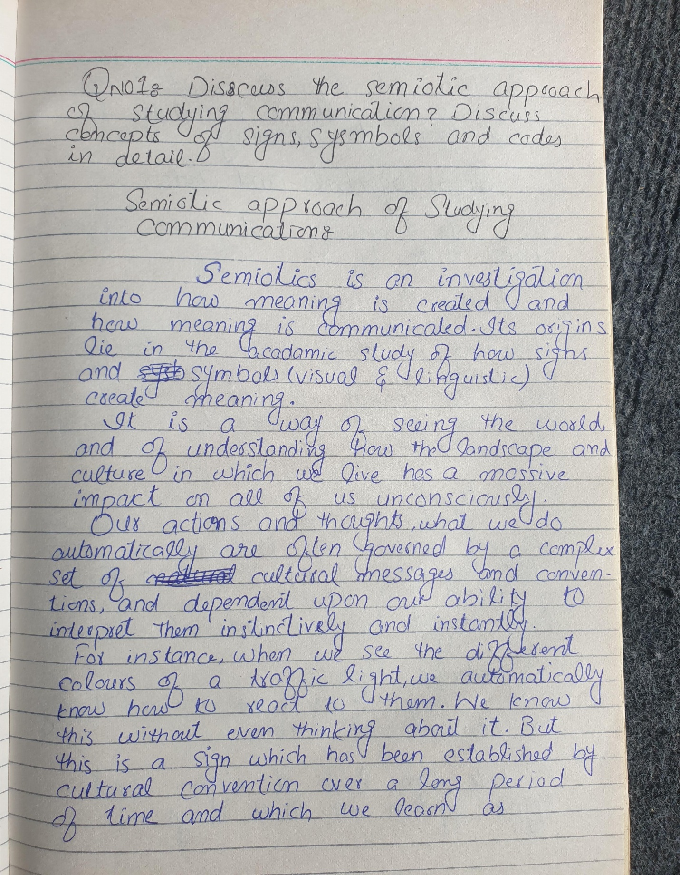
Qno1:-

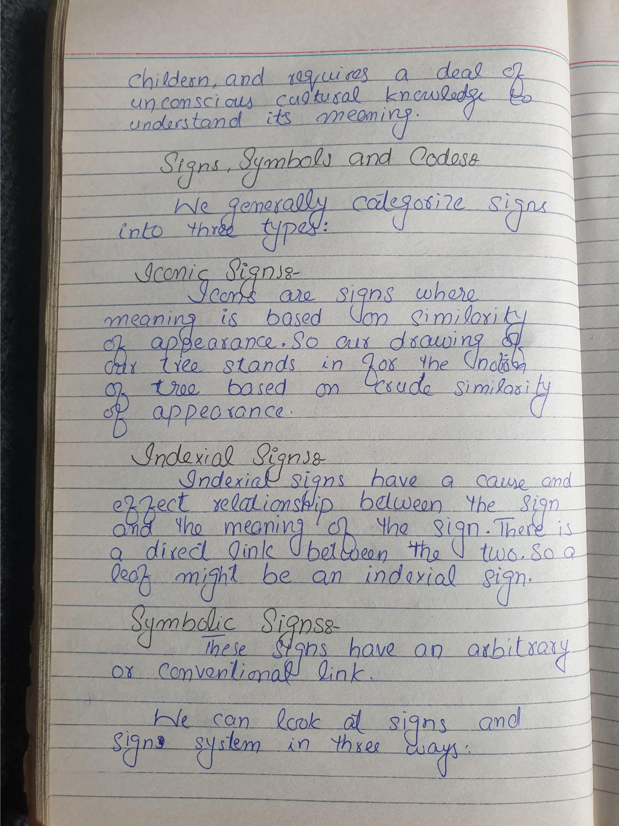
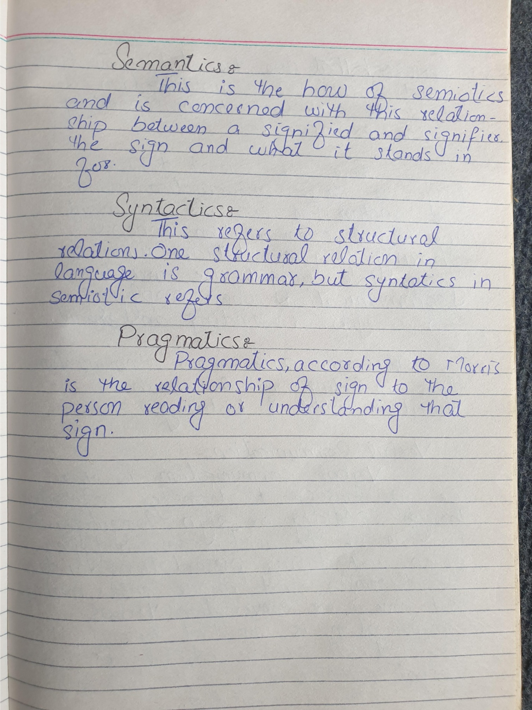
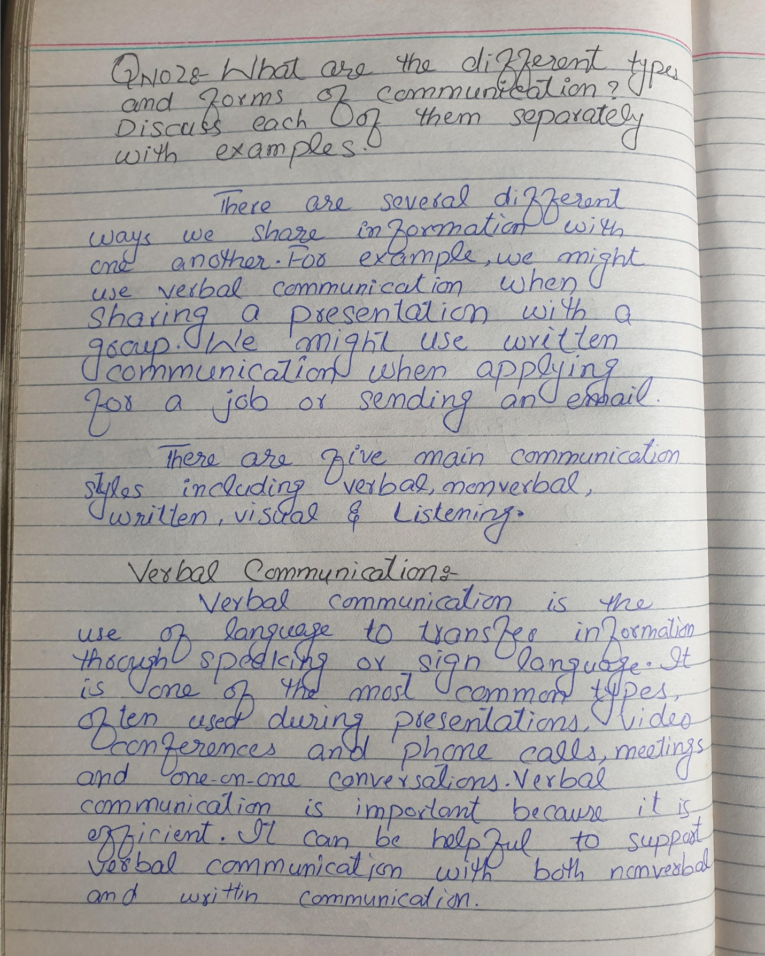
Qno2:-

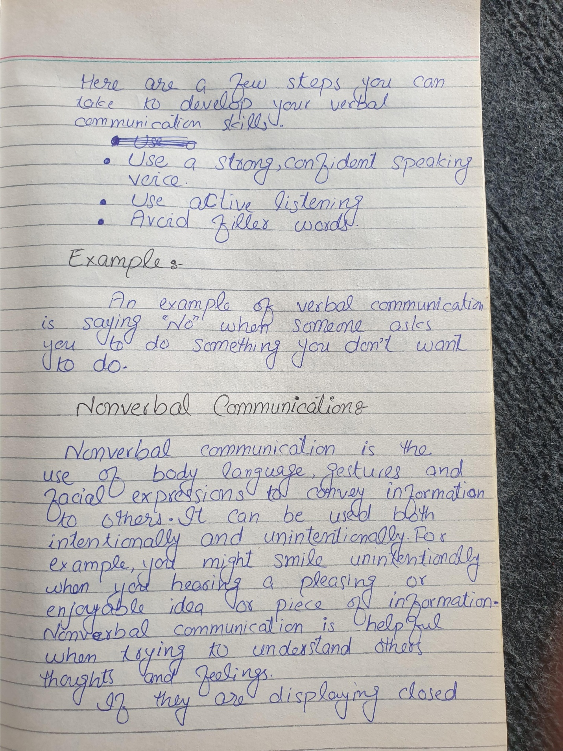
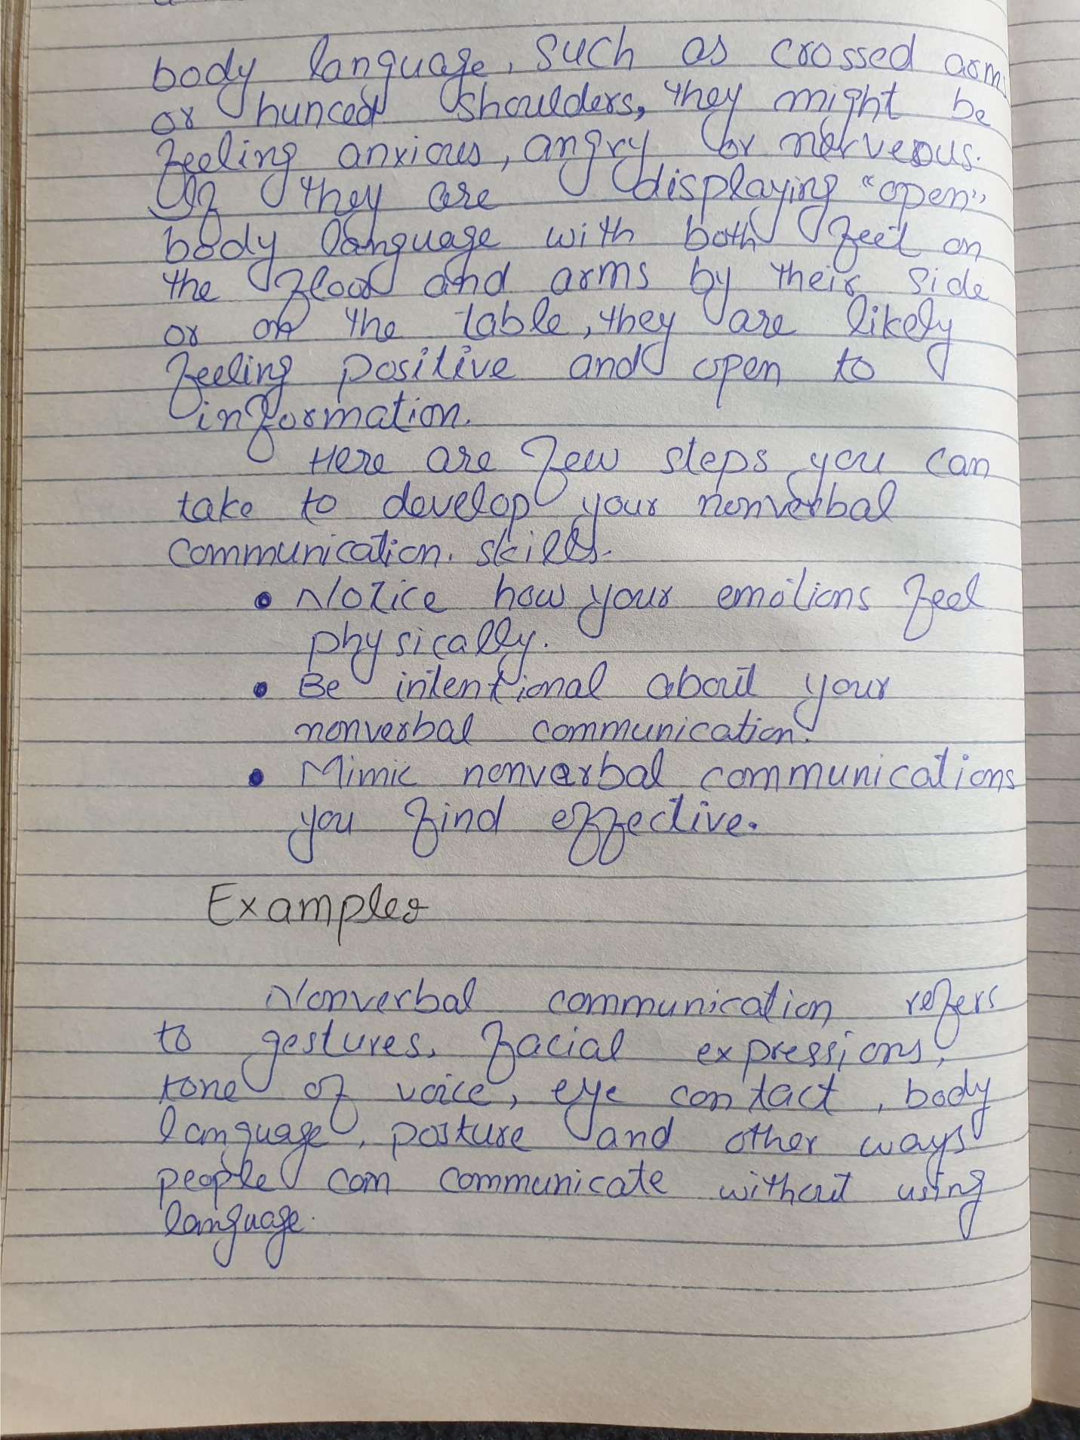
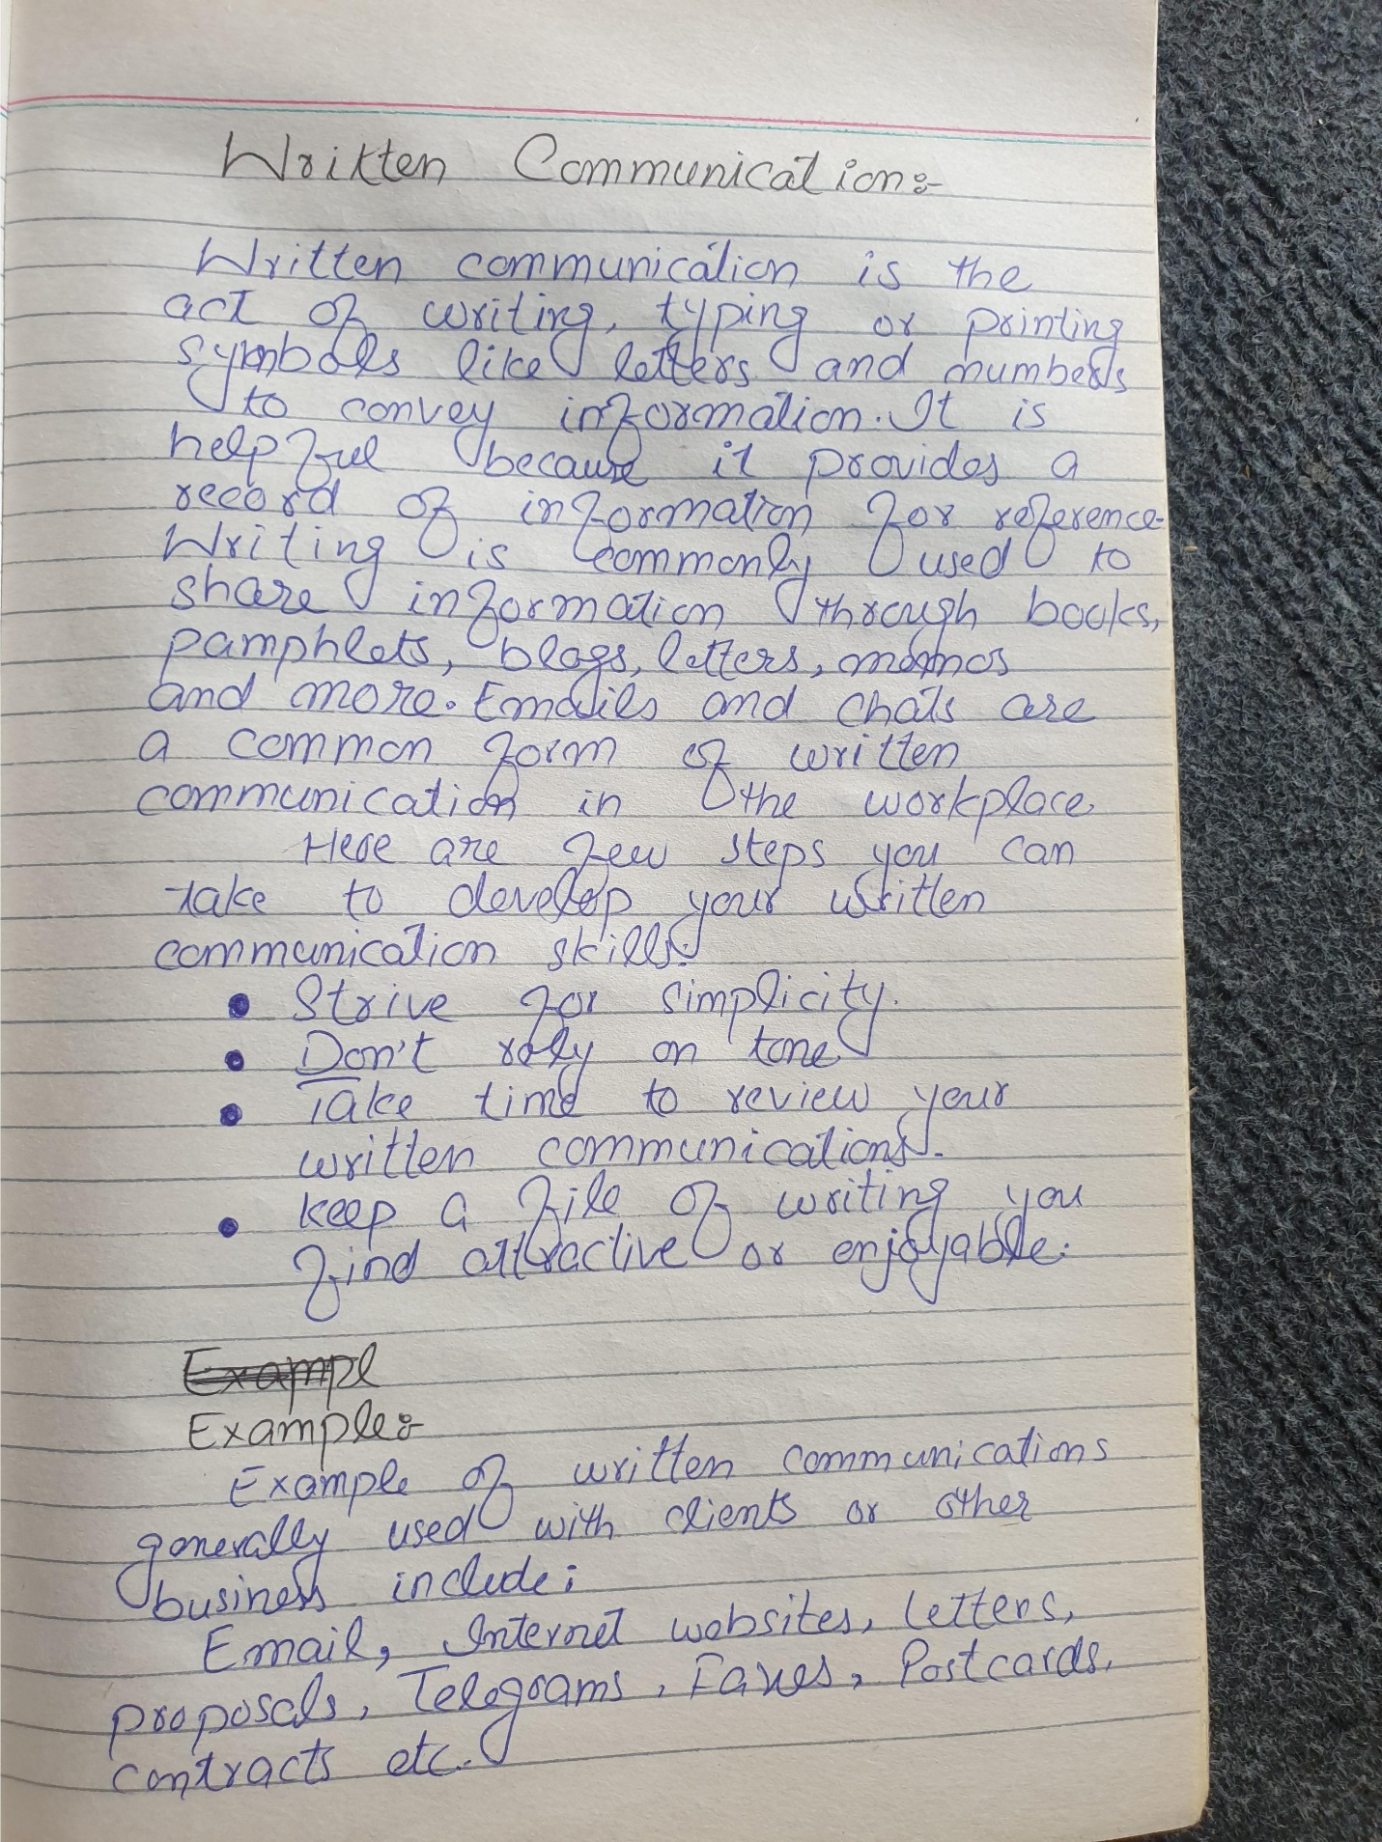
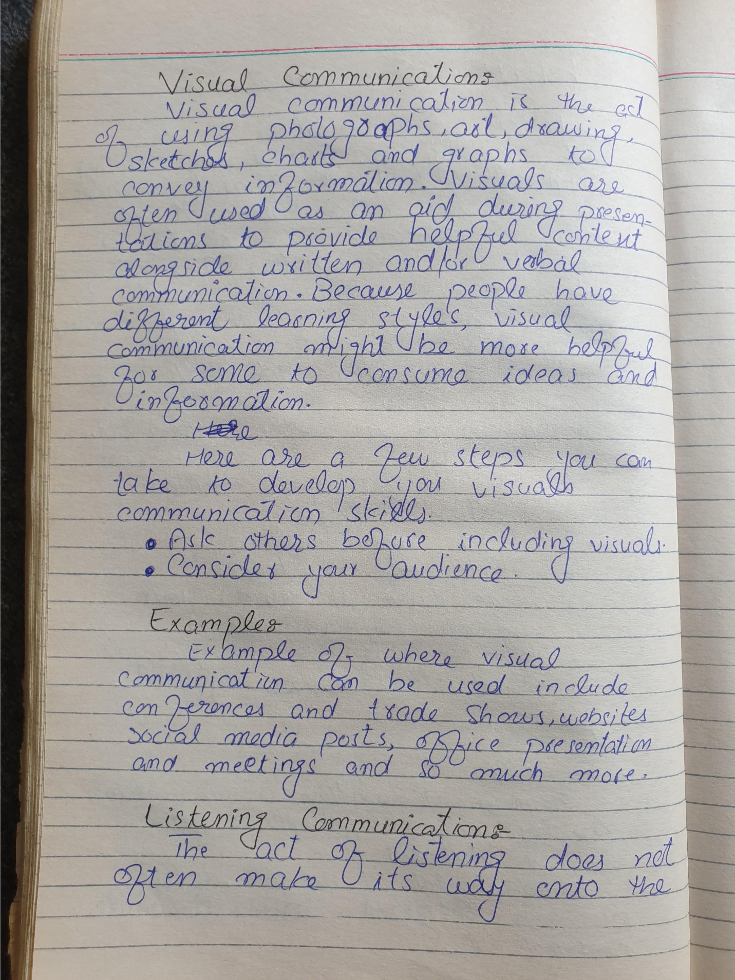
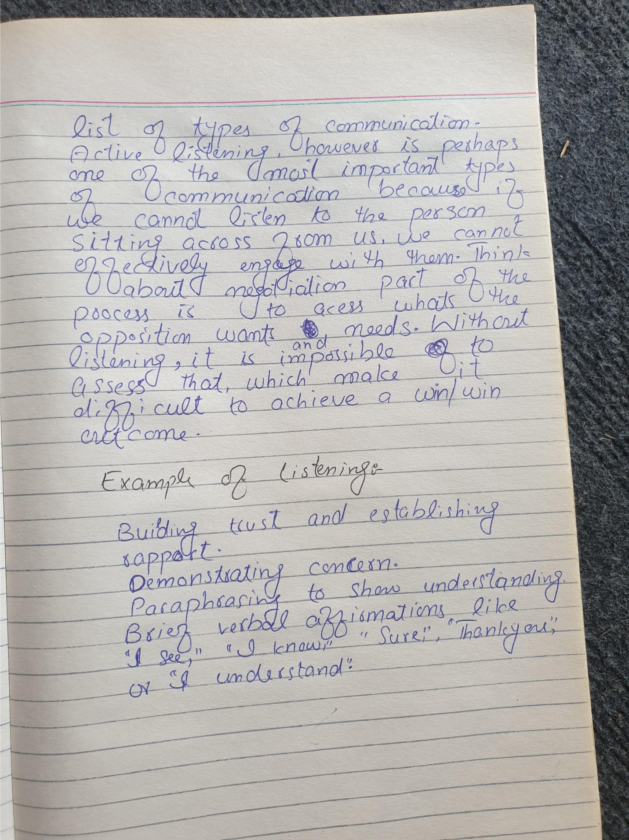
Qno3:- Discuss the interdisciplinary nature of communication. Also explain the academic origin of communication.
- Interdisciplinary Communication
Communication, in the sense of cross-fertilization of ideas, involving two or more academic disciplines (such as the disciplines that comprise the cross-disciplinary field of bioethics, including the health and biological sciences, the humanities, and the social sciences and law). Also includes problems in communication stemming from differences in patterns of language usage in different academic or medical disciplines.

How to say interdisciplinary communication in sign language?

Numerology
- Chaldean Numerology
The numerical value of interdisciplinary communication in Chaldean Numerology is: 2
- Pythagorean Numerology
The numerical value of interdisciplinary communication in Pythagorean Numerology is: 4

Origin of Communication:-

From Aristotle to Obama: A Brief History of Communication
While there are rich areas of study in animal communication and interspecies communication. Even though all animals communicate, as human beings we have a special capacity to use symbols to communicate about things outside our immediate temporal and spatial reality (Dance & Larson). For example, we have the capacity to use abstract symbols, like the word education, to discuss a concept that encapsulates many aspects of teaching and learning. We can also reflect on the past and imagine our future. The ability to think outside our immediate reality is what allows us to create elaborate belief systems, art, philosophy, and academic theories. It’s true that you can teach a gorilla to sign words like food and baby, but its ability to use symbols doesn’t extend to the same level of abstraction as ours. However, humans haven’t always had the sophisticated communication systems that we do today.
Some scholars speculate that humans’ first words were onomatopoetic. You may remember from your English classes that onomatopoeia refers to words that sound like that to which they refer—words like boing, drip, gurgle, swoosh, and whack. Just think about how a prehistoric human could have communicated a lot using these words and hand gestures. He or she could use gurgle to alert others to the presence of water or swoosh and whack to recount what happened on a hunt. In any case, this primitive ability to communicate provided an evolutionary advantage. Those humans who could talk were able to cooperate, share information, make better tools, impress mates, or warn others of danger, which led them to have more offspring who were also more predisposed to communicate (Poe, 2011). This eventually led to the development of a “Talking Culture” during the “Talking Era.” During this 150,000 year period of human existence, ranging from 180,000 BCE to 3500 BCE, talking was the only medium of communication, aside from gestures, that humans had (Poe, 2011).
The beginning of the “Manuscript Era,” around 3500 BCE, marked the turn from oral to written culture. This evolution in communication corresponded with a shift to a more settled, agrarian way of life (Poe, 2011). As hunter-gatherers settled into small villages and began to plan ahead for how to plant, store, protect, and trade or sell their food, they needed accounting systems to keep track of their materials and record transactions. While such transactions were initially tracked with actual objects that symbolized an amount—for example, five pebbles represented five measures of grain—symbols, likely carved into clay, later served as the primary method of record keeping. In this case, five dots might equal five measures of grain.
During this period, villages also developed class systems as more successful farmers turned businessmen prospered and took leadership positions. Religion also became more complex, and a new class of spiritual leaders emerged. Soon, armies were needed to protect the stockpiled resources from others who might want to steal it. The emergence of elite classes and the rise of armies required records and bookkeeping, which furthered the spread of written symbols. As clergy, the ruling elite, and philosophers began to take up writing, the systems became more complex. The turn to writing didn’t threaten the influential place of oral communication, however. During the near 5,000-year period of the “Manuscript Era,” literacy, or the ability to read and write, didn’t spread far beyond the most privileged in society. In fact, it wasn’t until the 1800s that widespread literacy existed in the world.
The end of the “Manuscript Era” marked a shift toward a rapid increase in communication technologies. The “Print Era” extended from 1450 to 1850 and was marked by the invention of the printing press and the ability to mass-produce written texts. This 400-year period gave way to the “Audio-visual Era,” which only lasted 140 years, from 1850 to 1990, and was marked by the invention of radio, telegraph, telephone, and television. Our current period, the “Internet Era,” has only lasted from 1990 until the present. This period has featured the most rapid dispersion of a new method of communication, as the spread of the Internet and the expansion of digital and personal media signalled the beginning of the digital age.
The evolution of communication media, from speaking to digital technology, has also influenced the field of communication studies. To better understand how this field of study developed, we must return to the “Manuscript Era,” which saw the production of the earliest writings about communication. In fact, the oldest essay and book ever found were written about communication (McCroskey, 1984). Although this essay and book predate Aristotle, he is a logical person to start with when tracing the development of the communication scholarship. His writings on communication, although not the oldest, are the most complete and systematic. Ancient Greek philosophers and scholars such as Aristotle theorized about the art of rhetoric, which refers to speaking well and persuasively. Today, we hear the word rhetoric used in negative ways. A politician, for example, may write off his or her opponent’s statements as “just rhetoric.” This leads us to believe that rhetoric refers to misleading, false, or unethical communication, which is not at all in keeping with the usage of the word by ancient or contemporary communication experts. While rhetoric does refer primarily to persuasive communication messages, much of the writing and teaching about rhetoric conveys the importance of being an ethical retro, or communicator. So when a communicator, such as a politician, speaks in misleading, vague, or dishonest ways, he or she isn’t using rhetoric; he or she is being an unethical speaker.
The study of rhetoric focused on public communication, primarily oratory used in discussions or debates regarding laws and policy, speeches delivered in courts, and speeches intended to praise or blame another person. The connections among rhetoric, policy making, and legal proceedings show that communication and citizenship have been connected since the study of communication began. Throughout this book, we will continue to make connections between communication, ethics, and civic engagement.
Much of the public speaking in ancient Greece took place in courtrooms or in political contexts.
Ancient Greek rhetoricians like Aristotle were followed by Roman orators like Cicero. Cicero contributed to the field of rhetoric by expanding theories regarding the five canons of rhetoric, which include invention, arrangement, style, delivery, and memory. Invention refers to the use of evidence and arguments to think about things in new ways and is the most studied of the five canons. Arrangement refers to the organization of speech, style refers to the use of language, and delivery refers to the vocal and physical characteristics of a speaker. Memory is the least studied of the five canons and refers to the techniques employed by speakers of that era to retain and then repeat large amounts of information. The Age of Enlightenment in the 1700s marked a societal turn toward scientific discovery and the acquisition of knowledge, which led to an explosion of philosophical and scientific writings on many aspects of human existence. This focus on academic development continued into the 1900s and the establishment of distinct communication studies departments.
Communication studies as a distinct academic discipline with departments at universities and colleges has only existed for a little over one hundred years (Keith, 2008). Although rhetoric has long been a key part of higher education, and colleges and universities have long recognized the importance of speaking, communication departments did not exist. In the early 1900s, professors with training and expertise in communication were often housed in rhetoric or English departments and were sometimes called “professors of speech.” During this time, tension began to build between professors of English who studied rhetoric as the written word and professors of speech who studied rhetoric as the spoken word. In 1914, a group of ten speech teachers who were members of the National Council of Teachers of English broke off from the organization and started the National Association of Academic Teachers of Public Speaking, which eventually evolved into today’s National Communication Association. There was also a distinction of focus and interest among professors of speech. While some focused on the quality of ideas, arguments, and organization, others focused on coaching the performance and delivery aspects of public speaking (Keith, 2008). Instruction in the latter stressed the importance of “oratory” or “elocution,” and this interest in reading and speaking aloud is sustained today in theatre and performance studies and also in oral interpretation classes, which are still taught in many communication departments.
The formalization of speech departments led to an expanded view of the role of communication. Even though Aristotle and other ancient rhetoricians and philosophers had theorized the connection between rhetoric and citizenship, the role of the communicator became the focus instead of solely focusing on the message. James A. Winans, one of the first modern speech teachers and an advocate for teaching communication in higher education, said there were “two motives for learning to speak. Increasing one’s chance to succeed and increasing one’s power to serve” (Keith, 2008). Later, as social psychology began to expand in academic institutions, speech communication scholars saw places for connection to further expand definitions of communication to include social and psychological contexts.
Today, you can find elements of all these various aspects of communication being studied in communication departments. If we use President Obama as a case study, we can see the breadth of the communication field. Within one department, you may have fairly traditional rhetoricians who study the speeches of President Obama in comparison with other presidential rhetoric. Others may study debates between presidential candidates, dissecting the rhetorical strategies used, for example, by Mitt Romney and Barack Obama. Expanding from messages to channels of communication, scholars may study how different media outlets cover presidential politics. At an interpersonal level, scholars may study what sorts of conflicts emerge within families that have liberal and conservative individuals. At a cultural level, communication scholars could study how the election of an African American president creates a narrative of post racial politics. Our tour from Aristotle to Obama was quick, but hopefully instructive. Now let’s turn to a discussion of the five major forms of communication

