NAME ISRAR HUSSAIN
ID 16075
SECTION (A)
DEPARTMENT BE(Civil)
PAPER ARCHITECTURE AND TOWN PLANING
REG NO 091-19-116075

Q1: Take any building from internet ,put its picture and microsoft word and explian its positive and negative points according to the principles of design.what could be done to make the building more attractive ? Answer must be at least 200 words.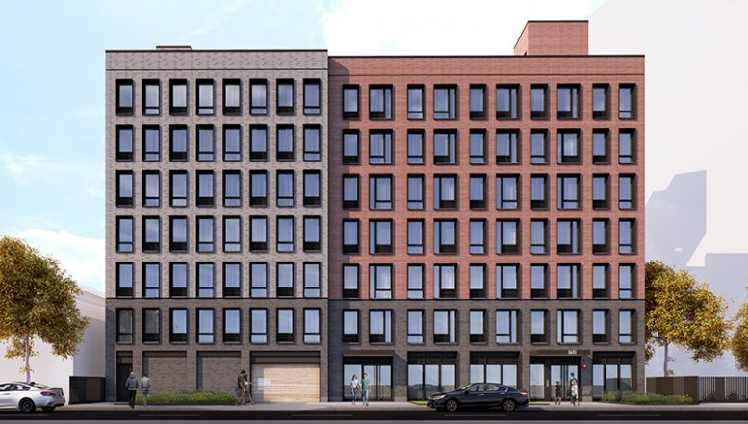
Ans:
POSITIVE POINTS:
The most positive points in the building is that it has in excellent focal pointwhich the viewer to navigate through the over all structure highlighted with black colour . The little dots in the black area more attractive the focus point also emphesized with the of top eves (chajja) with engage the viewer moe likely the colour combination between red and black with negative spaces ) which is white more pleasing to see . If we look up over all design its seems like it has applied a golden ratio between the and left sides which attract the viewer to spend more time the combination of black and red colour also creates minor contrast if we look at the wood building and its colour. Which is almost matched with to the structure have study it also seems like it has follow a specific pattern may according to the commercial bylaws.
NEGATIVE POINTS:
No doubt the building is outstanding but if we clarify it look more attrative a some more detail if we look at the window glasses .wecan see that it is an unmannged colours variation which damage the golden ratio.if we see the window of focal point and compare with each other. We can see how the golden ratio is damaged and also the window but the professioal design care about their design and make them as mistake free as they can.
Make the building more attrative:
- Simply the landscape
- Paint
- Wash the facade with light at night
- The address number
- Hide awkward element
- Clean extrior surface of glass
- Signage
- Directional sign

Q2:
Design and sketch an ideal single storey house on the site shown below. The design should be free hand and can be drawn on graph paper. If a graph paper is not available then make a grid of 5’x5’ on a separate white A4 size paper. The house should be naturally ventilated and have natural lighting. Also, it should be free of noise. The site is located in Peshawar. Label or explain the Plan neatly.

ANSWER:

SINGLE STORY HOUSE:
Total area of house 10x5m (Inches=meter)
SUMMER WINDS (OPEN DRAINAGE)
Summer winds site is totally protected
NOISE (WEST)
West side is leveled spaces is 3m to avoid noise
FRONT SIDE (SOUTH)
Leaved is equal to 11m for sun light
Open able glasses for naural ventilation purpose car parking and shadowed window for lightening eves to avoid the heat on the summer
WINTER WIND(NORTH EAST)
Winter wind is also protected
EAST SIDE
Leaved space is equal to 1.5m
NORTH SIDE
Leaved space is equal to 3m protected bricks wall to store heat .

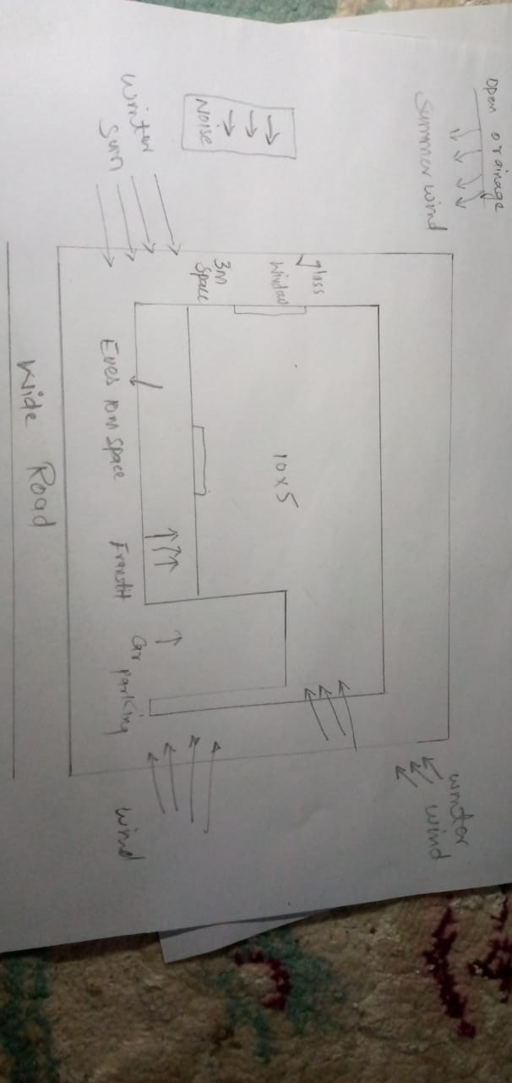

Q3: Select a site at the place where you live. Do Micro site analysis of Site and make its sketch on another A4 paper and write about it in detail. You can take your own lawn as a site for analysis or any other site in the neighborhood. Additionally, make a solar path diagram for your area on a separate piece of paper to find the exact sun angles for both winter and summer. Watch videos on YouTube to understand and make Solar Path diagram. Use these sun angles to make a rough sketch of a room. Show window height, type of fixed sun shade used, angle and height of shade as well as its depth and width by keeping sun angles in mind. The purpose for the sketch is to show how winter sun is allowed and summer sun is blocked.

ANSWER :

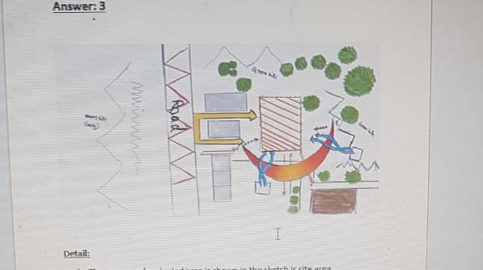
- The orange colour shaded area is shown in the sketch is site area
- It is a 10* 10 site area
- The red curves lines is shown us the noise or noisy area
- The grey shaded area is show in sketch is one story building
- The brown shaded colour show two story building
- The blue arrows shown the summer and winter winds
- The thin red arrows show the inward and outward view
- The green colour show trees in the sketch
- The yellow arrows show the path for car or other vehicle to the side or building.

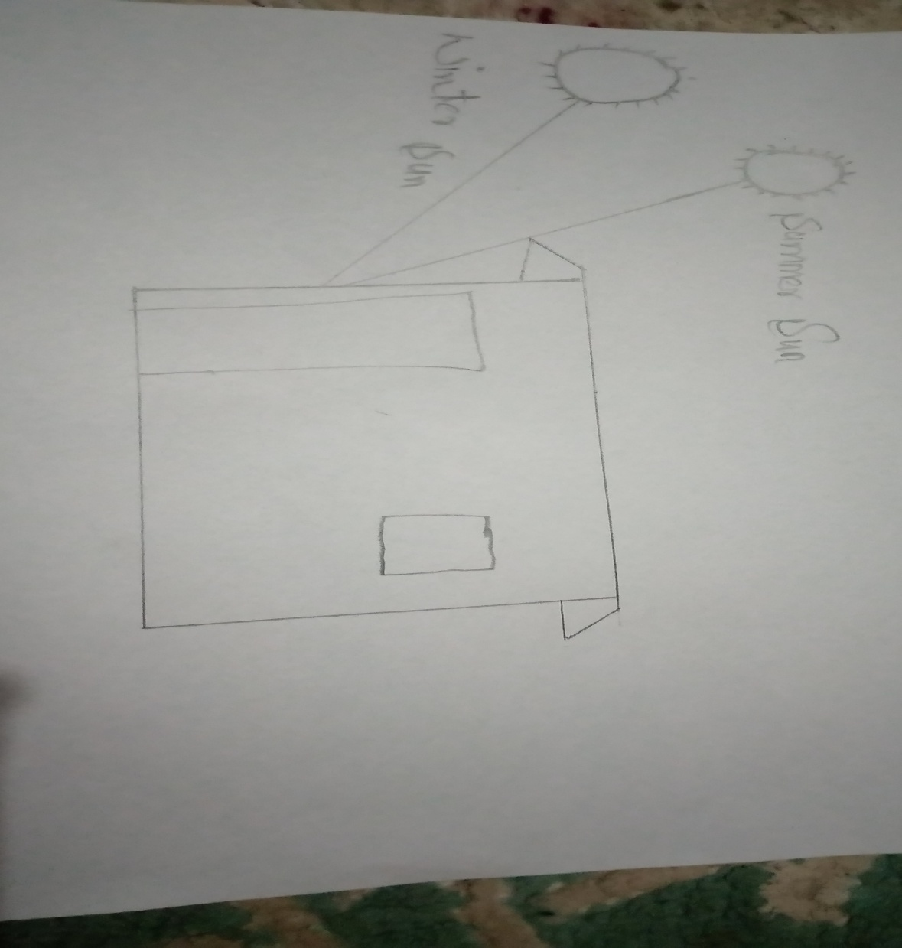
- The north and east side of the side is perfect view and its green hills which is beautiful and green area
- But the west side is not much good because it has a mining area which is too noisy due to the mining work and destruction of hill
- The south side has a perfect ground for people entertaintment and refreshment
- The black cures show us the hills
- The latitude of te sun and this area is34 .
- Sum altitude in the summer noon has 79.5
- Some altitude in the winter noon is 30.2

