Subject : Anatomy-IV
Submitted by: Dr. Arooba.
DPT 4th Semester
MidTerm Assignment, Spring 2020.

Total marks: 30.
Select the best possible answer.
1. Sub arachnoid hemorrhage is caused by the rupture of which vessel?a. Middle meningeal artery (true)
b. middle menigeal vein
c. cerebral artery
d. cerebral vein

2. The superior sagittal sinus is located between the?
a. inner table of the skull and the endosteal (parietal) layer of the dura
b. endosteal (parietal) and the meningeal (visceral) layers of the dura (true)
c. meningeal (visceral) layer of the dura and the arachnoid layer
d. arachnoid layer and the pia mater

3. How many poles does a cerebrum has?
a. 3 lobes
b. 4 lobes
c. 3 poles (true)
d. 4 poles

4. What type of cells is present in the fifth layer of cerebral cortex?
a. large pyramidal cells
b. giant pyramidal cells
c. Betz cells (true)
d. Both b & c

5. A fetal origin posterior communicating artery arises from the?
a. basilar artery (true)
b. middle cerebral artery
c. internal carotid artery
d. vertebral artery

6. Regarding sympathetic and parasympathetic nervous system, which of the following is true?
a. Long preganglionic fibers and short postganglionic fibers in SNS.
b. Long preganglionic fibers and short postganglionic fibers in PSNS.(true)
c. Short preganglionic fibers and short postganglionic fibers in SNS.
d. Short preganglionic fibers and long postganglionic fibers in PSNS
e. both b & c.
f. both a & d.

7. Sensory information enters the CNS via the dorsal portion, Motor commands exit the CNS via the ventral portion.
a. True (true)
b. False

8. Which of the following regarding taste area is true?
a. Brodmann's area 43
b. situated in lower end of post central gyrus in superior wall of lateral sulcus near the insula.
c. both a & b. (true)
d. none of them are true.

Questions 9-11 are related to the figure 1, given below. Question number 9, 10 carries 1 mark each. Question number 11 carries 5 marks.

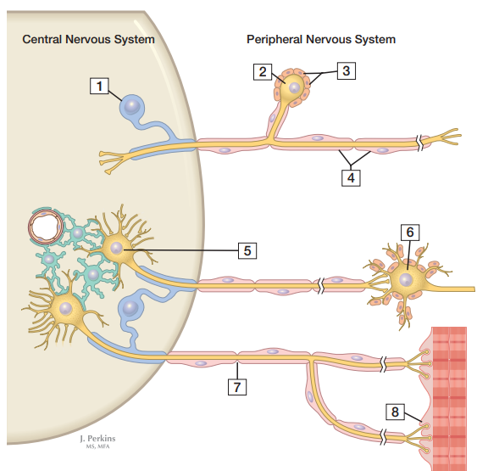
Figure 1

9. Given in the figure below, area labeled as 5 is?
a. Postganglionic autonomic neuron (true)
b. Preganglionic autonomic neuron
c. Motor end plate (neuromuscular junction)
d. Primary sensory (ganglion) cell body

10. Given in the figure below, area labeled as 6 is?
a. Postganglionic autonomic neuron (true)
b. Preganglionic autonomic neuron
c. Motor end plate (neuromuscular junction)
d. Primary sensory (ganglion) cell body

11. In the figure 1 shown above, label the following numbers;

2 ________cell body __
3 __________mylein sheath
4 _______schwan cells___
7 ________nodesof raniver__
8 _________neuromuscular juction_

Answer the following questions. Add diagrams/ pictures if needed.
Each question carries 5 marks.

1. Osman, a 23 years old boy suffered a traumatic brain injury on the right sided orbital lobe. Which side and which half of the retinal field's sensory input would be lost? Reason why?
Temporal field radiation does not cross so nasal field on right side will be affected
2. What are the differences between spinal nerves and cranial nerves?
Cranial nerves ::
- cranial nerves emerge from the brain
- their name are generally formed according to their structure
- crainal nerves are 12 pairs in number
- cranial nerves are sensory motor or mixed nerves
- crainal nerves are concerned with activities associated with head and neck
- in crainal nerves no roots are present
- neurons that give rise to sensory component are located in named ganglia
- motor neuron give rise to efferents are located in nuclei in brainstem
- crainal nerves are involved in dense of smell vision hearing and taste
- Crainal nerves arise from brain and passes through separate aperature in skull
Spinal nerves::
- 1.spinal nerves arise from spinal cord
- Spinal nerves are part of peripheral nervous system
- There are 21 pairs of spinal nerves
- They are named according to location of spinal cord
- They are concerned with all part of body below head and neck
- Spinal nerves are purely mixed nerves
- Spinal nerves are formed by union of sensory and dorsal roots
- Neurons that give to rise to sensory component are located in Doral root ganglia
- Neurons that give rise to motor component are located in dorsal root ganglia
- Spinal nerves are classified into 5 groups
8 cervical 12 thoracic 5 lumber 5 sacral and 1 coccygeal pair of nerves
3. What do you know about the reticular formation of spinal cord?
This is a system of motor and sensory fibers and nerve cells which forms the central core of brainstem
Location:
The reticular formation extend from the superior portion of spinal cord into diencephalon
Its complex system of nerves fibers connect center of hypothalamus basal ganglia cerebellum and cerebrum with the fibers in all major ascending and descending tracts
The retinal formation has ascending connections with central cortex and descending connections with spinal cord
A portion of reticular formation is known as reticular activating system ;when this area is stimulated many nerve impulses pass upward into thalamus and disappear to wide spread area of cerebral cortex
The reticular system is thus composed of ascending reticular system and descending reticular system
Ascending reticular system:
Its main function is to exert an activating influence on cortex.
For example…if in a sleeping animal reticular formation is electrically stimulated with
Electrodes the animal will awaken and will show typical pattern of auroral
Descending reticular formation:
Its contains many areas which are concerned with regulation of heartrate
Blood pressure respiration muscle tone and control many autonomic motor functions
Neurotransmitter in reticular formation:
Include serotonin acetylcholine nor adrenaline adrenaline and dopamine
Functions of reticular formation
- It has centers for control of heart rate respiration and blood pressure
- It is concerned with wakefulness and alertness
- It is involved in motor activities and certain spinal reflexes
- If reticular formation is injured it ceases to function the person remain unconscious even with strong stimulation
- It allows cerebral cortex to concentrate on more significant information by filtering the incoming sensory impulses
- it monitors all the activities that is going in the body and environment

