Final Term Paper

Name:
Malik Faizan

Id:
14313

Subject: CAB

Submitted to:
Sir Zakir Rahim

- Fill some random text; insert a section break to create two sections on same page.
- Use DropCap (use random text if needed).
- Insert an image, after inserting image fill the document with random text and use text wraping option to align text with image.
- Insert table of contents in your document.
- Write down the steps involved in Mail Merge.

Fill some random text; insert a section break to create two sections on same page.

What is Lorem Ipsum?

Lorem Ipsum is simply dummy text of the printing and typesetting industry. Lorem Ipsum has been the industry's standard dummy text ever since the 1500s, when an unknown printer took a galley of type and scrambled it to make a type specimen book.

It has survived not only five centuries, but also the leap into electronic typesetting, remaining essentially unchanged. It was popularised in the 1960s with the release of Letraset sheets containing Lorem Ipsum passages, and more recently with desktop publishing software like Aldus PageMaker including versions of Lorem Ipsum.

Use DropCap (use random text if needed).
I
qra National University aims to contribute towards the society through innovation in learning, advancement in research, exploring knowledge in diverse range of disciplines, with national and international collaborations; and to enable the students in problem- solving, developing their interpersonal and entrepreneurial skills.

Insert an image, after inserting image fill the document with random text and use text wraping option to align text with image.
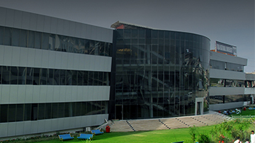
The University aims to contribute towards the society through innovation in learning, advancement in research, exploring knowledge in diverse range of disciplines, with national and international collaborations; and to enable the students in problem- solving, developing their interpersonal and entrepreneurial skills.

Insert table of contents in your document.
Contents
Fill some random text; insert a section break to create two sections on same page. 1
What is Lorem Ipsum? 1
Use DropCap (use random text if needed). 1
Insert an image, after inserting image fill the document with random text and use text wraping option to align text with image. 1
Insert table of contents in your document. 1
Write down the steps involved in Mail Merge. 2

Write down the steps involved in Mail Merge.

Mail Merge«Iqra_National_University»
There are six steps in the mail merge
- Select the document type
The first step is to select what Word calls a “document type” in the Mail Merge task pane, what kind of mail-merge you want to undertake: form letters, e-mail messages, envelopes for mass-mailings, labels for mass-mailings, or a directory (a list or catalog). Choose an option button and click Next at the bottom of the task pane to go to step 2.
- Start the document
What Word calls the “starting document” is the document in which the merging takes place. In other words, the address or other data you retrieve will land in the document you choose or create now. You can create a new start document or use an existing one. In the case of labels and envelopes, you tell Word what size labels or envelopes you intend to print on. In the case of form letters, e-mail messages, and directories, you supply the text either by making use of a document you’ve written already or writing a new document.
- Select recipients
In step 3, you tell Word where to get the data that you will merge into the starting document you created or supplied in step 2. You can retrieve the data from a table in a Word document, an Access database table or query, or the address book or contact list where you store your addresses. You can also create a new list for the data if you haven’t entered the data in a file yet.
- Write your letter
In step 4, you insert the merge fields, the parts of the starting document that differ from recipient to recipient. By inserting merge fields, you tell Word where to plug information from the data source into the starting document. You also tell Word which data to take from the data source. Word offers special tools for entering an address block the recipient’s address, including his or her name, company, title, street address, city, and zip code.
- Preview your letters
In step 5, you get a chance to see what your form letters, e-mail messages, envelopes, labels, or directory will look like after they are printed or sent. In this step, you find out what the document will look like when real data is plugged into it. If something is amiss in the document, you can click the Previous link to return to step 4, the Write/Arrange your document task pane, and make changes there.
- Complete the merge
Step 6 is where you complete the merge by either printing a new document or saving the new file and printing it later. By saving the merged data in a new file, you can edit the file before printing it. In the case of e-mail messages, you click the Electronic Mail link to tell Word to send the e-mail messages

MS Excel

Q1. Paste the following table in Excel and find total sale of pepsi using formula. (5)
Item Name | price Sold
Pepsi | 25.00
chips | 15.00
sugar | 65.00
miscellaneous | 80.00
pepsi | 25.00
sugar | 65.00
Pepsi | 25.00

Q2. Paste the following table in Excel and find total sales and average for quarter and for each moth. (10)
Sales Person | Jan | Feb | Mar | Total | Avg
Ali | 200 | 300 | 300
Sajid | 100 | 400 | 200
Shahid | 400 | 600 | 600
Junaid | 500 | 200 | 700
Tahir | 300 | 400 | 400
Total
Avg

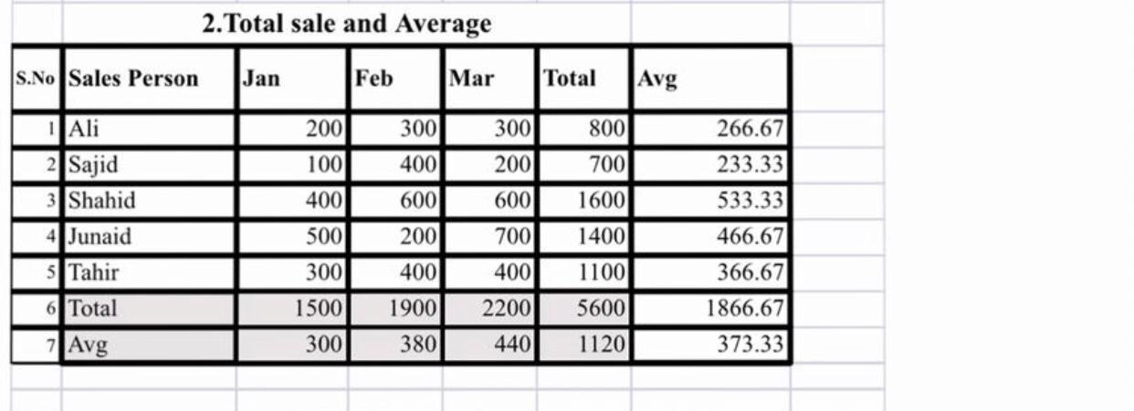

Q3. Paste the following table in Excel and find the total number of items sold. (5)
Item Name | Price
sugar | Rs 65.000
pepsi | Rs 80.000
snacks | Rs 150.000
lentils | Rs 200.000
sprite | Rs 80.000
pepsi | Rs 80.000
sugar | Rs 65.000
