Name Hayan ullah
I-D 15305
Discpline BS Radiology
Module 4th semester.
Paper Radiation Protection
Instructor Mam Atoofa azmat.

Q.1
ANSWER.
Law of bergonie and tribondeau
In 1906,two french scientist ,bergonie and tribondeau ,theorized and obsesrved that radiosensitivity was a function of the metabolic state of the tissue being irradiated.this has come to be known as the law of Bergonie and tribondeau.
Basically ,the law states that the radiosenstivity of living tissue varies with maturation and metabolism.
Law of bergonie and tribondeau
- Stem cells are radiosensitive ;mature cells are radioresistant.
- Younger tissues and organs are radiosenstive.
- Tissues with high metabolic activity are radiosenstive.
- A high proliferation rate for cells and a high growth rate for tissues result in incresed radiosensitivity.
It remind us that fetus cells are more sensitve to radiation exposure than a child or mature adult.
Radiosensitivity
It is a response of tissue determined by amount of energy deposited per unit mass (dose in Gy).
Some type of tissue respond more quickly to lower dose of radiation than others.
Radiosensitivity of a biological tissue is directly proportional to the mitotic avtivity and inversly proportional to the degree of differentation of its cell.
Physical factor Effecting Radiosensitivity
- Linear energy transfer (LET)
- Relative biological effectiveness
- Fractionation and protraction
Linear energy transfer (LET)
The rate at which energy is transferred from ionization radiation to soft tissues is called linear energy transfer.
It is expressed in the unit of kiloelectron volt of energy transferred per micrometer in soft tissues.
Relative biological effectiveness
As the linear transfer transfer of the radiation increases the ability to produce biologic damage also increases.
Qunatitatively described by relative biological effectiveness.
Radiation with a higher LET will have RBE greater than 1 while radiation with lower LET will have a RBE less than 1.
RBE=
$$\frac{dose of standard radiation to produce a given effect}{dose of test radiation to produce a given effect}$$

Fractionation and protraction
If the dose is delivered over a long time period of time is less than effective than that delivered quickly said to be fractionated
While if the dose is delivered continously but at a lower dose rate it is said to be proctracted

End of the question..
Q.2
ANSWER
1.A) effect of irradiation of macromolecules.
A solution is a liquid that contains dissolved substances, a mixture of fluds such as water and alchol is also a solution.
When macromolecules are irradiated in solution in vitro (irraditon outside of the cell or body) three major effect occur.
1.main chain scission
2.cross-linking
3.point-lesion.
1. Main-chain scission
It is the breakage of the backbone of the long chain macromolecules.
The result is the reduction of long ,single molecule into many smaller molecules.
Main chain scission reduces not only the size of the macromolecules but also the viscosity of the solution.
A viscus solution is very thick and slow to flow such as map syrup.
2. cross-linking
Some macromolecule have a small, spar like structure that extend off the main chain.
These side structure can behave as though they had a stciky substance on the end ,and attach to neighboring macromolecule or another segment of the same molecule.
This process is called cross-linking.
3. Point lesions
Radiation interaction with macromolecules can result the disruption of single chemical bond producing a point lesions.
Point lesions can result in the stochastic radiation effects observed at the whole body level.
b) Radiolysis of water
The human body is an aqueous solution that contain approximately 80% of the water molecules.
Irradiaion of water molecules represents the principal radiation interaction in the water.
When water molecules is irradiated it dissociates into other molecules this action is called radiolysis of water
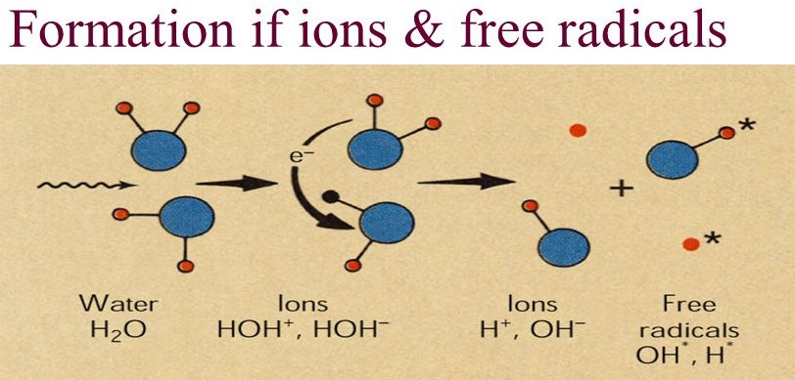
Radiolysis of water form ions and free radical.
Ionization
H₂O + HOH⁺ + e⁻
- It can recombine into stable water molecule
- The electron combine with other water molecule.
H₂O + e⁻ HOH⁻
HOHand HOH are unstable and further break.
HOH⁺ H⁺ + OH HOH⁻OH⁻ + H*
* =free radical are uncharged molecule that contain a single unpair electron in the outermost shell.
Hydrogen peroxide
OH* + OH * H₂O₂ Hydrogen Peroxide
H* + O₂HO*₂ Hydroperoxyl Formation
HO*2 + HO H2O2 + O2
c) effect of radiation on cell
radiation can effect the cell transformation which delay the mitosis process and can interfere with function and cause the chromosome breakage.
- Cell death
Can cause the instant reproductive death
And interphase death or mitotic or genetic death
The repairing are most common.
D) fractionation and protraction
Fractionation
A dose is delivered over a long period of time is less effective than that delivered quickly.
If the time of irradiation is lengthened, higher dose is required to produce the same effect.
Divide the dose into a series of small doses.
Example
if the 12Gy dose is delivered at the same doses rate (4Gy/min),but in equal 12 fractions of 1Gy each separated by 24hours ,the rat will survive .
the dose is said to be fractionated.
dose fractionation causes less effect due to intracellular repair and recovery between doses.
It is used in the treatment of tumor.

Protraction
It is the reduced dose rate.
If the dose is delivered continously but at a lower dose rate ,it is said to be protracted.
Example
A total of 12Gy is delivered in 3mins (4Gy/min) is lethal for rat however when 12Gy is delivered at a rate of 1Gy/hour for a total of 12 hours the rat will survive.
End of the question

Q.3
ANSWER
Early effect of radiation
Radiation has been described as double edged sword that could either help you or hurt you. On the other hand radiation itself is a useful tools for research medical diagnosis and therapy and on the other hand radiation exposure especially at high level can lead to increased frequencies or severities of various adverse health effects.
To produce a radiation responses in human within a few days to month the dose must be substantial (dose is large in size or increased in number or in larger amount) such a response is called an early effect of radiation exposure.
Early radiation response as described as deterministic..
All early effect and most tissue late effect is deterministic.
Determininstic effects of radiation on humans
1.acute radiation syndrome.
a. Hematologic syndrome
b. Gastrointestinal syndrome
c. Central nervous system
2. local tissue damage
A. Skin
B. Gonads.
3.hematologic depression
4.cytogenetic damage.
This is reversible. ionized atoms can become neutral again by attracting a free electron. Molecules can be mended by repair enzymes. Cells and tissues can regenerate and recover from irradiation injury.
If the radiation response increases in severity with increasing radiation dose it is called deterministic effect and occur within days after the radiation exposure.

