Name:Sawera khattak
ID:14915
Paper:Immunology
Date:24.6.202
Department :Microbiology

Question number:1
Answer:
Fill in the blanks.
1: immunogen
2: Autoantigens
3: Epitope
4: Glycoproteins and globulins
5:Solubility
6:IgG 80%-85%
7:C-region
8:Complement activation
9:Major histocompatibility antigen

Question number :2
Answer:
Antigen:
Any foreign substance in body is called antigen.
Stimulates immune response
It can be foreign or self
Immunogen that antigen which induces immune response.
Types of antigen:
- Foreign antigen:
That antigen which comes from outside of the body
They may be;
Microbial agent:
Microorganism or their part like bacteria ,viruses,capsule,cell wall etc
Non –microbial agent:
Particles from plants,animal or human like pollen, egg white,serum,tansplanted tissue etc.

- Self antigen(autoantigen):
Those antigens which show immune response against own cells.
e.g. Rheumatoids arthritis
autoimmune disease in which immune system attack its own tissues.

Epitope:
The 3D shapes on antigen where immune system recognize the antigen.

Chemical structure of antigen:
Protein:majority of antigens are protein.and these are good antigens.
Polysaccharides:pure polysaccharide or lipopolysaccharides
Nucleic acid:usually poorly antigen.
Lipids:generally non-immunogenic.

Complete antigen:
Contain both properties (immunogenicity and antigenicity).

In –complete antigens:
Contain only antigenicity property like haptens.

Super antigens:
That class of antigen which causes non-specific activation
of T-cells that results in polyclonal T-cell activation and massive cytokine release.

Antibodies:
- Antibody is a large protein constitutes glycoproteins.
- Produced by plasma membrane
- Used by immune system to recognize and neutralize pathogen like bacteria ,viruses etc
- Also called immunogloublins because they belong to group of glycoproteins and globulins.

Basic structure of antibodies:
Have four polypeptide chains
Two identical heavy chain (H –chains)
Two identical light chains (L-chains)
- Due to molecular weight L-chain and H-chain connected by single disulphide bonds.
- Two H-chain by double disulphide bonds
- To each heavy chain short carbohydrate chains are attached increasing solubility of antibodies.
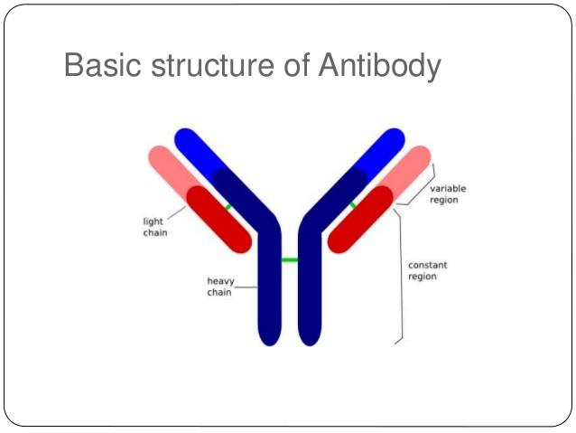

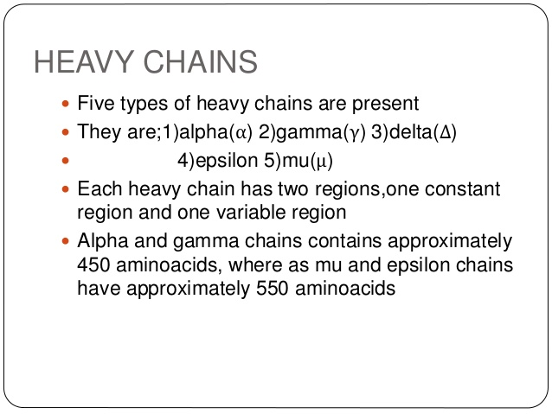

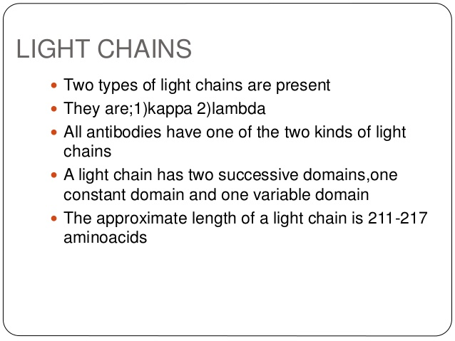

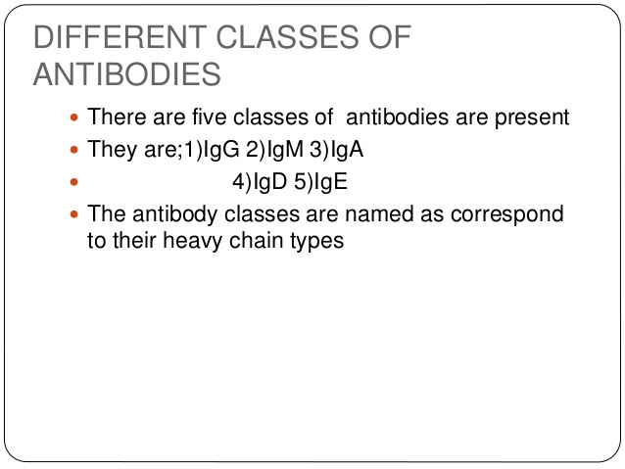

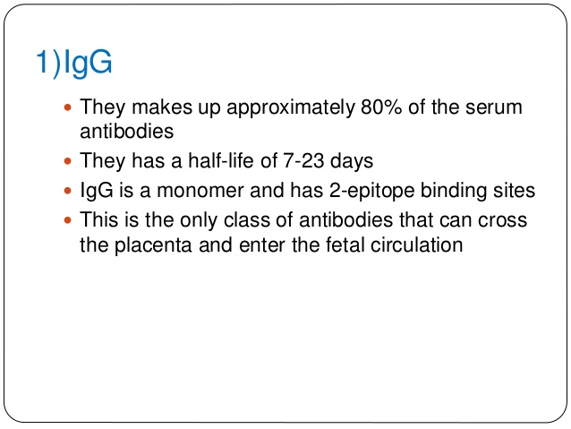

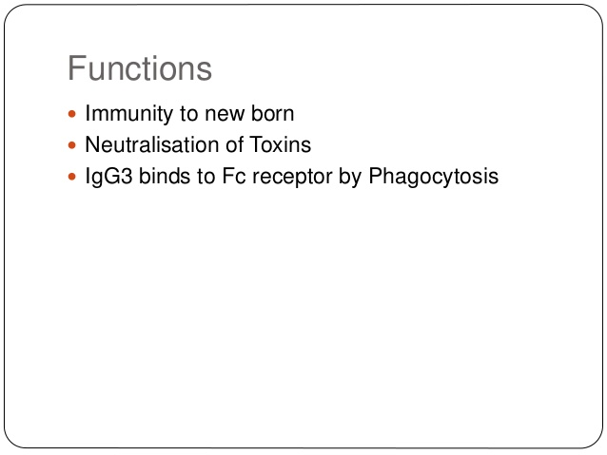

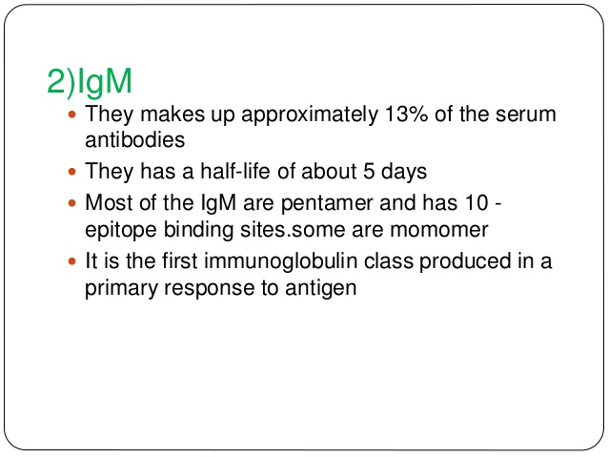

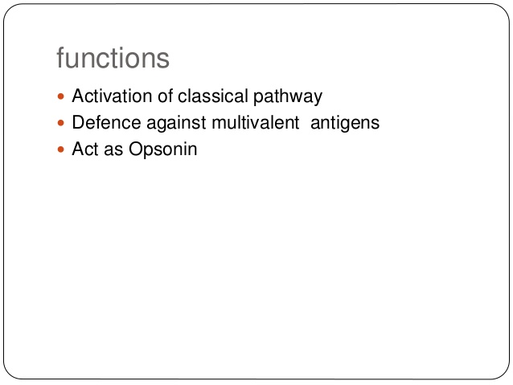

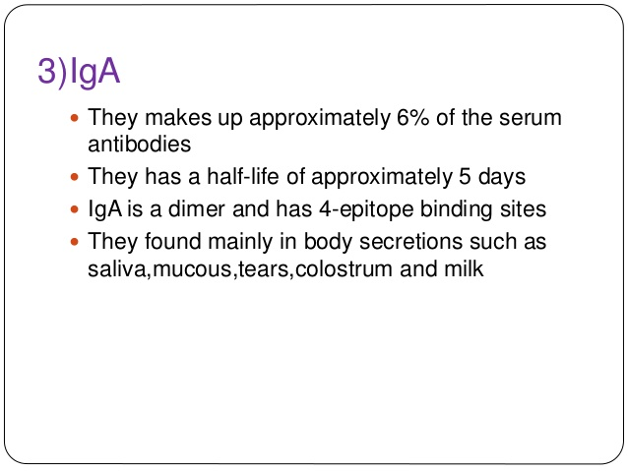

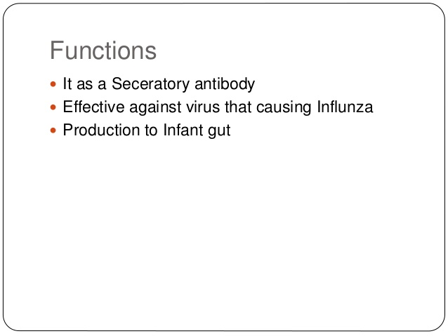

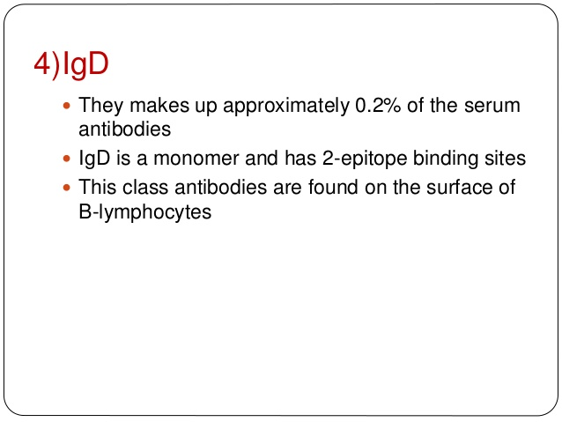

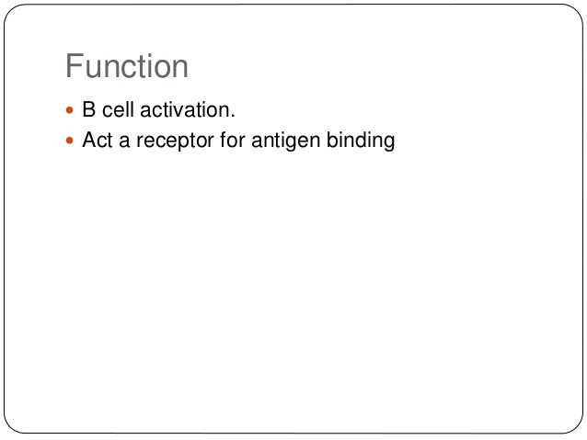

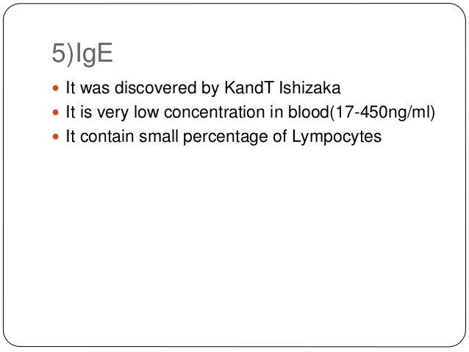

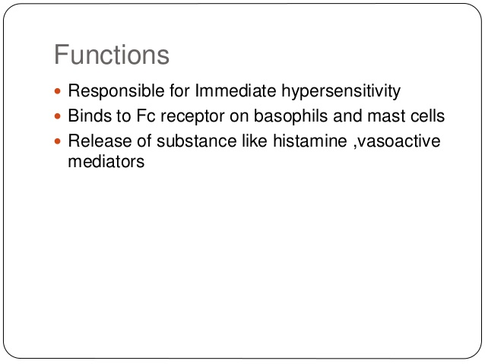

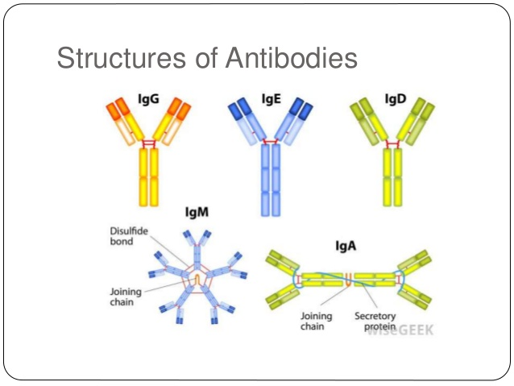

Question number:3
Answer:
Complemet system:
- Part of immune system (innate)
- Not adoptable and does not change
- Most of these found in serum
- However ,can be recruited and brought into action by adoptive immune system.
- Set of plasma protein
- Made by liver
present in blood ,lymph and extra cellular fluid.
- Proteolytic enzyme
- Circulate in inactive form
- When any infection causes these become active called complemented activation.
- Complemented protein act in a cascade .one reaction stimulate another reaction and so on.
This activation lead to three consequences
1:enhanced phagocytosis
2:inflammation
3:cytolysis
Components are designated by number C1-C9 and latters factor D
Complement receptors:cell surface,recognize activated components
Regulatory protein of complement:both in serum and cell surface
Inhibit activation components.

Classical pathway:
Part of acquired or adaptive immunity
Activated by Ag-Ab complexes

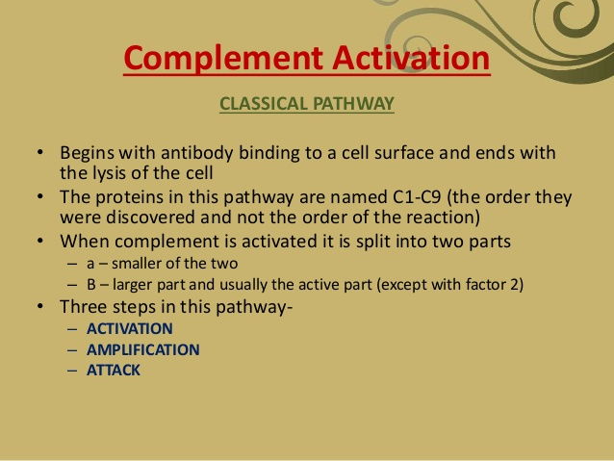

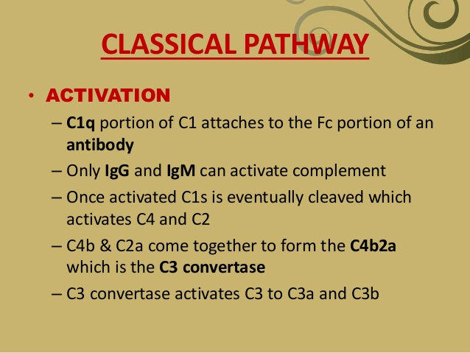

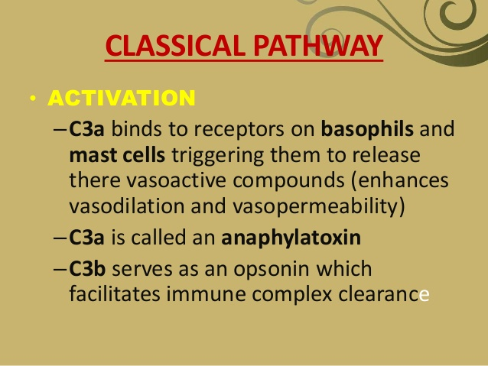
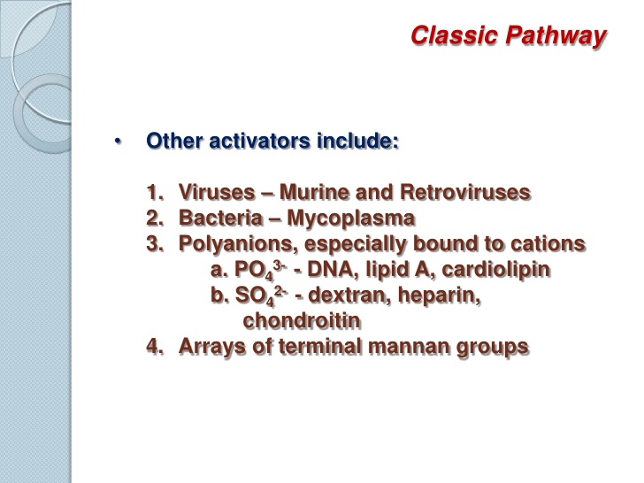
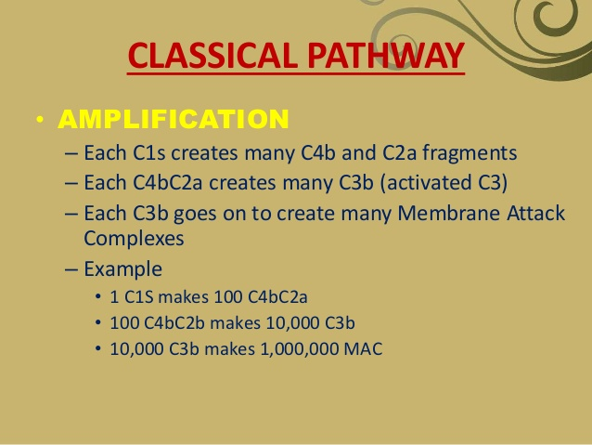

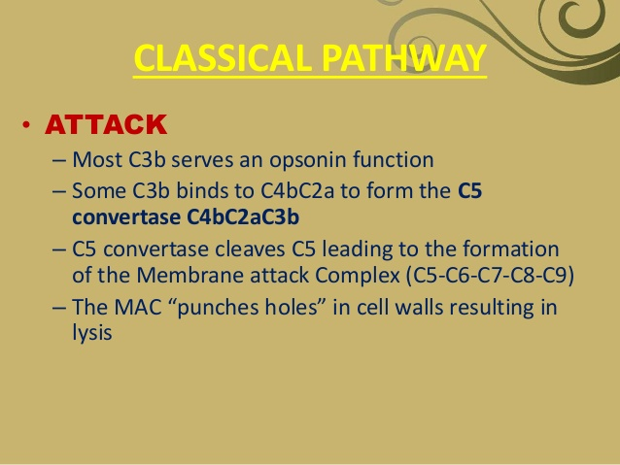

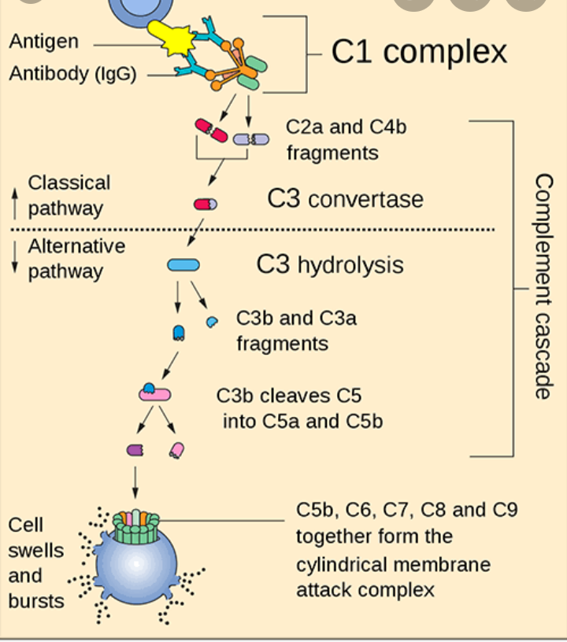

Question number:4
Answer:
Antigen antibody reaction:
- Antigens & antibodies combine specifically with each other.
- This interaction between them is called ‘Antigen-Antibody reaction’. Abbreviated as Ag – Ab reaction.
- They form the basis for humoral/antibody mediated immunity.
- They are used for detection of disease causing agents & some non-specific Ag’s like enzymes.
- When Ag-Ab reaction occurs in-vitro they are known as ‘serological reactions’.
The reactions b/w Ag & Ab occurs in 3 stages:
- formation of Ag-Ab complex.
- leads to visible events like precipitation, agglutination etc.
- destruction of Ag or its neutralization.
Silent features:
- Specificity:
- Refers to the ability of an individual antibody combining site to react with only one antigenic determinant (epitope).
- Each antibody binds to a specific antigen; an interaction similar to a lock and key.

- Immune complex:
An immune complex is formed from the integral binding of an antibody to a soluble antigen.
Ag + Ab à Ag-Ab complex

- Binding Site of Antigen:
- The part of antigen which combines with antibody is called ‘Epitope’, recognized by the immune system, specifically by antibodies, B cells, or T cells.
- Part of an antibody that recognizes an epitope is called a ‘paratope’.

- Binding Force of Antigen:The binding b/w Ag & Ab is due to three factors
- Closeness b/w Ag & Ab
- more close = good strength of binding.
- Non covalent bonds or Intermolecular forces
- hydrogen bonds
- vander walls forces
- hydrophobic bonds.
- Affinity of antibody :
- strength of reaction b/w a single epitope & single paratope.

Types of antigen-antibody reaction;
- Precipitation Reaction.
The phenomenon of aggregation of sensitized antigen on addition of specific antibody (precipitin) to antigen in solution is called ‘precipitation’.
Precipitation occurs in two media:
- Liquid
- Gel

1:precipitation in liquid:
- Place constant amount of Ab in a series of tubes.
- Add increased amount of antigen.
- Antigen – Antibody reacts together resulting in precipitation.
- Plotting the amount of precipitate against increasing antigen
conc. yields a ‘precipitin curve’.
- Precipitation curve shows 3 zones:
  - Zone of Ab axis.
  - Zone of equivalence.
  - Zone of Ag axis.

2:precipitation in Gel:
- In these methods agar gel or similar gels are used on petri-plates.
- Both Ag and Ab diffuse freely in the gel system in all directions.
- At a certain point depending on the rate of diffusion & conc. of the reactants, a zone of equivalence will be formed, seen as a visible ppt.
- If Ag or Ab preparations are complex, multiple bands form.
- - These are again of 2 types:
* Single diffusion methods
* Double diffusion methods.

- Agglutination Reaction:
The interaction between antibody & particulate (Insoluble) antigen results in visible clumping called ‘agglutination’.
- The Ab of the serum causes the cellular Ag’s to form clumps and these are called ‘Agglutinins’.
- The particulate antigens that are aggregated are termed ‘Agglutinogens’.
- Agglutination can be performed in
1: A tube agglutination:
- Serum containing Ab is diluted serially with saline in small test tubes, a constant volume of Ag suspension is added.
Control tube is kept which has no antiserum.
The tubes are incubated until visible agglutination is observed.
APPLICATION -> Widal test is used for
the estimation of typhoid fever

2:On a glass slide/passive agglutination:
- Ag is coated on the surface of a carrier particle.
This helps to convert a precipitation reaction to an agglutination reaction making the reaction more sensitive.
The carrier particles used can be RBC, latex particles or bentonite.
When patients serum is mixed with these, it leads to agglutination.
APPLICATION -> diagnosis of
Rheumatoid arthriti

- Complement Fixation:
Test which is used to detect the presence of either specific antibody or specific antigen in a patients serum,based on whether complement fixation occurs.
Used to diagnose infection.

- E L I S A – Enzyme Linked ImmunoSorbent Assay:
Described by Engvall perlmann in 1971
Technology used to detect and m easures antibodies in your blood.
Can be used to determine antibodies related to certain infections conditions.
- Immunofluorescence:
Procedure to detect antigens in cellular context using antibodies.the specificity of antibodiesb to their antigens is the base of immunoflourescence.

Samples include tissues and cells.

Question number:5
Answer:
Scientists found that sometimes transplant tissues from donor mice accepted by recipient mice while sometimes rejected by recipient .
This rejection rise a lot of questions.
The answer were given by American scientist George Davis snell
He concluded that rejection was due to incompatibility of the donor and recipient tissues.
In simple words when two animals are not closely related there transplant usually not successful. The recipient reject to accept their tissues.
Further research revealed that group of related genes was the cause of rejection.
These genes were named as Major histocompatibility complex.
Histo: tissue, compatibility: agreeable, complex: group of genes localized to a large genetic region containing multiple loci.
Defination of MHC:A tightly linked group of genes whose product play important role in intracellular recognition and in discrimination between self and non-self.
Gene is the region encode proteins, that determine whether a tissue transplanted will be accepted or rejected.

MHC encode proteins MH antigen on surface of the cells .This antigen is main cause of rejection.
MHC present in chromosome-6 (Human leukocyte antigen) and chromosome -17(H-2 complex)
B-cell receptor:
b-cells react with antigen on its own
T-cell
T-cell react with antigen in peptide form and that too when combined with MHC molecule
Other function of MHC is to bring antigen on surface of cell for recognition by T-cell
In Human MHC are found in three classes:
Class I expressed in all nucleate
Class II expressed on antigen.
Class III code for complement protein but not expressed on cell surface.
Class II class I
DP DQ DR C B A
Class III

centromere

The end

