Department of Electrical Engineering
Final – Term Assignment Spring 2020
Date: 22/06/2020
Course Details

Course Title: | Computer Communication Network | Module: | 06
Instructor: |  | Total Marks: | 50

Student Details
Name: | hassankhan | Student ID: | 6620

Q1. | (a) | 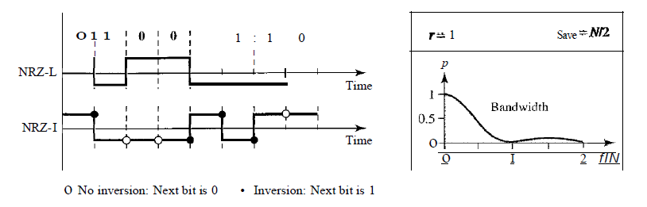  - An NRZ-I signal has a data rate of 100 Kbps. Usingthe following Figure, calculate the valueof the normalized energy (P) for frequencies at 0 Hz, 50 KHz, and 100 KHz.  - What is the Nyquist sampling rate for each of the following signals?  a. A low-pass signal with bandwidth of 200 KHz?  b. A band-pass signal with bandwidth of 200 KHz if the lowest frequency is100 KHz?  - We have sampled a low-pass signal with a bandwidth of 200 KHz using 1024 levelsof quantization.  a. Calculate the bit rate of the digitized signal.  b. Calculate the SNRdB for this signal.  c. Calculate the PCM bandwidth of this signal.  - What is the maximum data rate of a channel with a bandwidth of 200 KHz if weuse four levels of digital signaling. | Marks 20
 |  |  | CLO 1
Q2. | (a) | Draw the graph of the NRZ-L, NRZ-I, Manchester and differential Manchester scheme using each of the following data streams  a. 01010101  b. 00110011 | Marks 16
 |  |  | CLO 1
Q3. | (a) | - A TV channel has a bandwidth of 6 MHz. If we send a digital signal using onechannel, what are the data rates if we use one harmonic, three harmonics, and fiveharmonics?  - A signal travels from point A to point B. At point A, the signal power is 100 W. Atpoint B, the power is 90 W. What is the attenuation in decibels?  - The attenuation of a signal is -10 dB. What is the final signal power if it was originally5 W?  - A signal has passed through three cascaded amplifiers, each with a 4 dB gain.What is the total gain? How much is the signal amplified?  - If the bandwidth of the channel is 5 Kbps, how long does it take to send a frame of100,000 bits out of this device?  - The light of the sun takes approximately eight minutes to reach the earth. What isthe distance between the sun and the earth? | Marks 12
 |  |  | CLO 1
 | (b) | A signal has eight data levels with a pulse duration of 2ms.Calculate the pulse rate and bit rate. | Marks 02
 |  |  | CLO 1

