Subject: Computer Applications
Name: Qaiser Afzal

Q1. (a) Discuss a few limitations of image scanners? How Optical Character Recognition (OCR) device overcomes these limitations?
Ans: Few Limitations of Image Scanners:
Scanners can be used to convert images or text on paper into a digital format that can be used by the computer. Some of the limitations of Image Scanners are as follows:
- Images produced by the scanner can take up a lot of memory space.
- Images lose some quality in the scanning and digitizing process.
- The quality of the final image is dependent on the quality of the original image.
- Emotional value - is there value in the original image?
- Scanners rely on software and moving parts like a transport wand to operate, and in many cases, they also need a host computer. As a result, scanners may encounter glitches and require maintenance which is costly.
- Scanners are also relatively slow, so companies and individual’s users will need to consider the time involved in scanning all of their paperwork.
Optical Character Recognition (OCR) device overcomes these limitations:
OCR (Optical Character Recognition) also called Optical Character Reader is a system that provides a full alphanumeric recognition of printed or handwritten characters at electronic speed by simply scanning the form. More recently, the term Intelligent Character Recognition (ICR) has been used to describe the process of interpreting image data, in particular alphanumeric text.
OCR has overcome Image Scanners in many ways. Some of them are as follows:
- Cheaper than paying someone to manually enter large amounts of text
- Much faster than someone manually entering large amounts of text.
- The latest software can recreate tables and the original layout.
- OCR has increased Storage Space.
- OCR has overtaken Image Scanner by making document editable.
- OCR has more accuracy than Image Scanner.

(b) Elaborate the use of Magnetic Ink Character Recognition Device (MICR)?

Ans: MICR (magnetic ink character recognition) is a technology used to verify the legitimacy or originality of paper documents, especially checks. Special ink, which is sensitive to magnetic fields, is used in the printing of certain characters on the original documents. Information can be encoded in the magnetic characters.

USES:
- The use of MICR can enhance security and minimize the losses caused by some types of crime. If a document has been forged - for example, a counterfeit check produced using a color photocopying machine, the magnetic-ink line will either not respond to magnetic fields, or will produce an incorrect code when scanned using a device designed to recover the information in the magnetic characters. Even a legitimate check can be rejected if the MICR reader indicates that the owner of the account has a history of writing bad checks.
- Retailers commonly use MICR readers to minimize their exposure to check fraud. Corporations and government agencies also use the technology to speed up the sorting of documents.
- Other uses are:
  - In spite of rough handling, one can read the MICR information with high degree of accuracy.
  - The processing of MICR information is fast.
  - It offers greater security compare to OCR technology as printed characters cannot be altered.
  - There is no manual input and hence errors are reduced.
  - The characters can be read even if somebody write on them. This is due to the fact that special ink containing iron particles is used to print the characters.
  - The document is not easy to forge.

Q2. (a) Differentiate between printer and plotter?
Ans: A printer is an output device that produces graphics and texts on a physical medium such as paper. A printer draws images and texts on a page with the help of commands given through a computer. Printers are often connected to computers either wirelessly or through the use of USB cable. More importantly, one printer can be connected to many computers allowing all computers to be able to print on that printer. Today, wireless printing technology makes the task of printing from smart phone, notebook computer or digital camera even easier. Software for printers includes Photoshop and any other image-editing program.
A plotter is a special output device used to produce hard copies of large graphs and designs on paper, such as construction maps, engineering drawings, architectural plans and business charts. The plotter is either a peripheral component that you add to your computer system or a standalone device with its own internal processor. Plotters can read files in the DWG, CDR, Al and other vector formats.

Difference between Printer and Plotter are as follows:
BASIS OF COMPARISON | PRINTER | PLOTTER
Description | A printer is an external (peripheral) hardware output device that takes the electronic data stored on a computer or any other storage device and generates a hard copy of the data. | A plotter is an output device commonly used for computer-aided design applications, to output large vector designs such as architectural blueprints.
Nature Of The Device | Printer is a peripheral device in nature and creates a solid copy of the digital data that is represented on the computer screen. | The plotter is either a peripheral component that you add to computer system or a standalone device with its own internal processor.
File Reading | Plotters can read files in the DWG, CDR, Al and other vector formats. | Printers can read BMP, PDF and JPG TIFF formats.
Software | Software for printers includes Photoshop and any other image-editing program. | Plotter software includes Adobe Illustrator, Corel, Flexi and CAD.
Cost | Printers are less costly when compared to plotters. | Plotters are relatively expensive when compared to printers.
Output Data Format | A printer provides the output file data in a format such as bitmap or pixels. | A plotter provides the output in a format that is similar to a vector graphic/ image created with lines.
Output Data Production Rate | Printer produces the data in hardcopy format at a faster speed when compared to a plotter. | Plotter produces the data in hardcopy at a relatively slower rate when compared to a printer.
Line Drawing | Printer can only print a single line at a time. | Plotters can easily draw continuous lines from point-to-point at same time.
Application | Printers are mainly used to produce graphics and text on a physical medium such as paper. They are also, mostly used by graphic artists for posters, signs and other professional quality display. | Plotters are mainly used in specialized fields such as drawing, architecture and engineering.
Pen Like Instrument | A printer uses a needle or a pen to draw lines and figure on a page. | In plotters, there is more than one automated pen like instrument that can create designs such as diagrams, blueprints etc.
Resolution | Printers are resolution dependent, an image produced by a printer (raster image) is enlarged, the size of the pixels simply gets bigger resulting in distortion of the image. | Usually, plotters are resolution independent, an image produce by a plotter can be enlarged to any size without losing clarity.
Types | There two main type of printers, they include impact and non impact printers. | There are four main types of plotters.

(b) Explain the printing process of a LASER Printer?
Ans: Laser printing is an electrostatic digital printing process. It produces high-quality text and graphics (and moderate-quality photographs) by repeatedly passing a laser beam back and forth over a negatively charged cylinder called a "drum" to define a differentially charged image. The drum then selectively collects electrically charged powdered ink (toner), and transfers the image to paper, which is then heated in order to permanently fuse the text, imagery, or both, to the paper. As with digital photocopiers, laser printers employ a xerographic printing process. Laser printing differs from traditional xerography as implemented in analog photocopiers in that in the latter, the image is formed by reflecting light off an existing document onto the exposed drum.
Printing Process:
There are typically seven steps involved in the process:

Raster image processing:

The document to be printed is encoded in a page description language such as PostScript, Printer Command Language (PCL), or Open XML Paper Specification (OpenXPS). The raster image processor (RIP) converts the page description into a bitmap which is stored in the printer's raster memory. Each horizontal strip of dots across the page is known as a raster line or scan line.

Charging

In older printers, a corona wire positioned parallel to the drum or, in more recent printers, a primary charge roller, projects an electrostatic charge onto the photoreceptor (otherwise named the photoconductor unit), a revolving photosensitive drum or belt, which is capable of holding an electrostatic charge on its surface while it is in the dark.

Exposing
A laser printer uses a laser because lasers are able to form highly focused, precise, and intense beams of light, especially over the short distances inside of a printer. The laser is aimed at a rotating polygonal mirror which directs the light beam through a system of lenses and mirrors onto the photoreceptor drum, writing pixels at rates up to sixty-five million times per second.

Developing
As the drums rotate, toner is continuously applied in a 15-micron-thick layer to the developer roll. The surface of the photoreceptor with the latent image is exposed to the toner-covered developer roll.

Transferring
A sheet of paper is then rolled under the photoreceptor drum, which has been coated with a pattern of toner particles in the exact places where the laser struck it moments before.

Fusing
The paper passes through rollers in the fuser assembly, where temperatures up to 427 °C (801 °F) and pressure are used to permanently bond the toner to the paper. One roller is usually a hollow tube (heat roller) and the other is a rubber backed roller (pressure roller).

Cleaning and recharging
As the drum completes a revolution, it is exposed to an electrically neutral soft plastic blade that cleans any remaining toner from the photoreceptor drum and deposits it into a waste reservoir. A charge roller then re-establishes a uniform negative charge on the surface of the now clean drum, readying it to be struck again by the laser.

Continuous printing
Once the raster image generation is complete, all steps of the printing process can occur one after the other in rapid succession. This permits the use of a very small and compact unit, where the photoreceptor is charged, rotates a few degrees and is scanned, rotates a few more degrees, and is developed, and so forth. The entire process can be completed before the drum completes one revolution.

Malfunctions
The mechanism inside a laser printer is somewhat delicate and, once damaged, often impossible to repair. The drum, in particular, is a critical component: it must not be left exposed to ambient light for more than a few hours, as light is what causes it to lose its charge and will eventually wear it out. Anything that interferes with the operation of the laser such as a scrap of torn paper may prevent the laser from discharging some portion of the drum, causing those areas to appear as white vertical streaks.
Q3. (a) Explain Metropolitan Area Network (MAN) with a suitable example?
Ans: A metropolitan area network (MAN) is a network that interconnects users with computer resources in a geographic area or region larger than that covered by even a large local area network (LAN) but smaller than the area covered by a wide area network (WAN).
A metropolitan area network (MAN) is similar to a local area network (LAN) but spans an entire city or campus. MANs are formed by connecting multiple LANs. Thus, MANs are larger than LANs but smaller than WAN.
MANs are extremely efficient and provide fast communication via high-speed carriers, such as fiber optic cables. A MAN is ideal for many kinds of network users because it is a medium-size network. MANs are used to build networks with high data connection speeds for cities and towns.
The working mechanism of a MAN is similar to an Internet Service Provider (ISP), but a MAN is not owned by a single organization. Like a WAN, a MAN provides shared network connections to its users. A MAN mostly works on the data link layer, which is Layer 2 of the Open Systems Interconnection (OSI) model.
Distributed Queue Dual Bus (DQDB) is the MAN standard specified by the Institute Of Electrical And Electronics Engineers (IEEE) as IEEE 802.6. Using this standard, a MAN extends up to 30-40 km, or 20-25 miles.
Example 1:
A typical MAN example can be comprising of city which includes many houses, buildings etc. interconnected with each other.
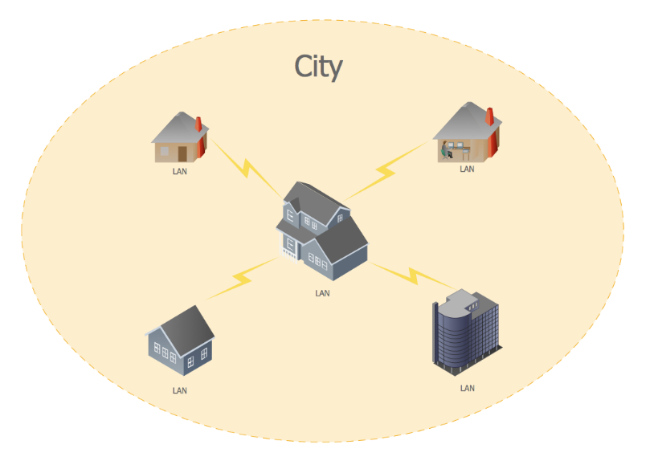
A Typical MAN Example
Example 2:
Another example of MAN can be if INU Hayatabad Campus connected with INU City Campus.
Example 3:
A Cable TV Network

(b) Define topology? Which topology would you choose to setup a local area network and why?
Ans: “The Topology is the geometric representation of the relationship of the links and the linking devices (Nodes) in a Network”
- “Topology defines the physical or the Logical Agreement of Links in a Network”
- Topology of a Network is suggestive of how a network is laid out.
- Two or more devices connect to a Link and two or more Links form a Topology.
Categories of Topology:
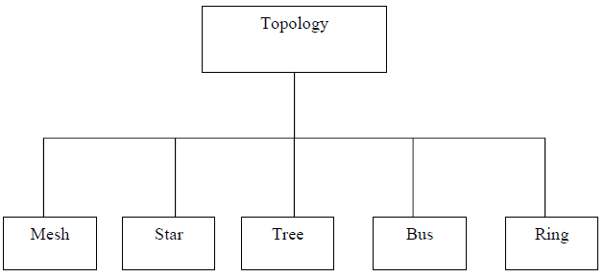
Setup a Local Area Network:
I would choose Star Topology as it is the widest used LAN topology which can be seen in our daily lives e.g: WiFi. All the devices are connected with the centralized controller called Hub, Switch or a Router.
A star topology is a topology for a Local Area Network (LAN) in which all nodes are individually connected to a central connection point, like a hub or a switch. A star takes more cable than e.g. a bus, but the benefit is that if a cable fails, only one node will be brought down.
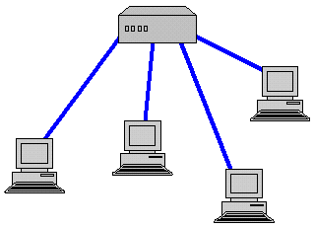
Star topology

All traffic emanates from the hub of the star. The central site is in control of all the nodes attached to it. The central hub is usually a fast, self-contained computer and is responsible for routing all traffic to other nodes. The main advantages of a star network are that one malfunctioning node does not affect the rest of the network. However, this type of network can be prone to bottleneck and failure problems at the central site. A star network is often combined with a bus topology. The central hub is then connected to the backbone of the bus. This combination is called a tree.
Q4. In your opinion, what are the different types of common media used for storage, access and transmission of information? Explain each type in detail?
Ans: Types of common Media used for Storage:
Information stored on backing store is placed on a storage medium. The most common media which are
used for backing store are: Magnetic Disks, Magnetic Tapes, Optical Disks such as CD-ROMs.
The data is read from or written to the storage medium by a piece of hardware known as a drive or a storage device.

Immediate Access Store (IAS) OR Main Internal Memory (RAM and ROM):

There are two different types of IAS:

Read Only Memory (ROM): The contents of ROM is permanent. It cannot be altered by the user. The content is written onto the ROM when it is first made. ROM keeps its contents even when the computer is turned off and so is known as non-volatile memory. ROM is also often used in embedded systems where a small built-in computer is used to control a device such as a washing machine. The program that controls the machine is stored on ROM.

Random Access Memory (RAM): RAM is used to store programs and data that are being used by the computer. When the computer is turned on the RAM is empty. Data and programs can be put into RAM from either an input device or backing store. The data in RAM is lost when the computer is turned off so it is known as volatile memory. To keep data, the user must save it to backing store before the computer is turned off.

Secondary Backing Storage:

Magnetic disks are the most common backing storage device. The two main types of magnetic disks are floppy disks and hard disks.
• 1.44Mb floppy disk.
• 120Gb hard disk drive.

Floppy Disks:
Data stored on disks is arranged along a series of concentric rings called tracks. Each track is divided up into a number of sectors. Data is read to and written from a disk one sector at a time. A sector usually contains 512 or 1024 bytes of data. The process of dividing a disk up into tracks and sectors so it can be used on a computer is known as formatting. You must format a new disk before you can use it.

Hard Disks:
Hard disks are magnetic disks. They have much larger storage capacities than floppy disks. Data can be transferred to and from a hard disk much more quickly than from a floppy disk. Hard disks are usually fixed inside a computer and cannot be moved between different machines. Some expensive hard disks can be moved between computers. These are called exchangeable hard drives.

Magnetic Tape:
Magnetic tape comes in two different forms:
Reels: Large reels of tape (1/2-inch-wide and 2400 feet long) which must be loaded into a reel-to-reel tape drive. This type of tape is usually used by mainframe computers.
Cartridges: The tape is supplied in a small cartridge rather like a music tape. The tape is typically 1/4 inch wide and 300 feet long. This type of tape is used on PCs (microcomputers) and the device used to read/write the tapes is called a tape streamer. The picture below is of a tape streamer for a PC. Capacities of cartridges vary from 10Gb to 200Gb.

Optical Disks
Optical disks store data by changing the reflective properties of a plastic disk. Like floppy disks, optical disks can be moved from one computer to another. They have much larger storage capacities than floppy disks but can not store as much data as a hard disk. Data can be read from an optical disk more quickly than from a floppy disk but hard disks are much quicker. As with a hard disk the drive head in an optical drive can move directly to any file on the disk so optical disks are direct access.
Types of Optical Disks are:
- CD-ROM
- DVD-ROM

Flash Memories and Memory Sticks:

Flash memory: is non-volatile computer memory that can be electrically erased and reprogrammed. It is a technology that is primarily used in memory cards and USB flash drives for general storage and transfer of data between computers and other digital products.

Memory Stick: Memory Stick is a removable flash memory card format, launched by Sony, and is also used in general to describe the whole family of Memory Sticks.

Types of Common Media Access:

Serial or Sequential ACCESS: sequential access means that a group of elements (e.g. data in a memory array or a disk file or on a tape) is accessed in a predetermined, ordered sequence.
Sequential access is sometimes the only way of accessing the data, for example if it is on a tape. It may also be the access method of choice, for example if we simply want to process a sequence of data elements in order.

Random or Direct ACCESS: is the ability to access an arbitrary element of a sequence in equal time. The opposite is sequential access, where a remote element takes longer time to access. A typical illustration of this distinction is to compare an ancient scroll (sequential; all material prior to the data needed must be unrolled) and the book (random: can be immediately flipped open to any random page. A more modern example is a cassette tape (sequential—you have to fast-forward through earlier songs to get to later ones) and a compact disc (random access—you can jump right to the track you want).

Access Speeds: Main internal memory (RAM or ROM) is located inside the computer. Data can be written to and read from RAM or ROM electronically at very high speeds, much faster that it can be written to or from backing store.

Types of Common Transmission Media:

A transmission medium or media can be broadly defined as anything that can carry information from a source to a destination. For example, the transmission medium for two people having a dinner conversation is the air. The air can also be used to convey the message in a smoke signal or semaphore. For a written message, the transmission medium might be a mail carrier, a truck, or an airplane.
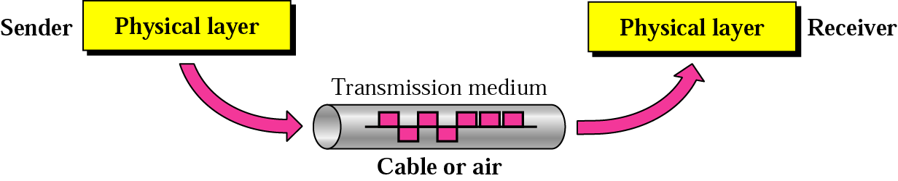

Transmission Media
1. Guided Media
- Twisted-Pair Cable: Shielded, unshielded
- Coaxial Cable
- Fiber-Optic
2. Unguided Media:
- Wireless Radio Waves
- Omnidirectional Antenna
- Microwaves
- Infrared

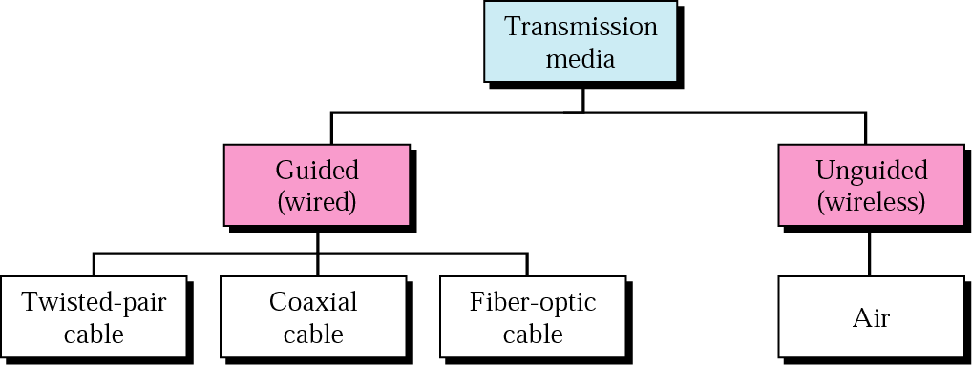

Guided Media – UTP, STP

• Twisted-Pair Cable

Twisted Pair - Transmission Characteristics
- Analog
- Amplifiers every 5km to 6km
- Digital
- Use either analog or digital signals – repeater every 2km or 3km
- Limited distance
- Limited bandwidth (1MHz)
- Limited data rate (100MHz)
- Susceptible to interference and noise
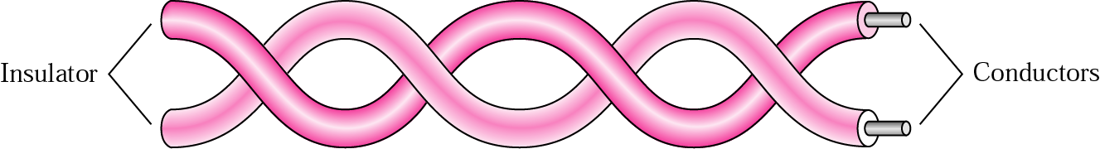

Unshielded and Shielded TP
• Unshielded Twisted Pair (UTP)
– Ordinary telephone wire – Cheapest
– Easiest to install
– Suffers from external EM interference

• Shielded Twisted Pair (STP)
– Metal braid or sheathing that reduces interference
– More expensive
– Harder to handle (thick, heavy)

Coaxial Cable - Transmission Characteristics
• Analog
– Amplifiers every few km – Closer if higher frequency – Up to 500MHz
• Digital
– Repeater every 1km
– Closer for higher data rates

Optical Fiber
• Greater capacity
– Data rates of hundreds of Gbps
• Smaller size & weight
• Lower attenuation
• Electromagnetic isolation
• Greater repeater spacing
– 10s of km at least
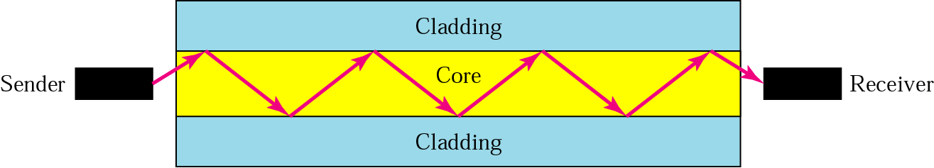

Unguided Transmission Media:

Wireless Transmission Media
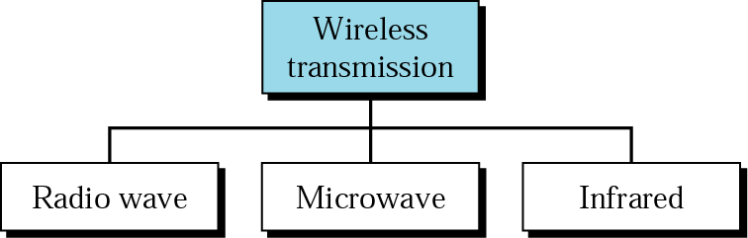

Broadcast Radio:
• Omnidirectional
• FM radio
• UHF and VHF television
• Line of sight
• Suffers from multipath interference
– Reflections

Infrared:
• Modulate noncoherent infrared light
• Line of sight (or reflection)
• Blocked by walls
• e.g. TV remote control, IRD port

Satellite Microwave:
• Satellite is relay station
• Satellite receives on one frequency, amplifies or repeats signal and transmits on another frequency
• Requires geo-stationary orbit – Height of 35,784km
• Television
• Long distance telephone
• Private business networks

_____________________________________________________________________________________

