Name : Awais Khan
ID : 16400
Programe: BBA
Semester : 2nd
Paper : Principle of Marketing
Submitted: Shoala Rasheed Khan

Q1. Explain a five-stage Buying decision process in detail? Must be in your own words.
Ans :

1. Problem/need recognition
This is often identified as the first and most important step in the customer’s decision process. A purchase cannot take place without the recognition of the need. The need may have been triggered by internal stimuli (such as hunger or thirst) or external stimuli (such as advertising or word of mouth)

2. Information search
Having recognised a problem or need, the next step a customer may take is the information search stage, in order to find out what they feel is the best solution. This is the buyer’s effort to search internal and external business environments, in order to identify and evaluate information sources related to the central buying decision. Your customer may rely on print, visual, online media or word of mouth for obtaining information.

3. Evaluation of alternatives
As you might expect, individuals will evaluate different products or brands at this stage on the basis of alternative product attributes – those which have the ability to deliver the benefits the customer is seeking. A factor that heavily influences this stage is the customer’s attitude. Involvement is another factor that influences the evaluation process. For example, if the customer’s attitude is positive and involvement is high, then they will evaluate a number of companies or brands; but if it is low, only one company or brand will be evaluated.

4. Purchase decision
The penultimate stage is where the purchase takes place. Philip Kotler (2009) states that the final purchase decision may be ‘disrupted’ by two factors: negative feedback from other customers and the level of motivation to accept the feedback. For example, having gone through the previous three stages, a customer chooses to buy a new telescope. However, because his very good friend, a keen astronomer, gives him negative feedback, he will then be bound to change his preference. Furthermore, the decision may be disrupted due to unforeseen situations such as a sudden job loss or relocation.

5. Post-purchase behaviour
In brief, customers will compare products with their previous expectations and will be either satisfied or dissatisfied. Therefore, these stages are critical in retaining customers. This can greatly affect the decision process for similar purchases from the same company in the future, having a knock-on effect at the information search stage and evaluation of alternatives stage. If your customer is satisfied, this will result in brand loyalty, and the Information search and Evaluation of alternative stages will often be fast-tracked or skipped altogether.
On the basis of being either satisfied or dissatisfied, it is common for customers to distribute their positive or negative feedback about the product. This may be through reviews on website, social media networks or word of mouth. Companies should be very careful to create positive post-purchase communication, in order to engage customers and make the process as efficient as possible.
Q2. Enlist different kinds of Segmentation? Explain the difference between geographic, demographic and geodemographic segmentation in detail with examples.
Ans :

What Is Market Segmentation?
Market segmentation is the process of dividing a target market into smaller, more defined categories. It segments customers and audiences into groups that share similar characteristics such as demographics, interests, needs, or location.

The Four Types of Market Segmentation
The four bases of market segmentation are:
- Demographic segmentation
- Psychographic segmentation
- Behavioral segmentation
- Geographic segmentation
Within each of these types of market segmentation, multiple sub-categories further classify audiences and customers.
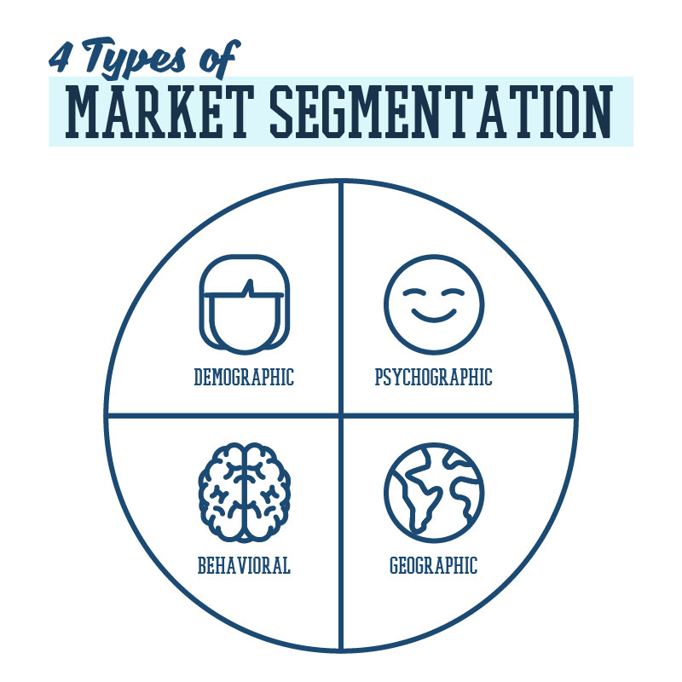

Demographic Segmentation
Demographic segmentation is one of the most popular and commonly used types of market segmentation. It refers to statistical data about a group of people.
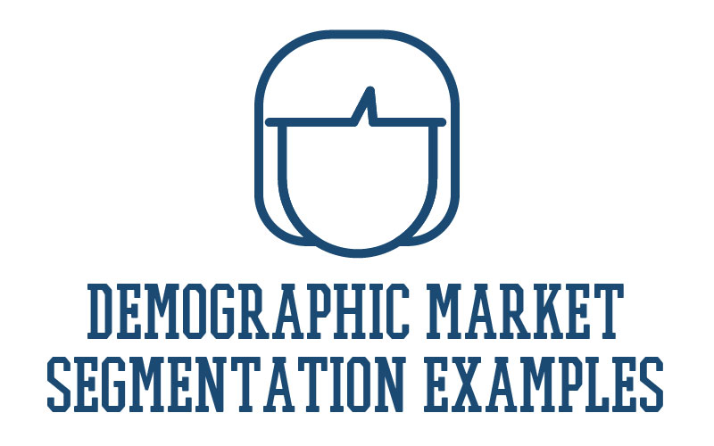
Demographic Market Segmentation Examples
- Age
- Gender
- Income
- Location
- Family Situation
- Annual Income
- Education
- Ethnicity
Where the above examples are helpful for segmenting B2C audiences, a business might use the following to classify a B2B audience:
- Company size
- Industry
- Job function
Because demographic information is statistical and factual, it is usually relatively easy to uncover using various sites for market research.
A simple example of B2C demographic segmentation could be a vehicle manufacturer that sells a luxury car brand (ex. Maserati). This company would likely target an audience that has a higher income.
Another B2B example might be a brand that sells an enterprise marketing platform. This brand would likely target marketing managers at larger companies (ex. 500+ employees) who have the ability to make purchase decisions for their teams.

Psychographic Segmentation
Psychographic segmentation categorizes audiences and customers by factors that relate to their personalities and characteristics.
Psychographic Market Segmentation Examples
- Personality traits
- Values
- Attitudes
- Interests
- Lifestyles
- Psychological influences
- Subconscious and conscious beliefs
- Motivations
- Priorities
Psychographic segmentation factors are slightly more difficult to identify than demographics because they are subjective. They are not data-focused and require research to uncover and understand.
For example, the luxury car brand may choose to focus on customers who value quality and status. While the B2B enterprise marketing platform may target marketing managers who are motivated to increase productivity and show value to their executive team.

Behavioral Segmentation
While demographic and psychographic segmentation focus on who a customer is, behavioral segmentation focuses on how the customer acts.
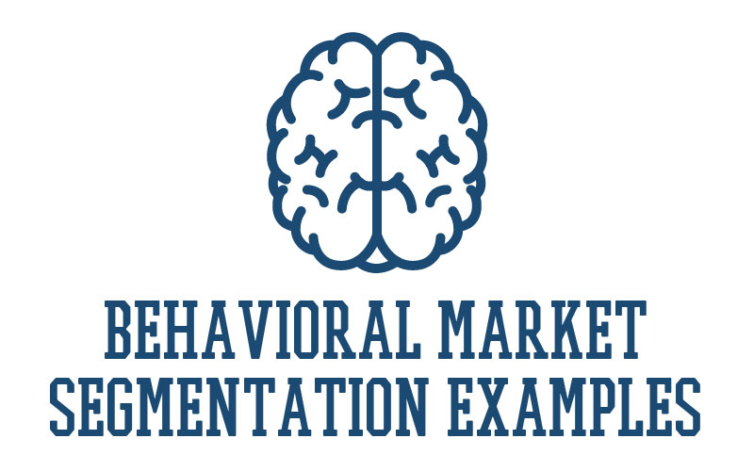
Behavioral Market Segmentation Examples
- Purchasing habits
- Spending habits
- User status
- Brand interactions
Behavioral segmentation requires you to know about your customer’s actions. These activities may relate to how a customer interacts with your brand or to other activities that happen away from your brand.
A B2C example in this segment may be the luxury car brand choosing to target customers who have purchased a high-end vehicle in the past three years. The B2B marketing platform may focus on leads who have signed up for one of their free webinars.

Geographic Segmentation
Geographic segmentation is the simplest type of market segmentation. It categorizes customers based on geographic borders.
Geographic Market Segmentation Examples
- ZIP code
- City
- Country
- Radius around a certain location
- Climate
- Urban or rural
Geographic segmentation can refer to a defined geographic boundary (such as a city or ZIP code) or type of area (such as the size of city or type of climate).
An example of geographic segmentation may be the luxury car company choosing to target customers who live in warm climates where vehicles don’t need to be equipped for snowy weather. The marketing platform might focus their marketing efforts around urban, city centers where their target customer is likely to work.
Q3. Explain the new Product Planning and development process in detail.
Ans :

Product Planning and Development:

This article throws light upon the seven main steps in product planning and development. The steps are: 1. Generation of New Product Ideas 2. Screening of Ideas 3. Product Concept Development 4. Commercial Feasibility 5. Product Development 6. Test Marketing 7. Commercialisation.

1. Generation of New Product Ideas:
The first step in product planning and development is generation of ideas for the development of new/innovative products.
Ideas may come from internal sources like company’s own Research and Development (R&D) department, managers, sales-force personnel etc.; or from external sources like, customers, dealers, competitors, consultants, scientists etc. At this stage, the intention of management is to generate more and more new and better product ideas; so that the most practical and profitable ideas may be screened subsequently.

2. Screening of Ideas:
Screening of ideas means a close and detailed examination of ideas, to determine which of the ideas have potential and are capable of making significant contribution to marketing objectives. In fact, generation of ideas is not that significant as the system for screening the generated ideas.
The ideas should be screened properly; as any idea passing this stage would cost the firm in terms of time, money and efforts, at subsequent stages in product planning and development.

3. Product Concept Development:
Those product ideas which clear the screening stage must be developed into a product concept – identifying physical features, benefits, price etc. of the product. At this stage product idea is transformed into a product concept i.e. a product which target market will accept.

4. Commercial Feasibility:
At this stage, the purpose is to determine whether the proposed product idea is commercially feasible, in terms of demand potential and the costs of production and marketing. Management must also ensure that product concept is compatible with the resources of the organization technological, human and financial.

5. Product Development:
Product development encompasses the technical activities of engineering and design. At this stage, the engineering department converts the product concept into a concert form of product in view of the required size, shape, design, weight, colour etc. of the product concept.
A model or prototype of the product is manufactured on a limited scale. Decisions are also made with regard to packaging, brand name, label etc. of the product.

6. Test Marketing:
A sample of the product is tested in a well-chosen and authentic sales environment; to find out consumers’ reaction. In view of consumers’ reactions, the product may be improved further.

7. Commercialisation:
After the management is satisfied with the results of test marketing, steps are taken to launch a full-fledged programme for the production, promotion and marketing of the product. It is the stage where the new product is born; and it enters it life cycle process.

Q4. What is a product? Explain its different types in detail with examples.
Ans.
Product: Product is one of the important elements of marketing mix. A marketer can satisfy consumer needs and wants through product. A product consists of both good and service. Decisions on all other elements of marketing mix depend on product. For example, price is set for the product; promotional efforts are directed to sell the product; and distribution network is prepared for the product. Product is in the center of marketing programme. Therefore, product has a major role in determining overall success of marketing efforts.
A marketer tries to produce and sell such products that satisfy needs and wants of the target market. Other words used for product are good, commodity, service, article, or object. In marketing literature, product has comprehensive meaning.
Let us examine some standard definitions:
1. Philip Kotler:
“Product is anything that can be offered to someone to satisfy a need or a want.”
2. William Stanton:
“Product is complex of tangible and intangible attributes, including packaging, colour, price, prestige, and services, that satisfy needs and wants of people.”
3. W. Alderson:
“Product is a bundle of utilities, consisting of various product features and accompanying services.”

Types of Product:
They can be classified into two groups, such as:
1. Consumer Product, and
2. Industrial Products

1. Consumer Products:
Consumer products are those items which are used by ultimate consumers or households and they can be used without further commercial and engineering processes.
Consumer products can be divided into four types as under:
i. Convenient Products:
Such products improve or enhance users’ convenience. They are used in a day-to-day life. They are frequently required and can be easily purchased. For example, soaps, biscuits, toothpaste, razors and shaving creams, newspapers, etc. They are purchased spontaneously, without much consideration, from nearby shops or retail malls.
ii. Shopping Products:
These products require special time and shopping efforts. They are purchased purposefully from special shops or markets. Quality, price, brand, fashion, style, getup, colour, etc., are important criteria to be considered. They are to be chosen among various alternatives or varieties. Gold and jewelleries, footwear, clothes, and other durables (including refrigerator, television, wrist washes, etc.).
iii. Durable Products:
Durable products can last for a longer period and can be repeatedly used by one or more persons. Television, computer, refrigerator, fans, electric irons, vehicles, etc., are examples of durable products. Brand, company image, price, qualities (including safety, ease, economy, convenience, durability, etc.), features (including size, colour, shape, weight, etc.), and after-sales services (including free installation, home delivery, repairing, guarantee and warrantee, etc.) are important aspects the customers consider while buying these products.
iv. Non-durable Products:
As against durable products, the non-durable products have short life. They must be consumed within short time after they are manufactured. Fruits, vegetables, flowers, cheese, milk, and other provisions are non-durable in nature. They are used for once. They are also known as consumables. Mostly, many of them are non-branded. They are frequently purchased products and can be easily bought from nearby outlets. Freshness, packing, purity, and price are important criteria to purchase these products.
v. Services:
Services are different than tangible objects. Intangibility, variability, inseparability, perishability, etc., are main features of services. Services make our life safe and comfortable. Trust, reliability, costs, regularity, and timing are important issues.
The police, the post office, the hospital, the banks and insurance companies, the cinema, the utility services by local body, the transportation facilities, and other helpers (like barber, cobbler, doctor, mechanic, etc.,) can be included in services. All marketing fundamental are equally applicable to services. ‘Marketing of services’ is the emerging facet of modern marketing.

2. Industrial Products:
Industrial products are used as the inputs by manufacturing firms for further processes on the products, or manufacturing other products. Some products are both industrial as well as consumer products. Machinery, components, certain chemicals, supplies and services, etc., are some industrial products.
Again, strict classification in term of industrial consumer and consumer products is also not possible, For example, electricity, petroleum products, sugar, cloth, wheat, computer, vehicles, etc., are used by industry as the inputs while the same products are used by consumers for their daily use as well.
Some companies, for example, electricity, cements, petrol and coals, etc., sell their products to industrial units as well as to consumers. As against consumer products, the marketing of industrial products differs in many ways.
Industrial products include:
1. Machines and components
2. Raw-materials and supplies
3. Services and consultancies
4. Electricity and Fuels, etc.

