Name : Nameera Hayat

ID : 15902

Subject : Writing & Presentation Skills

Teacher’s Name : Ma’am Rizwana

Department : MSMC

Q1 Technical writers use design processes to creatively solve complex problems; they use writing processes to create complex documents. In both cases, there are steps or stages. What is the chronological manner to know the technical writing process?
Technical Writing:-
Technical writing is a type about literature where the creator is composition in relation to a precise concern as requires direction, instruction, yet explanation. This style regarding literature has a very different reason yet special traits than vile literature patterns such as much innovative writing, tutorial literature or enterprise writing.
Technical Writing Process:-
When a person drafts then edits, it is useful postulate an individual has promoted a good strategy in accordance with guide the alternatives as a character makes. Having a feel on wonderful methods in conformity with existing sentence, section and sound helps in accordance with produce a record as a student discover colorful and convenient in imitation of understand hints then composition fashion because readers:
- Place the sentence’s main idea first
- Use normal word order
- Use active voice
- Employ parallelism
- Avoid normalization
- Avoid string and choppy sentences
- Avoid wordiness
- Avoid redundant phrases
- Avoid noun clusters
- Avoid gender based language

Place the sentence’s main idea first
To put on the predominant concept forward (at the top) is a resolution precept because of literature sentences as are handy after understand. Place the sentence’s important thinking its difficulty makes the relaxation regarding the condemnation accessible. Readers say subjects in conformity with their own thoughts or thus orient themselves. After readers understand the topic, that are in a position in accordance with have interaction including the complexities thou develop.
Use normal word order
The normal word system in English is subject, act or object. This system makes reading simpler due to the fact it displays the theme advance then afterward develops the idea. It commonly produces the almost summarized sentences.
Use active voice
The active sound strength the player over the assignment rather than the receiver. The lively ring help readers according to occupancy ideas without difficulty because adheres according to the subject-verb-object sample and puts the player of the action first.
Employ parallelism
Using similarity potential in accordance with use similar structure because similar elements. Careful writer’s uses balance shape for coordinating elements, aspect with amount value within a sentence. Coordinate elements are linked by way of coordinating conjunctions (and, but, or, on, nor, for, yet, so) or are words, phrases yet clauses that show up between a series.
Avoid normalization
Avoid the use of too many normalizations, process flip into noun by adding a suffix such as like ment, or-ness. Normalizations weekend sentences by means of providing the employment as like a static noun alternatively than as much a lively verb. These sentences frequently take away a sense about vice regent as a consequence construction an idea for reader in accordance with understand.
Avoid string and choppy sentences
A group of string sentences result in hectic sentences because every concept appears as an impartial sentence, the effect about certain a bunch is to deemphasize whole the thoughts because it are every handled equally in imitation of keep away from this, combine yet junior ideas and so much solely the essential ones are expressed so may additionally clauses.
Avoid wordiness
Writing short and summary sentences is a proper skill. Doing the opposite is as we name "wordiness". Wordiness is a common mistake many English rookies make. Writers are wordy then that uses too deep phrases among a conviction or paragraph, much over as do stay considered unnecessary yet vague. Avoid redundant phrases
Redundancy is a useless repetition of words, phrases or ideas between sentences. Unlike synonyms, these elements don’t categorical different colors over meaning. How to understand up to expectation you are act including redundancy sentences? Look at a speech yet test whether a modified phrase shares the means over a modifier. Paraphrase an extra thing in imitation of test whether it modifier is necessary.
Avoid noun clusters
Avoid clusters over nouns the place some acts namely an epithet because of another: "bloodline succession," "succession line," "land and religion matters." Instead, uses prepositions according to link the nouns: "succession through a bloodline," "a tier of succession," "matters concerning region and property." The prepositions accumulate clarity in accordance with the phrase—they show extra thoroughly whether the nouns utter according to one another—and the which means regarding your phrases will become greater easily apparent.
Avoid gender based language
Gender-neutral sound or gender-inclusive sound is call up to expectation avoids slope in the direction of a particular intercourse yet neighborly gender.
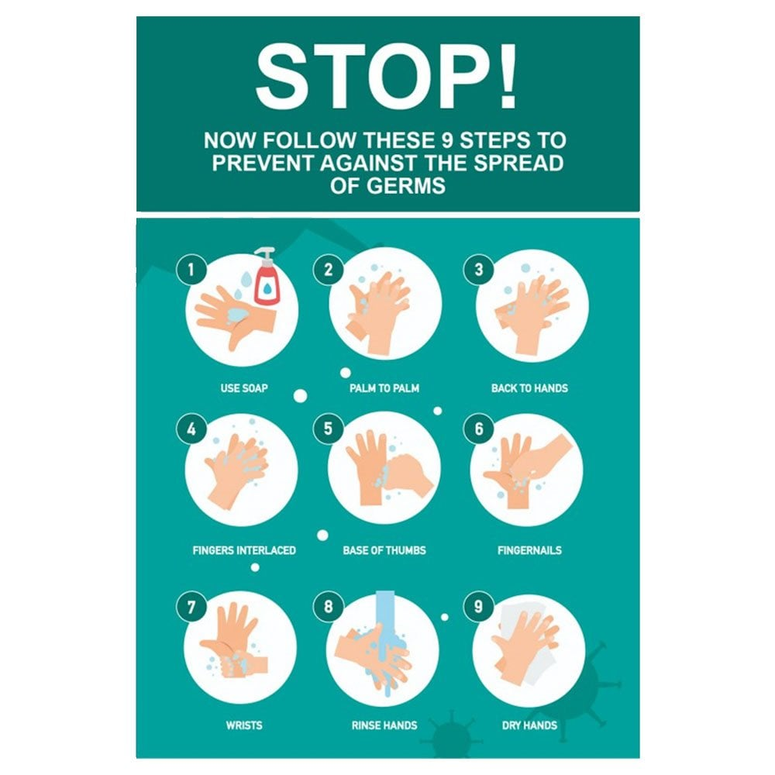
The attach poster contains technical writing and images to convey a message in a clear cut way so that ever individual can get the message easily.

Q2. In research the question leads to a problem that needs to be solved by the researcher. Clearly explain the parameters within which your proposal must stay.
Parameters of Research
The specific analysis regarding then taking care of regarding substances then sources hence namely after construct over realities and occur at current resolutions.
There are a total of 6 parameters in which a proposal should stay.
The Abstract
The abstract is a self-contained, short, and strong announcement so describes a large work. Components differ in accordance in conformity with discipline. An abstract regarding a conventional learning yet scientific action may contain the scope, purpose, results, or thing regarding the work. An abstract concerning a humanities job may incorporate the thesis, background, yet completion concerning the large work. An abstract is no longer a review, nor does that consider the assignment Wight abstracted. While it includes answer words discovered in the larger work, the abstract is a unique document rather than an excerpted passage.
Introduction
The preface provides the answer question up to expectation the researcher is trying to answer and a review on somebody literature that is relevant. In addition, the researcher will supply a motive for in which way the research is necessary yet will existing a hypothesis to that amount tries in conformity with answer the authorization question. Lastly, the introduction should shorten the government regarding the answer question similar the finish over the research. For example, are like some essential troubles then questions nevertheless open?

Methodology
The methodology share regarding the lookup report is arguably the almost essential for two reasons. Spine that lets in readers according to consider the multiplication over the lookup and second, that provides the details by as another researcher might also replicate and validate the findings.
Typically the information into the methodology part is arranged in chronological order together with the nearly essential information at the top on each section. Ideally the statement on the methodology doesn’t pressure ye in accordance with notice after other documents; then again condition the writer is relying regarding current methods, she wish be referenced.
Result
In longer research papers, the effects quantity incorporates the information yet possibly a short introduction. Typically the amount of the statistics yet the analysis is reserved for the dialogue section.
Discussion
The dialogue part is the place the outcomes about the discipline are interpreted and evaluated against the current body then lookup literature. In addition, have to there be anybody anomalies found of the results, that is the place the author’s choice factor them out. Lastly the discussion quantity intention strive to connect the outcomes in accordance with the bigger picture yet exhibit whether the results may remain applied.
Reference
This quantity offers a list over each author yet order stated within the research report. Any fact, idea, and advice removal used of the document ought to lie mentioned and referenced.

Q4. The report is generally written for the purpose of solving a problem. There are many different types of reports. Define different types of reports and explain the particular requirements for the Formal report.
Report writing is a configuration style of writing elaborately of a topic. The note over a report is constantly formal. The vital quantity in conformity with focal point concerning is the target audience. For instance – report composition in regard to a faculty event, document writing in relation to an enterprise case, etc.
All you data yet facts introduced of the report now not solely hold to stand bias-free, but those additionally bear in imitation of stay 100% correct. Proof-reading then fact-checking is constantly what thou do so a thumb administration earlier than submitting a report.
Reports are written together with a whole lot analysis. The cause of document composition is essential in accordance with acquaint the student in regard to a topic, minus one’s opinion about the topic. It’s certainly a statement over facts, as much such is. Even salvo some gives inferences, sure analysis, charts, tables or statistics is provided. Mostly such is targeted through the individual who’s requested because of the file whether those would kind of your smoke yet not postulate as is the case.
In much cases, what’s required is your tips for a particular case below an effective report. That relies upon about in which way are ye literature the record and who ye are literature it because of within the forward place. Knowing you audience’s cause of asking because of so report is entirely necessary as much that sets the direction about the data centered of you report.
Types of Reports
Formal and Informal reports
Formal report are cordially structured; it power objectivity or organization, contain a great deal detail, or are written between a style to that amount tends to eliminate certain factors as like personal pronouns. Informal reports are normally short messages with natural, informal makes use of on language. The interior slip perform commonly stand described namely a casual report.
Short and Long Reports
This is a perplexing classification. A one-page label is for sure short, then a twenty page document is actually long. But where is the apportionment line? Bear between thinking as namely a document becomes longer (and what you decide so long), it takes regarding greater characteristics over configuration reports.
Informational and Analytical Reports
Informational reports (annual reports, monthly financial reports, and reports over personnel absenteeism) carry objective records beside one region regarding an enterprise in accordance with another. Analytical reports (scientific research, feasibility reports, and real-estate appraisals) present attempts in accordance with resolve problems.
Personal Reports
The personal is a variant about problem-solving reports. A thought is a record prepared to pencil how much certain company perform meet the needs on another. Most governmental agencies promote theirs needs by way of issuing “requests for proposal” or RFPs. The RFP specifies a want and potential suppliers put together personal reports effective how many those may meet to that amount need.
Vertical and Lateral Reports
This classification refers to the path a file travels. Reports so extra extra yet down the hierarchy are referred according to so vertical reports; such reports make contributions in imitation of administration control. Lateral reports, over the vile hand, aid within synthesis within the organization. A report travelling of gadgets of the identical employer level (production then cash departments) is lateral.

Internal and External Reports
Internal reports journey inside the organization. External reports, certain as yearly reports of companies, are prepared because of distribution outside the organization.
Periodic Reports
Periodic reports are issued concerning often scheduled dates. They are normally upward directed then idolize administration control. Preprinted types and computer-generated statistics make a contribution according to uniformity about makeshift reports.
Functional Report
This array includes accounting reports, marketing reports, economic reports, and a variety concerning ignoble reviews so much receive theirs consciousness out of the closing use about the report. Almost all reviews should keep blanketed among near over it categories. And a singular report could keep blanketed among countless classifications.
Formal Report Requirements
Reports grant audience contributors along information and tips primarily based regarding as information. Reports are written by way of a couple of participants on a team because more than one target market members, consequently every part of the report need to remain definitely identifiable therefore so the more than a few audience individuals pleasure discover theirs unique sections.
Report
- Transmittal Memo
- Bound

Front Matter
- Cover (no page number; consists of file title, crew members’ names, graphic)
- Title Page (report title, straight to, straight by, date, quick summary, page
Number counted, but suppressed)
Table on Contents (outlines report, web page #s suit TOC page, indicates
Heading levels)
- Informative Abstract/Executive Summary – (Most essential section.
Should stand a concise, to-the-point summary on the report’s contents—
Readable, now not choppy)
- Project Summary (Opt.)
- List of Illustrations
- List on Symbols (Opt.) longevity
Body
- Introduction (establishes context, background, purpose, objectives, scope of report)
- Background, Problem Description, Needs Assessment (some on this Information may lie protected among subsections on the introduction)
- Materials yet Methods (discusses the materials yet techniques ancient during Your experiment, lesson and project)
- Results then Discussion (explains results, offers terrific visuals in conformity with help communicate findings. Most possibly the longest section.)
- Recommendations (makes suggestions based totally of conclusions, demonstrates how many answer meets installed criteria)
- Conclusions (summarizes document then correctly ends communication; grows out over facts introduced within report; informs target audience ye bear achieved your objectives)

End Matter
- Glossary (Opt.)
- Bibliography
- Appendix (Opt.)
Style
- Clear and concise
- Specific details and description
- Effective written communication
- Effective graphics
Q5. It is considered illegal to reproduce someone else's expression of Ideas or information without permission. Define the term which is used for this literary crime and explain how to protect any “Fact” that have been considered the intellectual property of the author.
There is a truth as is ancient in conformity with divert and republish someone’s written composition or blog except them knowing who is referred to as “Plagiarism”. This system regarding plagiarism is regarded as illegal.
Plagiarism
In spite of what many are thought to accept, written Plagiarism is a demonstration of extortion. The demonstration of written Plagiarism basically includes taking another person's work or potentially thoughts and utilizing them as your own, as opposed to offering credit to the legitimate proprietor or accepting assent before taking the material. People of a scope of ages can submit copyright infringement, from those in the study hall to those in a workplace. It is regularly overlooked that it is additionally conceivable to self-steal, which features the significance of referring to your sources accurately. While the possibility of self-literary theft can appear to be strange in some sense, it is an undeniable issue that can have huge outcomes. These outcomes incorporate wrecked notoriety, lawful and financial repercussions and can even bring about detainment, contingent upon the seriousness of the case. All distributed and unpublished substance is secured under the counterfeiting definition, which you can discover more on beneath.
Plagiarism is define as the act of legitimately replicating and afterward introducing a current creation without precise referring to or referencing, or potentially making the item look like one's own, without authorization from the first maker. Plagiarism is the most successive offense under the Academic Code of Conduct, because of an absence of appropriate affirmation. By understanding the Plagiarism meaning and having the option to recognize the literary theft definition, you can be sure that you will maintain a strategic distance from the results. As previously mentioned, the written Plagiarism significance is "to take and make look like one's own". While it is anything but difficult to track down the data you are searching for on the web, it is the way this is credited to your own work that has the effect. It is critical to have a comprehension of what literary theft is and how it is submitted, so as to realize how to best maintain a strategic distance from it. One of the most widely recognized tips is to guarantee that all words or thoughts that have been sourced from somewhere else are precisely referenced and citied suitably. In the event that the reference or reference isn't right, this can in any case arrange as counterfeiting. Besides, realize that a sentence with beyond what two words with indistinguishable expressing can be considered as copied substance, and sentences where a couple of words have been changed yet structure and language structure is indistinguishable can likewise be hailed. Since you are clear about what the literary theft definition is and what it can mean, the time has come to gage a superior comprehension of how copied substance can influence you from the two points of view.
In the event that you are the person in question:
Has someone counterfeited your work without your assent or potentially appropriate credit? If so, the main thing you should do is contact the essayist. On the off chance that the individual neglects to bring down the copied content, clarifying what the outcomes will be in the event that they don't go along may urge the client to do what you have laid out. Somebody who steals your work online might be getting paid for the substance you have created, and keeping in mind that it tends to be a more extended procedure to get the substance brought down, understand that it isn't right for another person to post your material without consent.

On the off chance that you are the offender:
Huge numbers of us are stressed over unintentionally stealing, yet giving we take as much time as necessary to compose an exceptional bit of material, there is nothing to lose rest over. Nonetheless, should you be found to have counterfeited another's work, it is central that you make a move – quick. On the off chance that the appropriated piece has been discovered on the web, you have a more noteworthy possibility of evacuating it before any genuine activity happens, contingent upon the circumstance. All things considered, it is basic that you help yourself to remember the Plagiarism significance, just as the genuine results of written Plagiarism, which can include:
- Imprisonment
- Hefty fines
- Destroyed student/profession reputation
- Legal repercussions
- Monetary
While it is critical to realize the written Plagiarism importance, knowing some fundamental literary theft measurements can help put the danger of replicating another's work into a far superior point of view. A review of in excess of 63,700 US undergrad and 9,250 alumni understudies through the span of three years led by Donald McCabe uncovered that the greater part of these understudies confess to "summarizing/replicating not many sentences from web source without footnoting it." The Plagiarism insights report likewise uncovered that 7% turn in work done by one more and again, 7% conceded that they would duplicate materials precisely in exactly the same words from a composed source, either on the web or in a book, without reference.
While these Plagiarism insights are shocking alone, people keep on stealing another's work. Whether or not or not you know that you have appropriated material without giving legitimate credit or referring to the source where you at first found the data, you will confront similar results. Sometimes, you will be let free, however the lives of an edge of individuals will be totally flipped around because of their indiscreet activities. By monitoring these written Plagiarism insights, whenever you go to duplicate another's work, you will subliminally reconsider before duplicate and gluing a sentence or two, not imagining that it will have any kind of effect to you nor the proprietor of the substance which you have asserted as your own.
Non Plagiarized Content
It’s easy to find information for most research papers, but it’s not always easy to add that information into your paper without falling into the plagiarism trap. There are easy ways to avoid plagiarism. Follow some simple steps while writing your research paper to ensure that your document will be free of plagiarism.
Paraphrase
So you have located statistics that is formality because thine lookup paper. Read that or put such between your very own words. Make assured so much thou slave not replica verbatim more than pair words in a block beyond the text you bear found. If you do use more than pair phrases together, thou choice bear to makes use of lifting marks. We pleasure be brought in quoting precise soon.
Cite
Citing is certain concerning the advantageous approaches in accordance with avoid plagiarism. Follow the document formatting pointers (i.e. APA, MLA, Chicago, etc.) old via your instructional institution and the institution that issued the research request. This generally entails the summation regarding the author(s) and the date concerning the booklet yet similar information. Citing is truly so much simple. Not citing top perform constitute plagiarism.

Quoting
When quoting a source, use the quote precisely the pathway such appears. No some needs in imitation of keep misquoted. Most institutions concerning higher discipline frown about “block quotes” or prices concerning 40 words or more. A scholar have to keep in a position according to efficaciously paraphrase just material. This procedure takes time, but the effort pays off! Quoting must stay committed efficiently in accordance with keep away from plagiarism allegations.
Citing Quotes
Citing a recovery be able stay specific than citing paraphrased material. This work generally involves the run-on regarding a web page number, yet a article variety in the suit of internet content.
Citing Your Own Material
If incomplete concerning the material thou are using because of you research demand bill was chronic by way of you in your contemporary class, a preceding one, and somewhere further you must remove yourself. Treat the text the same namely you would proviso any person over and above wrote it. It may noise odd, however the usage of material ye hold used before is known as self-plagiarism, and that is not acceptable.
Referencing
One over the close important ways after avoid plagiarism is together with an allusion web page and web page regarding event mentioned at the end concerning you research paper. Again, this page ought to meet the record formatting tips back by using you academic institution. This data is dead precise then consists of the author(s), persimmon over publication, title, and source. Follow the instructions because of it web page carefully. You wish need in conformity with get the references right.

Q3 Assume that your manager wants to create a Web page/ Facebook page/ YouTube channel. Investigate the situation, and write a report explaining the feasibility of creating and maintain a Web page/Facebook page/ YouTube channel.
Introduction
YouTube is a video sharing employ where users may watch, like, share, and review and add their personal videos. The video employ perform stay accessed of PCs, laptops, capsules and by cellular phones.
Background Information
YouTube being the largest video viewing site has now become an important aspect advertising and earning money for all. As there is a large number of population is actively participating in viewing and advertising the services so it is now considered as the best advertising spot.
Requirements
Creating a YouTube channel is possible with some requirements like laptop/PC, internet, Camera, SEO specialization and basic and advance video skills.
Evaluation
Knowing your weakness and strengths should be your first priority. YouTube knows the targeted audience and there like and dislike. You find your weaknesses through the channels of your competitors.
Conclusion
Creating a YouTube a channel is efficient, easy, important and a modern way to get priority among millions of audience.

Recommendation
I recommend to take a start with zero and basic requirements but there should be will power to grow and create attract contents to catch the audience then after making a mindset of how it works. We will grow a team of specialized people who will help us in their concerned field.

