Name Ahmad Ilyas
Roll No 16188
Paper Mechanics of material
Teacher Marvan Sir
Semester 2nd Btech (civil)
Q No 1; Steel railroad reels 10 m long are laid with a clearance of 3 mm at a temperature of 25°C. At what temperature will the rails just touch? What stress would be induced in the rails at that temperature if there were no initial clearance? Assume α = 11.7 µm/(m·°C) and E = 250 GPa.
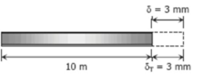
Sol;
Temperature at which $δt$ = 3mm
$δt=$ $αL \left(∆T\right)$
$δt= αL (Tf-Ti)$
3 = (11.7 * 10power -6)(10000)(Tf – 25)
Tf = 50 $℃$
Required stress;
$δ=δt$
$σ\frac{L}{E}= α$ L ($∆T)$ = $αE \left(Tf-Ti\right)=$(11.7*10pwr -6)(250000)(50 -25)
$σ=$ 73 MPa
………………………………………………………………………………………………………………………
………………………………………………………………………………………………………………………
Q No 2; A steel rod is stretched between two rigid walls and carries a tensile load of 5000 N at 20°C. If the allowable stress is not to exceed 200 MPa at -40°C, what is the minimum diameter of the rod? Assume α = 11.7 µm/(m·°C) and E = 200 GPa.
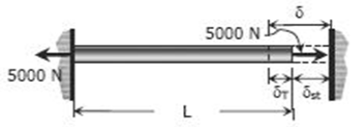
Sol;
$δ= δt+ δst$
$\frac{σL}{E}= αE\left(∆T\right)+PL/AE$
$σ=αE\left(∆T\right)+P/A$
200=(11.7*10 pwr -6)(200000)(60)+5000/A = 59.9
A = 5000/59.9 = 83.47mm2
1/4$πd2$= 83.47; d = 10.13 mm
……………………………………………………………………………………………………………….
……………………………………………………………………………………………………………….
Q No 5; Find Shear force and bending moment diagram of given beam.
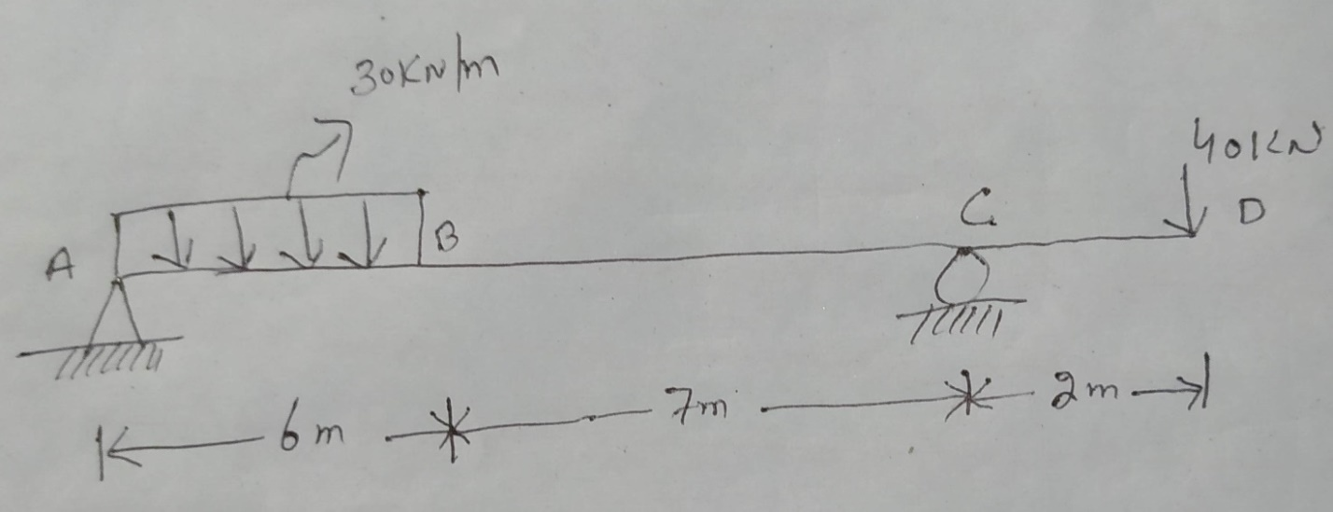
Sol;
Find reactions at A And B
Taking moment at A
3*180 = RC * 13
RC = 180*3/13 = 42KN
Now;
RA + RC =180
RA= 180- 42 = 138 KN ………………………………Ans
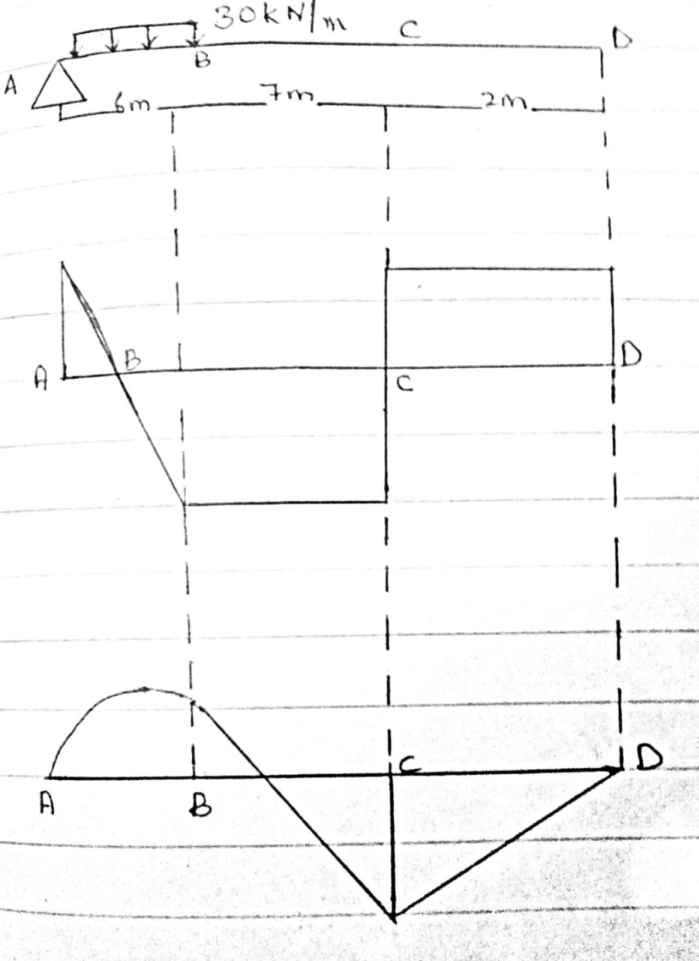

……………………………………………………………………………………………………………………..
……………………………………………………………………………………………………………………..
Q No 4; A column is used to support an axial compressive load. The length is 30 feet. The column is shown in the figure. The ends of column are fixed. Find the critical buckling load. Take E = 31000ksi and I = 1540 in4. Also find the slenderness ratio if the area of the column is equal to 160 in2.

Given data;
Length = 30 ft
I = 1540 in4
E = 31000 ksi
A = 160 in2
Sol;
We know that
F = n$π2\frac{EI}{L2}$
Here both ends are fixed so , n = 4
F = (4)(3.142)2 (31000)(1540) / (30*12)2
F = 1451354 klb
F = 1.45*10 pwr4 Klb
Also find cyclindrial ratio = ?
Cyclindrical ratio = L/r
A = $πr2$
160 = 3.142* (r)2
(r)2 = 160 / 3.142 =50.96
Taking $\sqrt{}on b.s$
$\sqrt{r }2=$ $\sqrt{50.96}$
r = 7.138 in
Now
Cyclindrial ratio = L/r = 30 * 12/ 7.138 = 50.434…………………………………………Ans
……………………………………………………………………………………………………………….
……………………………………………………………………………………………………………….
Q No 3; External and internal diameters of a propeller shaft are 600mm and 300mm respectively. Find maximum shear stress developed in the cross section when a twisting moment of 60 KN-m is applied. If span of shaft is 5m, also find twisting angle of shaft. Take modulus of rigidity, G = 0.8*10³ N/mm2.
Given data;
D = 600 mm
d = 300 mm
T = 60 KN-m
L = 5m
Sol;
As we know that
T = $π$ /16 *$τ$ * D(pwr 4) – d(pwr 4) / D
60*1000000 = 3.142 / 16 * $τ$ * 600(4) – 300(4) / 600
$τ$ = 0.66 KN / mm2
$\frac{τ}{R}-\frac{Gθ}{L}……………………$R –D/2 = 600/2 = 300mm= 0.0176 radians
………………………………………………………………………………………………………………………..
………………………………………………………………………………………………………………………..

