NAME: UROOJ ALTAF
DEPARTMENT: BS MICROBIOLOGY
SEMESTER: 4TH SEMESTER
SUBJECT: BACTERIAL GENETICS
ID NUMBER: 14888

ASSIGNMENT FOR VIVA:
Q: Select any one topic related to related to bacterial diseases give it brief introduction, importance of why you select this topic and risk or hazard of this topic for humanity

Tuberculosis:
Introduction:
- Tuberculosis (TB) is a disease caused by bacteria called Mycobacterium tuberculosis. The bacteria usually attack the lungs, but they can also damage other parts of the body.

- TB spreads through the air when a person with TB of the lungs or throat coughs, sneezes, or talks. If you have been exposed, you should go to your doctor for tests. You are more likely to get TB if you have a weak immune system.

- Symptoms of TB in the lungs may include:
- A bad cough that lasts 3 weeks or longer
- Weight loss
- Loss of appetite
- Coughing up blood or mucus
- Weakness or fatigue
- Fever
- Night sweats

Diagnosis:
Skin tests, blood tests, x-rays, and other tests can tell if you have TB. If not treated properly, TB can be deadly. You can usually cure active TB by taking several medicines for a long period of time.

Risk factors:
- You are at risk of TB infection if:

- You are around people with active TB disease who are coughing, which releases bacteria into the air.

- The risk of infection increases for intravenous drug users, healthcare workers, and people who live or work in a homeless shelter, migrant farm camp, prison or jail, or nursing home.

- Most people who are infected with the bacteria that cause TB do not develop active disease.

- The following factors increase the risk that latent disease will develop into active disease:

- Infection with HIV, the virus that causes AIDS and weakens the immune system

- Diabetes mellitus

- Low body weight

- Head or neck cancer, leukemia, or Hodgkin's disease

- Some medical treatments, including corticosteroids or certain medications used for autoimmune or vasculitic diseases such as rheumatoid arthritis or lupus, which suppress the immune system.

- Silicosis, a respiratory condition caused by inhaling silica dust.
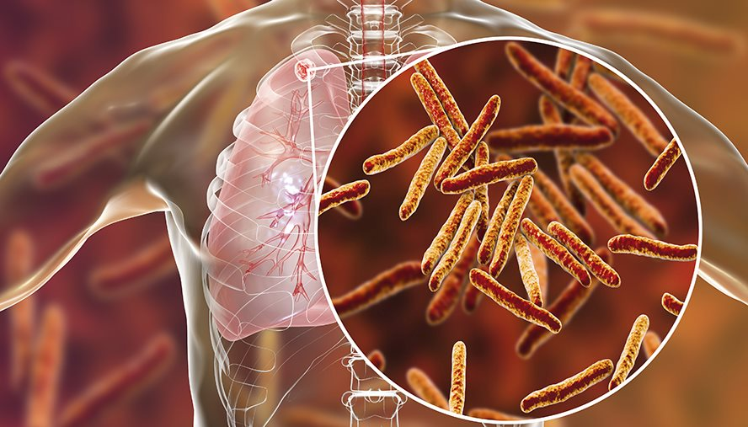

Reason of selecting this topic:
I selected this topic because Tuberculosis (TB) remains one of today’s global health challenges, ranking as the second leading infectious cause of death and one of the most burden-inflicting diseases in the world. The 2014 WHO Global Tuberculosis Report estimated a worldwide incidence of 9.0 million new cases and 1.5 million deaths in 2013.

The end

