Sara Amir
14135

Q#1
Organizations as a rule make an arrangement for dicey obligation to accommodate farfetched obligations. "Arrangement for farfetched obligations or recompense for terrible obligations or un-collectible records express the extent of exchange receivables that the business expects, yet may not be recuperated".

Explanation:
The arrangement should show the feasible size of things to come awful obligations. This is deducted from the exchange receivables figure on the accounting report in order to give a more sensible figure for the sums liable to be gathered.
Types:

There are following two sorts of arrangement for dubious obligations or stipend for awful obligations:
(1) General Provision for Doubtful Debts:
The expression "general" is utilized when there is no reasonable proof what exchange receivable won't clear his obligation. This is generally communicated as a % of shutting exchange receivables and is normally evaluated based on past pattern and future assumption regarding the receivables and other winning conditions.

(2) Specific Provision for Doubtful Debts:
"Specific" implies that there is clear narrative proof like prosecution and different discoveries that show that a specific exchange receivable may turn terrible (hopeless). The formation of this arrangement depends on evaluating the exchange receivables on singular premise. The bookkeeping treatment of a particular arrangement is equivalent to apply for the overall arrangement.

Computation:

The accompanying variables are considered to ascertain the arrangement for farfetched obligations:

(an) Economic atmosphere – recurrence of business disappointment

(b) Past record of each exchange receivable and the measures of obligations exceptional from every client

(c) How long every obligation has been exceptional

Bookkeeping Treatment for Provisions in Financial Statements:

The impacts of arrangement for dubious obligations in fiscal reports might be summarized as follows:

(1) Income Statement: Only change (increment or lessening) in arrangement for dubious is appeared in the salary articulation. At the point when increment at that point cost (deducted from benefit) and when decline then salary (included benefits).

(2) Balance Sheet: Total measure of arrangement at year end is deducted from exchange receivables.

General Journal Entries – Provision for Doubtful Debts:

The strategy for the chronicle of the arrangement for farfetched obligations is demonstrated as follows:

Section 1: Creation of arrangement for farfetched obligations:

Charge (Dr) Income proclamation

Credit (Cr) Provision for dicey obligations

Section 2: Recording increment in arrangement for farfetched obligations:

Charge (Dr) Income proclamation

Credit (Cr) Provision for dicey obligations

Section 3: Recording decline in arrangement for farfetched obligations:

Charge (Dr) Provision for dicey obligations

Credit (Cr) Income proclamation

Comprehended Example 1:

A business makes an arrangement of $3000, which was 2% of all his exchange receivables, and a further expected loss of $1200, the aggregate sum owed by one of its clients, Franklin, who had been proclaimed bankrupt.

Required:

Decide the measure of general and explicit arrangement for dubious obligations?

Arrangement:

General arrangement is $3000, though explicit arrangement is $1200 and all out arrangement for farfetched obligations would be made at $4200.

Tackled Example 2 – (Balance Sheet Extract):

Year 1: Assuming in year 1, we have to make an arrangement for suspicious obligations @ 10% of exchange receivables which were $800000. The first section is:

Arrangement for suspicious obligations 1:

Year 2: At the finish of year 2, we have looked into our exchange receivables which were $900000 at that date and chosen to make the arrangement again at the pace of 10% of exchange receivables. This change will build the arrangement by $10000 [(900000 x 10%) – $80000]. It would be recorded as:

Arrangement for suspicious obligations 2:

Year 3: At the finish of year 3, we have again checked on our receivables which were $720000 and arrangement was required to be at the pace of 10%. So it will diminish by $18000 [($720000 x 10%) – $90000]. It would be recorded as:

Arrangement for dicey obligations 3

Required:

Impacts of arrangement for dicey obligations in budget summaries or relevant salary proclamation and accounting report separates for a long time.

Arrangement:

Impacts in Income Statement:

For year 1: Profit is brought down by $80000

For year 2: Profit is brought down by $10000

For year 3: Profit is expanded by $18000

So in three years, generally benefit is brought down by $80000 + $10000 – $18000 = $72000

Impacts to be decided Sheets:

Toward the finish of year 1:

Arrangement of dubious obligations model 2 resources

Toward the finish of year 2:

Arrangement of suspicious obligations model 2 resources for year 2

Toward the finish of year 3:

Arrangement of dicey obligations model 2 resources for year 3

The expansion in arrangement for dicey obligations will diminish the benefit and furthermore decrease the estimation of the exchange receivables the monetary record.

Understanding the Allowance for Doubtful Accounts:

The recompense is built up by perceiving terrible obligation cost on the pay proclamation in a similar period as the related deal is accounted for. Just elements that stretch out credit to their clients utilize a recompense for dicey records. Despite organization arrangements and strategies for credit assortments, the danger of the inability to get installment is consistently present in an exchange using credit. Subsequently, an organization is required to understand this hazard through the foundation of the remittance account and balancing awful obligation cost. As per the coordinating rule of bookkeeping, this guarantees costs identified with the deal are recorded in a similar bookkeeping period as the income is earned.
Since the remittance for farfetched accounts is set up in a similar bookkeeping period as the first deal, an element doesn't know for certain which careful receivables will be paid and which will default. In this manner, sound accounting standards (GAAP) direct that the stipend should at present be set up in a similar bookkeeping period as the deal yet can be founded on an envisioned and evaluated figure. The recompense can collect across bookkeeping periods and might be balanced dependent on the parity in the record. Two essential strategies exist for assessing the dollar measure of records receivables not expected to be gathered.
QUESTION#2

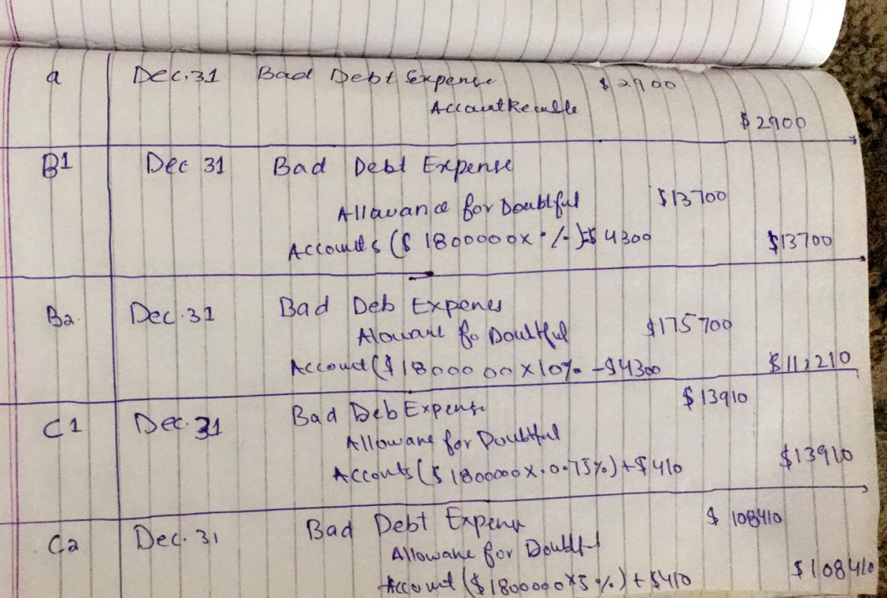

Q#3

The bookkeeping condition is an essential standard of bookkeeping and a principal component of the asset report.
The condition is as per the following:

Resources = Liabilities + Shareholder's Equity

This condition sets the establishment of twofold passage bookkeeping and features the structure of the accounting report. Twofold section bookkeeping is where each exchange influences the two sides of the bookkeeping condition. For each change to an advantage account, there must be an equivalent change to a related risk or investor's value account. It is imperative to remember the bookkeeping condition when performing diary sections.

The accounting report is separated into three significant areas and their different fundamental things: Assets, Liabilities, and Shareholder's Equity.

The following are a few instances of things that fall under each segment:

Resources: Cash, Accounts Receivable, Inventory, Equipment

Liabilities: Accounts Payable, Short-term borrowings, Long-term Debt

Investor's Equity: Share Capital, Retained Earnings

The bookkeeping condition shows the connection between these things.

Modifying the Accounting Equation

The bookkeeping condition can likewise be adjusted into the accompanying structure:

Investor's Equity = Assets – Liabilities
Asset:
Your business' benefits are things or assets of significant worth, for example, property, stock, brand names, or licenses that your business possesses. Entrepreneurs can select to change over advantages for money. Numerous business resources create income and advantage the proprietor over the long haul.

A business monetary record records your advantages and shows a depiction of how you oversee resources. Cautiously track resources in your bookkeeping records to guarantee your books are precise. You can record resource data physically or by utilizing bookkeeping programming.

There are various kinds of benefits in bookkeeping. You can arrange resources as:

Unmistakable

Elusive

Current

Fixed

Unmistakable versus impalpable resources

You can separate resources into unmistakable versus impalpable properties. The two kinds increase the value of your business.

Unmistakable resources

Unmistakable resources are physical things that increase the value of your organization. A few instances of substantial resources include:

Money

Hardware

Land

Stock

Bonds

Stocks

Substantial resources devalue after some time. At the point when you deteriorate a benefit, you spread its expense over a specific number of years.

Substantial resources can likewise be separated further into two different classes: current and fixed resources. You'll get familiar with current resources versus fixed resources later.

Elusive resources

Elusive resources are something contrary to substantial resources. Non-physical things that increase the value of your business are impalpable resources. In contrast to substantial resources, you can only with significant effort convert immaterial resources into money.

You can amortize immaterial resources. The amortization of advantages is the point at which you disseminate the expense of an impalpable resource after some time.

It tends to be hard to decide the expense of an elusive resource since they are not physical property or things.

Immaterial things incorporate things like:

Logos

Licenses

Brand names

Copyrights

Client records

Permits to operate

Current versus fixed resources

There are a couple of contrasts between current versus fixed resources.

Current Assets:

Current resources are things of significant worth your field-tested strategies to utilize or change over to money inside one year. Most organizations utilize current resources in their everyday business tasks. Current resources are likewise viewed as momentary ventures since you can change over or use them inside one year.

A portion of your present resources may likewise be fluid resources. Fluid resources are resources you can rapidly transform into money, similar to stocks. You can change over resources in a brief timeframe, for example, one month or 60 days.

Kinds of current resources may incorporate things like money, debt claims, stock, and prepaid costs.

Fixed Assets:

A fixed resource, or noncurrent resource, is a drawn out resource that constantly carries an incentive to your business following one year. You can't change over fixed resources into money inside one year. As you develop your business, fixed resources help bring long haul an incentive to your organization.
Liability: A liability, in its least difficult terms, is a measure of cash owed to someone else or association. Said an alternate way, liabilities are lenders' cases on organization resources since this is the measure of benefits loan bosses would possess if the organization exchanged.

A typical type of risk is a payable. Payables are something contrary to receivables. At the point when an organization buys merchandise or administrations from different organizations using a loan, a payable is recorded to show that the organization vows to pay different organizations for their advantages.

Here are a few instances of the absolute most regular liabilities:

Records payable

Bank credits

Credit extensions

Individual Loans

Official Loans

Unmerited pay

Value

Value speaks to the bit of organization resources that investors or accomplices own. As it were, the investors or accomplices own the rest of benefits once the entirety of the liabilities are paid off.

Proprietors can expand their possession share by contributing cash to the organization or decline value by pulling back organization reserves. In like manner, incomes increment value while costs decline value.

Here are some normal equity accounts:

Owner’s Capital

Proprietor's Withdrawals

Official Loans

Unmerited salary

Normal stock

Paid-In Capital

