Department of Business Administration
Summer semester- 2020 Course title: Principles of Marketing Program: BBA/MBA Total Marks: 50 Instructor: Shahzeb Anwar fina Assignment

Name: Sayed Abaseen
ID: 12534
Date: 24/9/2020

Q1
What can be marketed? Explain with examples. (15)

Answer:
A product or service anything that can be offered to customer for satisfaction manufacturers point of view} complex combination of various points
Marketers point of view is when a bundle of utilities and give functional, psychological and social satisfaction
Fallowing can be marketed
Physical product: or Goods is a tangible and we can see and touch eg TV soap mobile cat pen etc.
Services: it can’t be touch or see and intangible for eg insurance, transport, education etc.
Experience: which we use something or have an idea about something before for eg shows, movies etc.
Places: places can be anywhere like tourist place worship place or somewhere beautiful like Naran Kaghan , Chatral ,Swat etc.
Idea: bring something new for Eg No Smoking and 1 billion tree plantation project of Pakistan , polio awareness, stop corruption etc.
Information services: export and import procedures or admission information for new student which give more information about admission etc .
Persons: person can be also marketed for eg Mulana Tariq Jamel or any politician or scholars artist singers ,sports man etc.
Event: can be also marketed for Eg Eid or Ramazan or any sports event like world cup or Olympics.
Properties: intangible rights of ownership real property eg DHA or financial property like stock shares or malls

Q2: Discuss Product life cycle stages with examples. Also draw its Model (15)
Answer:
When a company launch their new product the management want their product to earn money and in maturity for long time. It’s hard to maintain a product in maturity for long time but a company wants to recover their cost and make a profit for a company there are 5 stages for a product life circle.
- Product development: it’s the begin of the product when a company find or create a new idea and develops a new-product idea eg Apple company launch iPhone 11 pro
- Introduction: In this stage, the product is being released into the market. When a new product is released, it is often a high-stakes time in the product's life cycle - although it does not necessarily make or break the product's eventual success. Lunch I phone 11 pro
- Growth: By the growth stage, consumers are already taking to the product and increasingly buying it. The product concept is proven and is becoming more popular - and sales are increasing. When everyone like and buy iPhone 11 pro
- Maturity: When a product reaches maturity, its sales tend to slow or even stop - signaling a largely saturated market. At this point, sales can even start to drop. Pricing at this stage can tend to get competitive, signaling margin shrinking as prices begin falling due to the weight of outside pressures like competition or lower demand. Marketing at this point is targeted at fending off competition, and companies will often develop new or altered products to reach different market segments.
The maturity stage may last a long time or a short time depending on the product. For some brands, the maturity stage is very drawn out, like Coca-Cola eg when iPhone 11 pro cover their cost and earn profit from iPhone 11 pro
- Decline: Although companies will generally attempt to keep the product alive in the maturity stage as long as possible, decline for every product is inevitable.
In the decline stage, product sales drop significantly and consumer behavior changes as there is less demand for the product. The company's product loses more and more market share, and competition tends to cause sales to deteriorate. Eg now I phone 11 pro decreases their selling product and now apple can a new Idea to developed I phone 12
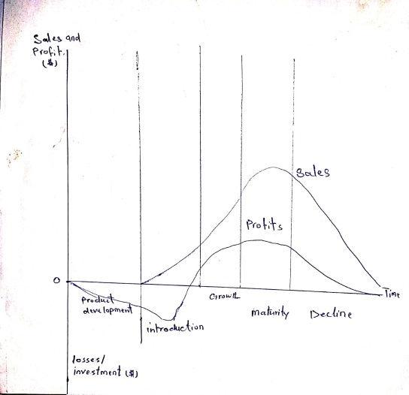
Question 3:
Discuss Promotion Mix along with examples.
There are five major promotion tools are defined as following:
The promotion mix consist of 5 ingredient
Advertising:
Sales promotion:
Personal selling:
Public relations:
Direct marketing:
All the above forms of sales promotion try to influence consumer’s attitude, belief, ways of living and life style
1 Advertising: it is defined as any paid foam of non-personal presentation and promotion of idea, goods and services by the identified promoter. it is impersonal salesmanship for mass selling a means of mass communication
Example for advertising on tv radio billboards in internet etc
2 Sales promotions: it covers there marketing activities other than advertising, publicity and personal selling that stimulate consumer purchasing
Example: Buy One, Get One Free. Free Gifts, Fairly self-explanatory, Discounted Prices
Such activities are displays, shows exhibitions, demonstration and many other non-routine selling affords
3 Personal selling: it is the best means of oral and face to face communication and presentation of the product
For Example Personal selling is of different types. For example, many companies send their sales executives to make sales presentations at prospective customers’ homes or businesses on a face-to-face basis. This type of selling is sometimes called door-to-door selling. Personal selling can also be conducted in retail and some wholesale locations in which customers come to the seller’ place of business. This type of selling is also called over-the-counter selling.
4 Publicity: it is non-personal stimulation of demand for a product, service or a business until by placing commercially significant news about the product
For Example: when new movie lunch actors publicity for their movie
5 Direct Marketing: is a promotional method that involves presenting information about your company, product, or service to your target customer without the use of an advertising middleman
Example: insurance man , Emails, online adverts, flyers, database marketing, promotional letters, newspapers, outdoor advertising, phone text messaging, magazine adverts, coupons, phone calls, postcards, websites, and catalog distribution are some examples of direct marketing

What is Branding? Why is it important? Explain with example. (10)
In Greek word its brandr. It means to burn out something
History : livestock people burn particular place of animal for identification now we are not burning something but we give name ,and labeling , packing for identification
Brand can be product can be service
We do branding to Differentiate from each other. Brand manager have to care and responsible for their brand
There are 4 stage of brand 1 introduction 2 growth 3 maturity 4 decline brand manager want their product service ever in maturity stage
At a small level it’s okay but when business growth they really need to take name for their business , and branding become a basic needs brand matter for both customers and for product as well if we want to globalize our business we should make a brand
For example if I want to buy shoes there are many product from different companies but if I want to buy shoes from nike it shows a specific brand name
If I want to eat pizza I would really love to take pizza hut or DOMINO'S pizza

