Foundation and Pavement

Submitted By Noman Khan
ID: 5856

Q#3;Ans
What is the purpose of a prime coat?
There are four primary purposes for the application of a prime coat on an aggregate base course;
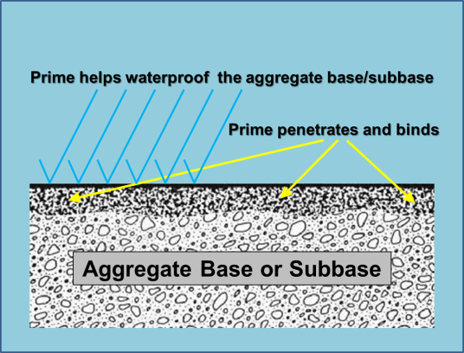

- Coat and bond loose material particles on the surface of the base.
- Harden or toughen the base surface to provide a work platform for construction equipment.
- Plug capillary voids in the base course surface to prevent migration of moisture.
- Provide adhesion between the base course and succeeding asphalt course.
What asphalt materials should be used for prime coats?
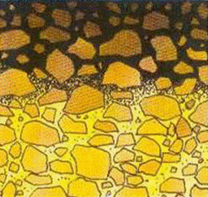
For a prime coat to be effective it must be able to penetrate into the base course. Typically a light grade of medium curing cutback such as an MC-30 or MC-70 will work well. However, these are cutback asphalts (asphalt cement by combining it with light petroleum oil) and “cure” or harden when the light oils evaporate into the atmosphere. As the light oils evaporate they release hydrocarbons into the air causing air pollution. As a result, EPA has severely restricted or eliminated the use of cutbacks for most areas of the U.S. Virginia Department Of Transportation (VDOT) discontinued the use of cutbacks more than 30 years ago when Virginia agreed to severely restrict the use of cutbacks in the late 1970’s as an offset to the emissions from a proposed oil refinery on the Chesapeake Bay. The refinery was never built but VDOT has stayed with emulsified asphalts (asphalt cement liquefied by suspending it in water) for surface treatment (chip seal), slurry seal, tack and prime applications ever since.
Is a prime coat necessary?
At one time it was thought that a prime coat was an essential element of good pavement construction. Aggregate base/subbase materials were more “open” or coarsely graded than today’s materials so it was necessary to bind the upper 1-2” together by spraying a heavy application of liquid cutback asphalt on the surface and allowing it to penetrate into the aggregate before “setting” or hardening. This formed a hard, waterproof surface and provided a good platform for the asphalt paving train.
However, the gradation of aggregate materials changed with the emphasis on achieving high density in
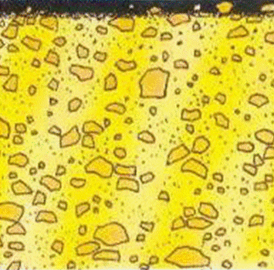

base and sub base layers. These new, finer gradations have more fines and proper compaction results in a very hard and almost impervious surface. As a result, prime materials no longer penetrate into the aggregate layer, solidifying instead as a heavy film on the aggregate base/sub base surface. This can be detrimental to the bond between the asphalt concrete and aggregate and can result in slippage failure of the asphalt. Having a thick, gummy layer of asphalt on the surface of the aggregate is also problematic for the paving train, sticking to the equipment tires, particularly the asphalt haul trucks.
Q#2; Ans
Sub base (pavement) this article needs additional citations for verification. Learn more Layers in the construction of a mortar less pavement: A.) Sub grade B.) Sub base C.) Base course D.) Paver base E.) Pavers F.) Fine-grained sand In highway engineering, sub base is the layer of aggregate material laid on the sub grade, on which the base course layer is located. It may be omitted when there will be only foot traffic on the pavement, but it is necessary for surfaces used by vehicles. Sub base is often the main load-bearing layer of the pavement. Its role is to spread the load evenly over the sub grade. The materials used may be either unbound granular, or cement-bound. The quality of sub base is very important for the useful life of the road and can outlive the life of the surface, which can be scrapped off and after checking that the sub base is still in good condition, a new layer can be applied [1] Unbound granular materials are usually crushed stone, crushed slag or concrete, or slate. Cement-bound materials come in multiple types. Mass concrete is used where exceptional loads are expected, with thickness usually 100 to 150 millimeters (4 to 6 in), and optional reinforcement with steel mesh or polymer fibers. Other cement bound materials (CBM), with less strength but also lower cost, are used. They are rated by strength, from the weakest CBM 1 (also formerly known as soil cement) through CBM 2 to CBM 3, 4, and 5, which are more similar to concrete and are called "lean mix". The thickness of sub base can range from 75 to 100 mm (3 to 4 in) for garden paths through 100 to 150 mm (4 to 6 in) for driveways and public footpaths, to 150 to 225 mm (6 to 9 in) for heavy used roads, and more for highways. Low quality sub base material, including large pieces of rock and concrete, which was hardly acceptable heretofore, can now be re-used when crushed in-situ with conventional milling machines to obtain a homogenous grain size. It may then be treated normally with hydraulic binders, augmented by specific polymer formulations.
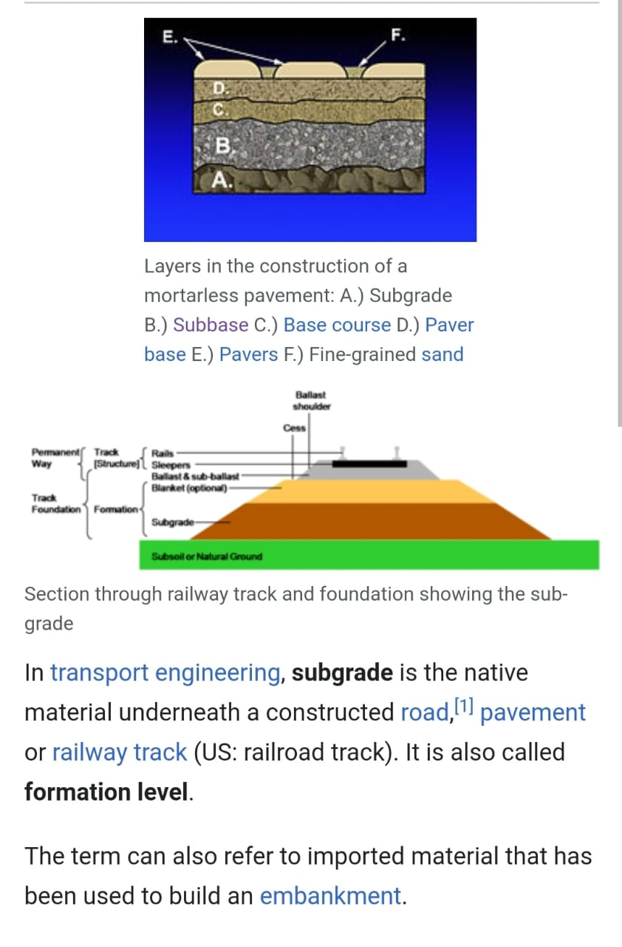

Q#1; Ans
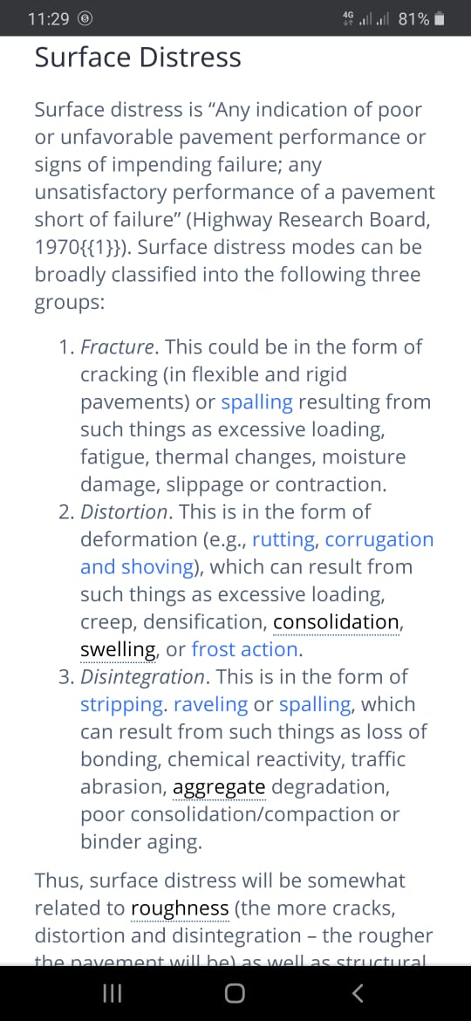

Q#1; Ans

Types of Distress in Bituminous Pavements and their Causes

a) Cracking in Bituminous Pavements and their Causes
Cracks in bituminous pavements are caused by deflection of the surface over an unstable foundation, shrinkage of the surface, thermal expansion and contraction of the surface, poorly constructed lane joints, or reflection cracking. Five types of cracks commonly occur in these types of pavements:

(i) Longitudinal and Transverse Cracks
Longitudinal and transverse cracks often result from shrinkage or contraction of the bituminous concrete surface. Shrinkage of the surface material is caused by oxidation and age hardening of the asphalt material. Contraction is caused by thermal fluctuations. Poorly constructed lane joints may accelerate the development of longitudinal cracks.

(ii) Alligator or Fatigue Cracking
Alligator cracks refer to interconnected cracks that form a series of small blocks resembling alligator skin. They may be caused by fatigue failure of the bituminous surface under repeated loading or by excessive deflection of the asphalt surface over a weakened or under-designed foundation. The weakened support is usually the result of water saturation of the bases or subgrade.

(iii) Block Cracking
Shrinkage of the asphalt concrete and daily temperature cycling, which results in daily stress/strain cycling, causes block cracking. These are interconnected cracks that divide the pavement into approximately rectangular pieces. This type of distress usually indicates that the asphalt has hardened significantly.
Block cracking generally occurs over a large portion of the pavement area and may sometimes occur only in non-traffic areas.

(iv) Slippage Cracks
Slippage cracks appear when braking or turning wheels cause the pavement surface to slide and deform. This usually occurs when there is a low-strength surface mix or poor bond between the surface and the next layer of the pavement structure. These cracks are crescent or half-moon-shaped with the two ends pointing away from the direction of traffic.

(v) Reflection Cracking
Vertical or horizontal movements in the pavement beneath an overlay cause this type of distress. These movements may be due to expansion and contraction caused by temperature and moisture changes or traffic loads. The cracks in asphalt overlays reflect the crack pattern in the underlying pavement.
They occur most frequently in asphalt overlays on Portland cement concrete pavements. However, they may also occur on overlays of asphalt pavements wherever cracks in the old pavement have not been properly repaired.

b. Disintegration in Bituminous Pavements and their Causes
Disintegration in a bituminous pavement is caused by insufficient compaction of the surface, insufficient asphalt in the mix, loss of adhesion between the asphalt coating and aggregate particles, or overheating of the mix.
The most common type of disintegration in bituminous pavements is raveling. Raveling is the wearing away of the pavement surface caused by the dislodging of aggregate particles and the loss of asphalt binder. As the raveling continues, larger pieces are broken free, and the pavement takes on a rough and jagged appearance.

c. Distortion in Bituminous Pavements and their Causes
Distortion in bituminous pavements is caused by foundation settlement, insufficient compaction of the pavement courses, lack of stability in the bituminous mix, poor bond between the surface and the underlying layer of the pavement structure, and swelling soils or frost action in the subgrade. Four types of distortion commonly occur:

(i) Rutting
A rut is characterized by a surface depression in the wheel path. In many instances, ruts become noticeable only after a rainfall when the wheel paths fill with water. This type of distress is caused by a permanent deformation in any one of the pavement layers or subgrade, resulting from the consolidation or displacement of the materials due to traffic loads.

(ii) Corrugation and Shoving
Corrugation results from a form of plastic surface movement typified by ripples across the surface. Shoving is a form of plastic movement resulting in localized bulging of the pavement surface. Corrugation and shoving can be caused by a lack of stability in the mix and a poor bond between material layers.

(iii) Depression
Depressions are localized low areas of limited size. In many instances, light depressions become noticeable only after a rain, when ponding creates “birdbath” areas. Depressions may result from traffic heavier than that for which the pavement was designed, localized settlement of the underlying pavement layers, or poor construction methods.

(iv) Swelling
An upward bulge in the pavement’s surface characterizes swelling. It may occur sharply over a small area or as a longer gradual wave. Both types of swell may be accompanied by surface cracking. A swell is usually caused by frost action in the subgrade or by swelling soil.

d) Loss of Skid Resistance in Bituminous Pavements and their Causes
Factors that decrease the skid resistance of a pavement surface and can lead to hydroplaning include too much asphalt in the bituminous mix, too heavy a tack coat, poor aggregate subject to wear, and buildup of contaminants. In bituminous pavements, a loss of skid resistance may result from the following:

(i) Bleeding
Bleeding is characterized by a film of bituminous material on the pavement surface that resembles a shiny, glass-like, reflecting surface that usually becomes quite sticky. It is caused by excessive amounts of asphalt cement or tars in the mix and/or low air-void content and occurs when asphalt fills the voids in the mix during hot weather and then expands out onto the surface of the pavement.
Bleeding may also result when an excessive tack coat is applied prior to placement of the asphalt surface material. Since the bleeding process is not reversible during cold weather, asphalt or tar will accumulate on the surface. Extensive bleeding may cause a severe reduction in skid resistance.

(ii) Polished Aggregate
Aggregate polishing is caused by repeated traffic applications. It occurs when the aggregate extending above the asphalt is either very small, of poor quality, or contains no rough or angular particles to provide good skid resistance.

(iii) Fuel Spillage
Continuous fuel spillage on a bituminous surface will soften the asphalt. Areas subject to only minor fuel spillage will usually heal without repair, and only minor damage will result.

(iv) Contaminants
Accumulation of rubber on the pavement surface will reduce the skid resistance of a pavement. Buildup of rubber deposits in pavement grooves will reduce the effectiveness of the grooves and increase the likelihood of hydroplaning
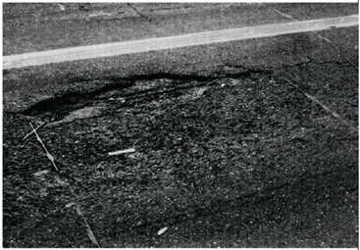
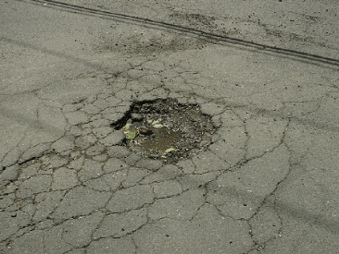

Q#4; Ans
TYPES OF PAVEMENT – FLEXIBLE AND RIGID

PAVEMENT

There are two types of pavements based on design considerations i.e. flexible pavement and rigid pavement. Difference between flexible and rigid pavements is based on the manner in which the loads are distributed to the subgrade.

Before we differentiate between flexible pavements and rigid pavements, it is better to first know about them. Details of these two are presented below:

Flexible Pavements:

Flexible pavement can be defined as the one consisting of a mixture of asphaltic or bituminous material and aggregates placed on a bed of compacted granular material of appropriate quality in layers over the subgrade. Water bound macadam roads and stabilized soil roads with or without asphaltic toppings are examples of flexible pavements.

The design of flexible pavement is based on the principle that for a load of any magnitude, the intensity of a load diminishes as the load is transmitted downwards from the surface by virtue of spreading over an increasingly larger area, by carrying it deep enough into the ground through successive layers of granular material.

Thus for flexible pavement, there can be grading in the quality of materials used, the materials with high degree of strength is used at or near the surface. Thus the strength of sub grade primarily influences the thickness of the flexible pavement.
University of Al-Qadissiyah |  | College of Engineering
Roads and Transport Department | Pavement Design | 3rd Year
Rigid Pavements:

A rigid pavement is constructed from cement concrete or reinforced concrete slabs. Grouted concrete roads are in the category of semi-rigid pavements.

The design of rigid pavement is based on providing a structural cement concrete slab of sufficient strength to resists the loads from traffic. The rigid pavement has rigidity and high modulus of elasticity to distribute the load over a relatively wide area of soil.
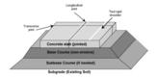

Fig: Rigid Pavement Cross-Section

Minor variations in subgrade strength have little influence on the structural capacity of a rigid pavement. In the design of a rigid pavement, the flexural strength of concrete is the major factor and not the strength of subgrade. Due to this property of pavement, when the subgrade deflects beneath the rigid pavement, the concrete slab is able to bridge over the localized failures and areas of inadequate support from subgrade because of slab action.
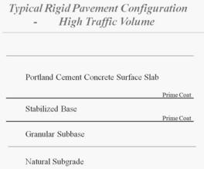

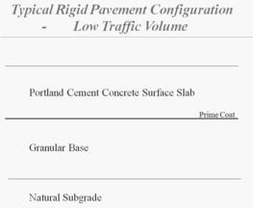

Difference between Flexible Pavements and Rigid Pavements:

 | Flexible Pavement | Rigid Pavement
1. | It consists of a series of layers with the | It consists of one layer Portland cement
 | highest quality materials at or near the | concrete slab or relatively high flexural
 | surface of pavement. | strength.
2. | It reflects the deformations of subgrade | It is able to bridge over localized failures and
 | and subsequent layers on the surface. | area of inadequate support.
3. | Its stability depends upon the aggregate | Its structural strength is provided by the
 | interlock, particle friction and cohesion. | pavement slab itself by its beam action.
4. | Pavement design is greatly influenced | Flexural strength of concrete is a major factor
 | by the subgrade strength. | for design.
5. | It functions by a way of load distribution | It distributes load over a wide area of subgrade
 | through the component layers | because of its rigidity and high modulus of
 |  | elasticity.
6. | Temperature variations due to change in | Temperature changes induce heavy stresses in
 | atmospheric conditions do not produce | rigid pavements.
 | stresses in flexible pavements.
7. | Flexible pavements have self healing | Any excessive deformations occurring due to
 | properties due to heavier wheel loads are | heavier wheel loads are not recoverable, i.e.
 | recoverable due to some extent. | settlements are permanent.

Flexible pavement layers

Subgrade:

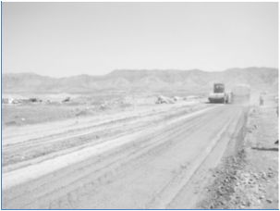
The subgrade is usually the natural materials located along the horizontal alignment of the pavement and served as a foundation of the pavement structure. The upper 15-20cm of the subgrade is scarified and blended to provide a uniform material before it is compacted to maximum density. The subgrade may also consists of borrow materials, well compacted to prescribed specifications. It may be necessary to treat the subgrade materials with certain types of stabilizers to achieve certain strength properties.

Subbase layer

Located immediately above the subgrade, the subbase component consists of material of a

superior quality to that which is generally used for subgrade construction. The requirements for

subbase materials usually are given in terms of the gradation, plastic characteristics, and strength.

When the quality of the subgrade material meets the requirements of the subbase material, the

subbase component may be omitted. In cases where suitable subbase material is not readily

available, the available material can be treated with other materials to achieve the necessary

properties. This process of treating soils to improve their engineering properties is known as

stabilization. This layer is usually consists of crushed aggregate or a mixture of fine and coarse

aggregate.

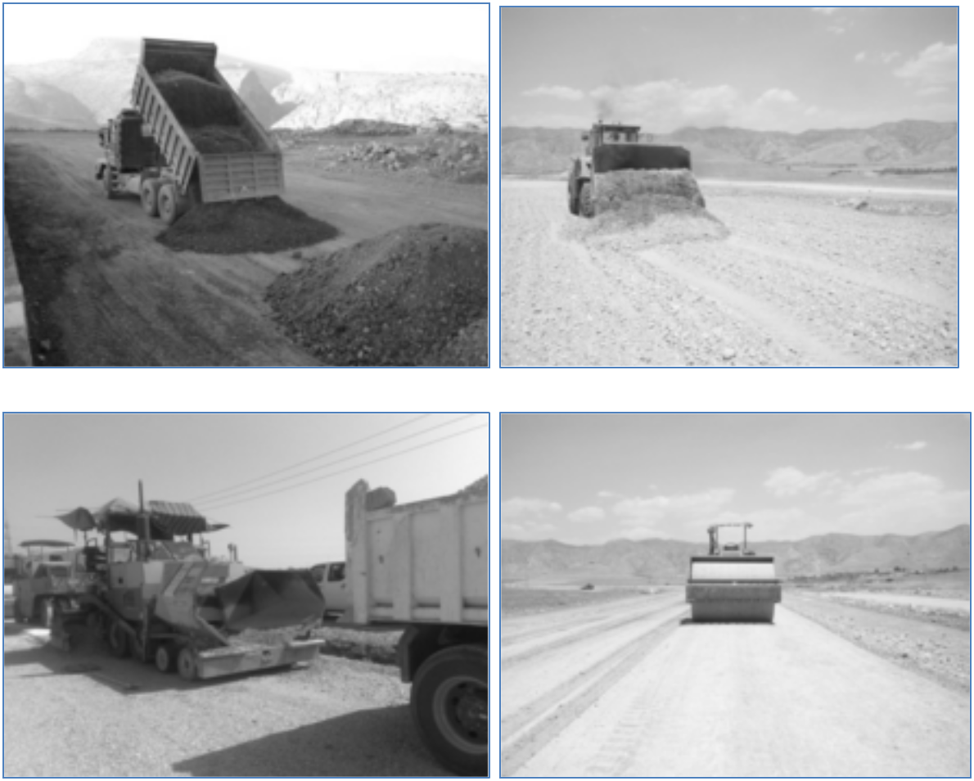

Base layer

The base course lies immediately above the subbase. This course usually consists of granular materials such as crushed stone, crushed or uncrushed gravel, and sand. The specifications for base course materials usually include more strict requirements than those for subbase materials, particularly with respect to their plasticity, gradation, and strength. Base course layer usually is stabilized with asphalt or Portland cement.

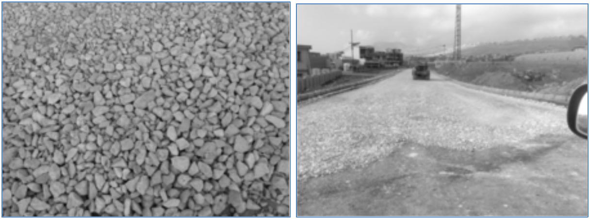

Surface layer

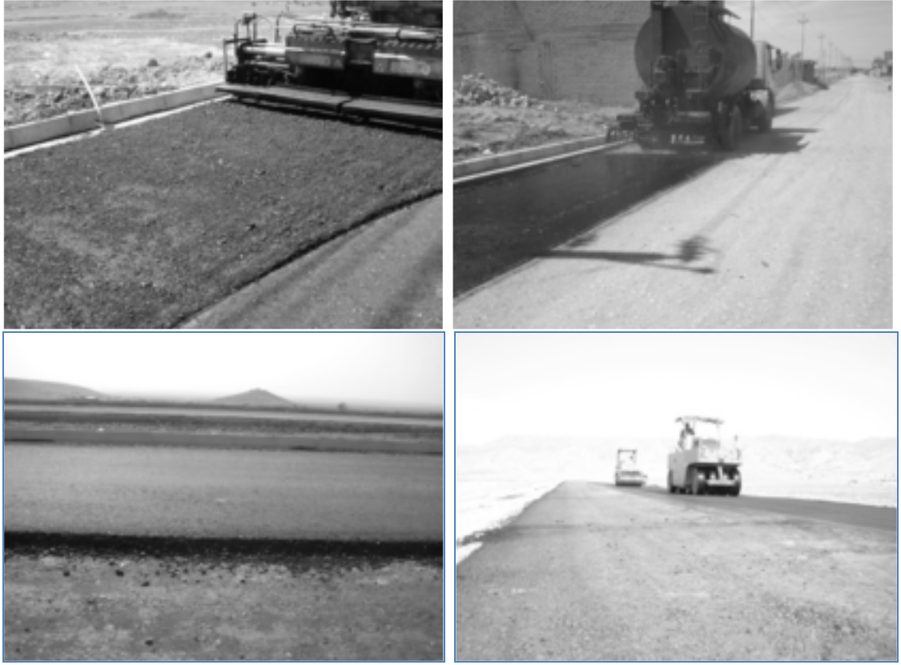
Usually made of asphaltic concrete, which is a mixture of asphalt cement and aggregate. The function of this layer is to withstand high tire pressure, resisting the wheel abrasion, provide a skid resisting surface and to waterproof the entire pavement structure. The quality of the surface material depends on the mix design of the asphalt concrete used. Thickness and properties of surface course vary according to the expected traffic on the pavement.

Soil stabilization
Soil stabilization is the treatment of natural soil to improve its engineering properties. Soil stabilization methods can be divided into two categories, namely, mechanical and chemical. Mechanical stabilization is the blending of different grades of soils to obtain a required grade. Chemical stabilization is the blending of the natural soil with chemical agents. The most commonly used agents are Portland cement, asphalt binders, and lime.

1- Soil stabilization with cement

The soil stabilized with cement is known as soil cement. Cement stabilization of soils usually

involves the addition of 5 to 14 percent Portland cement by volume of the compacted mixture to

the soil being stabilized. The cementing action is believed to be the result of chemical reactions

of cement with siliceous soil during hydration reaction. The important factors affecting the soil-

cement are nature of soil content, conditions of mixing, compaction, curing and admixtures used.
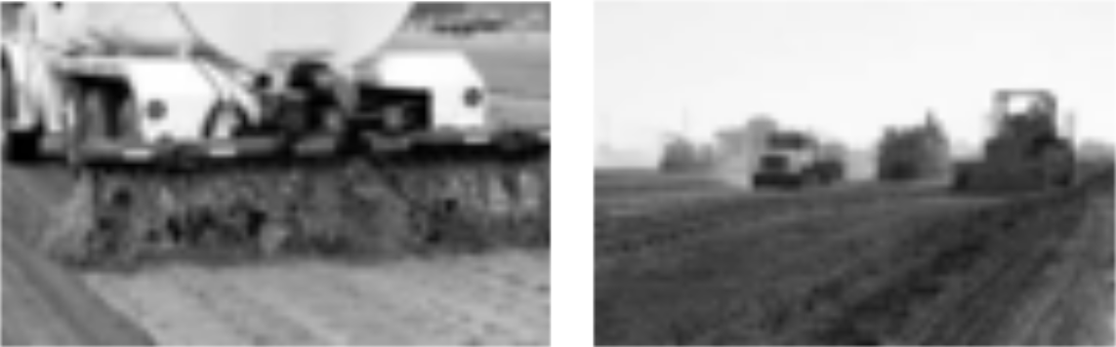

2- Soil Stabilization using Lime:

Slaked lime is very effective in treating heavy plastic clayey soils. Lime may be used alone or in combination with cement, bitumen or fly ash. Sandy soils can also be stabilized with these combinations. Lime has been mainly used for stabilizing the road bases and the sub grade.

The addition of lime leads to increase the strength and durability of soil. Normally 2 to 8% of lime may be required for coarse grained soils and 5 to 8% of lime may be required for plastic soils. The amount of fly ash as admixture may vary from 8 to 20% of the weight of the soil.
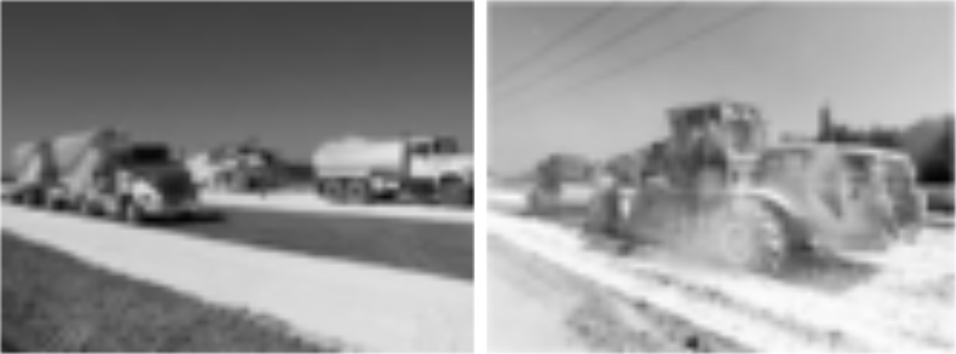

3- Soil Stabilization with Bitumen:

Asphalt stabilization is carried out to achieve one or both of the following:

- Waterproofing of natural materials

- Binding of natural materials

Waterproofing the natural material through asphalt stabilization aids in maintaining the water content at a required level by providing a membrane that impedes the penetration of water, thereby reducing the effect of any surface water that may enter the soil when it is used as a base course. In addition, surface water is prevented from seeping into the subgrade, which protects the subgrade from failing due to increase in moisture content. Binding improves the durability characteristics of the natural soil by providing an adhesive characteristic, whereby the soil particles adhere to each other, increasing cohesion.

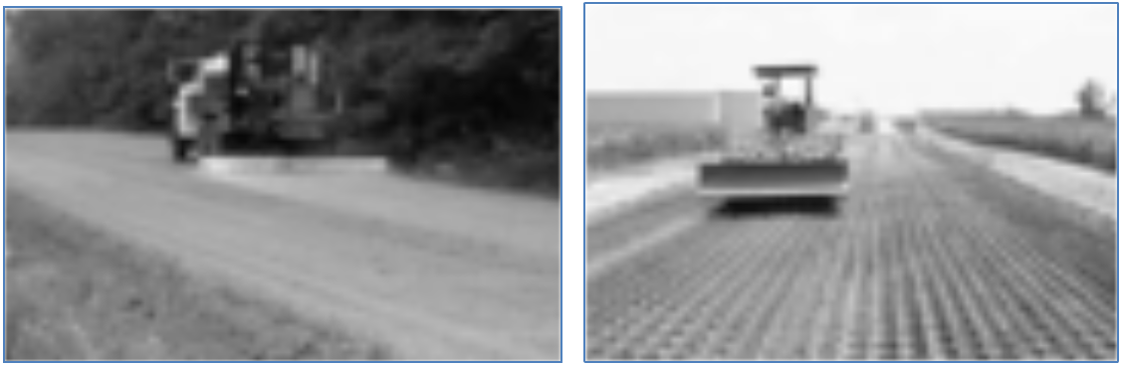

Distribution of stresses

Flexible pavements will transmit wheel load stresses to the lower layers by grain-to-grain transfer through the points of contact in the granular structure. In order to understand the stress distribution in flexible pavement, several theories have been proposed.

The concept of layered system has been found to understand the stress transmission from the wheel to pavement layers. This theory adopted the following assumptions:

1- The material properties are homogenous.

2- Each layer has finite thick except for the lower one, and all are infinite in lateral direction.

3- Each layer is isotropic.

4- Full friction is developed between layers at each interface.

5- Surface shearing forces are not present at surface.

6- Stress solution is characterized by two material properties for each layer (Poisson’s ratio and elastic modulus.

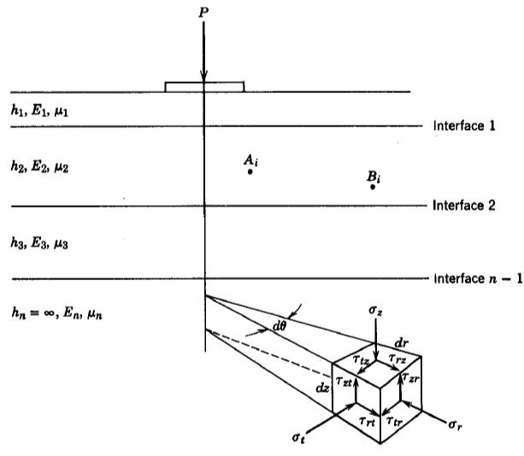

According to Bossinesq’s formula, the vertical stress is dependent on the depth and radial distance to point, and is independent on the properties of transmitting medium.
=
= | 3 |  |  |  |  | 1
 | ² (1+ |  |  |  |  |  | ₎ (/)

Where:

- The vertical stress at any depth below the earth surface due to a point load at the surface. r = radial distance from point load

z = depth

In the study of the flexible pavement the load at surface is not point load but is distributed over elliptical area. Pressure at tire-pavement contact is assumed equal to tire pressure. Bossinesq’s formula was extended to consider uniformly distributed circular load. The final modification was proposed by Ahlvin an Ulery as shown below.
- [ + ]
∆ = | (1+ ) | [ |  | +(1− ) ]

