Name : Aliya Aziz
I’d : 16501
Semester: 2nd
Section : B
Department : BsMLT
Submitted to sir Waqas ihsan
Assignment :
Question : 1
What is shock ? Explain its types ?
Answer :
SHOCK :
Shock is a medical emergency in which the organ and tissue of the boby are not receiving an adequate flow of blood .
- This deprives the organ and tissue of oxygen ( carried in blood ) and allows the buildup of waste products.
- Shock can result in serious damage or even death .
Types of shock :
- Hypovolemic shock
- Cardiogenic shock
- Neurogenic shock
- Septic shock
- Anaphylactic shock
Hypovolemic shock:
It occurs when a significant Amount of fluid is lost from the intravascular space ,fluid are may blood , plasma , electrolytes solution . It is the most common type of shock .
Causes :
- Sever bleeding e.g ; PPH , hematemesis, haemoptysis.
- Sever persistent vomiting e.g DVA, minor and major disorder in pregnancy
- Sever diarrhea e.g cholera
- Severe burns
- Inadequate fluid
Cardiogenic shock:
Cardiogenic shock occur when the heart’s ability to pump blood is impaired
This is a condition that results from inadequate perfusion of body tissue with oxgyenated blood that is insufficient to sustain life , cardiac output is decreased
Causes:
- Acute myocardial infarction resulting in massive damage to myocarduim.
- CHF, pulmonary embolism
- Cardiac temponade cardiomyopathy
Neurogenic shock :
- Inability of nervous system to control dilation of blood vessels.
- Neurogenic shock result from generalized vasodilation and loss of vasomotor tone due to
- Massive increase in vascular capacity
- Pooling of blood in periphery
- Decreased venous return to heart .
Causes :
- Brain traumatic injury
- Spinal cord injury
- During LP
- Deep spinal anesthesi
Anaphylactic shock:
Anaphylaxis is a life threatening systemic hypersensitivity reaction contact with an allergen.
Causes:
- Blood transfusion
- New clothes
- Dusting smokes
- Suddenly climate change
Septic shock:
It is the most common type odms shock and caused by widespread infection due to gram positive and negative bacteria and viruses.
Causes:
- UTI, abortion
- RTA
- Sever burn
- Indwelling lines and catheter

Question : 2
Answer :
Granulomatous inflammation:
- Granulomatous inflammation is a distinctive pattern chronic inflammation reaction .
- It is a protective response to chronic infection or foreign material , preventing dissemination and restricting inflammation.
- Some autoimmune diseases such as rheumatoid arthritis and crohns disease are also associated with granulomas.
Types :
There are two types of granulomas , which differ in their pathogensis.
- Foreign body granulomas
- Immune granulomas
Foreign body granulomas :
- Incited by relatively inert foreign bodies
- Typically , foreign body granulomas form when material such as talc ( associated with intravenous drugs abuse ) sutures, or other fibers are large enough to preclude phagocytesis by a single macrophage.
- Epithelioid cells and giant cells form and encompass the foreign body .
- The foreign material can usually, be identified in the center of the granuloma , particularly if viewed with polarized light , in which it appears refractile.
Immune granulomas :
- Caused by insoluble particles that are capable of including a cell mediated immune response
- Macrophages are transformed into epitheloid cells and multinucleate grant cells
- Example:
Bacteria , parasites and fungi
Main causes of granulomatous inflammation:
- Mildly irritant ‘ foreign’ material
- Mycobacteria : tuberculosis , leprosy
- Syphilis
- Other rare infections e.g some fungi
- Unknown causes : sarcoid , wegeners granulomatosis , crohns disease
Symptoms :
- Frequent bacterial and fungi infection .
- Abscesses that involve the lungs , liver ,spleen , bones or skin .
- Swollen lymph nodes
- Persistent diarrhea
- Chronic runny nose
Treatment :
- Chronic granulomatous disease is usually managed with antibiotics and antifungal medication to treat and prevent infection .
- Corticosteroids may be used to shrink granulomas ( area of inflamed tissue ).treatment may also include a medication called Actimmune ( also known as interferon gamma - 1b ) .
Question 3
Answer :
Effect of use of tobacco on health:
- Smoking leads to disease and disability and harms nearly every organ of the body .
- For every person who dies because of smoking , at least 30 people live with a serious smoking – related illness.
- Smoking causes cancer , heart disease , stroke , lung disease etc .
- Smoking also increase risk for tuberculosis, certain eye disease, and problems of the immune system, including rheumatoid arthritis.
- Secondhand smoke causes stroke , lung cancer, and coronary heart disease in adults .
- Children who are exposed to secondhand smoke are at increased risk for sudden infant death syndromes , acute respiratory infection, more severe asthma, respiratory symptoms and slowed lung growth.
- Women who smoke are more likely to die from COPD than men who smoke.
Cancer : tobacco use increase the risk for many types of cancer such as lung cancer.
Heart disease: studies show a direct link between cigraeette smoking and coronary heart disease.
COPD: smoking including during the teenage years , increase the risk of dying from COPD.
Pregnancy: smoking during pregnancy increase the risk for pregnancy complication .
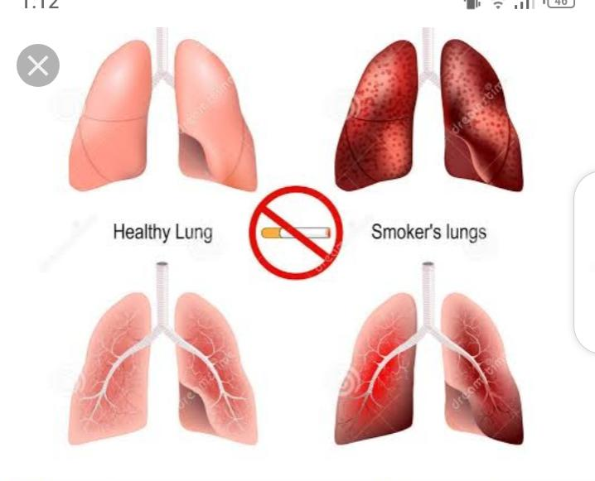
Question 4 :
Answer :

Malignant tumor:
A tumor that invades surrounding tissues , is usually capable of producing metastases, may recur after attempted removal , and is likely to cause death unless adequate treated .
Diagnosis of malignant tumor:
Timely diagnosis and detection of a malignant tumor is extremely important to mange and eliminate the tumor and its arrest its progress at an early stage. Most commonly used diagnostic techniques for malignant tumor
- Histology: Histology or microscopic examination of a tumor mass with help of a biopsy . This is the most valuable and the most reliable method to diagnose if the tumor is benign or malignant and event for staging the cancer.
- Cytology: Fine needle aspiration cytology collects samples of a lesion to be examined under a microscope. The procedure is less painful as compared to a biopsy.
- Histo-chemistry and cytochemistry : This method is an additional tool to help in understanding the chemical composition of cells by using various staining methods.
- Electron microscopy: this ultra- structural microscopy helps to understand the structure of tumor cells and their components for diagnostic purpose.
- Tumor markers : Tumor markers are biochemical assays of products secreted by a malignant tumor .

Treatment of malignant tumor:
There are over 100 different types of cancer, and malignant tumor can be found in many different parts of the body . All cancers start from abnormal cell growth , but some are more aggressive than others. Because cancer can differ so greatly in severity and aggressiveness , there needs to be different treatment available.
There are common two types of treatment for malignant tumor:
- Surgical
- Medical
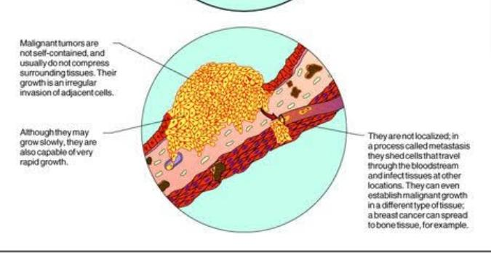
Question 5
Answer :
Hemorrhage :
Hemorrhage , also commonly knowns as bleeding , is the loss of blood from the body , due to external or internal injuries.
Types of haemorrhage :
There are two main types :
- Arterial
- Venous
Arterial : hemorrhages are difficult to control and life threatening .
- Venous : heamorrhages are easier to control than arterial haemorrhgaes . While requiring medical attention , venous bleeding is not serious as the arterial hemorrhage .
Symptoms of hemorrhage :
- Pallor
- Rapid feeble pulse
- Thirst
- Giddiness
- Nausea
- Cold and clammy skin
- Appearance of blood
- Fall in blood pressure
- Appearance of cyanosis ( bluish mark)
Causes:
Potential causes and risk factor for minor to moderate internal bleeding including:
- Minor injury
- Chronic or long term high blood pressure
- Blood thinning medication
- Antibiotic
- Smoking
- Cancer
- Deep vein thrombosis
- Gastrointestinal condition
Potential causes of severe or sudden hemorrhage include:
Traumatic injury from events such as car accident, bullet wounds ,and crush injuries
- Broken bones
- An aneurysm ( bulges that form in blood vessels)
- Surgery
- Ectopic pregnancy, where the fetus develops outside the uterus
Treatment :
Treating minor or mild hemorrhages typically involves rest and hydration . Typically, a clot will develop that temporarily limits bleeding while the blood vessels repairs itself . Over time , the surrounding bodily tissues will reabsorb the excess blood.
Depending on the severity of the hemorrhage ,surgery may be necessary to repair the blood vessels and remove excess blood.
Physical therapy and lifestyle changes , such as quitting smoking or drinking alcohol, may also be recommended to reduce the chance of further injury and bleeding .
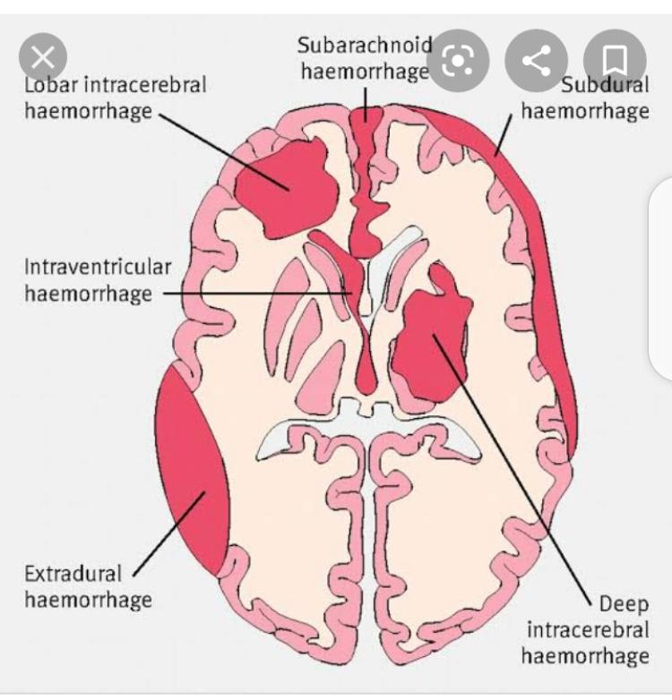

Thank you

