Name: Faisal nawab
Id: 16140
Section: A
Semester: 2nd
Subject: Architecture and town planning

Teacher: alina babar

Q no.#1
ANS:
SLUMS IN PESHAWAR:
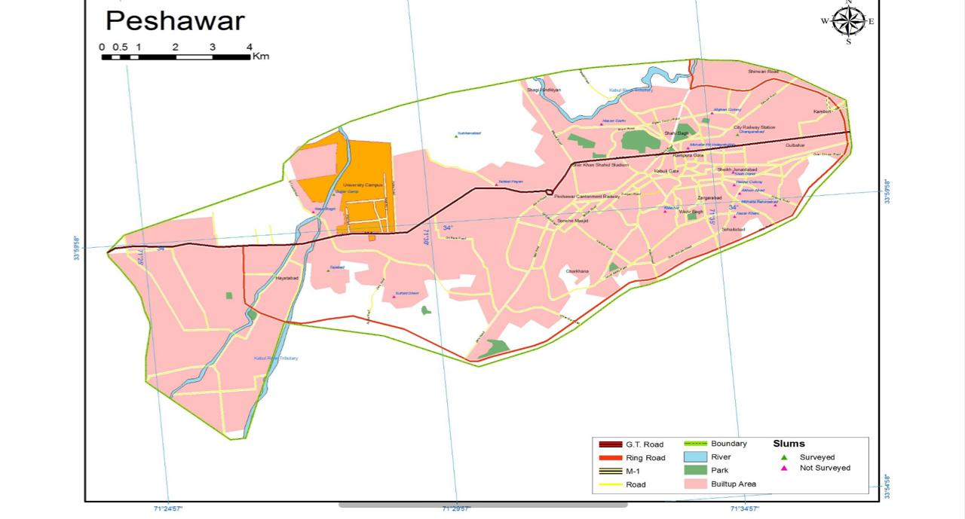
- SHAHEED ABAD/SUBHAN ABAD:
Shaheedabad and Subhanabad are located in Northern part of Peshawar City at 71.5083°E,
34.0232°N. These settlements are surrounded by agricultural land from all sides except in the
East where a Christian Colony shares the boundary with Subhanabad. One metaled and two
Unmetalled roads connect these settlements with Tehkal area in the South and are situated at a
Distance of 1 kilometer. In the North, the slum is connected to Warsak Road at a distance of 3
kilometers. In the East an unmetalled road connects it to the Canal Road 1 kilometer away from
the Subhanabad. Please refer to map titled “Land Use Map of Shaheedabad & Subhanabad”.

Shaheed Abad was developed in the 1970s by the locals who developed their agriculture land in
the surrounding area. The slum is divided into two main Mohallas namely; Shaheedabad and
Subhanabad. Majority of the slum property is privately owned, with the exception of 400 acres
adjoining land that is owned by the Pakistan Armed Forces. This proximity has an adverse effect
On the transport infrastructure, as the Military discourages the development of the road
connecting the area to the city.
Currently, there are about 2,500 to 3,000 households located in the slum, with an average
household size of 10 members. The slum’s population has increased by 50% since 2000.
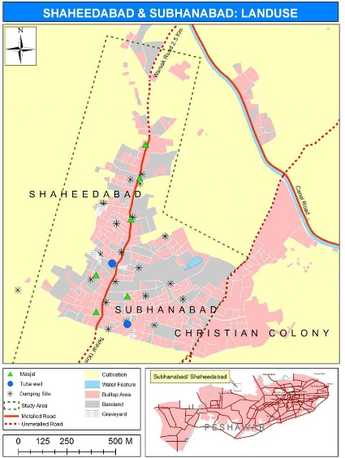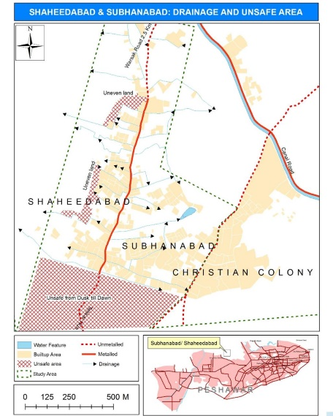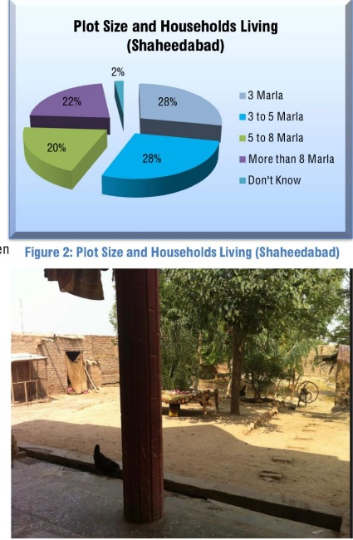

- TAJABAD:
The area of Tajabad is planned according to streets/lanes where each major lane is considered a mohalla; there are a total of 18 major lanes in Tajabad. The socio-economic and living conditions vary from lane to lane. Lane 10, also known as the Miangano Mohallah, is a slum and consists of about 2,000 housing units with an average household size of 8 persons. Tajabad was developed in early 1970s by the Mian family, who subsequently sold land to private individuals. Due to its central location and proximity to the economic activities in the well-known Board Bazar, Tajabad has seen large in-migration trends. In fact, the number of families residing in the slum has doubled over the past 15 years.
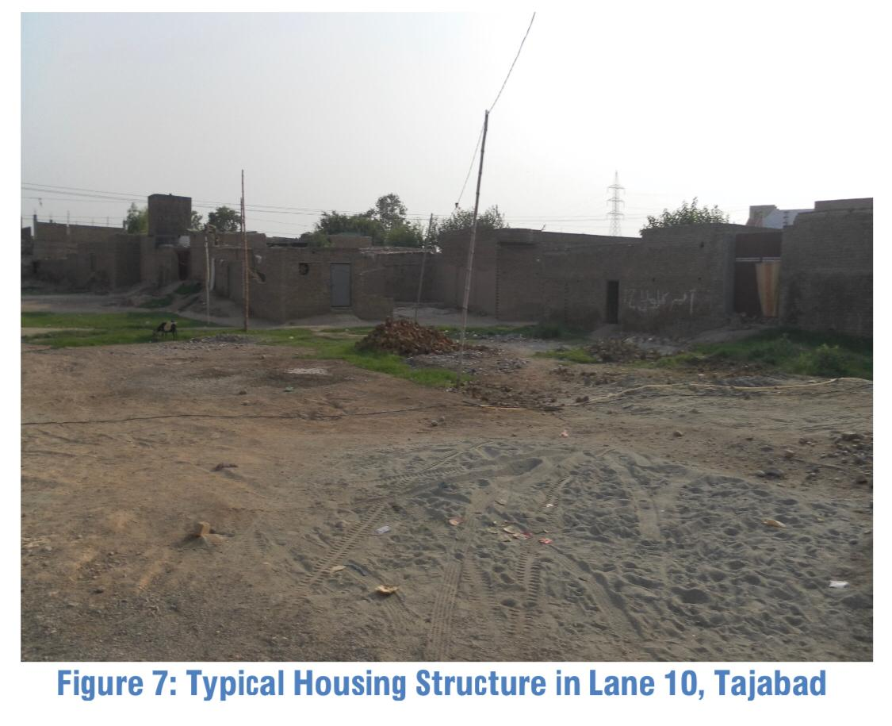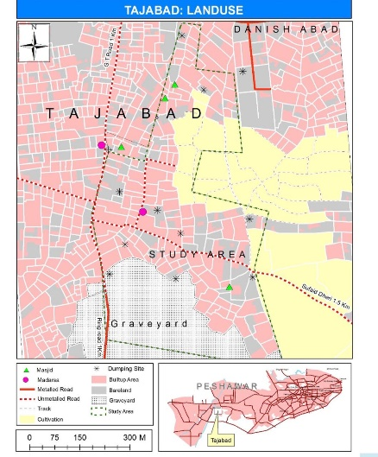
- GUJJAR CAMP:
Gujjar camp is located at 71.4715°E, 34.0093°N near Peshawar University. In West it is bounded by the Kabul river tributary. The slum is not directly accessible through a road. The nearest transport terminal is
available at a distance of 1.5 kilometers on Palosi road in the East through the University of Peshawar campus, and another access is situated 1 kilometer away towards the South on Canal Road and is accessible through congested streets. The nearby slum of Gujjar Camp is Tajabad. Please refer to map titled “Land Use Map of Gujjar Camp”.
Gujjar camp is a haphazard settlement of mud houses built across the slum with no proper planned mohallas. Streets or All the inhabitants are Afghan refugees who settled in this area in 1980s’ after fleeing the Soviet War in Afghanistan. Currently, there are about 400 to 500 houses in the slum, with an average
household size of 11 members. The land of Gujjar Camp belongs to the Arbab family who
Maintain full ownership of the land to this day, while permitting the refugees to build their dwellings and live on a lease-term basis. Plot sizes vary from 3 marlas and above, and average monthly rent in the slum is Rs.2,180, with a possibility of yearly contract renewal.

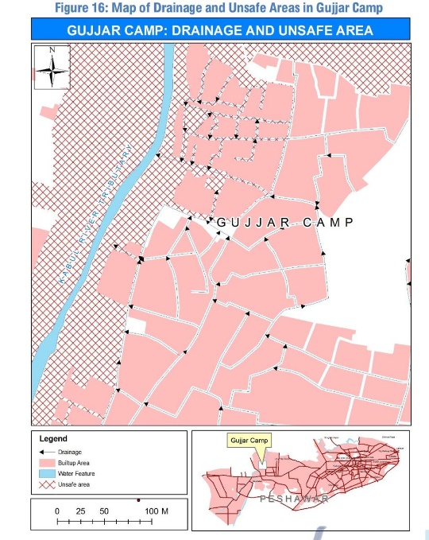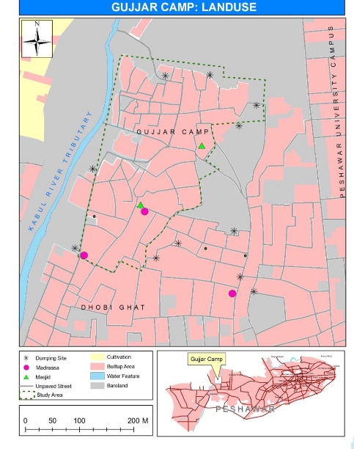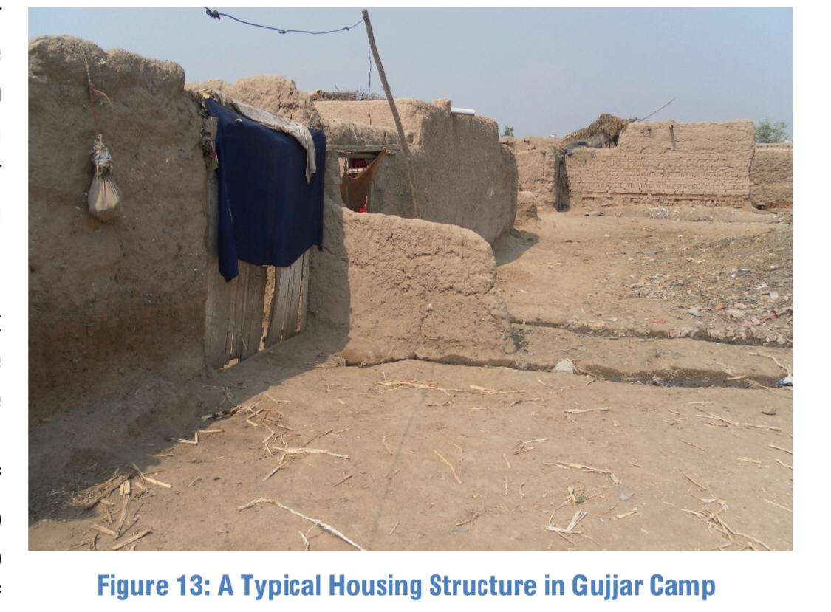
4. CHANGARABAD
5. ACHINI PAYAN

“SUGGESTIONS AND IMPROVEMENTS OF PEOPLE IN THESE SLUMS”
Drainage System:
A community sewage system in the surveyed slums is mostly nonexistent. Instead, according to the residents, to provide for some drainage, men in the community dig temporary unpaved drains on self-help basis and are responsible for maintenance. In addition, 61% respondents reported that the streets in their neighborhood are unpaved. The lack of sewage system coupled with improper waste unpaved disposal streets, and narrow extremely unhygienic conditions. The situation further deteriorates during rains as the drains block leading to a flood-like situation, thereby over spilling into homes and also hindering movement in and out of the slums.
ROADS IN TRANSPORTATION:
Most of the roads or streets connecting to the main road in the surveyed slums are unpaved and also in critical need of repair. Access to main road is especially problematic in Shaheedabad and Tajabad. In the former, Pakistan Army discourages the development of the link road as the neighboring area comes under military jurisdiction. Whereas, in Tajabad, Lane 10 is at a distance of about five kilometers from the road and the link road is in dire need of repairs.

Q NO.#2:

ANS:
MASTER PLAN OF ISLAMABAD:
The master plan provided an outline and a broad framework of concepts and vision for future development. Constantine A. Dioxides, prior to being tasked with the work for Islamabad, had been trying to find out the mechanism of the Master Plan of Islamabad growth of cities and the processes which shaped human settlements. He believed that the solution to our contemporary and future settlements lies in Ekistics, which he described as the science of human settlements. Dioxides believed that there are two basic elements of human settlements, the content and the container, which can be further sub-divided into five basic elements, which were Nature, Man, Society, Shell, and Network. Khawaja Zaheer-ud-Din Chief town planner of CDA explaining the master plan of administrative area to visiting foreign minister of Canada viable and meaningful settlements, a combination of these elements produces variable-sized settlements, determined by the number of people living in it. The size of a settlement may range from a one-man settlement to settlements of tens, hundreds, thousands, millions, and lately, even tens of millions of people.
Dioxides gave a lot of importance to nature and this he expressed as ―Nature provides the foundation upon which the settlements are created and the frame within which they function.‖ He further elaborated this point with reference to the city of the future in the following words: ―The surface of the city will allow the flora to spread again, beginning from the small gardens within the cells, to major zones of forests above the tunnels of the network, to big farming areas and natural reserves where man will find the rough conditions which he also needs.‖ 2 The element of Nature can define the size of the settlement by the extent of space, which is covered, either by the whole settlement, or by the intensively developed part of it. Similarly, the element of shell may define the physical dimensions, which can be expressed in area or in volume. The activity and the function of a settlement can be defined by the sway of its dimensions. A settlement can show a small or large degree of economic activity, it can be the center of a certain degree of productive activity, an administrative center of certain administrative importance, and so on.
Dioxides analyzed a number of cities and towns throughout the world. He believed that the ideal solution for city planning lies in the concept of dynapolis. It is a dynamically growing city, whose dimensions can range from the small ones of the past to the large ones of the present, provided the city has not become a multi-nuclei metropolis. A basic difference between the polis (city) and the metropolis is not only one of dimensions, which are larger in the metropolis, but the city also has one major nucleus and some subordinate ones. In comparison, the metropolis has several other nuclei as well, which, although less important than the central one, have a certain independence because of their history and other reasons. Dynapolis permits its natural growth, especially that of its center, without allowing the new additions to destroy the existing pattern.
The basic structure of Islamabad‘s Master Plan provides for a dynamic and parallel development of several functions within the Metropolitan Area of Islamabad and Rawalpindi. The layout concept has been devised so that it should be able to face the future problems arising out of its proximity with the expanding city of Rawalpindi. The basic idea was that Islamabad should be served by Rawalpindi and yet should remain free from intermingling with it. The plan was designed to help the simultaneous and coordinated, but not necessarily equal growth, for both Islamabad and Rawalpindi. 3 In this way the twin cities would retain their individual character, while at the same time, they would become part of the same Metropolitan Area.
The proposed Master Plan was based on a system of four highways defining the overall structure of the Metropolitan Area.
Murree Highway was the second important highway defining the direction for the future growth of the city. It follows the natural contours from the northeast to the southwest along valleys formed by series of hills running in the same direction. This highway separates the residential area of Islamabad from the low-density National Park and other institutional areas.

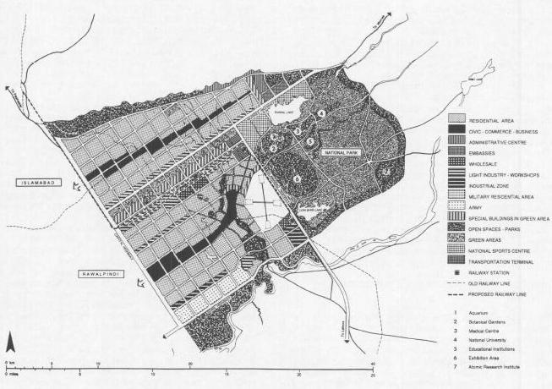

WHAT WENT WRONG IN ISLAMABAD?
Islamabad is facing a host of planning and implementation problems since its inception. These problems have grown as the city‘s construction has progressed. These problems appeared either due to following the rigid conceptual design strictly, or due to weak implementation and monitoring procedures, and practices. As a result the stated goals could not be achieved. For a moment if we forget the second aspect, even then the true aspiration of a new capital for Pakistan befitting the twenty-first century has not been achieved. The following paragraphs analyze Islamabad from four different perspectives. The first three are concerned with the master plan while the fourth one deals with the inappropriate policies and weak administration of the Capital Development Authority (C.D.A), which have aggravated the problem even further. The four important aspects analyzed
here are visionary dimensions of master plan, the degree of flexibility inherent in it to be molded and adjusted into any reasonable given situation by the evolving forces of urban growth, its compatibility with the given socio-cultural traditions, and finally, weaknesses and failures in its implementation.

QNO.3
ANS:
FORM OF PESHAWAR CITY:
Peshawar, city, central Khyber Pakhtunkhwa province, northern Pakistan. The city (capital of the province) lies just west of the Bara River, a tributary of the Kabul River, near the Khyber Pass. The Shahji-ki Dheri mounds, situated to the east, cover ruins of the largest Buddhist stupa in the subcontinent (2nd century CE), which attest the lengthy association of the city with the Buddha and Buddhism. Once the capital of the ancient Buddhist kingdom of Gandhara, the city was known variously as Parasawara and Purusapura it was also called Begram. The present name, Peshawar is ascribed to Akbar, the Mughal emperor of India (1556–1605). A great historic center of transit-caravan trade with Afghanistan and Central Asia Peshawar is today connected by highway and rail with Lahore, Rawalpindi, Hyderabad, and Karachi and by air with Rawalpindi, Chitral, and Kabul, Afghanistan.
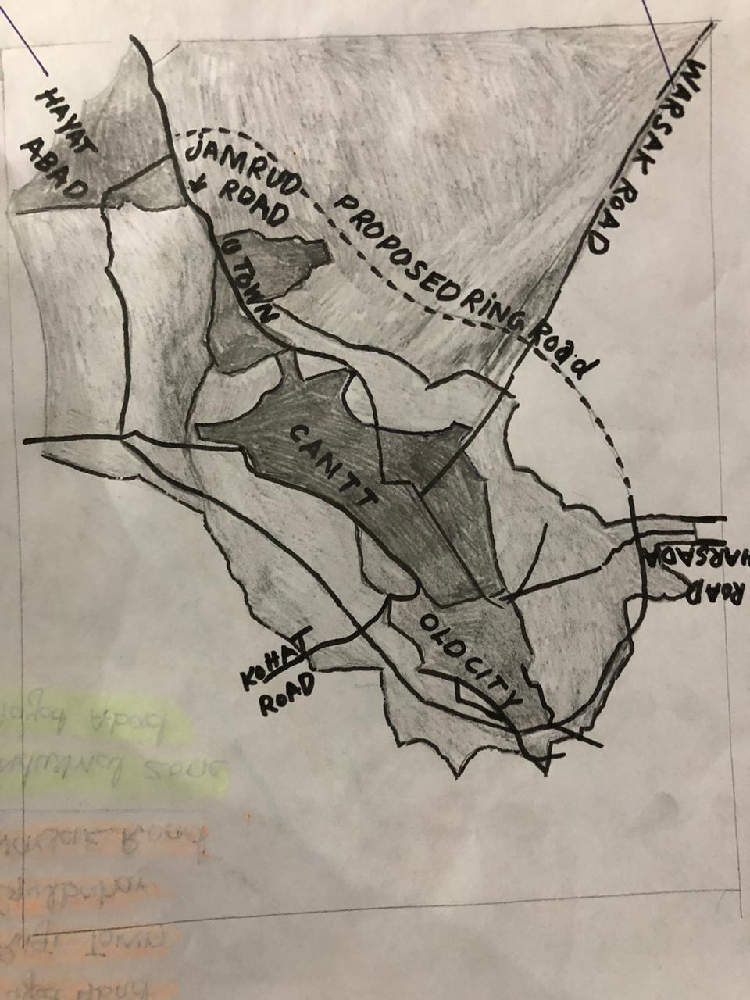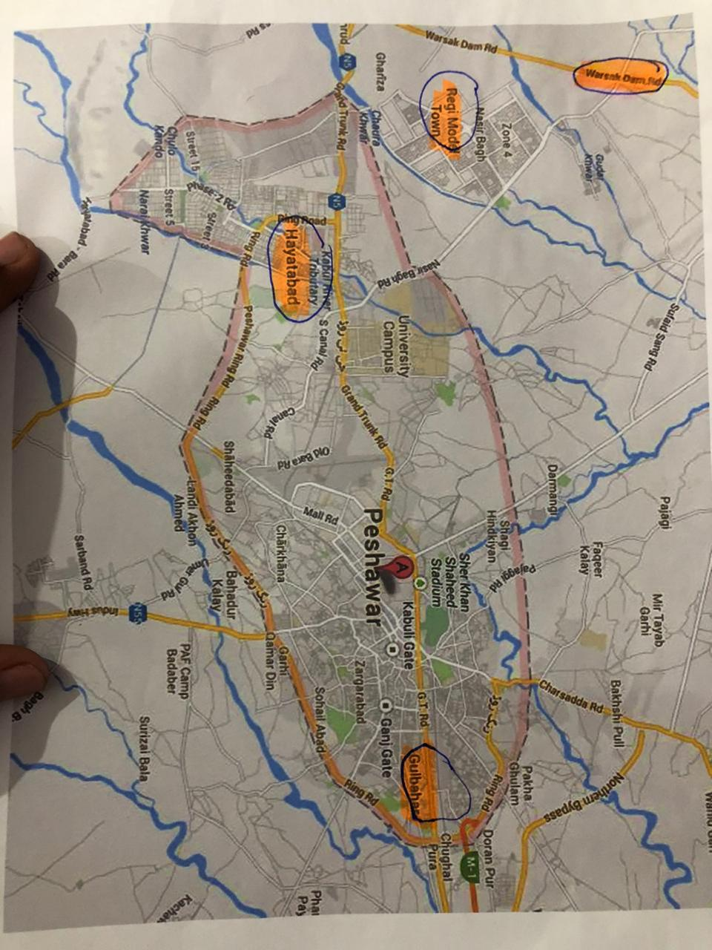

“the end”

