Subject
HR in Public Sector
Instructor
Wajahat Gul
Submitted By
Sadaqat Ali khan
ID# 15294
MS(HR)
Assignment
Mid Term Exam
Date
16th June, 2020

Recruitment and Selection Process Of Communication and Works Department, Civil Secretariat, Peshawar., Peshawar, Pakistan.

Introduction
- Established in 1903 as Public Works Department.
- Bifurcated as Building & Roads (B&R) Department and Irrigation Department in 1955.
- Public Health Engineering (PHE) established in 1970.
- Renamed as Communication & Works (C&W) Department in 1979.
- Communication & Works (C&W) Department merged with Public Health Engineer Department to for “Works & Services (W&S) Department on July 01, 2001.
- Again bifurcated in 2009 as Communication &Works Department and Public Health Engineering Department.

Vision
"C&W Department is committed to provide presentable, economical, sustainable and durable physical infrastructure for nation building, compatible with economic constraints to improve the quality of life of the citizens of the province."

Functions
Construction, equipment, maintenance, repairs internal electrification and fixation of rent of rent of al Government buildings, residential and non-residential, including tents, dak bungalows and circuit houses except those entrusted to Establishment & Administration Department.
Accommodation for Federal and Provincial Government servants in the province except that entrusted to Establishment & Administration Department.
Construction, maintenance and repairs of roads, bridges, ferries, tunnels, rope-ways, causeways and tram-ways lines.
Roads Funds.
Tolls (excluding those levies by Local Governments).
Engineering training other than, Engineering University, Engineering Collages, and Engineering Schools.
Evaluation/Fixation of Rent/Control/Management, leases and disposal sales of Government buildings.
Water supply of sanitary works pertaining to Government buildings and Government estates.
Laying standards and specifications for various types of roads and bridges for the province.
Planning and designing roads and connected a works for the department financed from Provincial and /or Federal Funds.
Road research and material testing.
Execution of works on behalf of other agencies/department as deposit Works. Preparation of architectural plans/drawing of buildings of Provincial Government.usiness

Recruitment & Selection in Public Sector organizations

Process of finding and employing the best-qualified candidate (from inside or outside of an organization) for an employment opportunity, in a convenient and cost effective way. The recruitment process includes examining the requirements of a job, attracting employees towards that job, screening and choosing candidates, recruiting and coordinating the new employee to the organization.
Selection is a process of picking a most suitable candidate for the empty position in the organization. In simple words, selection means finding out unacceptable candidates and choosing those people with essential capabilities and abilities to fill the jobs in the organization.

Recruitment Process in

Communication and Works Department, Civil Secretariat, Peshawar.
There are two types of recruitment in CWD.
Regular Services:
There are further two types of regular services BPS-less than 12 and BPS-12 and above.
Recruitment for the BPS-less than 12:
Department internal committee conduct recruitment for the BPS-less than 12 employees simply the department call them for interview, the shortlisting notifying committee shortlist the candidates and the internal selection committee select employees from the short list.
Recruitment for the BPS- 12 and above:
It is conducted by Public service commission
Recruitment advertising, also known as Recruitment communications and Recruitment agency, includes all communications used by an organization to attract talent to work within it. The use of a specialist recruitment advertising agency enables organizations to receive professional advice on media, design and copywriting specifically related to the recruitment process. This enables their advertisement to stand out in the relevant publication and build an employment brand. Advertisers are now able to use micro-sites to put most of the job content and allowing the advert to be more creative with minimal copy. Recruitment advertising has now developed into a specialty service where most leading organizations use the services of a specialist agency.
Criteria for recruitment;
- Zonal allocation of posts advertise in the newspapers
- Minimum educational Qualification
- Minimum prescribed Experience
- Age limit
- For general post minimum education is Matric or F.A/F.Sc.
- For higher post minimum education is B.A/B.Sc. or M.A/M.Sc.
- For passing test minimum marks is 60 out of 100
- Most of the post required minimum 3years experience and some post required minimum experience or no experience.

The shortlisting committee shortlist the candidates through test.
The selection committee of public service commission in which members from general and technical sides included. 60% marks for academic and 40% interview and test offer by Public service commission.
Contract based:
Contract posts comes from when project arrive for example BRT, C & W swat motor way etc.
There are three types of contract based recruitment and selection;
BPS-16 and below (non gazeted officers)
The requirements comes from planning commission PC1 for the post of BPS-16 and below.
BPS-17 and 18 (gazated officers)
The gazated officers are selected by promotion according to the project policy

Process for selection in CWD Peshawar.
To make it sure to select right person for the right job, making organization necessities to be fill the opportunity, choosing how and where the source initiates for the position and pulling an individual towards that job. For that you discover qualified candidates, leading meetings, and shortlisting candidates and at last select a correct candidate for that activity.
CWD is well known about their service due to many achievements since it’s founded, due to its great performance. For maintain that current current position they select that type of employee who is well educated and kind person.
When there was a vacant post in an organization the HR department recruits and selects new employees for the organization. First of all the advertisement are done for that position and after that test was conduct and after that top 5 or top 10 are called for interview and after successful interview 1 or 2 person selected in the organization who are the right to that post.
Their selection process is done by merit system. The merit includes prescribed education and test. Then after all activities they call top 5 candidates for interview if there is 1 vacant position in an organization. And if there were 2 vacant positions they call top 10 candidates for the interview. And after interview the most willing and appropriate person was selected for that position.
After the successful interview and the process which was set are done the person is the part of that esteem organization and then that person is under trainee staff of the department.

Training and Development
All staff after proper selection are directed to the experienced staff where they arrange seminar for their new staff to develop their skills.

Performance appraisal
Per annum every employee performance is evaluated. And by that system their records are submitted to HR on the basis of which the further promotions, training and development needed through approved service structure.

Conclusion
The recruitment and selection process by the HR department performing very well. They have their own board of governors which is nominate by KP government all issues which are facing by this organization are solved by the board if amendments are needed the board will make amendments in it.

Recommendations
The one thing which I recommend is that have an online portal for them by which they can communicate to other departments and do hiring firing process easily. The online portal help those to work for the organization easily does hiring and firing also do check on their employee activities and make their esteem organization well modified with the current and established era. The online portal will make that organization much prestigious and help to select most appropriate person for their organization to serve community very well.
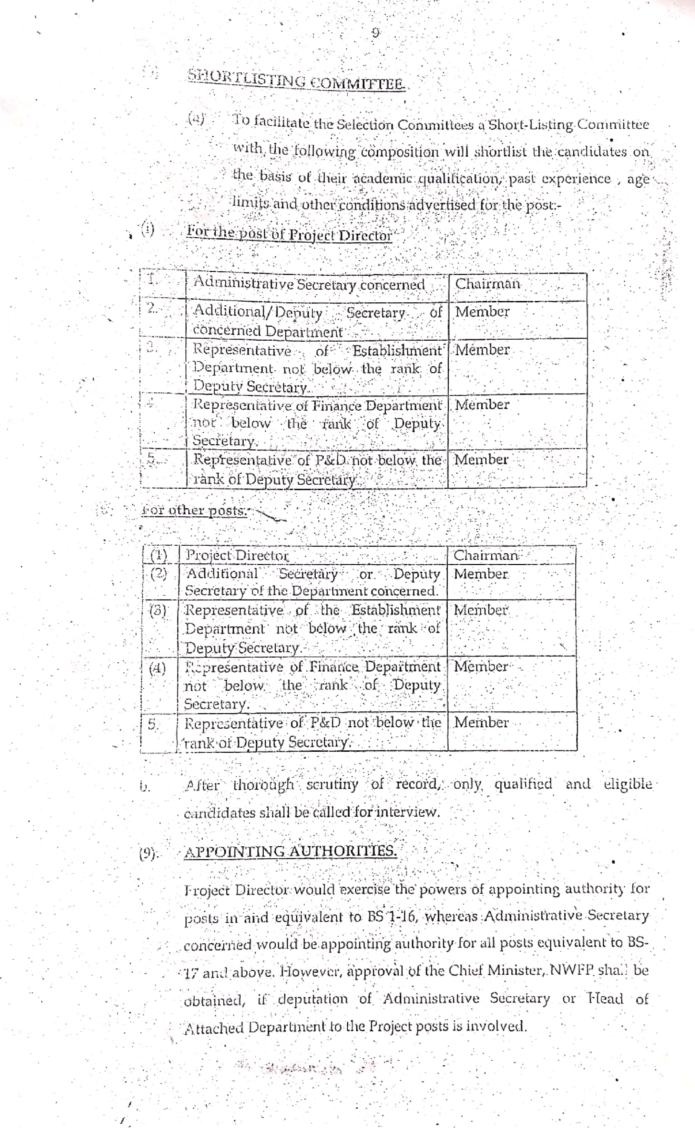

References
Self-visit to organization helped by XEn and Member of internal selection committee Mr. Muhammad Afaq Khalid.
www.cwd.gkp.pk/aboutcandw.php.
other reference documents are attached in the end

