Name: Salman Tahir
I’d : 15173
Subject: Business Mathematics
Assignment submitted to: Sir liaqat Ali
Topic of assignment: Statement Problems

Question#1
What number increased by 25 gives 85?
Answer
let the no. be x
so,
x + 25% of x = 85
x + 25/100 * x = 85
x + x/4 = 85
5x/4 =85
x = 85* 4/5
x = 68

Question#2
Heat and electricity together cost a company Rs: 1080 for the month of January. If the consumption for heating purposes is three times as much as light, how much each expense cost to the company?
Answer
Heat Expense is 720
Light Expense is 360
Question#3
A group bonus is divided among 4 employees in the ratio of their basic salaries. Ratio is 7, 4, 2 and 5 respectively. If a total bonus is Rs. 540; calculate the amount received by each employee.
Answer
let x = the multiplier
then the each bonus would be 7x, 4x, 2x, 5x
a simple equation
7x + 4x + 2x + 5x = 540
18x = 540
x = 540/18
x = 30
the bonus for each
30(7) = 210
30(4) = 120
30(2) = 60
30(5) = 150
--------------
Total = 540

Question#4
A father is four times as old his son now. After 24 years he would be twice as old as his son. What are the present ages of the father and the son?
Answer
Let x be the age of his son now, then the age of the father is 4x.
In 24 years,
The son's age = x + 24
The father's age = 4x + 24
As in 24 years the father will be twice as old as his son, we can set up an equation:
4x + 24 = 2(x + 24)
Solving the equation for x, we have
4x + 24 = 2x + 24
2x = 24
x = 12
So the age of his son now is 12, and the age of the the father now is 48.

Question#5
The sum of the ages of a girl and her brother is 26 years. Three years ago her age was four times the age of her brother. Find the present age of the girl and her brother.

Answer

- Let girl be x and boy be y.
x+y=26
x=26-y
3 years ago;
boy was y-3
girl was x-3
since girl was 4 times age of girl,
x-3=4(y-3)
x-3=4y-12
since x=26-y
(26-y)-3=4y-12
23-y=4y-12
23+12=4y+y
35=5y
y=7
x=26-7
x=19
hence girl is 19years and boy is 7years
Question#6
The sum of two numbers is 84, and one of them is 12 more than the other. What are the two numbers? (36 and 48)
Answer

a)Let x+y=84
x=y+12
b) x+y=84
y+12+y=84
2y=84-12
2y=72
y=36
c) x=y+12
x=36+12
x=48
therefore the two nos. are 36 and 48.
Question#7
List price = $150
Trade discount = 20%
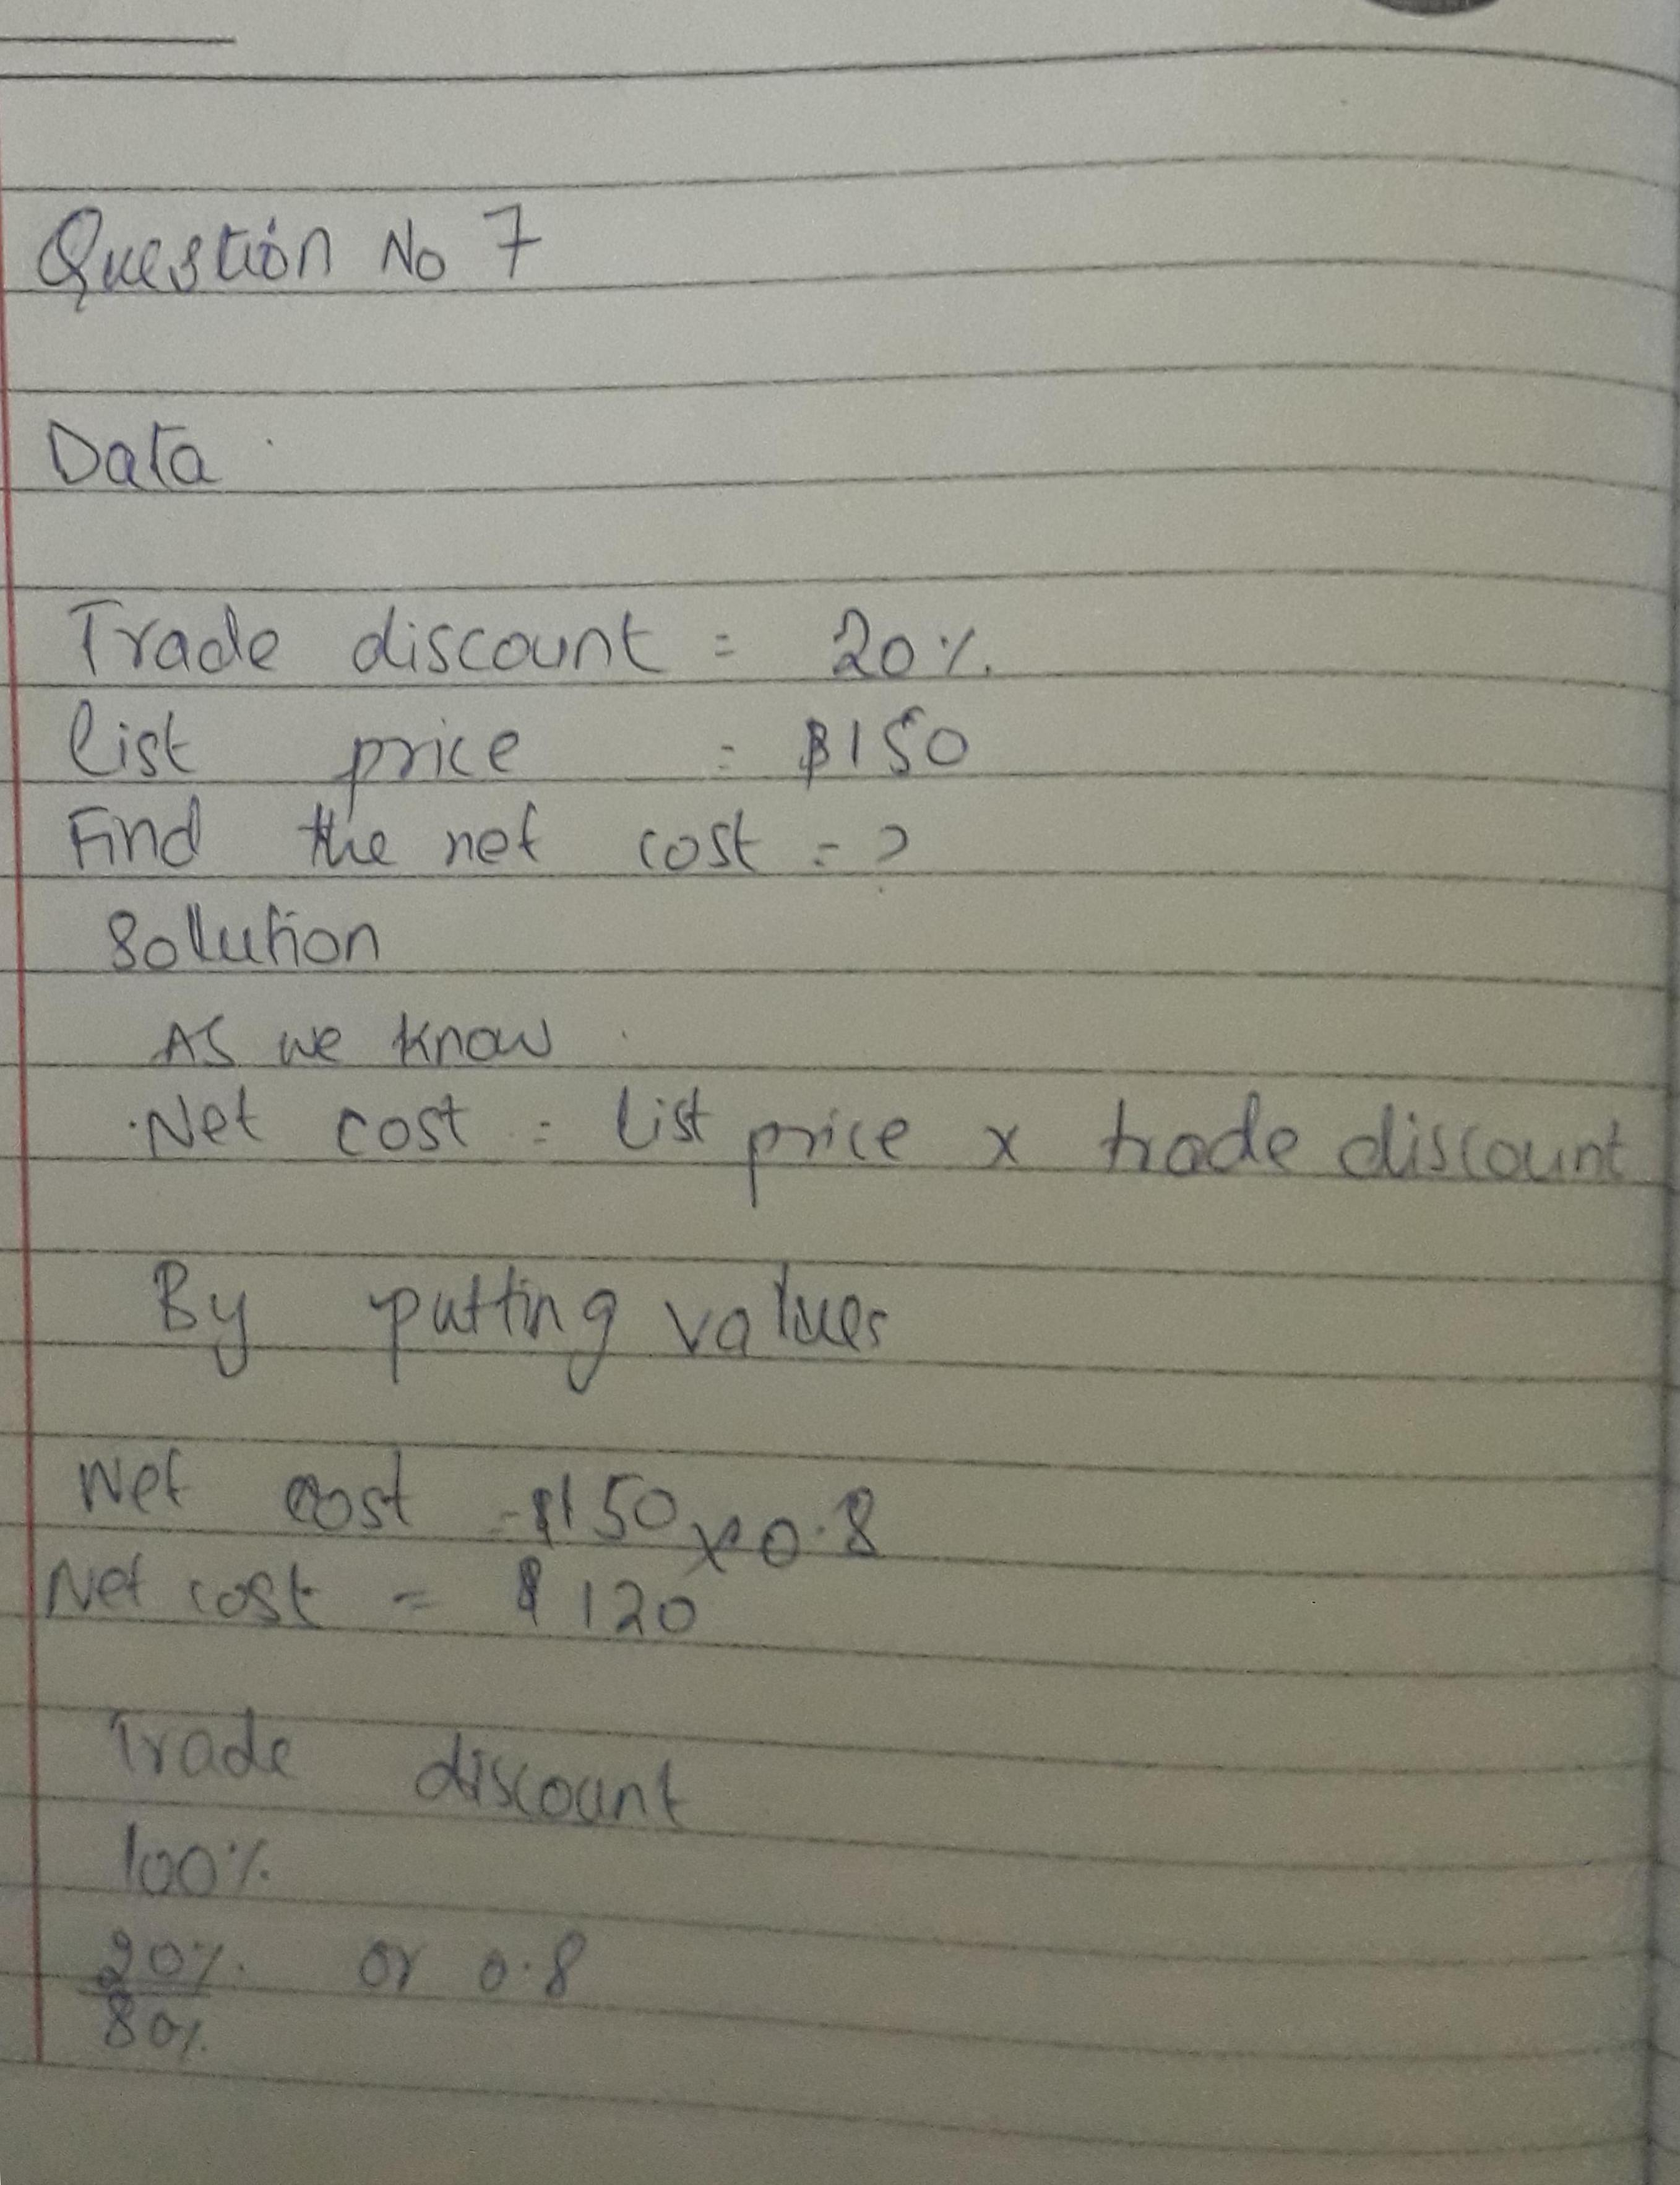
net cost
Question#8
Example#2
List price = $150
Trade discount = 20/10 (series discount)
Find the net cost
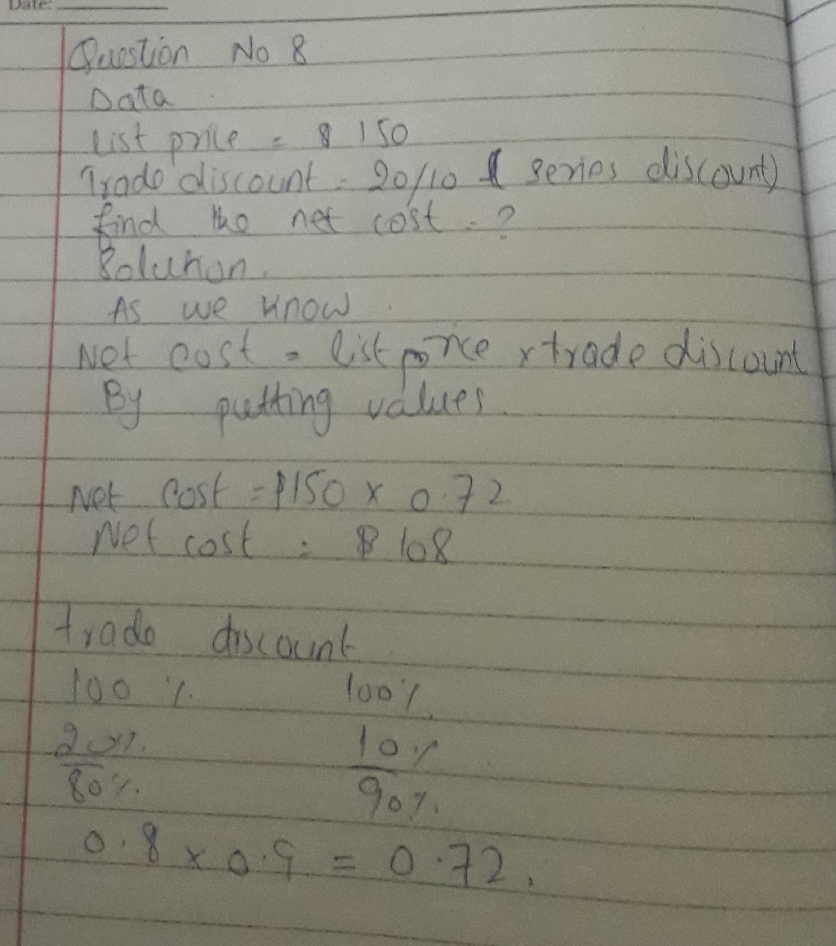

Question#9
Selling price = $18.75
Cost = $15
Markup based on cost = ?
Percent markup based on cost = ?
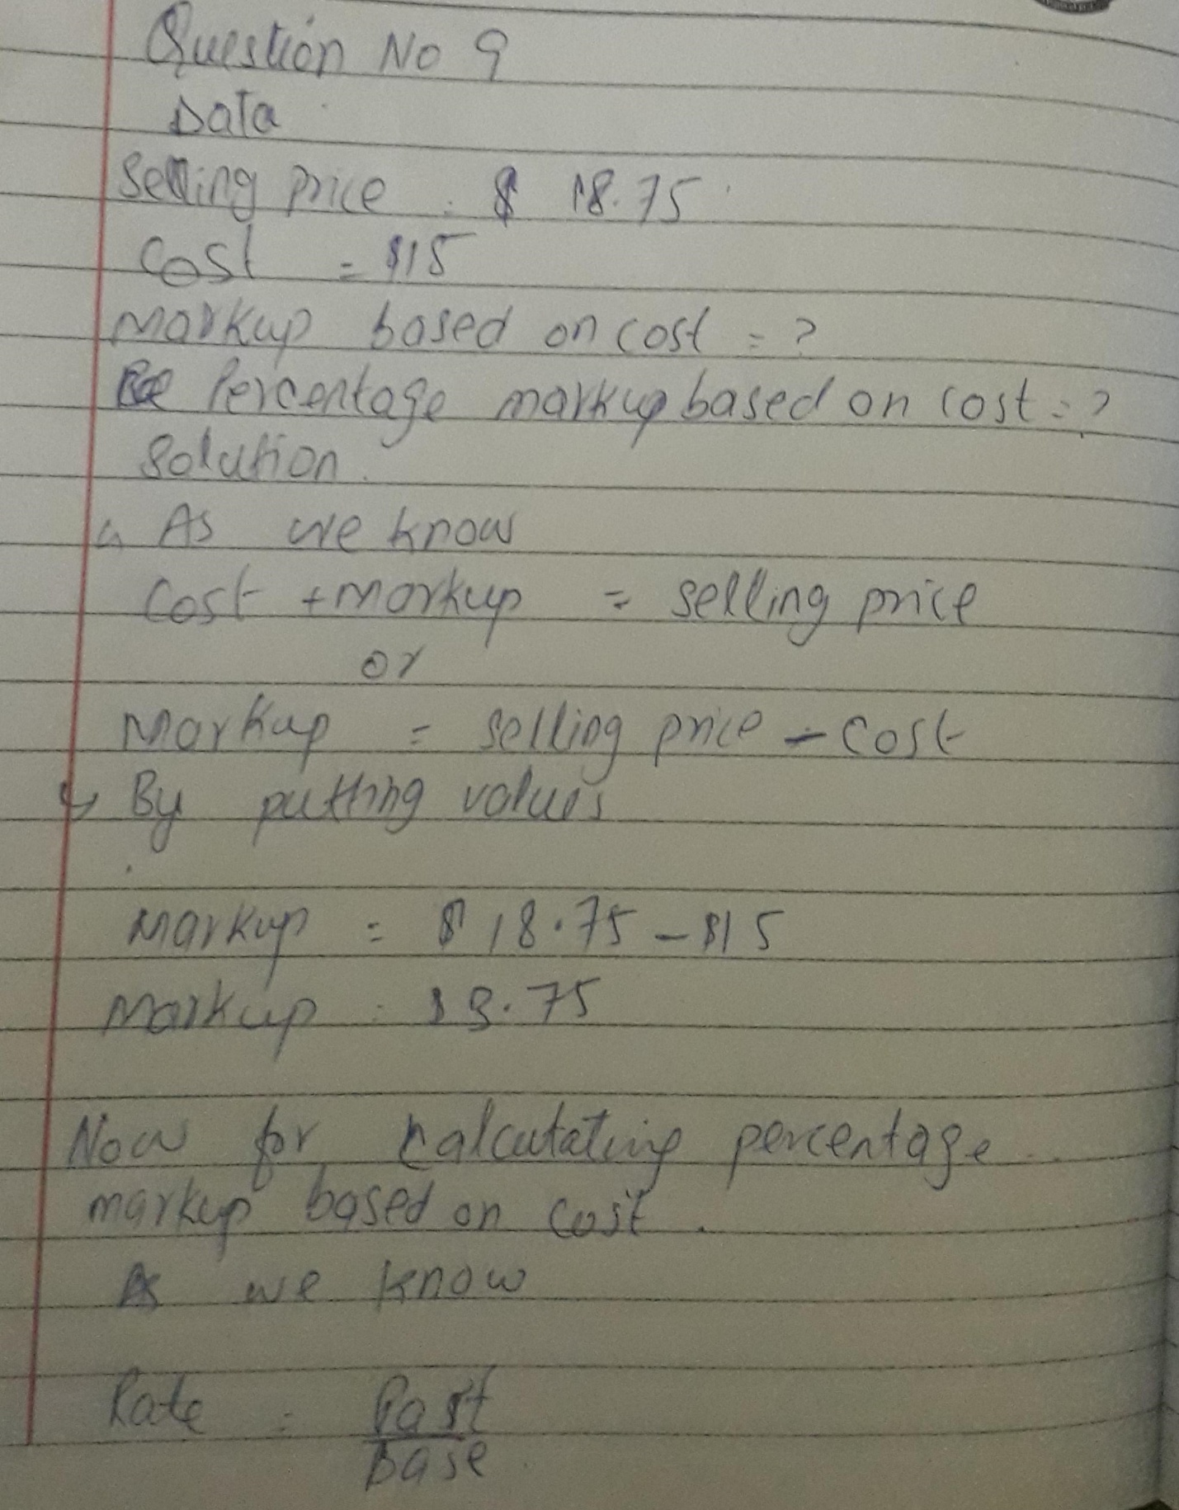
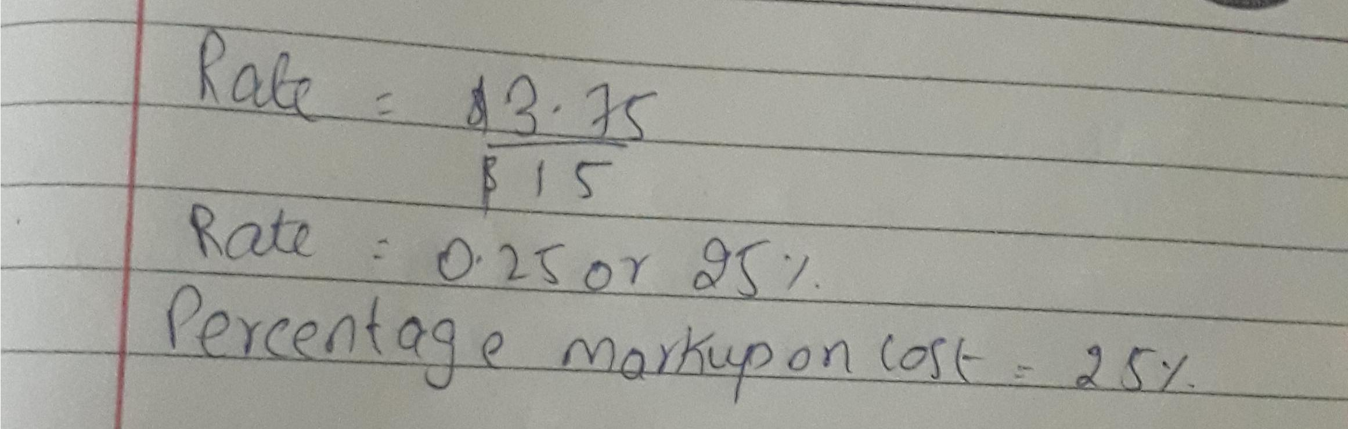

Question#10
The Tower Market sells aspirin for $3.38 per 100-tablet bottle. If they pay $2.60 per bottle, find the markup percent on cost.
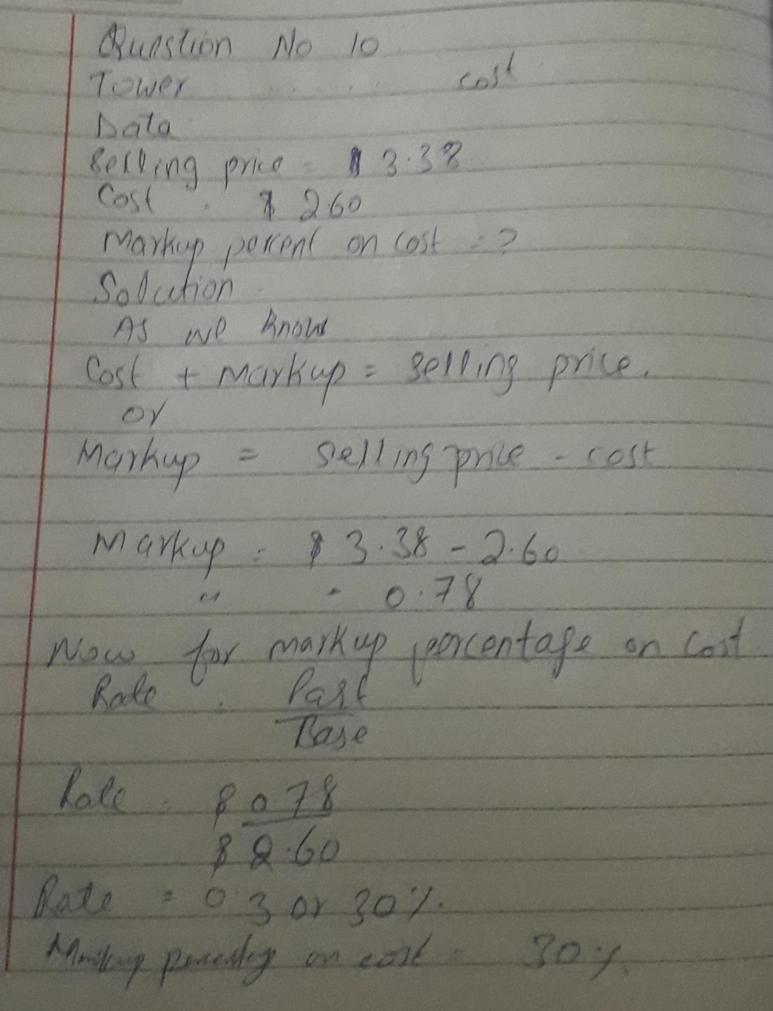

Question#11
Bismark Tractor put a markup of 26% on cost on some parts for which they paid $4.50. Find (a) selling price as % of cost (b) the selling price (c) the markup.

