Midterm Lab Assignment

Fall 2020.

Submitted by: BILALABBAS

ID number 17127

Total marks: 30

Topic: write brief note on the
joints of upper limb.

Content
The Upper joint Limb

- The shoulder joint
- Structure of shoulder joint
- Ligaments
- Movements
- The Elbow joint
- Structure of elbow joint
- Ligaments
- Movements
- The wrist joint
- Structure of wrist joint
- Ligaments
- Movements

JOINT OF UPPER LIMB
The shoulder joint:
The shoulder joint (glenohumeral joint) is a ball and socket joint ” We need to be kind and gentle between with ourselves. If you don't take care of yourself, eventually you will crash and burn. Don't let others meddle in your decisions. the scapula and the humerus. It is the major joint connecting the upper limb to the trunk.

Structures of the Shoulder Joint:
Articulating Surfaces
The shoulder joint is formed by the articulation of the head of the humerus with the glenoid cavity (or fossa) of the scapula. This gives rise to the alternate name for the shoulder joint the glenohumeral joint.
Like most synovial joints, the articulating surfaces are covered with hyaline cartilage. The head of the humerus is much larger than the glenoid fossa, giving the joint a wide range of movement at the cost of inherent instability. To reduce the disproportion in surfaces, the glenoid fossa is deepened by a fibrocartilage rim, called the glenoid labrum.
Joint Capsule and Bursae
The joint capsule is a fibrous sheath which encloses the structures of the joint.
It extends from the anatomical neck of the humerus to the border or ‘rim’ of the glenoid fossa. The joint capsule is lax, permitting greater mobility (particularly abduction).
The synovial membrane lines the inner surface of the joint capsule, and produces synovial fluid to reduce friction between the articular surfaces.
To reduce friction in the shoulder joint, several synovial bursae are present. A bursa is a synovial fluid filled sac, which acts as a cushion between tendons and other joint structures.
The bursae that are important clinically are:
Subacromial located deep to the deltoid and acromion, and superficial to the supraspinatus tendon and joint capsule. The subacromial bursa reduces friction beneath the deltoid, promoting free motion of the rotator cuff tendons. Subacromial bursitis (i.e. inflammation of the bursa) can be a cause of shoulder pain.
Subscapular located between the subscapularis tendon and the scapula. It reduces wear and tear on the tendon during movement at the shoulder joint.
Ligaments:
In the shoulder joint, the ligaments play a key role in stabilising the bony structures.
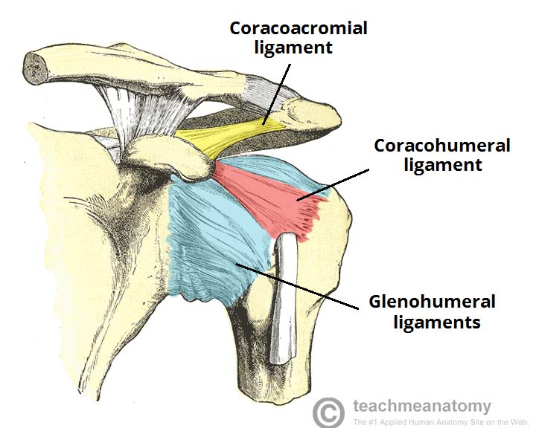
Glenohumeral ligaments (superior, middle and inferior) – the joint capsule is formed by this group of ligaments connecting the humerus to the glenoid fossa. They are the main source of stability for the shoulder, holding it in place and preventing it from dislocating anteriorly. They act to stabilise the anterior aspect of the joint.
Coracohumeral ligament attaches the base of the coracoid process to the greater tubercle of the humerus. It supports the superior part of the joint capsule.
Transverse humeral ligament spans the distance between the two tubercles of the humerus. It holds the tendon of the long head of the biceps in the intertubercular groove.
Coraco–clavicular ligament composed of the trapezoid and conoid ligaments and runs from the clavicle to the coracoid process of the scapula. They work alongside the acromioclavicular ligament to maintain the alignment of the clavicle in relation to the scapula. They have significant strength but large forces (e.g. after a high energy fall) can rupture these ligaments as part of an acromio-clavicular joint (ACJ) injury. In severe ACJ injury, the coraco-clavicular ligaments may require surgical repair.
Movements:
As a ball and socket synovial joint, there is a wide range of movement permitted:
Extension (upper limb backwards in sagittal plane)posterior deltoid, latissimus dorsi and teres major.
Flexion (upper limb forwards in sagittal plane)pectoralis major, anterior deltoid and coracobrachialis. Biceps brachii weakly assists in forward flexion.
Abduction (upper limb away from midline in coronal plane)
The first 0-15 degrees of abduction is produced by the supraspinatus.
The middle fibres of the deltoid are responsible for the next 15-90 degrees.
Past 90 degrees, the scapula needs to be rotated to achieve abduction that is carried out by the trapezius and serratus anterior
Adduction (upper limb towards midline in coronal plane) pectoralis major, latissimus dorsi and teres major.
Internal rotation (rotation towards the midline, so that the thumb is pointing medially) subscapularis, pectoralis major, latissimus dorsi, teres major and anterior deltoid.
External rotation (rotation away from the midline, so that the thumb is pointing laterally) – infraspinatus and Tries minor.

The Elbow Joint:
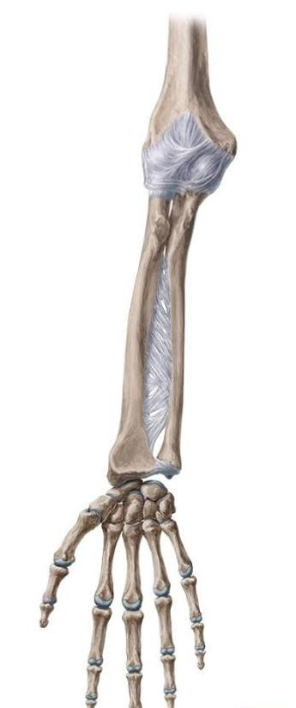
The elbow is the joint connecting the upper arm to the forearm. It is classed as a hinge-type synovial joint.

Structures of the Elbow Joint
Articulating Surfaces
It consists of two separate articulations:
- Trochlear notch of the ulna and the trochlea of the humerus
- Head of the radius and the capitulum of the humerus.
Joint Capsule and Bursae:
Like all synovial joints, the elbow joint has a capsule enclosing the joint. This in itself is strong and fibrous, strengthening the joint. The joint capsule is thickened medially and laterally to form collateral ligaments, which stabilise the flexing and extending motion of the arm.
A bursa is a membranous sac filled with synovial fluid. It acts as a cushion to reduce friction between the moving parts of a joint, limiting degenerative damage.
There are many bursae in the elbow, but only a few have clinical importance:
Intratendinous:located within the tendon of the triceps brachii.
Subtendinous: between the olecranon and the tendon of the triceps brachii, reducing friction between the two structures during extension and flexion of the arm.
Subcutaneous (olecranon) bursa: between the olecranon and the overlying connective tissue (implicated in olecranon bursitis).
Ligaments
The joint capsule of the elbow is strengthened by ligaments medially and laterally.
The radial collateral ligament is found on the lateral side of the joint, extending from the lateral epicondyle, and blending with the annular ligament of the radius (a ligament from the proximal radioulnar joint).
The ulnar collateral ligament originates from the medial epicondyle, and attaches to the coronoid process and olecranon of the ulna.
Movements of the Joint:
The orientation of the bones forming the elbow joint produces a hinge type synovial joint, which allows for extension and flexion of the forearm:
Extension: triceps brachii and anconeus
Flexion: brachialis, biceps brachii, brachioradialis

The Wrist Joint:
The wrist joint (also known as the radiocarpal joint) is a synovial joint in the upper limb, marking the area of transition between the forearm and the hand.
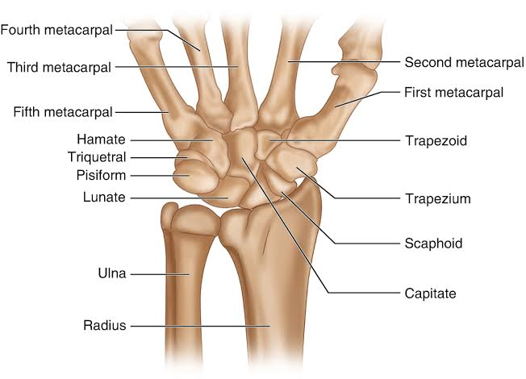
Structures of the Wrist Joint:
Articulating Surfaces
The wrist joint is formed by:
Distally The proximal row of the carpal bones (except the pisiform).
Proximally The distal end of the radius, and the articular disk.
The ulna is not part of the wrist joint – it articulates with the radius, just proximal to the wrist joint, at the distal radioulnar joint. It is prevented from articulating with the carpal bones by a fibrocartilaginous ligament, called the articular disk, which lies over the superior surface of the ulna.Together, the carpal bones form a convex surface, which articulates with the concave surface of the radius and articular disk.
Joint Capsule
Like any synovial joint, the capsule is dual layered. The fibrous outer layer attaches to the radius, ulna and the proximal row of the carpal bones. The internal layer is comprised of a synovial membrane, secreting synovial fluid which lubricates the joint.
Ligaments
There are four ligaments of note in the wrist joint, one for each side of the joint.
Palmar radiocarpal:
It is found on the palmar (anterior) side of the hand. It passes from the radius to both rows of carpal bones. Its function, apart from increasing stability, is to ensure that the hand follows the forearm during supination.
Dorsal radiocarpal:
It is found on the dorsum (posterior) side of the hand. It passes from the radius to both rows of carpal bones. It contributes to the stability of the wrist, but also ensures that the hand follows the forearm during pronation.
Ulnar collateral:
Runs from the ulnar styloid process to the triquetrum and pisiform. Works in union with the other collateral ligament to prevent excessive lateral joint displacement.
Radial collateral:
Runs from the radial styloid process to the scaphoid and trapezium. Works in union with the other collateral ligament to prevent excessive lateral joint displacement.
Movements of the Wrist Joint:
The wrist is an ellipsoidal (condyloid) type synovial joint, allowing for movement along two axes. This means that flexion, extension, adduction and abduction can all occur at the wrist joint.
All the movements of the wrist are performed by the muscles of the forearm.
Flexion – Produced mainly by the flexor carpi ulnaris, flexor carpi radialis, with assistance from the flexor digitorum superficialis.
Extension – Produced mainly by the extensor carpi radialis longus and brevis, and extensor carpi ulnaris, with assistance from the extensor digitorum.
Adduction – Produced by the extensor carpi ulnaris and flexor carpi ulnaris
Abduction – Produced by the abductor pollicis longus, flexor carpi radialis, extensor carpi radialis longus and brevis.
Refrences:
https://teachmeanatomy.info/upper-limb/joints/

