IQRA NATIONAL UNIVERSITY
NAME : SABIHULLAH KHAN
ROLL NO : 18001
SECTION : B
--------------------+-+-+++++-----------+++-------+++
The Acromioclavicular Joint
In this article, we shall look at the anatomy of the acromioclavicular joint – its articulation, ligaments, neurovascular supply, and any clinical correlations.

Structures of the Acromioclavicular Joint

Articulating Surfaces
By TeachMeSeries Ltd (2020)
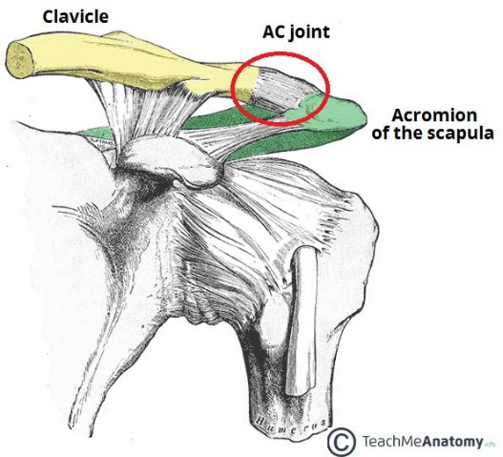
Fig 1.0 – Articulating surfaces of the AC joint.
- The acromioclavicular joint consists of an articulation between the lateral end of the clavicle and the acromion of the scapula. It has two atypical features:

Joint Capsule
The joint capsule consists of a loose fibrous layer which encloses the two articular surfaces. It also gives rise to the articular disc. The posterior aspect of the joint capsule is reinforced by fibres from the trapezius muscle.
- Intrinsic:
  - Acromioclavicular ligament – runs horizontally from the acromion to the lateral clavicle. It covers the joint capsule, reinforcing its superior aspect.
- Extrinsic:
  - Conoid ligament – runs vertically from the coracoid process of the scapula to the conoid tubercle of the clavicle.

ELBOW JOINTS
The elbow is the joint connecting the upper arm to the forearm. It is classed as a hinge-type synovial joint.

Structures of the Elbow Joint

Articulating Surfaces
It consists of two separate articulations:
- Trochlear notch of the ulna and the trochlea of the humerus
- Head of the radius and the capitulum of the humerus
- Intratendinous – located within the tendon of the triceps brachii.
- Subtendinous – between the olecranon and the tendon of the triceps brachii, reducing friction between the two structures during extension and flexion of the arm.
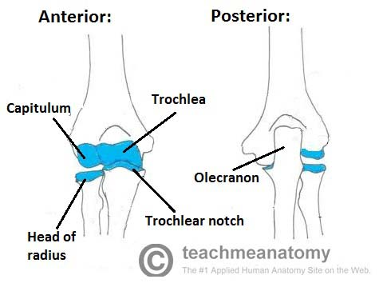
- Subcutaneous (olecranon) bursa – between the olecranon and the overlying connective tissue (implicated in olecranon bursitis).

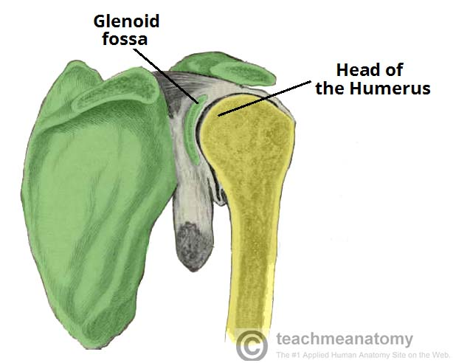
Ligaments
The joint capsule of the elbow is strengthened by ligaments medially and laterally.
The radial collateral ligament is found on the lateral side of the joint, extending from the lateral epicondyle, and blending with the annular ligament of the radius (a ligament from the proximal radioulnar joint).

The shoulder joint

Structures of the Shoulder Joint

Articulating Surfaces
The shoulder joint is formed by the articulation of the head of the humerus with the glenoid cavity (or fossa) of the scapula. This gives rise to the alternate name for the shoulder joint – the glenohumeral
- Subacromial – located deep to the deltoid and acromion, and superficial to the supraspinatus tendon and joint capsule. The subacromial bursa reduces
- frictionbeneath the deltoid, promoting free motion of the rotator cuff tendons. Subacromial bursitis (i.e. inflammation of the bursa) can be a cause of shoulder pain.
- Subscapular – located between the subscapularis tendon and the scapula. It reduces wear and tear on the tendon during movement at the shoulder joint.

The Wrist Joint

The wrist joint (also known as the radiocarpal joint) is a synovial joint in the upper limb, marking the area of transition between the forearm and the hand.

Structures of the Wrist Joint

Articulating Surfaces
The wrist joint is formed by:
- Distally – The proximal row of the carpal bones (except the pisiform).
- Proximally – The distal end of the radius, and the articular disk (see below).
The ulna is not part of the wrist joint – it articulates with the radius, just proximal to the wrist joint, at the distal radioulnar joint. It is prevented from articulating with the carpal bones by a fibrocartilaginous ligament, called the articular disk, which lies over the superior surface of the ulna.

Joint Capsule
Like any synovial joint, the capsule is dual layered. The fibrous outer layer attaches to the radius, ulna and the proximal row of the carpal bones. The internal layer is comprised of a synovial membrane, secreting synovial fluid which lubricates the joint.

Ligaments
There are four ligaments of note in the wrist joint, one for each side of the joint
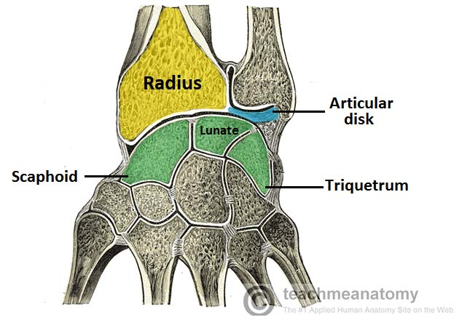
- Palmar radiocarpal – It is found on the palmar (anterior) side of the hand.

