Name: Salman Tahir
ID: 15173
Program: BBA
Course: Basic Statistics
Instructor: Raza Ahmed Khan

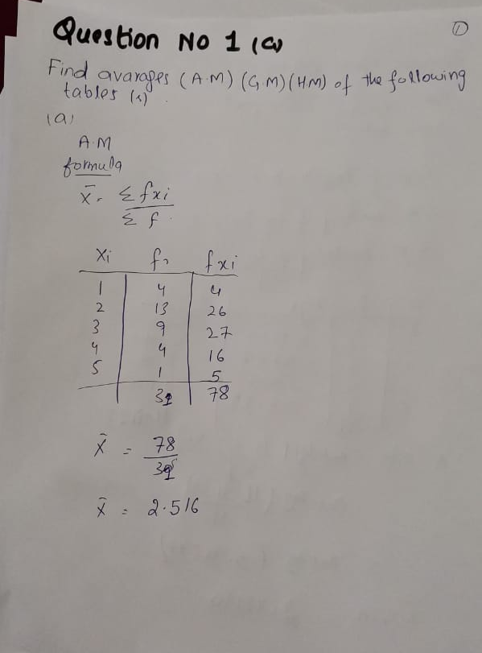
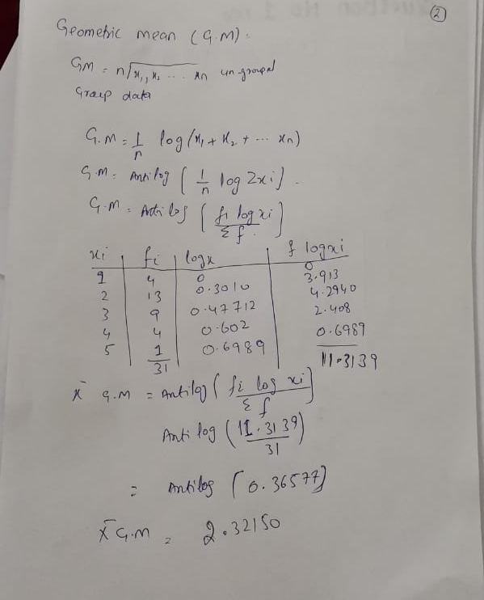
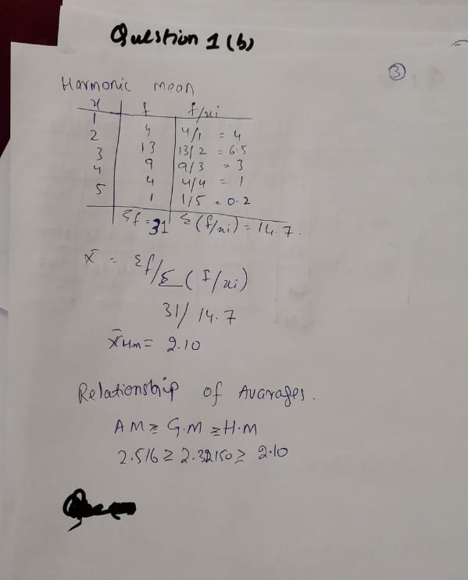
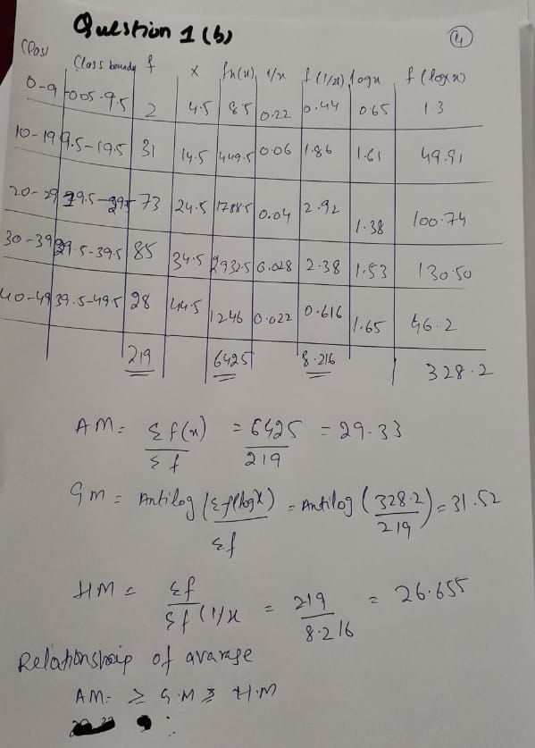
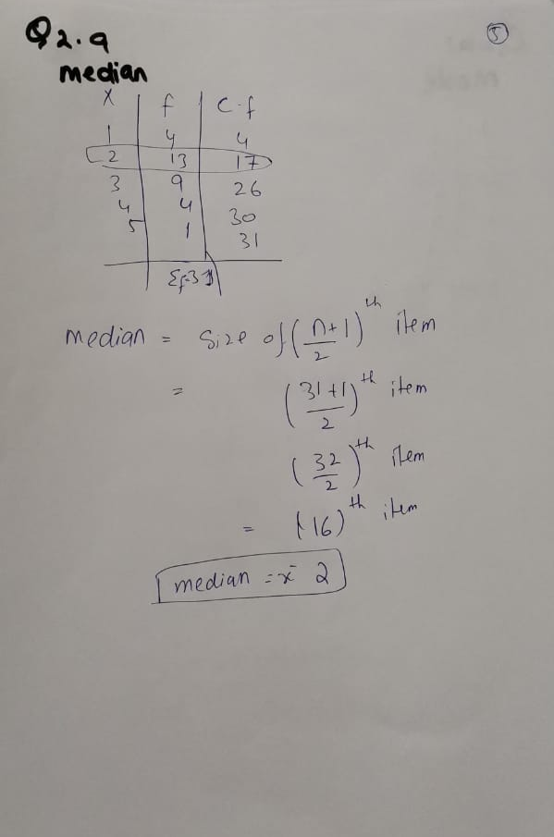
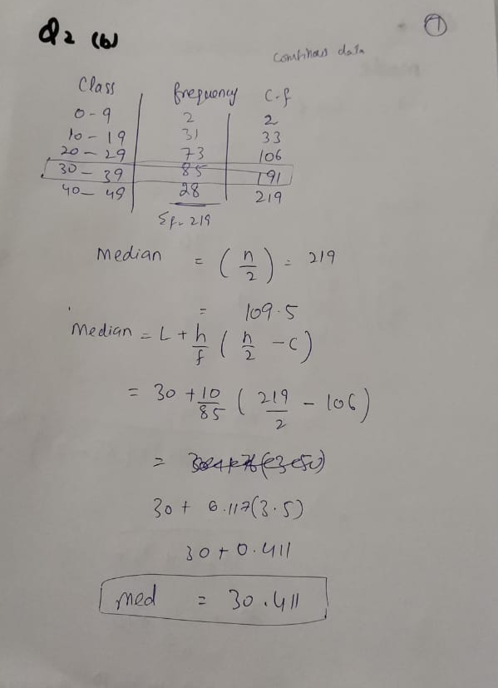
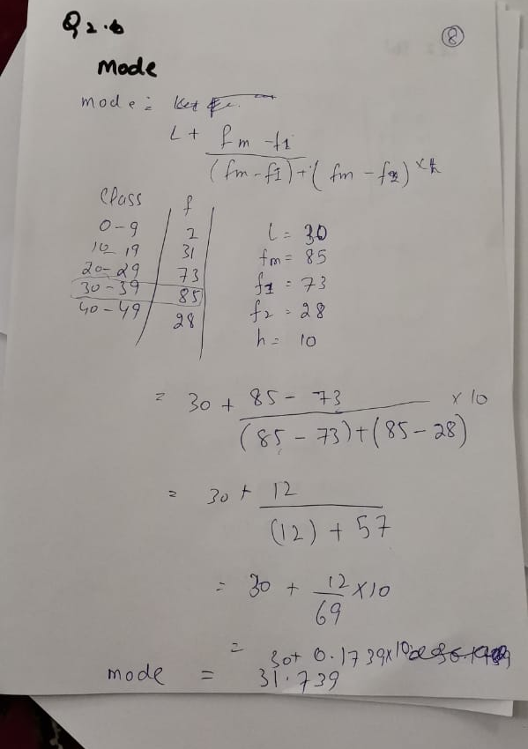
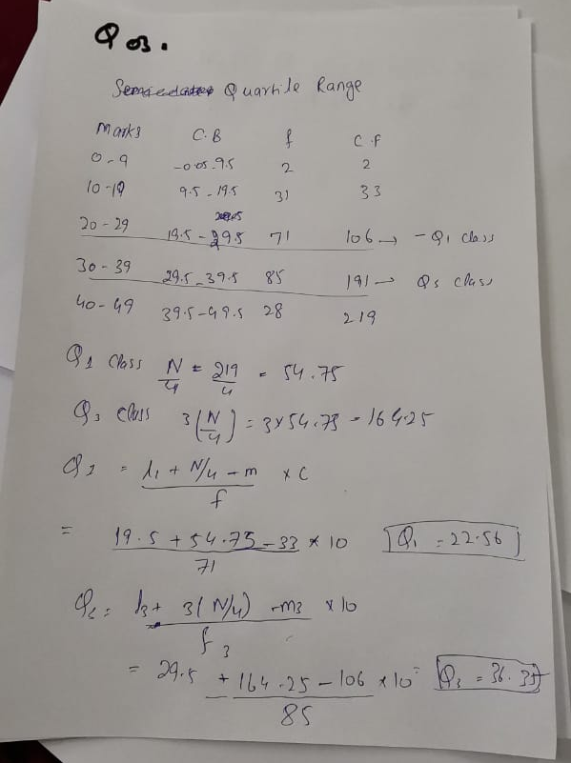
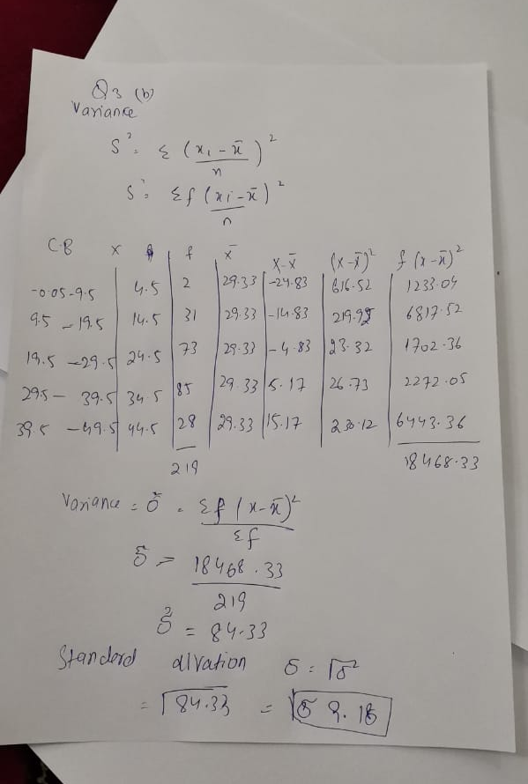
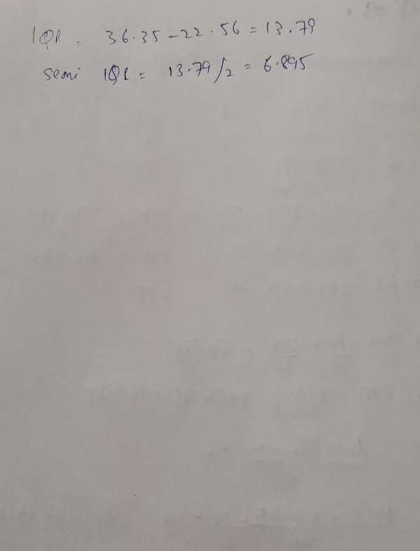

Question:
Differentiate the followings with valid examples
• Range & Quartile Range & Semi Inter Quartile Range
• Variance & Standard Deviation &Coefficient of Variation

Range.
The range of a set of data is the difference between the largest and smallest values.

Quartile Range
The interquartile range is a measure of where the “middle fifty” is in a data set. Where a range is a measure of where the beginning and end are in a set, an interquartile range is a measure of where the bulk of the values lie. That’s why it’s preferred over many other measures of spread when reporting things like school performance or SAT scores.
The interquartile range formula is the first quartile subtracted from the third quartile:
IQR = Q₃ – Q₁.

Semi Inter Quartile Range
The semi-interquartile range is half of the difference between the upper quartile and the lower quartile

Difference with example
In a set of data, the quartiles are the values that divide the data into four equal parts. The median of a set of data separates the set in half.
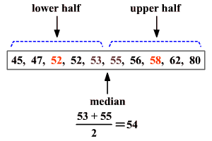
The median of the lower half of a set of data is the lower quartile (LQLQ) or Q1Q1.
The median of the upper half of a set of data is the upper quartile (UQUQ) or Q3Q3.
The upper and lower quartiles can be used to find another measure of variation call the interquartile range.
The interquartile range or IQRIQR is the range of the middle half of a set of data. It is the difference between the upper quartile and the lower quartile.
Interquartile range = Q3−Q1Q3−Q1
In the above example, the lower quartile is 5252 and the upper quartile is 5858.
The interquartile range is 58−5258−52 or 66.
Data that is more than 1.51.5 times the value of the interquartile range beyond the quartiles are called outliers.
Statisticians sometimes also use the terms semi-interquartile range and mid-quartile range.
The semi-interquartile range is one-half the difference between the first and third quartiles. It is half the distance needed to cover half the scores. The semi-interquartile range is affected very little by extreme scores. This makes it a good measure of spread for skewed distributions. It is obtained by evaluating Q3−Q12Q3−Q12.
The mid-quartile range is the numerical value midway between the first and third quartile. It is one-half the sum of the first and third quartiles. It is obtained by evaluating Q3+Q12Q3+Q12.
(The median, midrange and mid-quartile are not always the same value, although they may be.)

Variance
The variance is the average of the squared differences from the mean. To figure out the variance, first calculate the difference between each point and the mean; then, square and average the results.
For example, if a group of numbers ranges from 1 to 10, it will have a mean of 5.5. If you square the differences between each number and the mean, and then find their sum, the result is 82.5. To figure out the variance, divide the sum, 82.5, by N-1, which is the sample size (in this case 10) minus 1. The result is a variance of 82.5/9 = 9.17. Standard deviation is the square root of the variance so that the standard deviation would be about 3.03.
Because of this squaring, the variance is no longer in the same unit of measurement as the original data. Taking the root of the variance means the standard deviation is restored to the original unit of measure and therefore much easier to interpret.

Standard Deviation
Standard deviation is a statistic that looks at how far from the mean a group of numbers is, by using the square root of the variance. The calculation of variance uses squares because it weighs outliers more heavily than data closer to the mean. This calculation also prevents differences above the mean from canceling out those below, which would result in a variance of zero.
Standard deviation is calculated as the square root of variance by figuring out the variation between each data point relative to the mean. If the points are further from the mean, there is a higher deviation within the date; if they are closer to the mean, there is a lower deviation. So the more spread out the group of numbers are, the higher the standard deviation.

Coefficient of Variation (CV)
If you know nothing about the data other than the mean, one way to interpret the relative magnitude of the standard deviation is to divide it by the mean. This is called the coefficient of variation. For example, if the mean is 80 and standard deviation is 12, the CV = 12/80 = .15 or 15%.
If the standard deviation is .20 and the mean is .50, then the CV = .20/.50 = .4 or 40%. So knowing nothing else about the data, the CV helps us see that even a lower standard deviation doesn't mean less variable data.

