Mid Term
NAME:AHMAD QAYYUM KHAN
Subject Name: Applied Physics
Class: BSSE
ID:16223

Q1:
- Explain the phenomena of electron hole pair recombination?
ANS: There is a continuous transition of electrons between the two bands. When an electron falls from the conduction band into the valence band, into a hole, a recombination process occurs and an electron hole pair disappears. The energy of recombination will be emerged as a photon of light.

- What happens to the barrier potential when the temperature increases?
ANS: Semiconductors are characterized by two types of mobile carriers, electrons in the conduction band and holes in the valence band. Both bands are separated by the energy gap. This energy gap is about 1.1 eV in silicon. There is a continuous transition of electrons between the two bands. When an electron falls from the conduction band into the valence band, into a hole, a recombination process occurs and an electron hole pair disappears. The energy of recombination will be emerged as a photon of light. Inversely, when a valence electron is given an energy equal or greater than the energy gap it will be transferred to the conduction band and an electron hole pair will be generated.
There are different types of e-h generation: the thermal generation, the photo generation, the impact ionization according to the energy supplied in the process.
The recombination is always present and sets up an equilibrium in steady state. Recombination rate is controlled by the minority carrier lifetime.
Q2:
- Explain the difference between majority and minority carriers? Explain the majority and minority carriers in n-type and P-type semiconductors?
ANS:
The more abundant charge carriers are called majority carriers, which are primarily responsible for current transport in a piece of semiconductor. ... The less abundant charge carriers are called minority carriers

In an n-type semiconductor, the electrons are the majority carriers whereas, the holes are the minority carriers. In the p-type semiconductor material, the holes are the majority carriers, whereas, the electrons are the minority carriers as shown in the figures below.
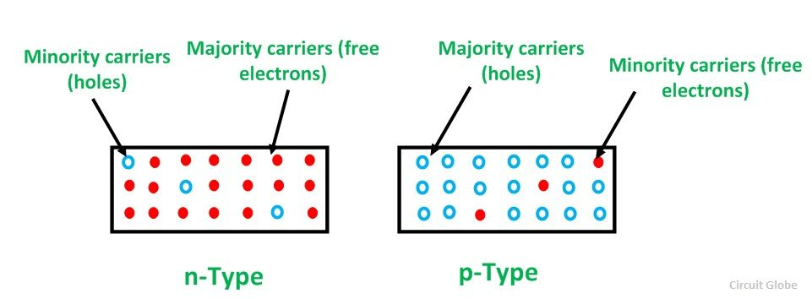

- When does reverse breakdown occur in a diode?
ANS: The reverse current in a diode is normally very small. If the external bias voltage is increased so on, the reverse current increases drastically at a particular value of the reverse bias voltage. This particular value of the reverse bias voltage is known as breakdown voltage.

Q3
a:Find the difference between electric potential energy and electric potential?
ANS: The basic difference between electric potential and electric potential energy is that Electric potential at a point in an electric field is the amount of work done to bring the unit positive charge from infinity to that point, while electric potential energy is the energy that is needed to move a charge against the electric field.

b.How to find the potential difference between any two points in the electric field lines?

ANS:
In a uniform electric field, the equation to calculate the electric potential difference is super easy: V = Ed. In this equation, V is the potential difference in volts, E is the electric field strength (in newtons per coulomb), and d is the distance between the two points (in meters)

