IQRA NATIONAL UNIVERSITY
DEPARTMENT OF ALLIED HEALTH SCIENCES
Student Name : jamal khan Id No: 13363
Final -Term Examination (summer 2020)
Course Title: Medical laboratory management skills Instructor: Mr. Adnan Ahmad
Max Marks: 50

- Explain quality management system and also draw path of workflow for laboratory?
Ans: A quality management system (QMS) is defined as a formalized system that documents processes, procedures, and responsibilities for achieving quality policies and Error! Hyperlink reference not valid.objectives. ... The documents only serve to describe the system.
- General quality management principles say that you should define and follow all the best practice processes that you need (determined by you) to run your business / organisation, plus a selection of quality management supporting processes (audit, non-conformance, mgt review etc.) that are applicable to everyone.

- Different industry standards / legal regulations then add to the list of mandatory processes and these are different depending on what you do. In some cases they even mandate what the processes have to contain. On top of this there may be voluntary codes of conduct.

- Unfortunately not all processes that are relevant to an industry are necessarily relevant to every business within that industry. For example, a primary engineering business might require processes for product design, product manufacture and new product testing, while a sub-contract business may only be involved in one of these.

- However, no matter what industry you're in, getting the right information to the right person at the right time is necessary for the success of your business. This is where quality management system (QMS) software comes into play.

Different types of QMS software support your business goals in different ways. Choosing the best QMS for your company requires looking at your objectives and determining the main quality challenges you need to resolve.
By module:
- Document control
- Change control
- Enterprise & operational risk management
- Supplier management
- Equipment and asset management
- CAPA management
- Policy management
- Internal audit
- Training records management
- Integrated BI / GRC Dashboard
- Complaints management system
- Accident and incident reporting management system

draw path of workflow for laboratory.

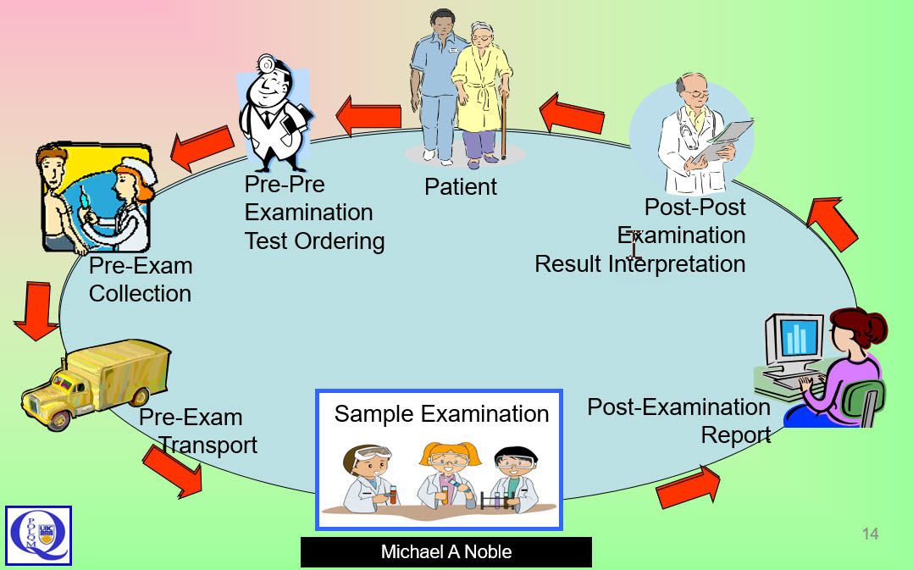

Q 2. Briefly Explain 12 Quality System Essentials.

Ans: 1. Organization
The laboratory needs to be organized around a formal quality management system that supports consistent procedures. The management team and quality unit play an integral role in a quality-driven culture, along with structures for monitoring ongoing quality.

2. Personnel
Capable staff members are the single most important asset to a laboratory. Training, motivation, and engagement are key parts of the quality management system.

3. Equipment
Every piece of equipment used in the laboratory must be maintained to operate safely.

4. Purchasing and Inventory

Properly managing the supply chain is critical to ensure that raw inputs and other supplies are consistently high-quality. Inventory activities should verify that materials and supplies are stored in a way that protects integrity.
5. Process Control
Process control encompasses QC processes for testing, including:
- Collection
- Handling
- Method Verification
- Process Validation

6. Information Management
The laboratory produces many forms of information, including QC test results, maintenance reports, and other data. This data needs to be managed in a way that ensures all information is accurate, secure, confidential, and accessible to individuals with the right privileges, such as lab managers and leadership.

7. Documents and Records
Documents are a similar concept to information management, and there’s a significant overlap between these categories. One of the most essential lab documents is standard operating procedures (SOPs) to create a standard for each process. Documents need to be available at the point of work, maintained, accurate, and secure.

8. Occurrence Management
An “occurrence” is any error or non-conformance. A QMS software can help you detect these issues and facilitate investigations to discover the root cause and prevent reoccurrence.

9. Assessment
Assessment involves comparing laboratory performance to internal standards for quality or external data sets, such as industry benchmarks. Assessments include the activities of lab or QC managers, internal auditors, or external inspectors.

10. Process Improvement
A quality management system should support continuous process improvement of laboratory processes. Components of the QMS which support improvement can include QC and CAPA (occurrence management).

11. Customer Service
Customer service is the goal of a laboratory. A laboratory’s QMS should support operations that consistently provide a positive customer experience through the production of consistently high-quality products or other missions. The laboratory needs to understand the customers and their needs and use customer feedback for improvement.

12. Facilities and Safety
Laboratories need a comprehensive set of procedures and standards to ensure a safe, secure, and clean environment. This includes physically securing the lab, containment procedures for hazards, worker safety, and ergonomics.
Q3.Write down a short note on Selecting and acquiring equipment.
Ans: Selecting and acquiring equipment: Acquiring equipment Selecting the best instrument for the laboratory is a very important part of equipment management. Some criteria to consider when selecting laboratory equipment are listed below. y Why and how will the equipment be used. The instrument should be matched against the service the laboratory provides. y What are the performance characteristics of the instrument. Is it suffi ciently accurate and reproducible to suit the needs of the testing to be done y.What are the facility requirements, including the requirements for physical space.Will the cost of the equipment be within the laboratory’s budget? y Will reagents be readily available.Will reagents be provided free of charge for a limited period of time? If so, for how long. How easy will it be for staff to operate? y Will instructions be available in a language that is understood Is there a retailer for the equipment in the country, with available services.Does the equipment have a warranty Are there any safety issues to consider If the decisions about purchasing are made outside the laboratory (e.g. by a central purchasing body), the laboratory manager should provide information that will support selecting equipment that will best serve the needs of the laboratory. In areas where there are national programmes for purchasing standard equipment, the laboratories of the country should have some input to decisions. In addition, in areas where donors are likely to provide some of the equipment that is used, laboratory management should have input into the choice of equipment. If this is not possible, management should consider declining equipment if it is inappropriate for laboratory needs. Is it better to purchase or lease equipment? When making this decision, it is a good idea to factor in repair costs. The manufacturer should provide all of the necessary information to operate and maintain equipment. The initial cost of an instrument may seem reasonable, but it may be expensive to repair. Also consider savings that could be negotiated if the laboratory needs more than one piece of equipment. Before purchasing ask if: y wiring diagrams, computer software information, a list of parts needed, and an operator’s manual are provided; y the manufacturer will install the equipment and train staff (covering travel expenses as necessary) as part of the purchase price;
4) Discuss the methods for Equipment maintenance documentation?

Ans: Equipment documentation
The objectives of technical documentation
The lack of equipment documentation is a major problem faced by maintenance services in production plants. Equipment documentation is necessary to ensure maintenance management, repair work, manufacture of spare parts, rapid troubleshooting, work safety, the correct selection and management of spare parts and efficient staff training. Unfortunately, when purchasing production equipment, technical documentation is frequently neglected by both supplier and customer.
Complete documentation is expensive. For a new factory it can vary between 8 and 22 per cent of the value of the equipment. In order to lighten expenses for existing plants, full documentation should only be prepared for priority equipment. In any case, investment in setting up or improving technical documentation will only be justified if the documentation is used efficiently. For this, the documents must be updated regularly and dispatched judiciously.

Content of equipment documentation
Technical documentation can be divided into three types:
- study and engineering;
- construction and start-up;
- exploitation.
We have paid most attention to the third type, which is vital for the efficient running of the factory, because most of the documents concerning engineering, construction and start-up are little used once the factory is in production.
Equipment documentation is classified in four different types of file, established by zone, department or production line: these are the general file, the machine files, the utilities file, and the standard files. All the documents should be presented in hard-cover A4 binders. The different headings are separated by numbered insertions so that each heading is easily accessible.

5)Write a comprehensive note on personal protective equipment?
Ans:Personal protective equipment, commonly referred to as "PPE", is equipment worn to minimize exposure to hazards that cause serious workplace injuries and illnesses. These injuries and illnesses may result from contact with chemical, radiological, physical, electrical, mechanical, or other workplace hazards. Personal protective equipment may include items such as gloves, safety glasses and shoes, earplugs or muffs, hard hats, respirators, or coveralls, vests and full body suits.
What can be done to ensure proper use of personal protective equipment?
All personal protective equipment should be safely designed and constructed, and should be maintained in a clean and reliable fashion. It should fit comfortably, encouraging worker use. If the personal protective equipment does not fit properly, it can make the difference between being safely covered or dangerously exposed. When engineering, work practice, and administrative controls are not feasible or do not provide sufficient protection, employers must provide personal protective equipment to their workers and ensure its proper use.Employers are also required to train each worker required to use personal protective equipment to know:
When it is necessary
What kind is necessary
How to properly put it on, adjust, wear and take it off
The limitations of the equipment
Proper care, maintenance, useful life, and disposal of the equipment
If PPE is to be used, a PPE program should be implemented. This program should address the hazards present; the selection, maintenance, and use of PPE; the training of employees; and monitoring of the program to ensure its ongoing effectiveness

