Final Assignment: - Blood banking
Submitted by Muhammad shah (13869)
Submitted To Huma Imtiaz
Department Allied Health Sciences
Degree BS (MLT)
Semester 6th

Q1
Define hemovigilance. Dicuss benefit and limitations of hemovigiliance.
ANSWER1
Hemovigiliance mean as a set of surveillance processe of whole transfusion chain from the collection of blood components follow up to its patients proposed to collect and allow asses information of on anticipated or undesirable result effect from the theurapetic uses of the blood product .
BENEFITS OF HEMOVIGILANCE :

HV data can be used for the purpose of priorities during blood transfusion .
Improve the quality of transfusion service .
Improve understanding of real hazards or risky for transfusion.
Understanding range and frequency of transfusion.
Improve public or people's trust and confidence too.
We should take corrective measurement to minimize or prevent the incidents rate .
HV teams always have an aim to reduce morbidity and mortality in donor's and recipients.
HV has increase the rate of safe transfusion.

LIMITATIONS :

Reporting efficiency is very low it's means that it reporting is incomplete .
It also shows limit details of a donor or recipients.
Due to new researches and invention day by day so it's terminologies and difinations are changing.
A small error can damage the whole process and thus you have to restart it.

Q2 What is the purpose of cross match ? Discuss the procedure of major cross match?
Definition ;
it is the transfusion medicine cross matching is testing before blood transfusion to determine the donor blood is compactable with blood of patient reciepient is called cross match but it is also known as compatibility testing .
PURPOSE
The primary purpose of cross matching is to detect ABO in compatibilities between donor and recipient .
This is carried out to prevent transfusion reaction by dectecting antibodies in reciepient serum.
It is the most important test before a blood transfusion is given.
The purpose of the cross match is to detect the presence of antibodies in the reciepent against the red blood cells of the donor.
These antibodies attach to the red blood cells of the donor after transfusion .
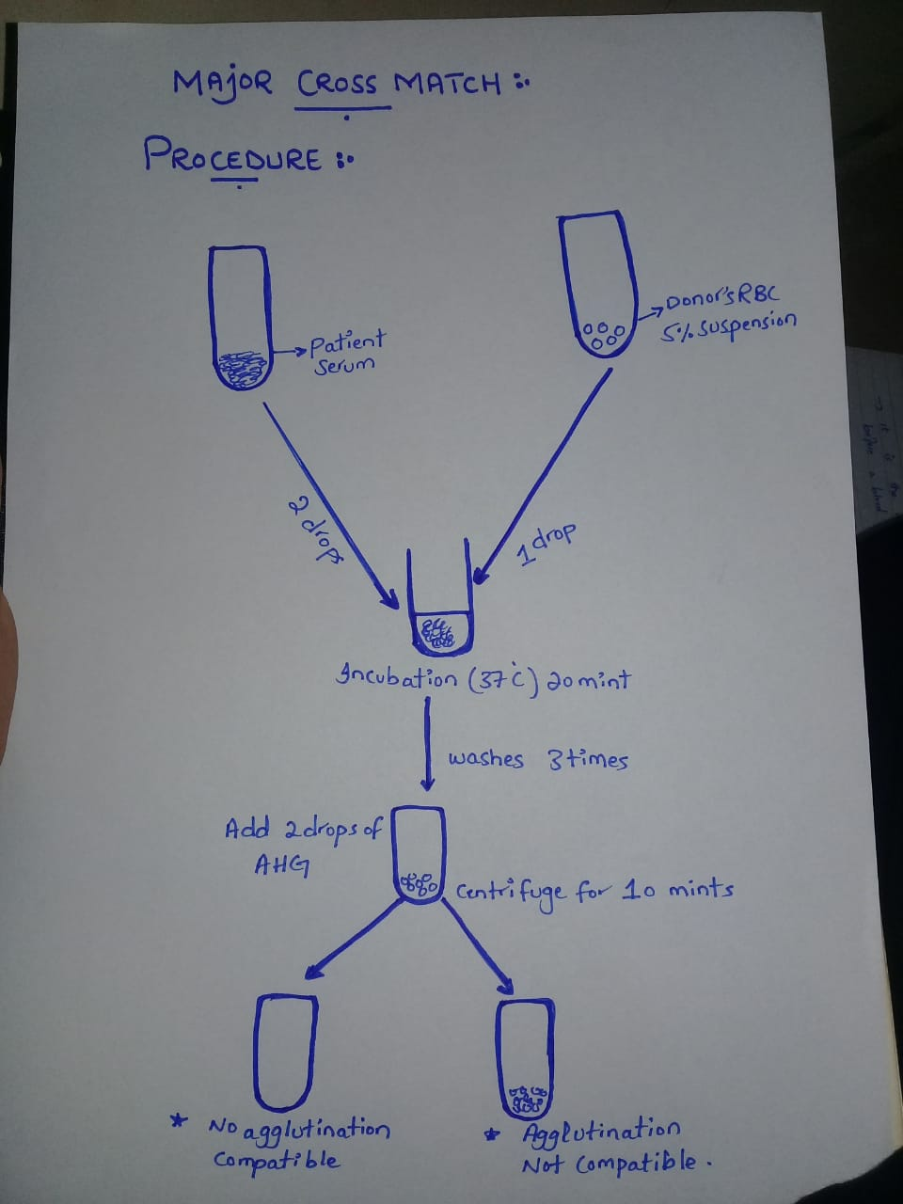
Q3

HDN (Hemolytic Disease of Newborn)
Also called “Erythroblastosis fetalis”
The major cause of HDN is Rh incompatibility of mother with her fetus; the D antigens are highly immunogenic that leads to cause hemolytic disease of the baby.

Pathogenesis
When the mother’s blood is Rh negative and her baby inherits the Rh positive trait from the father.

Because of chromosome “D” that the fetus received from the father is foreign to the mother, when this chromosome escapes into maternal circulation.

It will stimulate the formation of Antibodies.

During labour the maternal and fetal blood mixes

The mother’s body sensitized against baby’s blood.

The anti-D antibodies belong to class IgG circulating in the mother’s blood will cross the placenta and will attack on Rh positive gene of baby.

Result in the destruction of RBCs leads to anemia and excessive bilirubin level, Causing Hemolytic Disease of Newborn.

The hemolytic disease of newborn is characterized by;
- Pale yellow skin due to billirubinemia.
- Jaundice;whiteness of eyes.
- Hepatosplenomegaly.
- Multiple edemas throughout the body.

Q4
What is the function of Duffy antigen?
- Duffy antigen binds to the material secreted by cells during inflammation and recruits other blood cells to the area of damage.
- Duffy antigen act as a receptor on erythrocyte for the invasion of human malerial parasites , plasmodium viva and Plasmodium knowlesi. The individual who are duffy negative ensure that merozoite invasion resistant because of no receptor expression .
- Duffy antigen perform is important role in hematopoiesis immature RBC in bone marrow contain high expression of duffy antigen which promotes direct contact with hematopoietic stem cell.
- The absence of duffy antigen increase chance for hiv infection .
- Lungs transplantation rejection is also implicated through duffy antigen.
- During pneumonia the expression of duffy antigen increase in vascular body and in alveolar septa of the lung paranchyma.
- The HDN is also linked through the duffy antigen.
- The side effect of anti psychotic drugs like clozapine increases neutropenia in those whose are duffy null patients.

Q5
Prepration of coombs reagent ;
Coombs reagent are prepared by taking blood of human and separate the serum of human the separated serum then injected to animal mostly into rabbits .
The rabbits are immunize by the human genus glubulins.
The immune system of rabbits in response produces anti human globulin against the human antibodies.
The blood of rabbits or other animals then drawn and separated to get the formed antibodis.

PROCEDURE OF IAT;
