Name: Shah Fahad
ID: 16069
Section: A
Department: BE(C)
Subject: Architecture and town planning
Assignment: 1

Islamic Architecture (Mamluk Architecture)

History
The mamluks ruled Egypt and Syria from 1250 until 1517, when their dynasty was left from the Ottomans. But mamlus had first appeared in the abbasid caliphate in the ninth century. They wanted and continued to form an important part of egyption Islamic society. They destroyed the crusaders and saved Syria, Egypt and the holy places of Islam from Mongols. They made Ciaro the dominant city of Islamic world and the Cairo city was an example of mamluks architecture. The Mamluk sultans were known for their art and architecture and they encouraging artisans and craftsmen for making and thinking the best one and more features in a single building.

Location of Mamluks Architecture
if we talk about the main location of mamluks then the ciaro is the only and there owned places and also the example of mamluk architecture Cairo was the main and the dominant mamluks city of Islamic world. Although Cairo is the example of the mamluks architecture because of there owned Islamic city but we can also mention Egypt and Syria in the designing of mamluks because there is numbers of building in the design of mamluks architectures. The architecture of the mamluks is primarily built of stone and predominant in the two major regions under their control Egypt and Syria wood is used for elements such as doors and panels.major cities were endowed with commercial buildings, religious foundations and bridges. In Cairo the complex of Qaitbay in the northern Cemetery 1472-74 is the best known and admired structure of this period. Building continued under the last mamluk sultan al ashraf qansuh al Ghuri.

Mamluks architecture
We can say that the mamluks architecture is different and awesome of their time from other they use a complex and awesome tactics in building. The one of the complex tactic which they use in buildings is that they use multiple function in a single building means the can manage a single building for multiple uses. They build one building which can be functioning as more than one building. These could include charitable functions and social services such as mosque. Khanqah, madrasa, bimaristan(hospital), maktab(school) or commercial functions such as wikala( a place for merchants and their goods) and apartment for renters.These buildings and their institutions were protected by waqf agreements, which gave them trust of protection which were legally ruled under Islamic law. This allowed sultan legacy to be assured through his architectural projects and his tombs and the tomb of his family was typically placed in a mausoleum attached to his religious complex.
The architecture of mamluks were primarily built by stones the mostly used stones and woods Buildings, woods is used for elements such as doors, panels and mihrabs, as well as for latticeWindow screens known as mashrabiyyas, domes are mostly built of stones, stucco is used fordecorative elements.
The minaret in the mamluks traditions has different sections along the component parts of its shaft, resulting in an arrangement of three tiered minaret. The minaret would have a square base, followed by an octagonal shaft, the upper part of which might be colonnaded.
The dome shapes in the mamluk architecture often have a cylindrical drum are generalities In their buildings mostly they use to build the minaret on the buildings. In earlier examples wood Wood is used for these transitional elements, but stone later comes. Both round and pointed arches are used, but pointed ones are more prevalent. Especially in later mamluk architecture.
The mamluk used calligraphy extensively also the ablaq technique, which was introduced during the late ayyubid period which become extensively and even characteristic of mamluk architecture. The use of stone muqrnas(roof) would be located everywhere, the most elaborate examples is the half domes located over entry portals. Even column capitals sometime consist of muqarnas units. Dome are decorated with carved stone, revealing ribbed, zigzag and star shaped as well as arabesque patterns. Coloured glass and stucco grills are common for window openings and marble is frequently used for surface decoration.

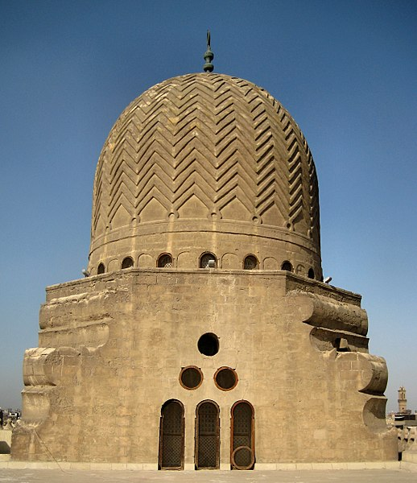

The above building can describe the feature of mamuluk architecture it is the example of their style and decoration if we notice the tomb of this building which is decorated by some zigzag lines and make some symmetry in the building but if we talked about the symmetry of the building then the mamluks building have never symmetrical but so
The architecture of Mamluks was very cosmopolitan in nature. Cairo was an important international political and commercial centre, and it attracted artisans from various regions, mamluk architecture consequently incorporated from al Andalus, north Africa, crusader, central asia and Persia.
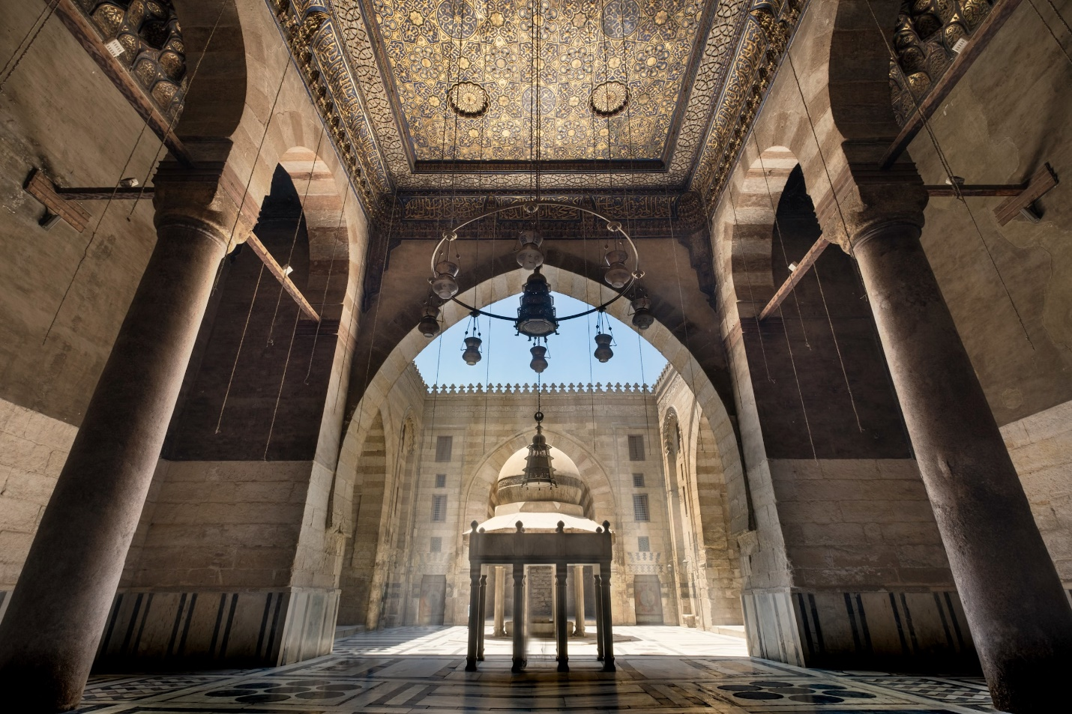
The above picture is of mosque-madrassa of sultan Barquq. It is opened in 1386 in the Cairo city. It is the interior place of the mosque. We can see the whole decoration and the art. We can see that how they use stones and glass for decoration. The little minaret is the focus point and if we notice the roof then we can conclude of the artistry of mamluks. It is not only the mosque but it is also include mausoleum and khanqah, it is a complex building not only for its decoration and art but also for the portions in it.
The Mamluks buldings are generally not symmetrical, instead they tend to emphasis the use of balance over symmetry in their overall composition.the alignment of the building with different directions of the street and the qibla is emphasized, and this results in a rich variety of entry sequences to buildings. The buildings are monumental in scale especially those located in Cairo.

Famous buildings
The most common features of mamluks architecture is the patterns carved on domes ranged from ribs and zigzags to floral and geometric star designs. The dome of Aytimish al Bajasi and the mausoleum dome of Qiatbay sons reflect the detail of mamluk architecture.

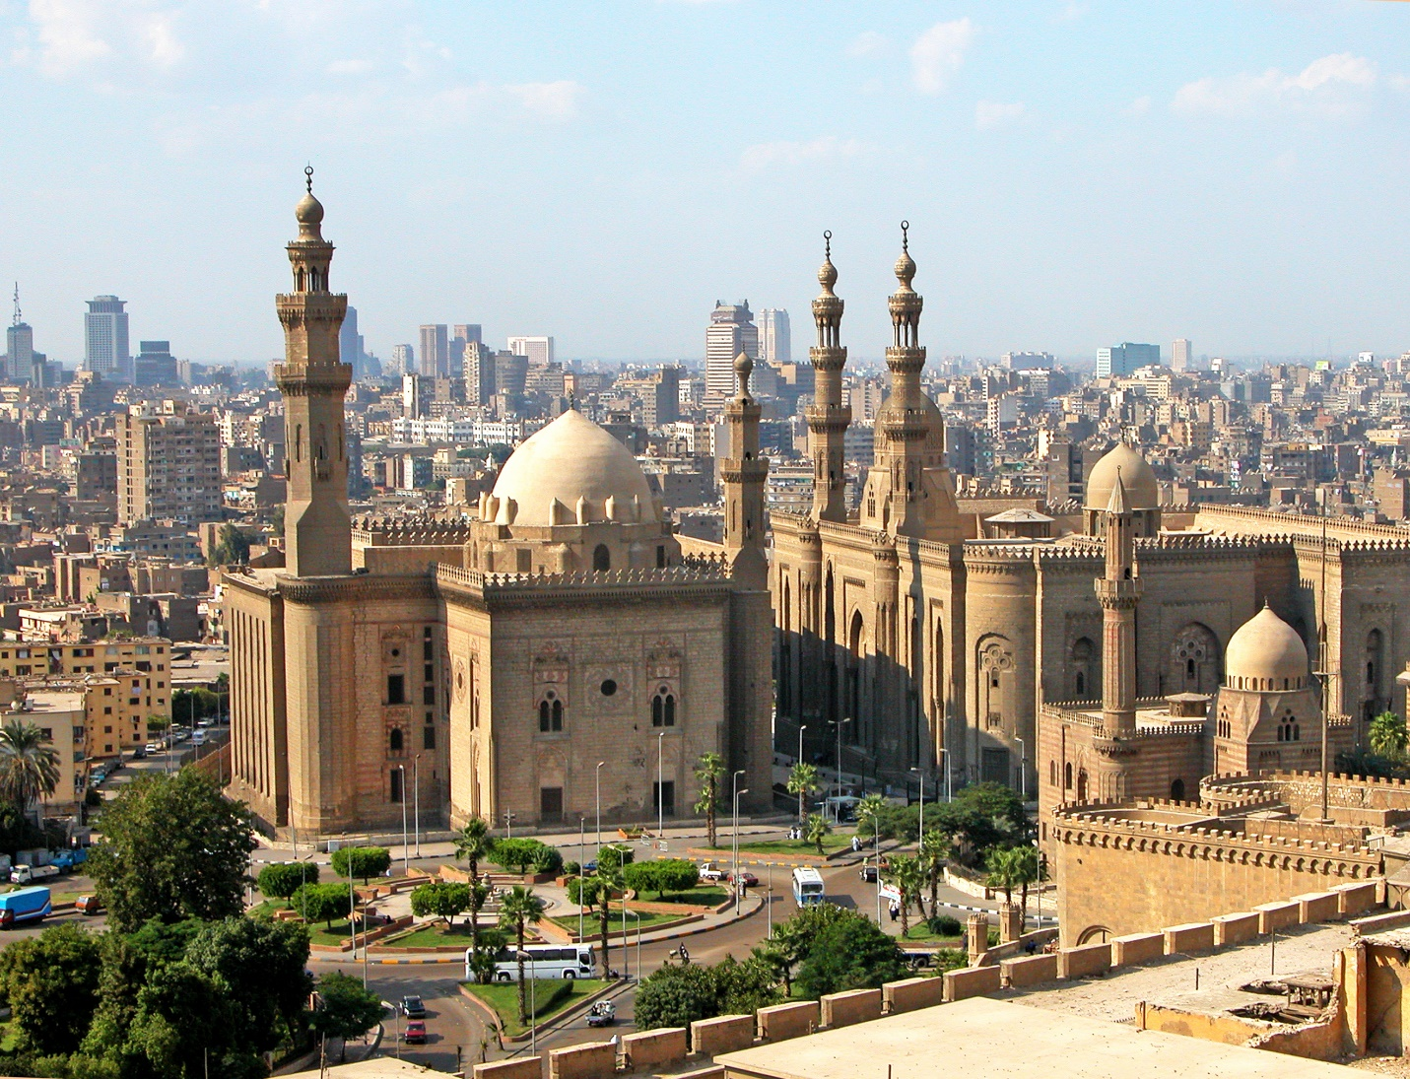
(The mosque-madrassa of sultan Hassan)
The mosque madrassa of sultan Hassan is one of the famous buildings of mamluks period.
The mosque mafrassa of sultan Hassan is a monumental mosque and madrassa located in the historic district of Cairo, Egypt. It was built between 1356 and 1363 during the Bahri mamluk period, commissioned by sultan an nasir Hassan.
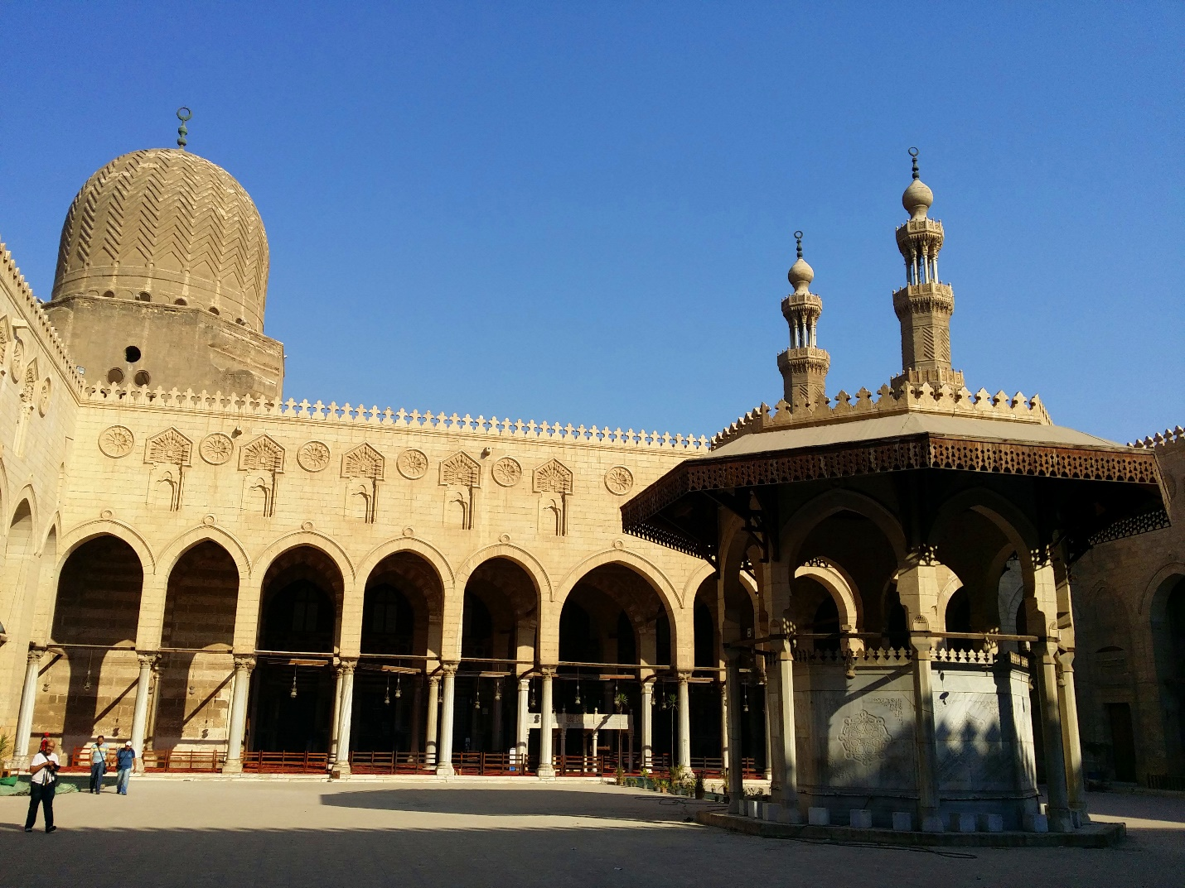
(Sultan al Muayyad mosque)
The mosque of sultan al Muayyad is a mosque in cairo,Egypt next to Bab Zuwayla built under the rule of sultan Al Muayyd sayf ad Din Shaykh from whome it takes its name, “Al Muayyad”, construction began in 1415 and the mosque was completed in 1421

