ID no = 16069
Name = Shah Fahad
Department = BE(C)
Semester = 2nd
Section = A
Subject = Concrete Technology

Question: 1
Which step is taken to prevent flash setting of cement? Also, write steps to prevent false setting of concrete.an
Answer: 1
Step to prevent flash setting of cement:
Gypsum is added to cement clinker during grinding to regulate early hydration reactions to prevent flash setting.
Improve strength and reduce drying shrinkage.
Step to prevent false setting of cement:
This rigidity of false set can be overcome and regain plasticity by further mixing without addition of water and set in normal manner without any loss of strength.
Question: 2
Draw a graph showing the strength development of pure compounds of cement.

Answer: 2
Graph of showing strength development of pure compounds: 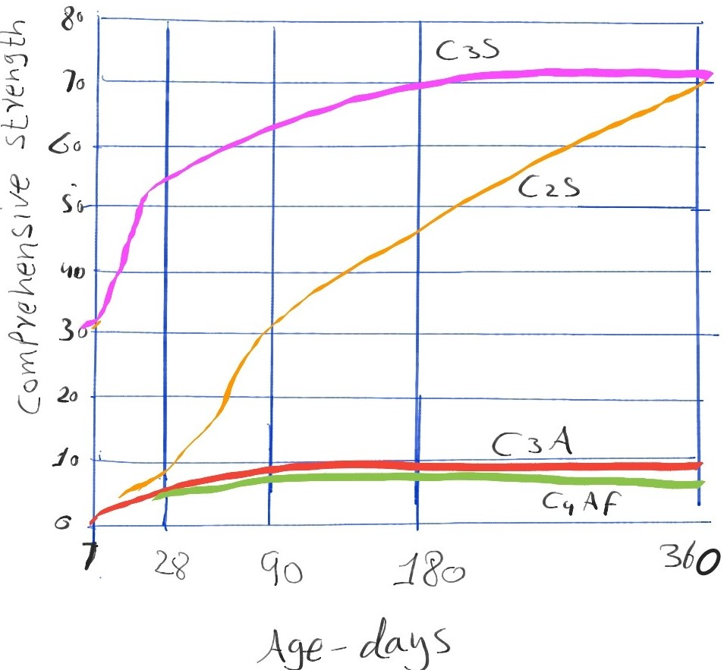

Question: 3
Why Type III cement is Rapid Hardening and Type IV Low Heat producing? Draw a graph showing the development of heat of hydration of different cement types.
Answer: 3
Type 3:
The type 3 cement is rapid hardening because they ground more finely and may have slightly more C3S.

Type 4:
The type 4 cement is low heat of hydration (slow, reading) because they have low content of C2S (<50%) and C3A.

Graph of development of heat of hydration of different type of cement

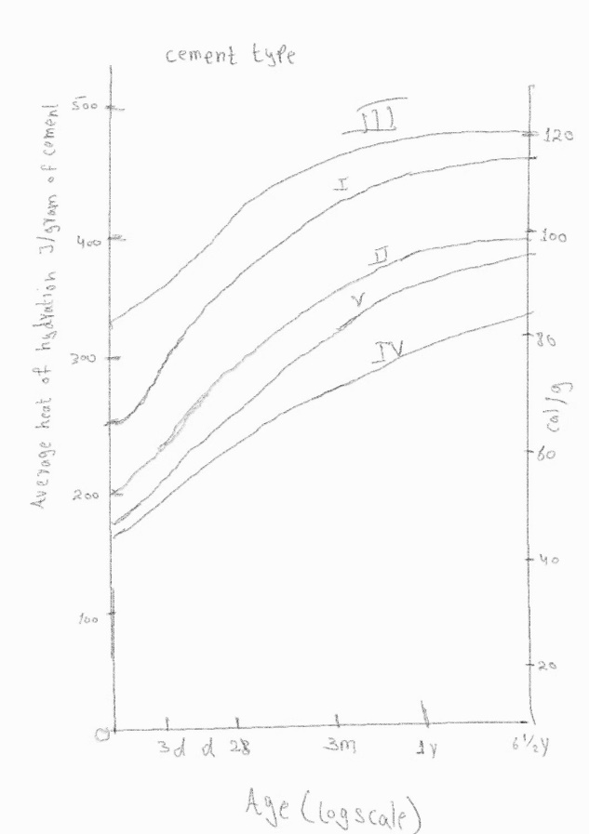

Question: 4
What is the effect of compaction on entrapped air of concrete? What will be the effect on strength if concrete is not compacted sufficiently? Explain with graph.
Answer: 4

Effect of compaction of concrete:
Compaction is the process which expels entrapped air from concrete from freshly placed concrete. It increase the density of concrete and significantly increase ultimate strength of concrete and enhances bond with reinforcement.
Strength of not compacted concrete:
If the concrete is not compacted then the strength of concreted will be decreases.
Void are created, reinforced steed will not be well covered, so that cracks will developed when harden.
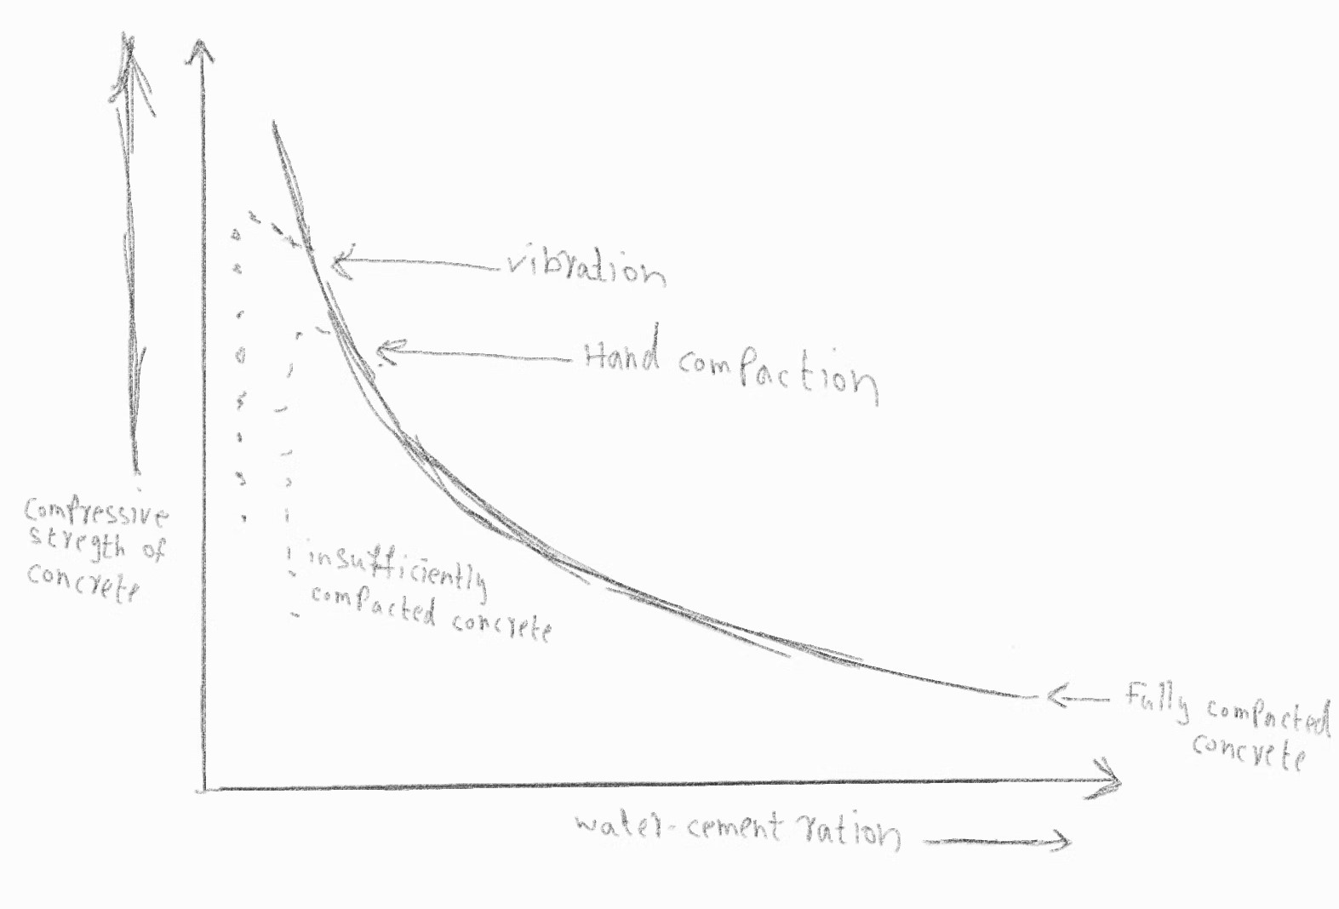

Question: 5
Why is the percentage of gypsum added to cement limited only to 5%?
Answer: 5
Gypsum is added to cement 2 to 4% during cement manufacturing to control flash set. The limit is 5% but if we exceed the limit it will effect harmful. If you have high amounts of C3A then it may react with extra sulfates of gypsum which form ettringite. Ettringite can expand in volume which may cause cracks in plaster.

Question: 6
What is the effect of following on the bond strength of concrete?
- Shape of aggregate
- Size of aggregate
- Texture of aggregate
- Bleeding

Answer: 6
Shape of aggregate:
The larger surface area of more angular aggregate is provide a greater bond compare rounded aggregates.
Size of aggregate:
Maximum aggregate size is harmful for bond strength when smaller size aggregates are used.

Texture of aggregate:
Rough surface provide more contact area for cement paste and hence a stronger bond but required more paste, therefore the final concrete is less dense.
Smooth surface provide thin cement paste layer resulting in less dense packing.

Bleeding:
In the process if bleeding the accumulation of water creates a water voids and reduces bond between the aggregates and cement paste.

Question; 7
What is the effect of following on workability of Concrete?
- Porosity and absorption
- Air entraining agent
- Coarse aggregate to fine aggregate ratio
- Grading of aggregate

Answer: 7
Porosity and absorption:
The water cement ratio is the water added to unit weight of. If the aggregate absorbs water and equivalent water for this absorption is not added above the required W/C ratio, the workability reduces maybe becoming unworkable depending on the dryness of the aggregates.

Air entraining agent:
Air entraining agent affects very widely the properties of concrete. Slump value of concrete increases by using air entraining agent, by using 1% air entraining agent value of slump increases almost 10_15mm when slump value increases, then this mean workability of concrete will also increases.
Coarse aggregate to fine aggregate ratio:
The ratio of coarse aggregate fine aggregate w.r.t cement quantity also be called as the aggregate cement ratio of concrete. The more cement is used, concrete become richer and aggregates will have proper lubrications for easy mobility or flow of aggregates.
The low quantity of cement w.r.t aggregates will make less pate available for aggregates and mobility of aggregates is restrained.

Grading of aggregates:
Well graded aggregates tend to fill up voids and easily get workability. Less amount of water can make it workable if grading is better, there will be fewer voids and excess paste will be available to give better lubricating effect.

Question: 8
What is the effect of fineness of cement on the following?
- Strength of concrete
- Rate of heat evolution during hydration
- Total heat of hydration
- Workability of concrete

Answer: 8
Strength of concrete:
The hydration is depend on fineness of cement. More the fineness of cement more will be the strength of concrete.

Rate of heat evolution during hydration:
Higher the fineness of cement results that the hydration of heat generated will faster compared to coarser in early ages
Total heat of hydration:
The rate of heat generation increases as cement fineness increase and result indicate that heat of cement fineness has no effect on total heat of hydration at 7 days.

Workability of concrete:
The workability of non air entrained concrete is increased by the increase fineness of cement. In air entrained concrete the effect of fineness of cement on workability is very much less pronounced.

Question: 9
What steps can be taken during transportation and placement of concrete to prevent segregation of concrete?

Answer: 9

STEPS:
. Check the concrete is not too wet or too dry.
. Make sure the concrete is properly mixed. It is important that the concrete is mixed at the correct speed in a transit mixer for at least two minutes immediately prior to discharge.
. The concrete should be placed as soon as possible.
. Always pour new concrete into the face of concrete already in place.
. Use certain workability agents, pozzolanic material and air entraining agents can significantly reduce segregation.
. Avoid excessive compaction by vibration of too wet mic.
. If placing concrete straight from a truck, pour vertically and never let the concrete fall more than one and a half meters.

