

**Name: Sayed Abaseen   
ID: 12534**

**Subject: Quantitative Management**

**Submitted to: Sir Raza Ahmed**

**Final-term Assignment**

**Date 6/30/2020**

**IQRA NATIONAL UNIVERSITY, KPK, PESHAWAR, PAKISTAN**

Note:

Solved all Questions!

Solutions are in pictures which are attached

Thanks

**Question no 1 12.5 marks**

Students at multiple grade schools were asked what their personal goal (get good grades, be popular, be good at sports) was and how important having money were to them (1 very important and 4 least important). Do the data provide enough evidence to show that goal attainment and importance of money are independent in following given table? Test at the 5% level.

Table: Personal Goal and Importance of Money



Answer

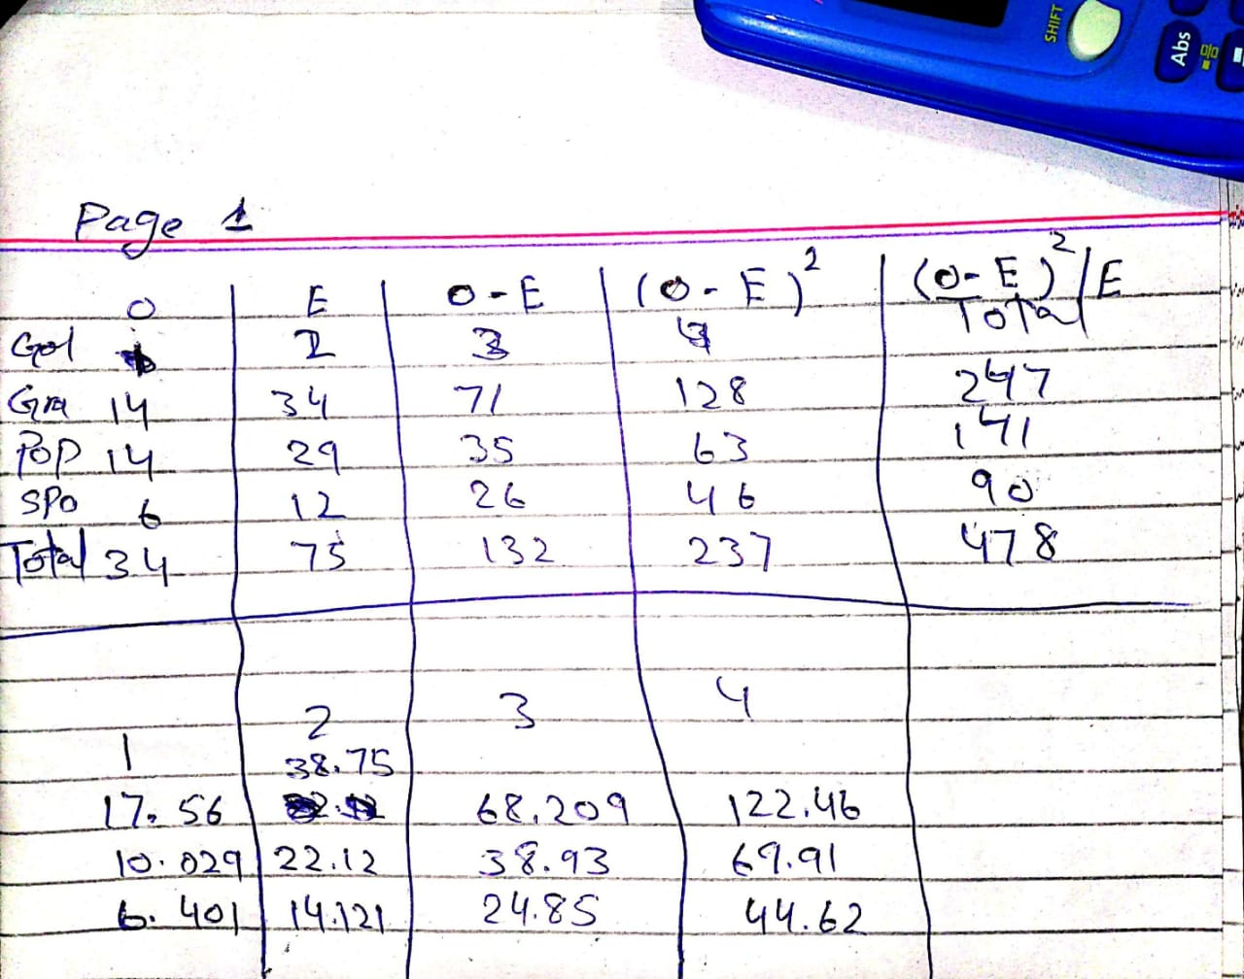

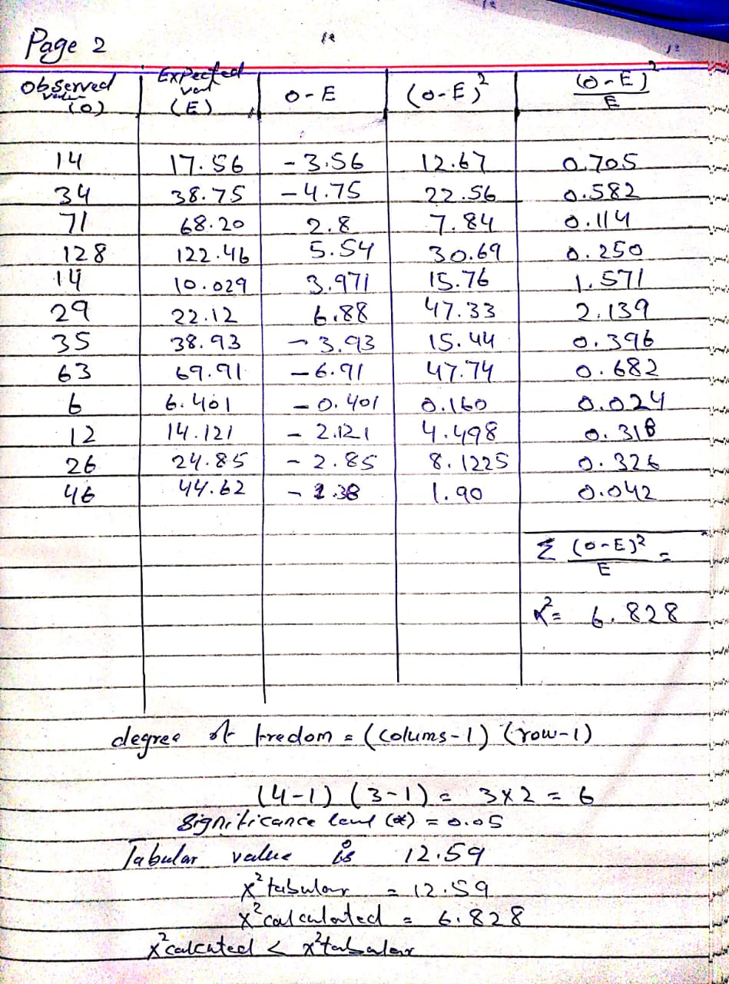

We accept Null hypothesis, and reject alternate hypothesis

**Question no 2 12.5 marks**

1. **Write down the basic assumptions of Binomial Distribution.**

**Answer:** Use of the binomial distribution requires three assumptions:

1. Each replication of the process results in one of two possible outcomes (success or failure),
2. The probability of success is the same for each replication, and
3. The replications are independent, meaning here that a success in one patient does not influence the probability of success in another.

**b) If X is binomially distributed with 8 trails and probability of success equal to ¾ at each attempt, what is the probability of?**

**i. Exactly 5 successes ii. At least one success**

**Answer**

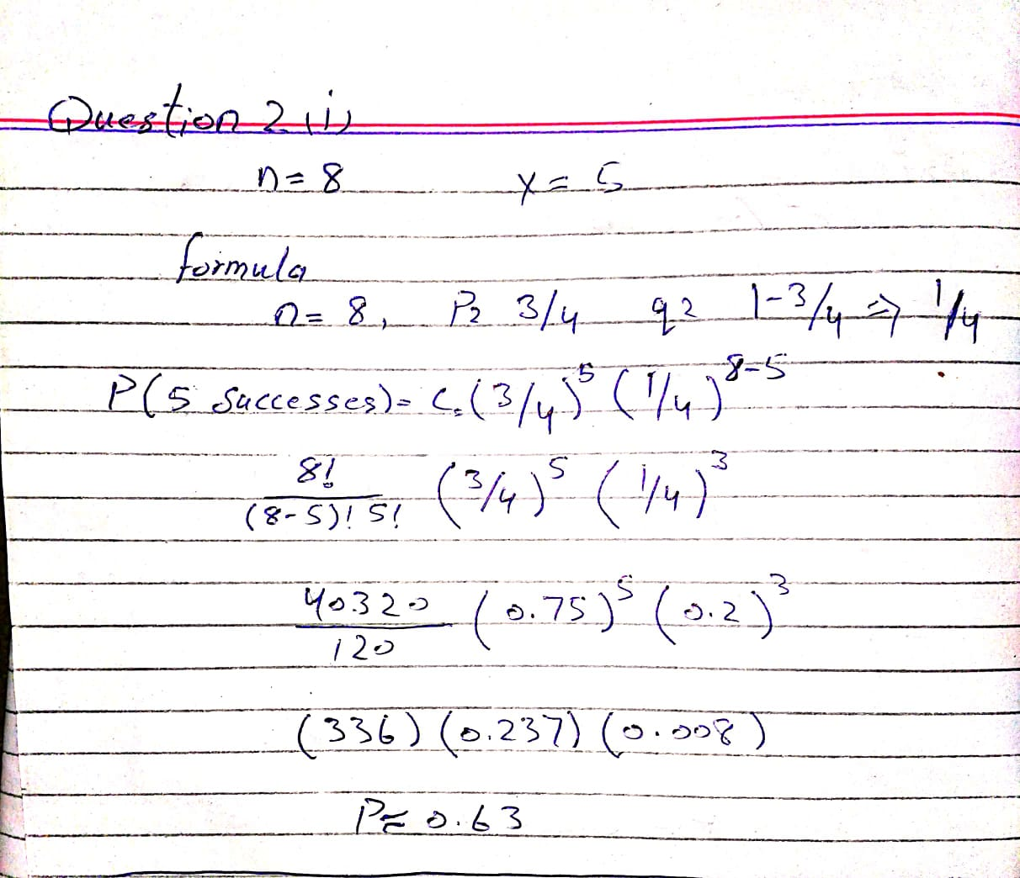

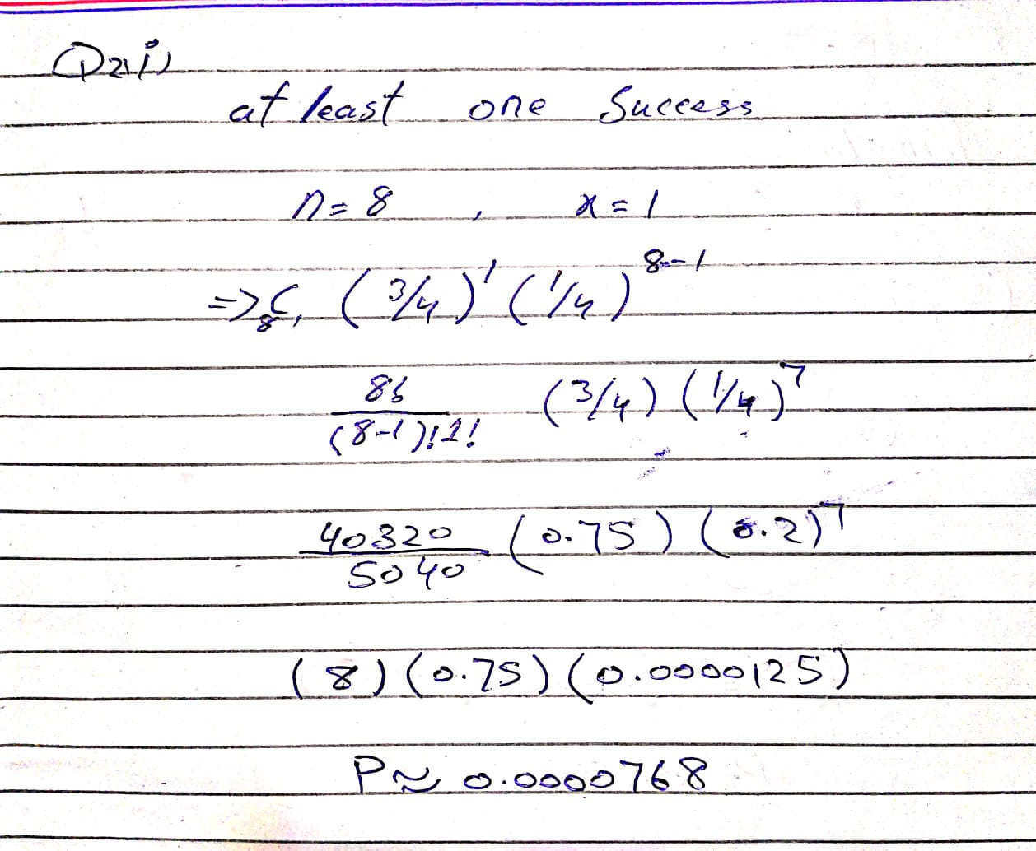

**Question no 3 12.5 marks**

**A. Differentiate between Z-test, t-test & ANOVA test**

**Answer:**

T-test refers to a univariate hypothesis test based on t-statistic, wherein the mean is known, and population variance is approximated from the sample. On the other hand, Z-test is also a univariate test that is based on standard normal distribution.

Analysis of variance (ANOVA) is an analysis tool used in statistics that splits an observed aggregate variability found inside a data set into two parts: systematic factors and random factors. The systematic factors have a statistical influence on the given data set, while the random factors do not. Analysts use the ANOVA test to determine the influence that independent variables have on the dependent variable in a regression study.

**B. Write down the basic assumptions for Chi-square test.**

**Answer:**

Assumptions of the Chi-square

As with parametric tests, the non-parametric tests, including the χ2 assume the data were obtained through random selection. However, it is not uncommon to find inferential statistics used when data are from convenience samples rather than random samples. (To have confidence in the results when the random sampling assumption is violated, several replication studies should be performed with essentially the same result obtained). Each non-parametric test has its own specific assumptions as well. The assumptions of the Chi-square include:

The data in the cells should be frequencies, or counts of cases rather than percentages or some other transformation of the data.

The levels (or categories) of the variables are mutually exclusive. That is, a particular subject fits into one and only one level of each of the variables.

Each subject may contribute data to one and only one cell in the χ2. If, for example, the same subjects are tested over time such that the comparisons are of the same subjects at Time 1, Time 2, Time 3, etc., then χ2 may not be used.

The study groups must be independent. This means that a different test must be used if the two groups are related. For example, a different test must be used if the researcher’s data consists of paired samples, such as in studies in which a parent is paired with his or her child.

There are 2 variables, and both are measured as categories, usually at the nominal level. However, data may be ordinal data. Interval or ratio data that have been collapsed into ordinal categories may also be used. While Chi-square has no rule about limiting the number of cells (by limiting the number of categories for each variable), a very large number of cells (over 20) can make it difficult to meet assumption #6 below, and to interpret the meaning of the results.

**Question no 4 12.5 marks**

The p.d.f of the age of babies, x years, being brought to a post-natal clinic is given by (𝑥) = { 34 𝑥(3 − 𝑥) 0 𝑜𝑡ℎ𝑒𝑟𝑤𝑖𝑠𝑒 0 < 𝑥 < 2

If 45 babies are brought in on a particular day, how many are expected to be under 8 months old?

