Submitted by Watan Mal
Submitted to Ms Benish Shuja

Business and labour law final paper

Question 1:

Answer 1:

Negotiable instrument plays an important role in day to day business, as it provides ease of doing business when the buying and selling is on credit or on large scale.
Negotiable instruments are signed documents that promises to pay specific amount to the specific person on specific or on demand date. They are transferable instruments which means it can be transfer from one to another, and the final assignee can use the funds as a cash or however wants.

Bill of Exchange:

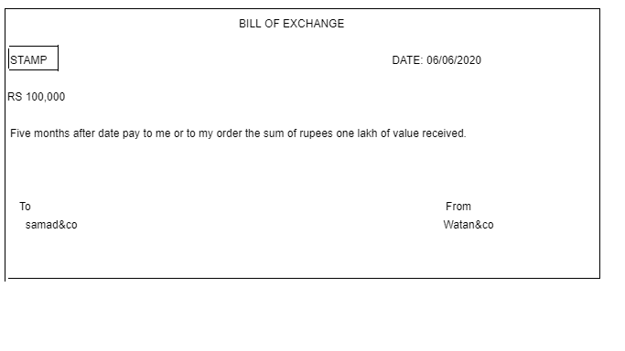

Bill of Exchange is written document that is created by creditor to debtor to pay written amount to second party on specified date.

Question 2:

Answer2:

Unpaid seller has two rights one is right against goods and another is right against buyer

1: Right against goods:
- Right of lien:
Right of lien means that when a buyer fails to fulfil the payment of goods or any property that have been bought. The seller has right to take the property in his custody until he made the payment. The common example is of leased cars, and taking property on mortgage.

- Right of stopping in transit:
Right of stopping in transit means that, when a buyer fails to pay full payment or agreed payment then seller has right to ask the shipment company to return back or keep with yourself until the buyer paid full payment.

- Right of re sale:
A buyer has right to resale the sold goods if the buyer fails to pay for the goods. If the goods are of perishable nature then seller is not bound to give notice to the buyer before selling the goods but if the goods are of non-perishable nature then seller is not bound to give notice to the buyer before selling.

2: Right against buyer:

- Suit for price:
If a buyer fails to pay the payment, seller has right to suit the buyer for the payment. Seller can register a case against the buyer.

- Suit for damages:
When seller deliver goods to the buyer but if buyer reject to accept the goods then buyer has right to ask for the damages.

- Suit for interest:
When the payment from the buyer side is delayed, then seller has right to ask for the interest with the remining balance amount on the agreed %.

Question 3:

Answer 3:

TRUST ACT 1882
According to Sec. 3 a trust is an obligation annexed to the ownership of the property and arising out of a confidence reposed in and accepted by the owner and declare and accepted by him, for the benefit of another and the owner.

4. KINDS OF TRUST
Kinds of trust are as under
i. Constructive Trust
ii. Executed Trust
(iii) Private Trust
(iv) Public Trust or Charitable
(v) Expressed Trust
(vi) Secret Trust
(vii) Executory Trust
(viii) Implied Trust

5. PARTIES OF TRUST
i. Trustee
The person who accepts the confidence is called a trustee.

(ii) Author
The person who reposes or declares confidence is called author of the trust.

(iii) Beneficiary
The person for whose benefit the confidence is accepted is called the beneficiary.

6. TRUST PROPERTY
The subject matter of the trust is called trust property.
7. INSTRUMENT OF TRUST
The instrument by which the trust is declared is called the instrument of trust.

8. WHO MAY CREATE A TRUST
(i) By every person competent to contract.

(ii) With, the permission of a principal civil court or original jurisdiction, by or on behalf of a minor.

9. DECLARATION OF A TRUST
A trust regarding immoveable property is not valid unless it is declared by a non-testamentary instrument in writing signed by the author of the trust, or the trustee and, registered or by the will of the author or of the trustee. Similarly a trust regarding moveable property is not valid unless it is declared as aforesaid or unless the ownership of property is transferred to the trustee.

10. CREATION OF TRUST
According to Sec. 6 a trust is created when the author of the trust indicates with reasonable certainty by words or acts.

(i) An intention on his part he creates it.
(ii) The purpose of a trust.
(iii) The beneficiary.
(iv) The trust property

11. REQUISITES OF A VALID TRUST
Requisites of a valid trust are as under:
(i) The intention of the author of the trust.
(ii) The beneficiaries.
(iii) Lawful purpose of the trust.
(iv) Subject matter.
(v) Transfer of possession of trust property.
12. PURPOSE OF TRUST
According to Sec 4, a trust may be mated for lawful purpose. If the purpose is unlawful, it is void.
13. RULE OF CERTAINTY
Following are rule of certainty:
(i) Certainty of words.
(ii) Certainty of subject matter.
(iii) Certainty of object.
14. UNLAWFUL PURPOSES OF TRUST
Following purposes of a trust are unlawful. Forbidden by Law
I. If it is forbidden by law, the purpose will be unlawful.
II. Fraudulent
If it is fraudulent.
III. Against Provision of any Law
It would defeat the provisions of any law.
IV. Involves any Injury
If it involves or implies any injury to the person or property of author.
V. Immoral
If it is regarded by the court as immoral.
VI. Against Public Policy
If it is regarded by the court as opposed to public policy.
15. EFFECT OF UNLAWFUL PURPOSE 0R OBJECT
If purpose of trust is not lawful. It is absolute void.
I. In case of two Purposes
Where two purposes are so interconnected that they cannot be separated, the whole trust shall become void.
16. CONCLUSION
To conclude I can say that the trust is defined as that relation between two persons by virtue of which one of them holds property for benefit of the other, or as an equitable right, title or interest in property, real or personal, distinct from the legal ownership thereof. A trust can only be created for a lawful purpose. If purpose of trust is unlawful, it is void.

Question 4:

Answer 4:
According to the constitution of Pakistan labour has the followings right.

1: According to the article 11 of constitution there is ban on child labour, force labour and slivery. No one can force any labour to perform the duty that is not on his or her well.
2: Article 17 states that labours are free to make any union for their unity.
3: Article 18 says that no one can force any labour to enter to any lawful jobs and do any lawful activity of trade or business.
4: Article 25 lays down the right to equality before the law and prohibition of discrimination on the grounds
5: Article 37(e) stated that the life condition of the labour should take in mind. Women, children and old aged group should not give much duties so they would not be able to perform.

Question 5:

Answer 5:

Free consent:
Free consent is the essential element of valid contract. Free consent means that every party of the agreement are agree on the same thing in the same mind and the same sense. If the free consent is missing in the agreement it means that is void.

: Essential of offer:
1: offer / proposal:

Offer is first and basic element of a contract. One party made offer to another. It contains all the details term and condition about the contract.

Acceptance:

Once the offer is placed then it is in the hand of offeree to accept or reject the offer. Acceptance of offer means that all parties are agreed on the term and conditions. Once the offer is accepted then the contract moves to 3rd stage.

Metting of minds:

Mattings of minds means that all the parties must be agreed on term and conditions that has been settled earlier.

Consideration:
Consideration means each party will receive some sort of benefits from one another. Usually the benefits are in the form of monetary or goods.

Capacity:
Capacity means that the party entering into the contract must be at the age of 18 or above. Must be mentally sound and must not be disqualified by any law.

Legality:

Contract enforceable by law, cannot be created if there is illegal tread of product or services. For example, if there is a trade of narcotics so this trade illegal and for this trade contract can't be created.

