Name Muhammad Uqail Nawaz
ID# 13623
Program BS (MLT) 6TH
Exam final term
Subject blood bank
Instructor name Mam Huma imtiaz
Date 26-06-2020

Q1: Define Hemovigilance. Discuss benefits and limitations of Hemovigilance.
Answer No 1
Hemovigilance
It is derived from two Greek words Heama means blood and Vigilans means watchful or paying special attention.
Hemovigilance is defined as a set of surveillance procedures covering whole transfusion chain from the collection of blood and its components to the follow up of its recipients, intended to collect and access information on unexpected or undesirable effects resulting from the therapeutic use of blood products.
It includes the monitoring, reporting, investigation and analysis of adverse events associated with the donation, processing and transfusion of blood, and taking action to forestall their occurrence or recurrence. The reporting systems play a fundamental role in enhancing patient safety by learning from failures and so fitting place system changes to forestall them in future.

Benefits of Hemovigilance
- Hemovigilance data can be used to define priorities for blood transfusion
- Improve public confidence and trust.
- Improve the quality of Transfusion Service.
- Understanding of frequency and range of transfusion related events.
- Improve understanding of real risks/hazards of transfusion.
- Understanding the frequency and the range of transfusion related events
- Supply information to the medical community regarding the risks related to transfusion
- Taking corrective measures to prevent or minimize incidences
Limitations of Hemovigilance
- Incomplete reporting
- Limited details
- Variation in terminology and definitions
- Influence of health care system’s or institution’s culture regarding compliance, process improvement and reporting.

Q 2: What is the purpose of cross match? Discuss the procedure of major cross match.
Answer
Cross match
In transfusion medicine cross matching is testing before blood transfusion to determine if the donor blood is compatible with blood of the patient.
purpose of cross match
- The main purpose of cross match is to detect ABO incompatibilities between donor and patient.
- This is carried out to prevent transfusion reaction by detecting antibodies in recipients’ serum
Types of Cross match
There are two types of cross match.
- Major
- Minor
Major cross match
- Maxing patient plasma with donor RBCs
- Test donor cell with recipient’s serum to detect antibodies in patient.
Procedure of cross match
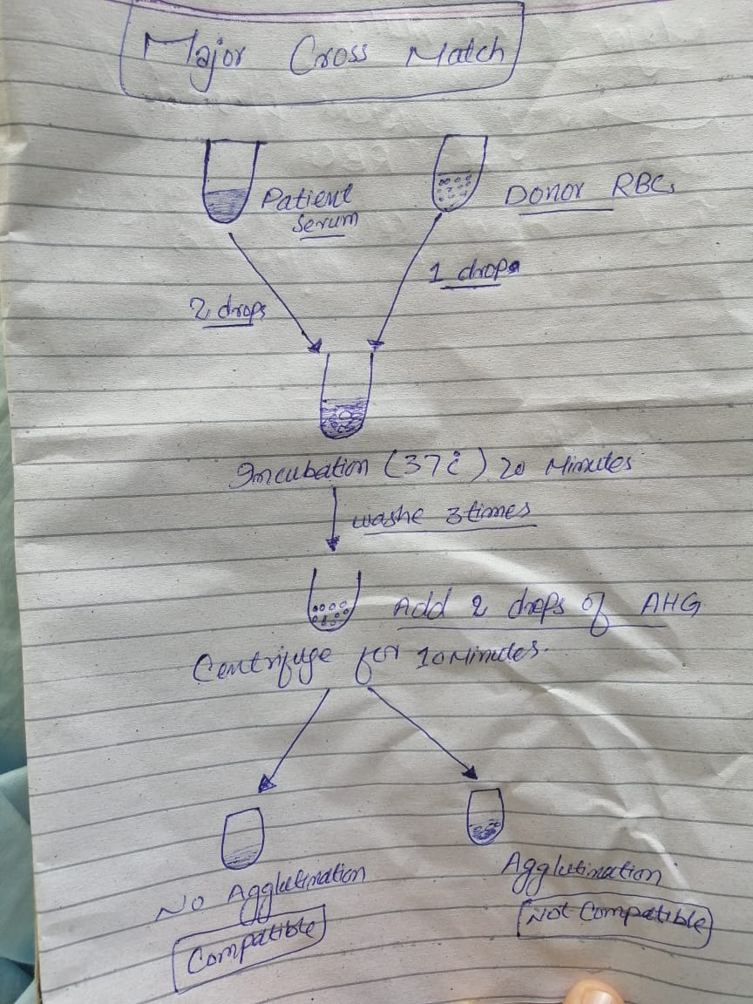

Q3: Describe the pathogenesis of HDN.
Answer
Hemolytic disease of newborn (HDN)
Haemolytic disease of the new born and fetus (HDN) may be a destruction of the red blood cells (RBCs) of the fetus and neonate by antibodies produced by the mother
It is a condition during which the life of the fetal/neonatal red cells is shortened thanks to maternal allo-antibodies against red cell antigens acquired from the daddy.

Pathogenesis of HDN
The antibodies answerable for haemolysis are often naturally occurring (e.g., anti-A or anti-B antibodies) or can develop as a results of a sensitising event like pregnancy or transfusion. the foremost well recognised is rhesus alloimmunisation (Greek: allo = 'other' or 'different from') which begins with red blood cells from a rhesus-positive fetus crossing the placental barrier during pregnancy and delivery, and entering the maternal blood circulation. A Rh-positive father and a Rh-negative mother are required for this example to develop. The incompatible antigens introduced end in a primary immunologic response and stimulate the assembly of maternal antibodies. a awfully bit of fetal-maternal haemorrhage (FMH) has to occur (less than 0.1 ml) and most go unrecognised. Primary exposure also can be the results of amniocentesis, villus sampling and cordocentesis.
Several fetal rhesus antigens may cause alloimmunisation (c, C, d, D, e and E) and this could also occur with the Kell, Duffy, ABO and other blood type systems. The overwhelming majority of haemolytic disease accustomed be caused by the rhesus D antigen but the incidence has reduced significantly with the administration of Rh immunoglobulin to rhesus-negative women during pregnancy and shortly after birth of a rhesus-positive baby. Consequently, ABO incompatibility is now the one largest reason behind HDFN within the western world.
There are rarely any problems during primary exposure but subsequent pregnancies end in large amounts of maternal anti-D antibodies being produced and therefore the risk increases with each gestation. These are capable of crossing the placenta, where they affix to fetal red blood cells, which then become recognised as 'foreign' by the fetal system and haemolysed by fetal macrophages and lymphocytes. If the speed of red cell destruction exceeds the speed of production it leads to fetal anaemia which, if severe, can result in fetal cardiopathy, fluid retention and swelling (hydrops). Red cell breakdown ends up in bilirubin release which isn't an issue during fetal life because it is cleared by the placenta. After birth, however, the immature neonatal liver isn't capable of handling a high bilirubin load and this will lead to severe neonatal jaundice. High levels of jaundice if untreated may result in permanent brain damage (kernicterus) due to deposition of bilirubin in certain areas of the neonatal brain.

Q4: What is the function of Duffy antigen?
Answer
As a chemokine receptor, it binds to the chemicals that are secreted by cells during inflammation and recruits other blood cells to the world of injury
These chemokines include
- Acute inflammation chemokines
- Chronic inflammation chemokines
- Interleukin-8
It binds to the chemicals which bind to the cell during inflammation
Antibody against the duffy antigen are implicated as the cause of transfusion reaction.

Q5: How is Coombs reagent prepared? Write down the procedure of IAT.
Answer.
Coombs reagent
- Coombs reagent made by taking blood from a human then separating the serum with auto antibodies.
- Then the serum is injected to the lab animal and the animal produces antibodies against the auto antibodies.
- Then the blood from the animal is drawn and separated to give the formed antibodies.

IAT
Indirect antiglobuline test.
The aim of the IAT is to detect antibodies in the plasma.

Procedure of IAT
