NAME AHMED YAR KHAN
ID 15964
MAM WAJEEHA AMIN
MACRO ECNOMICS

QUESTION#1 EXPLAIN THE FUNCTION OF CENTRAL BANK?

CENTRAL BANK

INTRODUCTION
The central bank is a financial institution mandated to regulate the production and distribution of money and debt of a nation or group of nations. In today's economy, the central bank often deals with the formulation of monetary policy and the regulation of member banks.

FUNCTIONS
BANK OF ISSUE
The now-top-of-the-day bank has brand recognition capabilities in all countries. Money notes printed and issued by the central bank have been declared unlimited legal tender across the country.
BANKER Agent and adviser to the government
Today's top-level bank has product recognition capabilities across countries. Currency notes are printed and issued by the central bank announcing unlimited legal tender across the country.
CUSTODION OF CASH RACIVER
Today’s central bank has product recognition capabilities across countries. Currency notes are printed and issued by a central bank announcing unlimited legal tender across the country.
CUSTODIAN OF FOREIGN BALANCE
Today’s central bank has product recognition capabilities across countries. Currency notes are printed and issued by a central bank announcing unlimited legal tender across the country.
LENDOR OF LAST RESORT
Today's central bank has strong brand recognition capabilities across countries. Currency notes are printed and issued by a central bank announcing unlimited legal tender across the country.
CLEARING HOUSE
Today's central bank has strong brand recognition capabilities across countries. Currency notes are printed and issued by a central bank announcing unlimited legal tender across the country
CONTROLLER OFCREDIT
The control or adjustment of credit of commercial banks by the central bank is accepted as its most important function. Commercial banks create lot of credit which sometimes results in inflation.
PROTECTION OF DEPOSOTER INTREST
The central bank should oversee the operation of commercial banks to protect depositors' interest and ensure the development of sound banks. Therefore, the banking business has become known as a public service that requires legal protection to prevent bank failures
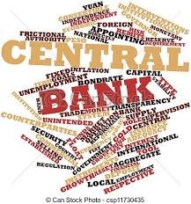

Q2: Discuss the impact of Corona virus on Pakistan’s economy?
Impact of corona virus on Pakistan’s economy:
The corona virus has wreaked havoc all over the world. The economic impact could be even worse than that of the great Depression. The IMF expects the global GDP to fall by 3% in 2020
Demand:
Demand is an economic principle referring to a consumer's desire to purchase goods and services and willingness to pay a price for a specific good or service.
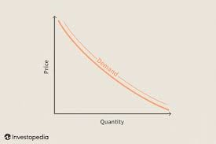
Impact of corona virus on Demand:
Due to Corona virus the demand in Pakistan have been decreased at a very high stage due to which Pakistan has faced a big loss economically Because the purchase of goods, Cars and electrical appliances etc. have been decreased. Due to lockdown most of the people stay at home and ignore to visit markets and Purchase of goods.
Definition of supply:
Supply is the willingness and ability of producers to create goods and services to take them to market. Supply is positively related to price given that at higher prices there is an incentive to supply more as higher prices may generate increased revenue and profits.
Impact of corona virus on supply:
Corona virus had a great impact on supply because due to lockdown most of the fuel pumps are closed. So Due to shortage of fuel the transport services are closed. Other reason that all the industries are closed due to lockdown as the order of government.
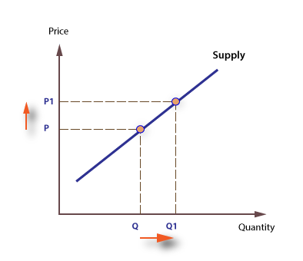
Definition of Price:
The amount of money given or set as consideration for the sale of a specified thing
Impact of corona virus on price:
Corona virus has a great impact on prices. Due to lockdown many prices are increased almost double. So it increased difficulties for poor to spend their life. Because of high prices.
Example:
The prices of Sanitizer, Gloves and masks etc. are almost double
Impact of corona virus on market:
The Corona virus has a positive impact on our markets. Due to the closure of the area almost complete markets closed. It provides huge losses to the economy and markets of Pakistan. All retailers sell goods at (black) at very high prices. Like (Masks, sanitizer, gloves). Because it has a huge market demand. Most people can't afford these because of the very high prices.
The effect of the corona virus on the job:
The Corona virus has a positive effect on the work. Restrictions on daily life have resulted in the closure of many companies and the temporary or temporary closure of employees. Hunt is expected to cut 6.7% of global working hours during the second quarter of 2020. That equates to 195 million full-time workers losing their jobs. The worst-hit region is said to be Arab countries, with an 8.1% decrease in working hours (5 million full-time employees). The ILO said it was "the biggest crisis" since World War II. It adds that the final increase in global unemployment by 2020 will depend largely on two factors:
How fast the country's economy accelerated in the second half of the year. Measures how effective policies can increase the number of employees. There is a high risk that the global unemployment rate will be much higher than the initial ILO estimate of 25 million people.
Definition of depreciation:
Inflation equals the annual percentage change in the average inflation.
Effect of corona virus on growth rates:
Inflation-linked resources are widely used to lower market-based inflation expectations and inflation risk. After the COVID-19 outbreak and the unprecedented shock of the oil price, the five-year euro, the five-year inflation-related fluctuations are currently hovering around the all-time low of just 1%. This column shows that about 60% of the fluctuating depreciation since 2015 can be attributed to a risk premium, while the inflation expectation component describes the remaining 40%. In addition, inflation rates suggest that inflation-related distribution has shifted to the left since January 2020, suggesting that markets expect the exit of CCID-19 to be a further shock to inflation.
THE END

