Course Title: General Pathology (MLT 2nd Semester Sec A and B )
Final term assignment
TIME: 6HRS Marks:50

Name: ……Muhammad Umar…………………………………………
Class ID:…16799……………………………………..
Section:………B…………
Note:
- Write in your own words, do not copy paste.
- Use only MS word to attempt questions.

Attempt all questions.Each question carry equal marks.
Q1.What are the circulating cells in acute inflammation?Also write the characteristics of Acute inflammation.
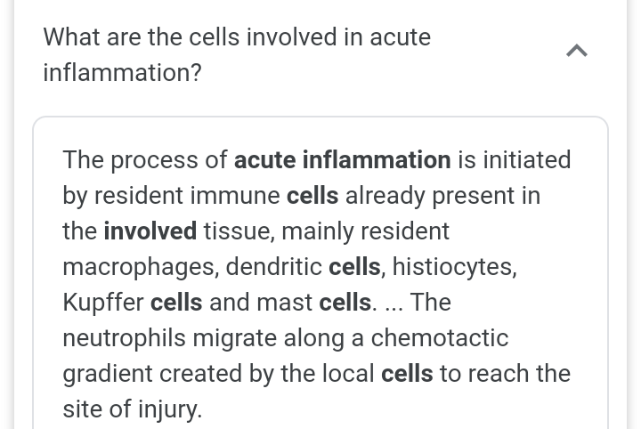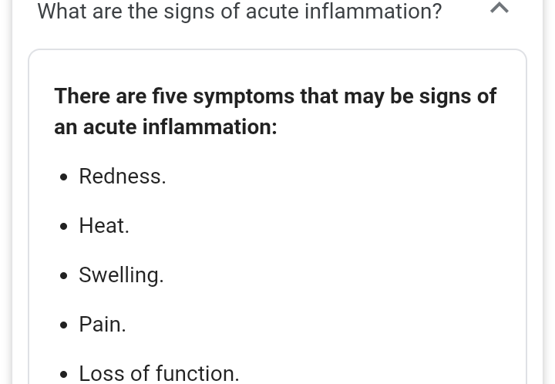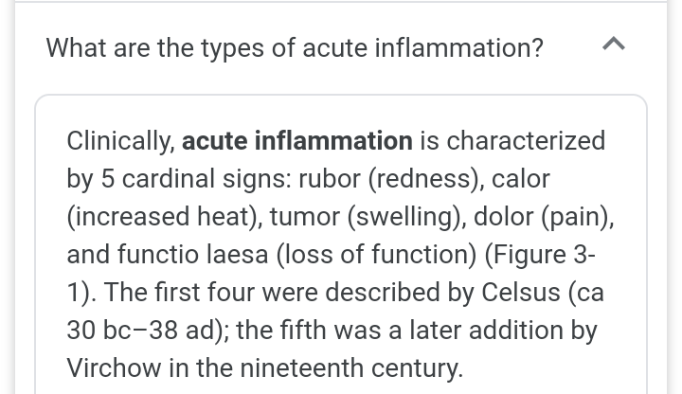
Q2. Write a note on infarction and its types and write a note on Mast cells.
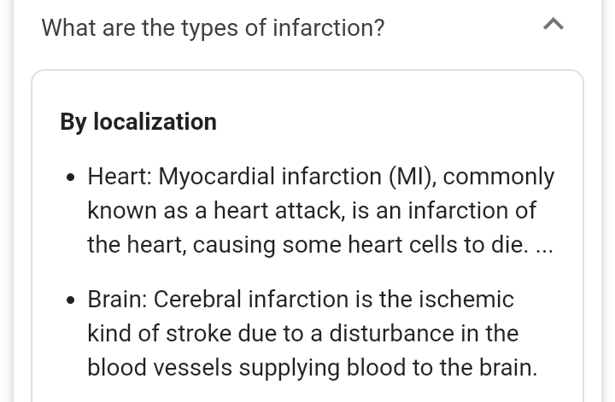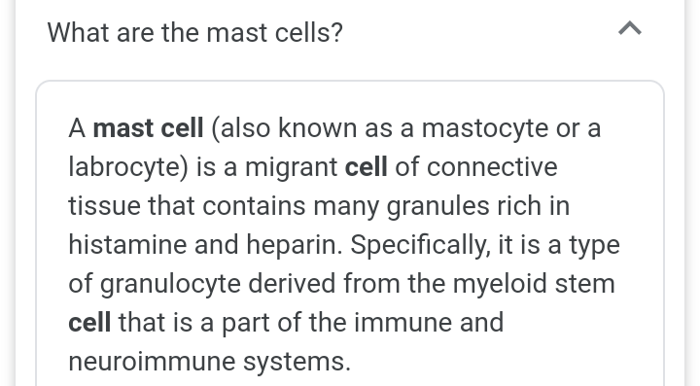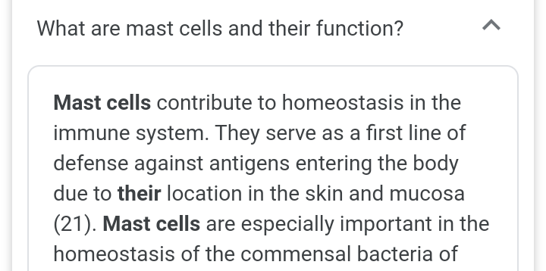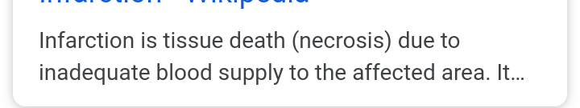
Q3. Which are the cells having proliferative capacity?Explain them,also write about the characteristics of Benign tumor?
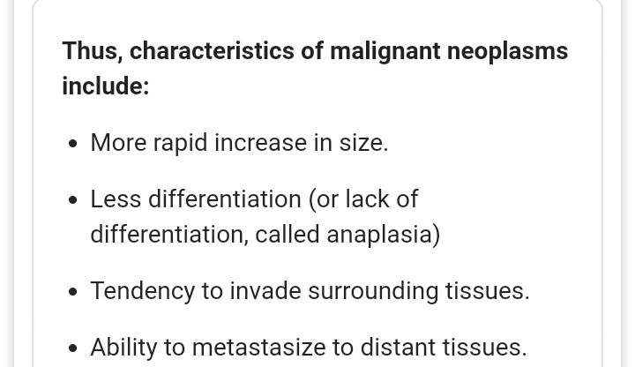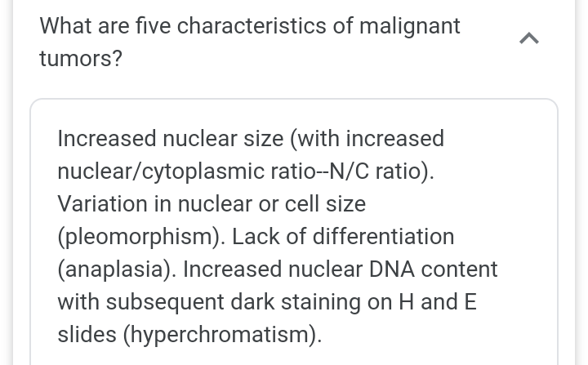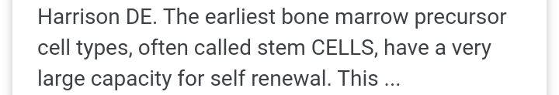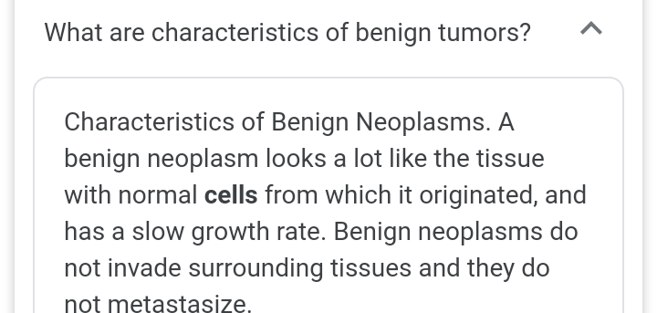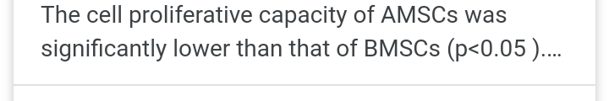
Q4. What is hypovolumic shock?Explain along with its conditions.
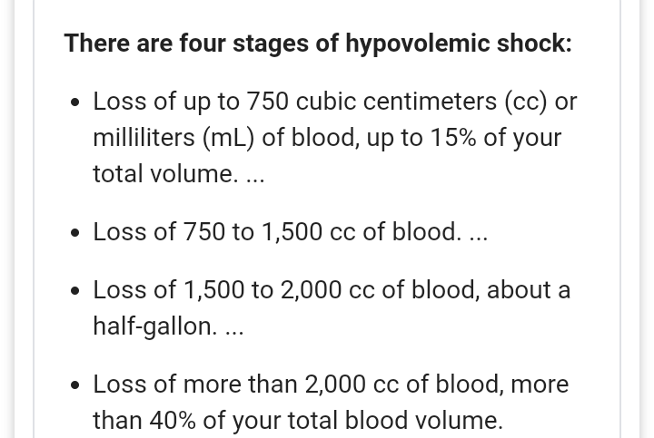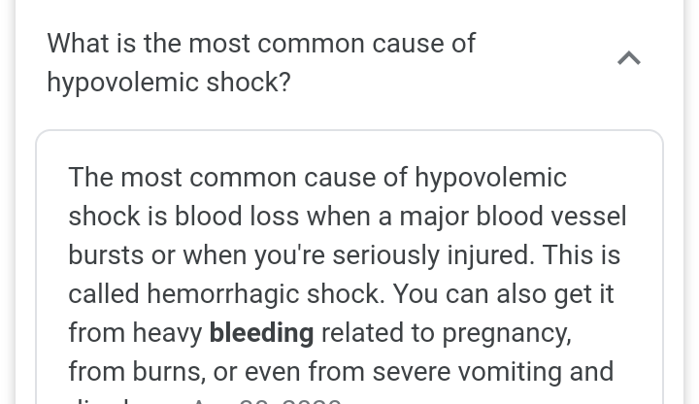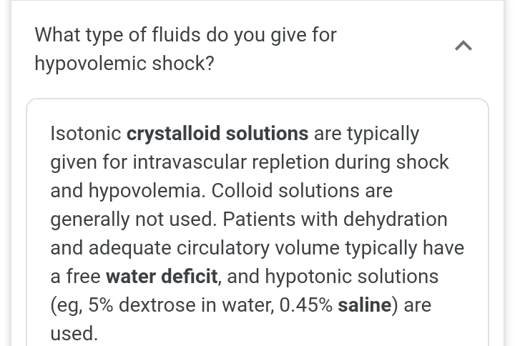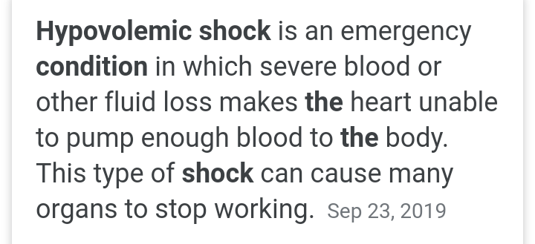
Q5.What is Edema?Explain its types also write about the classification of Thrombosis.
