IQRA NATIONAL UNIVERSITY
DEPARTMENT OF ALLIED HEALTH SCIENCE
SUBMITTED BY ; MUHAMMAD Usama
ID; 13622
PROGRAME ; BS(Dental)
Assignment ; Orthodontics
SUBMITTED TO; Mam, Salma Ishaq
Semester; 6th
Date ; 11/07/2020

Q; Parafunctional habits?
Ans;

Definition;
- A para- functional habit is the habitual exercise of a body part in a way that is other than the most common use of that body part. The term is most commonly used by dentists, orthodontics, or maxollofacial specialists to refer to para- functional uses of the mouth , tongue and jaw.
Introduction;
- A parafunctional habit, like grinding, thumb sucking, or tongue thrusting, is basically the repeated use of the oral structures for things other than eating, swallowing, speaking or breathing. Why are they so bad? The mouth is an amazing place! When everything is working properly, it is like a piece of precision machinery. When something goes wrong in the mouth, though, it causes a chain reaction of failures. Parafunctional habits are like the monkey wrench in the machine. Let’s explore a few of the most common parafunctional habits and how they affect the mouth.
Nail Biting;
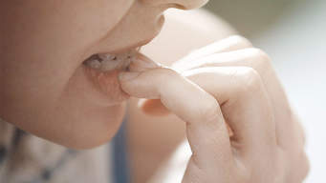
Bruxism:
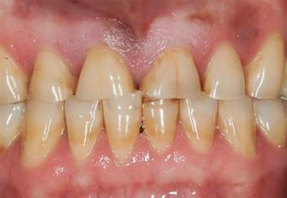
- Bruxism, or grinding is the monkey wrench of all monkey wrenches. It happens during sleep and comes in episodes where the jaws exert large amounts of force and grind against each other. Over time, bruxism leads to a breakdown of the teeth and can cause damage to the temporomandibular joint (TMJ).
- There are likely different causes of bruxism. Bruxism can be caused by things like a bad bite, obstructive sleep apnea, or possibly stress. Many people are unaware that they grind until they are told either by their dentist, who can see signs of bruxism in the mouth or by a spouse or roommate who can see or hear the grinding.
Symptoms of bruxism:
- Sore or stiff jaw muscles
- Headaches especially upon waking
- Sore back or neck
- Sensitive teeth
- Painful Salivation when first eating
- Jaw pain
- Snoring – grinding can be caused by Obstructive Sleep Apnea
Treatment of bruxism:
Finding the cause of your grinding is the first step to choosing a treatment. Your dentist will evaluate your teeth and oral structures and look at your medical history. They will ask you questions about your sleep and snoring and examine your bite for discrepancies that may contribute to your grinding. Depending on what they find, they will make a treatment recommendation.
Thumb Sucking;

- Oh yes. Thumb, finger, or pacifier sucking, also called non-nutritive sucking, is a parafunctional habit. Sucking is a reflex and is important for self-soothing in infancy. Infants suck their fingers or thumbs after feeding for comfort, and for some, it becomes a habit. Most children outgrow it in early toddlerhood, but those who don’t are faced with a parafunctional habit that is both difficult to manage and destructive.
Treatment of Thumb Sucking:
Thumb sucking can be a very difficult habit to break. Prevention is the key here. The sucking reflex starts to diminish around 3 to 4 months of age. If babies are given a pacifier to suck rather than their thumbs in infancy, it can be pulled between 4 and 6 months fairly easily with just a few difficult bedtimes. If it’s too late, and the thumb sucking habit is already established, there are methods to try, but unfortunately, there is no silver bullet approach to sucking a thumb.
Tongue Thrust:
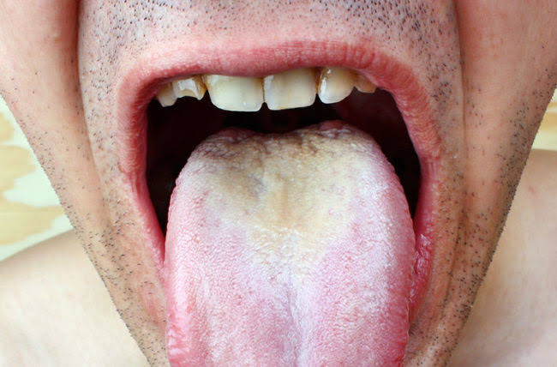

All babies are born with tongue thrust. It is how the infant eats. As you grow, the pattern of swallowing changes and tongue thrust should disappear. If it lingers after about the age of four, it is considered to be a parafunctional habit. So what is it, exactly? When you swallow, your tongue should be positioned on the hard palate behind the upper front teeth. In people with tongue thrust, the tongue is positioned on the backs of the front teeth and the result is that the tongue protrudes through them. Keep in mind that the average person swallows between 1200 and 2400 times a day and each time you swallow, you exert 4 pounds of pressure with your tongue. Move the tongue from the palate to the teeth and you can see how a tongue thrust can quickly change things. In thumb sucking, we talked about how the pressure from the thumb caused the palate to become high and narrow. Well, think about that precision machine, again. The palate is U-shaped for a reason–it accommodates the tongue. If the palate becomes narrow and high, the tongue has nowhere to sit and the jaw drops open and now the tongue isn’t able to exert its force to properly shape the palate, so even in speech and at rest, the tongue is exerting pressures where it shouldn’t be.
Causes Tongue Thrust:
There are many possible causes. We know that anything that prevents nose breathing can contribute to tongue thrust. It makes sense. If you can’t breathe through your nose, you open your mouth. Your tongue comes out of your palate space and anatomy shifts. Face elongates, palate narrows and gets deeper, teeth protrude. Other possible causes include:
- Thumb sucking
- Difficulty swallowing
- Large tongue
- Angle of jaw line
- Genetics
- Muscular, neurological, or other abnormalities
- Short tongue or being tongue-tied.
Types of Tongue Thrust:
Yep. A tongue can thrust in more than one direction. Depending on where the pressure is exerted, different malformations of the teeth occur. Your dentist or orthodontist is able to look at the pattern of the teeth to determine which type of thrust is present. Cool, huh!
- Anterior Open Bite
Most common type of thrust. Lips close improperly, tongue protrudes through lips. This type of thrust is often seen with a large tongue.
- Anterior Thrust
This happens when the lower lip pulls on the lower teeth and the tongue is thrusting against the upper front teeth. The upper teeth become very protruded.
- Unilateral Thrust
This happens when the tongue postures to one side. The result is an open bite on one side of the mouth.
- Bilateral Thrust
In bilateral thrust, the tongue thrusts to the sides of the mouth. This causes the teeth on the sides and back of the mouth to open. This is a very hard situation to correcmout.
- Bilateral Anterior Open Bite
The tongue is usually large in this instance. The only teeth that touch are the molars and everything else is open.
- Closed Bite Thrust
In this type of thrust, the teeth meet, so they are closed, not open. But, both the top and bottom teeth are flared out
- Mandibular Thrust
This type of thrust is seen in people with an inherited pattern of growth. The tongue is held low and forward causing a protrusion of the lower jaw.
Treatment of Tongue Thrust:
- Treating a tongue thrust can be difficult, but it is successful about 75% of the time. Even if you correct the alignment of the teeth with orthodontics, unless your treat the tongue thrust, the orthodontics will fail. As long as there is a thrust, the teeth will move. There are two basic types of treatments.
- Myofunctional or Tongue Therapy
- Therapy helps to retrain the tongue by doing exercises.
- Appliance Therapy
- A crib type of appliance is worn to keep the tongue from the backs of the front teeth.

