Prosthodontic
Answer No 3;
Major Connector
It is defined as “A part of a removable partial denture which connects the components on one side of the arch to the components on the opposite side of the arch.
Types Of Major Connector
- Types of Maxillary Major Connector
• Single posterior palatal bar.
(It is a bar running across the palate. It has a narrow half-oval cross section, which is thickest at the center.)
• Palatal strap.
(It is the most versatile major connector. It comprises of a wide, thin band of metal plate that runs across the palate.)
• Single broad palatal major connector or
Palatal plate type major connector.
(It has a thin broad contoured palatal coverage. It is broader than a palatal strap)
• Double or anteroposterior palatal bar.
(It is a combination of an anterior palatal strap and a posterior palatal bar. The anterior strap is narrower than a conventional palatal strap.)
• Horseshoe or U-shaped connector.
(It has a thin metal band running along lingual surface of posterior teeth)
• Closed Horseshoe or anteroposterior palatal
Strap.
(It is similar to the ‘U’ shaped major connector but a strap of metal extends between the two open ends of the horseshoe)
• Complete palate.
(This major connector covers the entire palate.)
(2)Types of Mandibular Major Connector
There are six common types of mandibular
major connectors.
• Lingual bar.
(It is half pear-shaped in cross-section with the thickest portion placed inferiorly)
• Lingual plate.
(It is similar to the lingual bar but the superior border extends up to the cingulum of the lingual surface of the teeth)
• Kennedy bar or double lingual bar.
(It is also called lingual bar with cingulum bar (continuous bar) retainer.)
• Sublingual bar.
(it is placed more inferiorly and posteriorly than the lingual bar i.e. overlying the anterior part of the floor of the mouth)
• Mandibular cingulum bar (continuous
bar).
(It is also known as the ‘continuous bar retainer’. It is located on or slightly above the cingula of the anterior teeth)
• Labial bar.
(It is a mandibular major connector similar to a lingual bar placed on the labial surface, but it is broader and thicker than a lingual bar )
Answer No 2
Reasons For Low Density Of Dentures.
- Low density of denture will help the adhesive forces of saliva to retain the denture.
- Low density will contribute in low weight of denture which will help in denture retention, stability and support maxillary denture.
- There is high possibility of your denture base to adapt any changes in tissue architecture over time as compared to a more dense denture base.
- Density of denture will also contribute to the brittle nature of acrylic resin. The more dense your denture base the more brittle it will be.
- A dense denture base will entrap more of the residual monomer in it as compared to a thin denture base.
- A denture must be of low density in order NOT to compress the oral mucosa to generate inflammatory condition with subsequent bone resorption.
- Because high density of denture contribute to the impairment in the opening and closing of the mouth and TMJ disorder.

Answer No 1
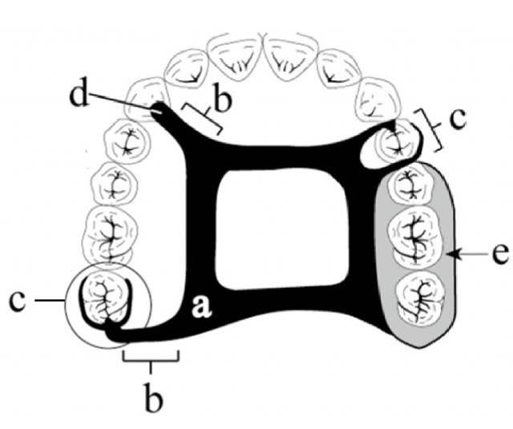
A is Major connector.
B is Minor connector.
C is Direct retainer.
D is Indirect retainer.
E is Denture base.
Major Connector
A part of a removable partial denture which connects the components on one side of the arch to the components on the opposite side of the arch.
Minor Connector
It connect other components like direct retainer, indirect retainer, denture base, to the major connector.It gives rigidity to the denture.
Direct retainer
It resist the movement of prosthesis away from teeth or tissues.
Indirect retainer
It is used in the distal extension cases that is kennedy class 1 and class 2.
Denture base
It support the artificial teeth.It also enhances the cosmetic effect.

