Final Term Examination AHMED TARIQ (13457)
Subject Name: Applied Physics
Class: BS SE-1, CS-1
Instructor: M Khalid Hamid
Total Marks: 50
Note: Attempt all Questions
Q1:
- How to calculate the magnetic force on current carrying wire? (10 marks)
We can derive an expression for the magnetic force on a current by taking a sum of the magnetic forces on individual charges. (The forces add because they are in the same direction.)

The force on an individual charge moving at the drift velocity v_{d} is given by F = qv_{d}B sin θ.
Taking B to be uniform over a length of wire l and zero elsewhere, the total magnetic force on the wire is then
F = (qv_{d}B sin θ)(N),
where N is the number of charge carriers in the section of wire of length l.
Now, N = nV, where n is the number of charge carriers per unit volume and V is the volume of wire in the field. Noting that V = Al, where A is the cross-sectional area of the wire, then the force on the wire is
F = (qv_{d}B sin θ) (nAl).
Gathering terms,
F=(nqAvd)lBsinθF=(nqAvd)lBsin⁡θ.
Because nqAv_{d} = I

F=IlBsinθ

- What is the difference between Resistance and Resistivity?
Resistance is defined as the property of the conductor which opposes the flow of electric current. It is also defined as the ratio of the voltage applied to the electric current flowing through it. The resistance of a conductor depends on the length, area of cross-section, and the nature of the material that is used in the manufacturing of the conductor. For a conductor, the resistance is directly proportional to the length of the conductor and inversely proportional to the area of cross-section.
Resistivity is defined as the resistance offered by the material per unit length for unit cross-section. The SI unit of resistivity is Ohm.meter. Resistivity increases linearly with temperature. The resistivity of conductors is low when compared to the resistivity of the insulators. Therefore, it can be represented as:
Resistivity of conductors < Resistivity of alloys < Resistivity of insulators.

Q2:
- What is the difference between reflection and refraction? (10 marks)
Reflection – Reflection is the phenomenon in which light reflects back after striking a smooth surface.
In reflection , the ray which strikes the smooth surface is called the incident ray . The ray which reflects back from smooth surface is called reflected ray. The angle in between the incident ray and the normal ray is called angle of incidence and the angle between the normal ray and reflected ray is called the angle of reflection.
Refraction – Refraction is the process in which, when the incidence ray strikes the surface in some medium and it gets diverted or bent while passing through another medium .
The ray generally bends towards the normal ray while travelling to rarer medium to a denser medium and it bends away from normal ray while travelling to denser to rarer medium.

- Explain the difference among angle of incident, angle of reflection and angle of refraction with the help of formulae and a single diagram?
In order to follow the quickest path through a system, a ray changes direction as it travels from a medium of one refractive index to another medium that has a different refractive index.
Snell’s Law, which can be stated as
nA Sinθ A = nB Sinθ B
predicts how the ray will change direction as it passes from one medium into another, or as it is reflected from the interface between two media. The angles in this equation are referenced to a surface normal, as is illustrated below.
In the following figure, a ray is incident on an interface between two dissimilar media. A plane that includes the incident ray and a line drawn normal to the surface is called the plane of incidence. This plane also contains the reflected and refracted rays. A refracted ray is transmitted into the second medium and travels in a different direction than the incident ray. The angle that the incident, reflected, and refracted rays make with the surface normal are called the angles of incidence, qi , reflection, qr, and refraction, qt, respectively. The refractive index of medium 1 is n1 and of medium 2 is n2.
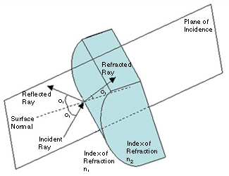
Illustration of incident, reflected, and refracted rays.
In the case of a reflected ray, nA = nB = n2 = n1,
n1 Sinθ i = n1 Sinθ r, which is the same as Sinθ i = Sinθ r.
From this, it is easy to see that the angle of incidence and the angle of reflection are the same!
In the case of the transmitted, or refracted, ray,
n1 Sinθ i = n2 Sinθ t.
If n1<n2, then the angle of refraction is always smaller than the angle of incidence. If n1>n2, then the angle of refraction is larger than the angle of incidence…when there is an angle of refraction! Imagine the angle of incidence getting larger and larger for the case of n1>n2. Eventually the refracted ray will make an angle of 90° with the surface normal. If the angle of incidence is increased beyond that angle, then refraction does not occur! All of the light incident on the interface is reflected back into the incident medium

Q3:
- Find the difference between electric potential energy and electric potential? (10 marks)
ANS
The basic difference between electric potential and electric potential energy is that Electric potential at a point in an electric field is the amount of work done to bring the unit positive charge from infinity to that point, while electric potential energy is the energy that is needed to move a charge against the electric field.
The electric potential energy of a system of point charges is defined as the work required assembling this system of charges by bringing them close together, as in the system from an infinite distance.
SI unit: joule (J)

The electric potential, or voltage, is the difference in potential energy per unit charge between two locations in an electric field.
That's why physicists use a single positive charge as our imaginary charge to test out the electrical potential at any given point.
Its SI unit is J/c=Volts.

- How to find the potential difference between any two points in the electric field lines?
ANS

The electric potential difference is nothing more than the voltage difference between two points. By looking at our circuit, since the poing A and and point B are not connected, there is no current flow for the 4V4V battery. The only current flow is from the 12V12V battery. To determine the current flowing through the circuit, we can simplify the following into:
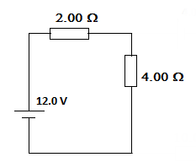
The following resistors are connected series. We further simplify the following.
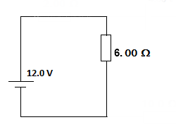
Solving for the current I.

V=IR
I=V/R
I=(12V)/(6Ω)
I=2A

Remember that the current flow from the positive terminal of the battery to the negative terminal.
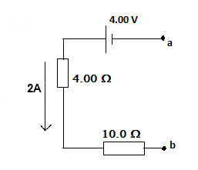
Finally, the voltage difference ΔV from A to B.

ΔV=−4V+4Ω(2A)

Here, take note of the sign convention. We take battery as negative since we are moving from the negative terminal to the positive terminal. Also, the the resistor flowing with the current is a positive potential difference.
ΔV=−4V+8V
ΔV=4V

Q4:
- Compare the depletion regions in forward bias and reverse bias? (10 marks)
- The forward bias has large forward current while the reverse bias has very small forward current.
- The current in the diode when flow in the forward direction is called forward current.
- The depletion layer of the diode is very thin in forward biasing and thick in reverse bias.
  - The depletion layer is the region around the junction in which the free charge carriers are depleted.
- The Forward bias decreases the resistance of the diode whereas the reversed bias increases the resistance of the diode.
- In forward biasing the current is easily flowing through the circuit whereas reverse bias does not allow the current to flow through it.
- In forward biasing the magnitude of the current depends on the forward voltage whereas in reverse bias the magnitude of the current is very small or negligible.
- In forward biasing the device operates as a conductor whereas in reverse bias the device act as an insulator.
- The forward voltage of the silicon diode is 0.7 volts, and the forward voltage of the germanium is 0.3 volts.

- How reverse breakdown occur in a diode?
ANS
If we keep on increasing the applied reverse voltage, the depletion width will increase accordingly. At a point which we can call as “breakdown point”, the diode will get damaged. At this point, the diode behave more like a shorted wire and hence current flows through it easily.
Electrical break down of any material (say metal, conductor, semiconductor or even insulator) can occur due to two different phenomena. Those two phenomena are
1) Zener breakdown and
2) Avalanche breakdown
In a Zener breakdown, the electric field necessary to break electrons from covalent bond is achieved with lesser voltage than in avalanche breakdown. The reason is thin depletion layer width.
In avalanche breakdown, the depletion layer width is higher and hence much more reverse voltage has to be applied to develop the same electric field strength (necessary enough to break electrons free)

Q5:
  - Explain the Magnetic field of solenoids?
A solenoid is a coil of wire designed to create a strong magnetic field inside the coil. By wrapping the same wire many times around a cylinder, the magnetic field due to the wires can become quite strong. The number of turns N refers to the number of loops the solenoid has. More loops will bring about a stronger magnetic field. The formula for the field inside the solenoid is
B = m₀ I N / L
This formula can be accepted on faith; or it can be derived using Ampere's law as follows. Look at a cross section of the solenoid.
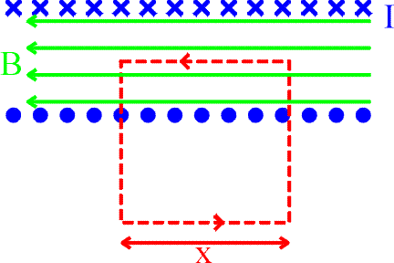
The blue crosses represent the current traveling into the page, while the blue dots represent the currents coming out of the page. Ampere's law (left) for the red path can be written as.
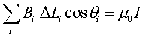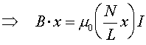
where the number of loops enclose by the path is (N/L)x. Only the upper portion of the path contributed to the sum because the magnetic field is zero outside, and because the vertical paths are perpendicular to the magnetic field. By dividing x out of both sides of the last equation, one finds:
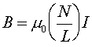
The magnetic field inside a solenoid is proportional to both the applied current and the number of turns per unit length. There is no dependence on the diameter of the solenoid, and the field strength doesn't depend on the position inside the solenoid, i.e., the field inside is constant.

  - Explain the Magnetic field of Toroids?
Let n be the number of turns per unit length of toroid and I be the current flowing through it.
A magnetic field of constant magnitude is set up inside the turns of toroid in the form of concentric circular magnetic field lines.
The direction of the magnetic field at a point is given by the tangent to the magnetic field line at that point.
We draw three circular amperian loops, 1, 2 and 3 of radii r₁, r₂ and r₃ to be traversed in clockwise direction as shown by dashed circles in Fig (b), so that the points P, S and Q may lie on them.
The circular area bounded by loops 2 and 3, both cut the toroid. Each turn of current carrying wire is cut once by the loop 2 and twice by the loop 3. Let B₁ be the magnitude of magnetic field along loop 1.
Line integral of magnetic field B₁ along the loop 1 is

