NAME: MUHAMMAD ADEEL
SUBMITEED BY: MAM AROOBA SAJJAD
ID NUMBER: 17278
TOPIC: JOITNS OF UPPER LIMB
DEPARTMENT: BS ANESTHSIA
JOINTS OF UPPER LIMB
The upper limb has a wide range of precise movements associated with it to allow us to effectively interact with our environment, the 6 main joints covered here (from proximal to distal) are the sternoclavicular, acromioclavicular, shoulder , elbow ,radioulnar , and wrist joints.
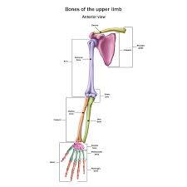
The Shoulder joint.
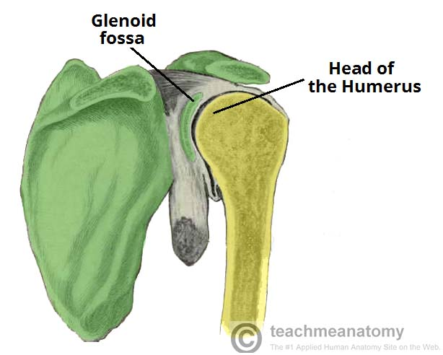
The shoulder joint (glenohumeral joint) is a ball and socket joint between the scapula and the humerus.
It is the major joint connecting the upper limb to the trunk.
It is one of the most mobile joints in the human body at the cost of joint stability. In this article, we shall look at the anatomy of the shoulder joint and its important clinical correlations.
Joint Capsule And Bursae
The joint capsule is a fibrous sheath which encloses the structure of the joint.
It extends from the anatomical neck of the humerus to the border or rim of the glenoid fossa. The joint capsule is lax, permitting greater mobility (particulary abduction).
The synovial membrane lines the inner surface of the joint capsule, and produces synovial fluid to reduce friction between the articlar surface.
LIGAMENTS
- Glenohumeral ligaments.
- Coracohumeral ligaments.
- Transverse humeral ligament.
- Coraco-clavocular ligament.
THE ELBOW JOINT.
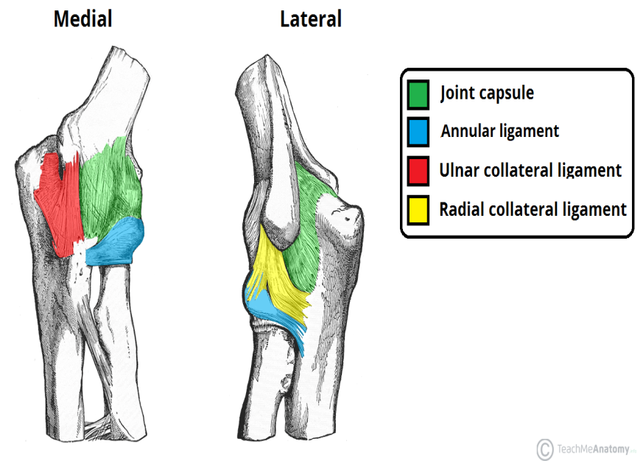
The elbow is the joint connecting the upper arm to the forearm. It is classed as a hinge-type synovial joint.
In this article, we shall look at the anatomy of the elbow joint; its articulating surfaces ,movements, stability, and the clinical relevance.

Joint Capsule And Bursae
Like all synovial joints, the elbow joint has a capsule enclosing the joint. This in itself is strong and fibrous, strengthening the joint. The joint capsule is thickened medially and laterally to form collateral ligments, which stabilize the flexing and extending motion of the arm.
A bursa is a membranous sac filled with synovial fluid. It acts as a cushion to reduce friction between the moving parts of a joint, limiting degenerative damage. There are many bursae in the elbow, but only a few have clinical importance:
- INTRATENDINOUS _ Located within the tendon of the triceps brachii.
- SUBTENDINOUS _ between the olecranon and the tendon of the triceps brachii, reducing friction between the two structures during extension and flexion of the arm.
- SUBCUTANEOUS (olecranon) bursae _ between the olecranon and the overlying connective tissue (implicated in olecranon bursitis).
LIGAMENTS
The point capsule of the elbow is strengthened by legaments medially and laterally.
The radial collateral ligament is found on the lateral side of the joint, extending from the lateral epicondyle, and blending with the annular ligament of the radius (a ligament from the proximal radioulnar joint).

THE WRIST JOINT.
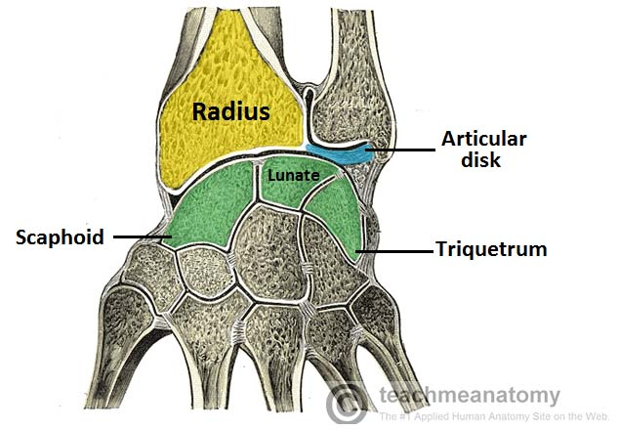
The wrist joint (also known as the radiocarpal joint) is a synovial joint in the upper limb, marking the area of transition between the forearm and the hand.
In this article, we shall look at the stractures of the wrist joint, the movements of the joint, and the relevant clinical syndromes.
JOINT CAPSULE.
Like any synovial joint, the capsule is dual layered. The fibrous outer layer attaches to the radius, ulna and the proximal row of the carpal bones. The internal layer is comprised of a synovial membrane, secreting synovial fluid which lubricates the joint.
LIGAMENTS.
There are four ligaments of note in the wrist joint, one for each side of the joint.
- Palmar Radiocarpal
It is found on the palmar (anterior) side of the hand. It passes from the radious to both rows of carpal bones. Its function, apart from increasing stability.is to ensure that the hand follows the forearm during supination.
- Dorsal radiocarpal
It is found on the dorsum (posterior) side of the hand. It passes from the radious to both rows of carpal bones.it contributes to the stability of the wrist ,but also ensures that the hand follows the forearm during pronation.
- Ulnar collateral
Runs from the ulnar styloid process to the triquetrum and pisiform. Works in union with the other collateral ligament to prevent excessive lateral joint displacement.

- Radial callateral.
Runs from the radial styloid process to the scaphoid and trapezium. Works in union with the other collateral ligament to prevent excessive lateral joint displacement.

