Course: Transportation Planning and Management Program: MS
Exam: Final Term Exam
Name: Zahid Ullah Instructor: Engr.M.Majid Naeem
ID No: 14373
Date: 24 June 2020

Ans Q#1.
Trip distribution of 8-zones required in question by using Gravity model
Abbreviations used in question are:
A_{i} Attractiveness
W_{ij} Interzonal impedance
i Origin zone
j Destination Zone
T_{ij} Trips produced at zone i & attracted to zone j
P_{i} Trips produced from zone i
A_{j} Trips attracted to zone j
W_{ij} Impedance for interchange ij
C Exponent of impedance term, in question it is given 3

Zone,+D8:M22 i | Name | Trip Productions, P_{i} | Attractiveness, A_{i}
1 | peshawar | 67000 | 45
2 | Charsada | 63300 | 37
3 | Mardan | 59400 | 24
4 | Nowshera | 56200 | 28
5 | swabi | 53100 | 24
6 | Abbot abad | 50300 | 14
7 | Kohat | 47800 | 21
8 | DI khan | 51500 | 13
 |  | for I=1 P1=67000
Zone i |  | Interzonal impedance W_{ij}
 |  | Zone j
 |  | 1 | 2 | 3 | 4 | 5 | 6 | 7 | 8
1 | peshawar | 45 | 30 | 45 | 37 | 60 | 240 | 45 | 480
2 | Charsada | 30 | 30 | 25 | 30 | 45 | 220 | 60 | 500
3 | Mardan | 45 | 25 | 30 | 15 | 30 | 195 | 85 | 535
4 | Nowshera | 37 | 30 | 15 | 25 | 30 | 180 | 105 | 547
5 | swabi | 60 | 45 | 30 | 30 | 35 | 170 | 115 | 580
6 | Abbot abad | 240 | 220 | 195 | 180 | 170 | 27 | 280 | 725
7 | Kohat | 45 | 60 | 85 | 105 | 280 | 230 | 30 | 440
8 | DI khan | 480 | 500 | 535 | 547 | 580 | 725 | 440 | 25
For i =1, P₁ = 67000
j |  | a_{j} | F_{1j} | K_{1j} | a_{j} F_{1j}K_{1j} | P_{1j} | Q_{1j}
1 | peshawar | 45 | 1.1E-05 | 1 | 0.0004938 | 0.163354 | 10945
2 | Charsada | 37 | 4E-05 | 1 | 0.0013704 | 0.453308 | 28694
3 | Mardan | 24 | 1E-05 | 1 | 0.0002634 | 0.087122 | 5175
4 | Nowshera | 28 | 2E-05 | 1 | 0.0005528 | 0.182855 | 10276
5 | swabi | 24 | 5E-06 | 1 | 0.0001111 | 0.036755 | 1952
6 | Abbot abad | 14 | 7E-08 | 1 | 0.0000010 | 0.000335 | 17
7 | Kohat | 21 | 1E-05 | 1 | 0.0002305 | 0.076232 | 3644
8 | DI khan | 13 | 9E-09 | 1 | 0.0000001 | 3.89E-05 | 2
Total |  |  |  |  | 0.0030 | 1 | 60705
For i =2, P₃ = 63300
j |  | a_{j} | F_{3j} | K_{3j} | a_{j} F_{3j}K_{3j} | P_{3j} | Q_{3j}
1 | peshawar | 45 | 3.7E-05 | 1 | 0.001666667 | 0.279076 | 17666
2 | Charsada | 37 | 3.7E-05 | 1 | 0.00137037 | 0.229462 | 13630
3 | Mardan | 24 | 0.000064 | 1 | 0.001536 | 0.257196 | 14454
4 | Nowshera | 28 | 3.7E-05 | 1 | 0.001037037 | 0.173647 | 9221
5 | swabi | 24 | 1.1E-05 | 1 | 0.000263374 | 0.044101 | 2218
6 | Abbot abad | 14 | 9.39E-08 | 1 | 1.3148E-06 | 0.00022 | 11
7 | Kohat | 21 | 4.63E-06 | 1 | 9.72222E-05 | 0.016279 | 838
8 | DI khan | 13 | 8E-09 | 1 | 0.000000104 | 1.74E-05 | 1
 |  |  |  |  | 0.00597209
For i =, P₃ = 59400
j |  | a_{j} | F_{3j} | K_{3j} | a_{j} F_{3j}K_{3j} | P_{3j} | Q_{3j}
1 | peshawar | 45 | 1.1E-05 | 1 | 0.000493827 | 0.038068 | 2261.269
2 | Charsada | 37 | 0.000064 | 1 | 0.002368 | 0.182546 | 10843.24
3 | Mardan | 24 | 3.7E-05 | 1 | 0.000888889 | 0.068523 | 4070.284
4 | Nowshera | 28 | 0.000296 | 1 | 0.008296296 | 0.639551 | 37989.31
5 | swabi | 24 | 3.7E-05 | 1 | 0.000888889 | 0.068523 | 4070.284
6 | Abbot abad | 14 | 1.35E-07 | 1 | 1.8881E-06 | 0.000146 | 8.645724
7 | Kohat | 21 | 1.63E-06 | 1 | 3.4195E-05 | 0.002636 | 156.5812
8 | DI khan | 13 | 6.53E-09 | 1 | 8.4895E-08 | 6.54E-06 | 0.38874
 |  |  |  |  | 0.012972069
For i =4, P₄= 56200
j |  | a_{j} | F_{3j} | K_{3j} | a_{j} F_{3j}K_{3j} | P_{3j} | Q_{3j}
1 | peshawar | 45 | 1.97E-05 | 1 | 0.000888398 | 0.073595 | 4136.056
2 | Charsada | 37 | 3.7E-05 | 1 | 0.00137037 | 0.113522 | 6379.947
3 | Mardan | 24 | 0.000296 | 1 | 0.007111111 | 0.589088 | 33106.75
4 | Nowshera | 28 | 0.000064 | 1 | 0.001792 | 0.14845 | 8342.901
5 | swabi | 24 | 3.7E-05 | 1 | 0.000888889 | 0.073636 | 4138.344
6 | Abbot abad | 14 | 1.71E-07 | 1 | 2.40055E-06 | 0.000199 | 11.17608
7 | Kohat | 21 | 8.64E-07 | 1 | 1.81406E-05 | 0.001503 | 84.456
8 | DI khan | 13 | 6.11E-09 | 1 | 7.94294E-08 | 6.58E-06 | 0.369795
 |  |  |  |  | 0.012071388
 | For i= P5=53100
j |  | a_{j} | F_{3j} | K_{3j} | a_{j} F_{3j}K_{3j} | P_{3j} | Q_{3j}
1 | peshawar | 45 | 4.63E-06 | 1 | 0.000208333 | 0.067119 | 3564.025
2 | Charsada | 37 | 1.1E-05 | 1 | 0.000406036 | 0.130813 | 6946.182
3 | Mardan | 24 | 3.7E-05 | 1 | 0.000888889 | 0.286375 | 15206.51
4 | Nowshera | 28 | 3.7E-05 | 1 | 0.001037037 | 0.334104 | 17740.92
5 | swabi | 24 | 2.33E-05 | 1 | 0.000559767 | 0.180341 | 9576.109
6 | Abbot abad | 14 | 2.04E-07 | 1 | 2.84958E-06 | 0.000918 | 48.74872
7 | Kohat | 21 | 4.56E-08 | 1 | 9.56633E-07 | 0.000308 | 16.36542
8 | DI khan | 13 | 5.13E-09 | 1 | 6.66284E-08 | 2.15E-05 | 1.139833
 |  |  |  |  | 0.003103935
 | For i= P6=50300
j |  | a_{j} | F_{3j} | K_{3j} | a_{j} F_{3j}K_{3j} | P_{3j} | Q_{3j}
1 | peshawar | 45 | 7.23E-08 | 1 | 3.25521E-06 | 0.004443 | 223
2 | Charsada | 37 | 9.39E-08 | 1 | 3.47483E-06 | 0.004743 | 239
3 | Mardan | 24 | 1.35E-07 | 1 | 3.23674E-06 | 0.004418 | 222
4 | Nowshera | 28 | 1.71E-07 | 1 | 4.8011E-06 | 0.006553 | 330
5 | swabi | 24 | 2.04E-07 | 1 | 4.885E-06 | 0.006667 | 335
6 | Abbot abad | 14 | 5.08E-05 | 1 | 0.000711274 | 0.970775 | 48830
7 | Kohat | 21 | 8.22E-08 | 1 | 1.72598E-06 | 0.002356 | 118
8 | DI khan | 13 | 2.62E-09 | 1 | 3.41137E-08 | 4.66E-05 | 2
 |  |  |  |  | 0.000732687
 | For i= P7=478090
j |  | a_{j} | F_{3j} | K_{3j} | a_{j} F_{3j}K_{3j} | P_{3j} | Q_{3j}
1 | peshawar | 45 | 1.1E-05 | 1 | 0.000493827 | 0.324302 | 15502
2 | Charsada | 37 | 4.63E-06 | 1 | 0.000171296 | 0.112492 | 5377
3 | Mardan | 24 | 1.63E-06 | 1 | 3.908E-05 | 0.025664 | 1227
4 | Nowshera | 28 | 8.64E-07 | 1 | 2.41875E-05 | 0.015884 | 759
5 | swabi | 24 | 6.58E-07 | 1 | 1.57804E-05 | 0.010363 | 495
6 | Abbot abad | 14 | 4.56E-08 | 1 | 6.37755E-07 | 0.000419 | 20
7 | Kohat | 21 | 3.7E-05 | 1 | 0.000777778 | 0.510775 | 24415
8 | DI khan | 13 | 1.17E-08 | 1 | 1.52611E-07 | 0.0001 | 5
 |  |  |  |  | 0.001522739
 | For i= P8=51500
j |  | a_{j} | F_{3j} | K_{3j} | a_{j} F_{3j}K_{3j} | P_{3j} | Q_{3j}
1 | peshawar | 45 | 9.04E-09 | 1 | 4.06901E-07 | 0.000488 | 25
2 | Charsada | 37 | 8E-09 | 1 | 0.000000296 | 0.000355 | 18
3 | Mardan | 24 | 6.53E-09 | 1 | 1.56729E-07 | 0.000188 | 10
4 | Nowshera | 28 | 6.11E-09 | 1 | 1.71079E-07 | 0.000205 | 11
5 | swabi | 24 | 5.13E-09 | 1 | 1.23006E-07 | 0.000148 | 8
6 | Abbot abad | 14 | 2.62E-09 | 1 | 3.67379E-08 | 4.41E-05 | 2
7 | Kohat | 21 | 1.17E-08 | 1 | 2.46525E-07 | 0.000296 | 15
8 | DI khan | 13 | 0.000064 | 1 | 0.000832 | 0.998276 | 51411
 |  |  |  |  | 0.000833437
 |  | A1 | 54322
 |  | A2 | 72128
 |  | A3 | 73472
 |  | A4 | 84670
 |  | A5 | 22793
 |  | A6 | 48948
 |  | A7 | 29288
 |  | A8 | 51423

AnsQ# 2:
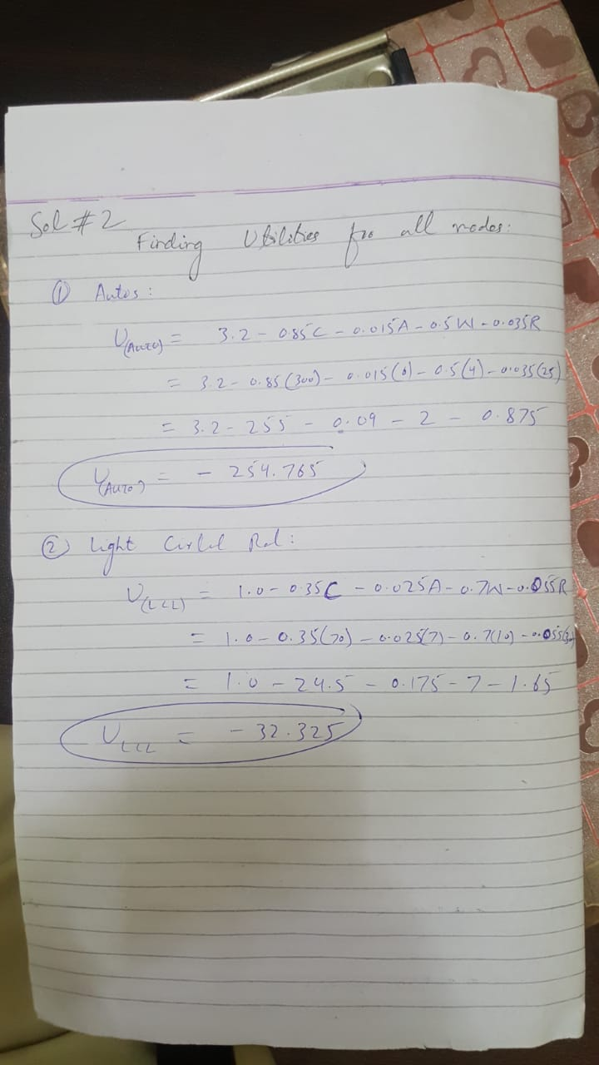
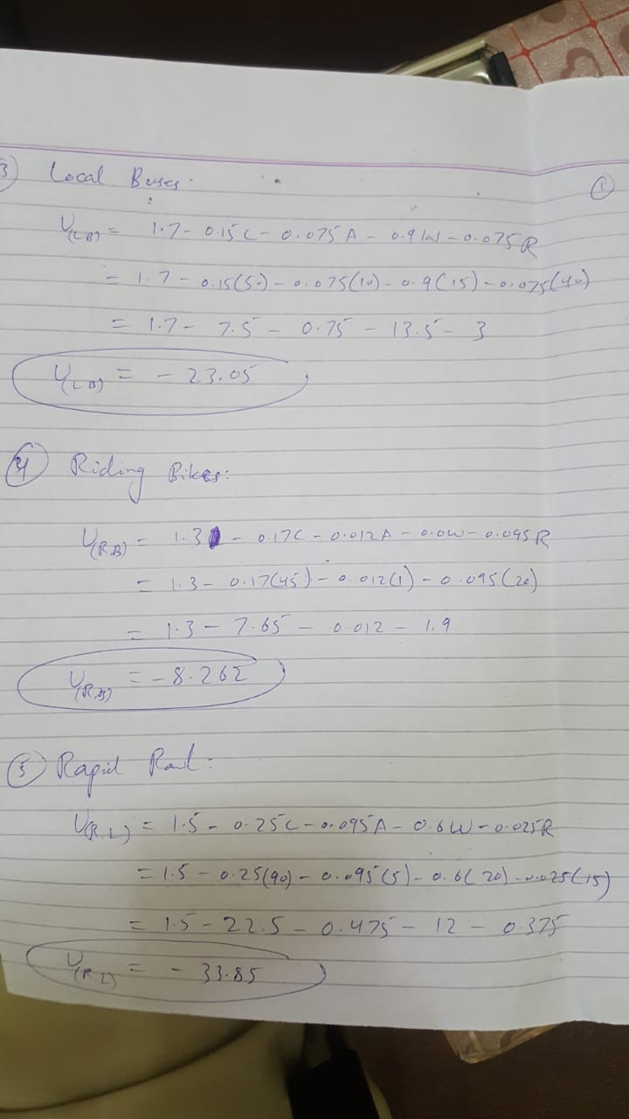
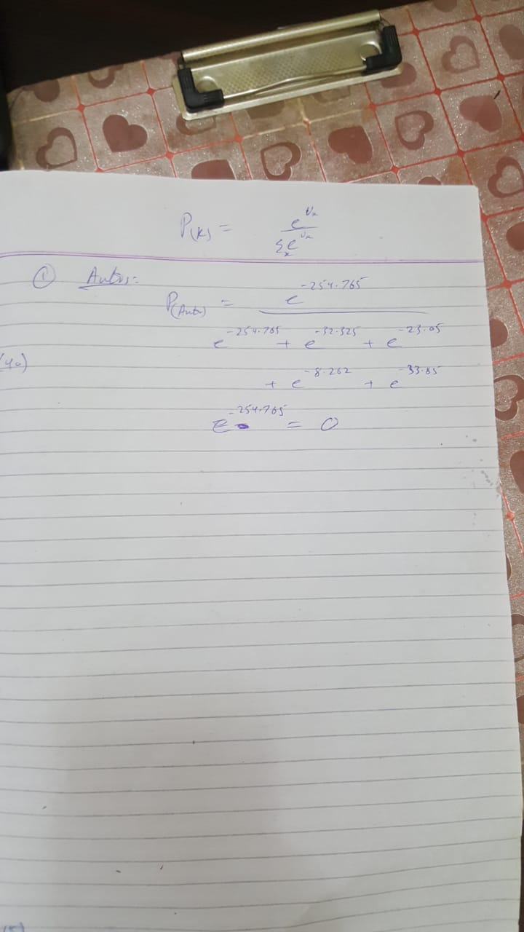
Q.3.

Solution # 3:
Link array for the given network:
Zone  ( i / j ) | A | B | C | D | 1 | 2 | 3 | 4 | 5 | 6 | 7 | 8 | 9
A |  |  |  |  | 4
B |  |  |  |  |  |  | 3
C |  |  |  |  |  |  |  |  |  |  | 5
D |  |  |  |  |  |  |  |  |  |  |  |  | 4
1 |  |  |  |  |  | 3 |  | 3
2 |  |  |  |  | 3 |  | 4 |  | 4
3 |  | 3 |  |  |  | 4 |  |  |  | 12
4 |  |  |  |  | 3 |  |  |  | 5 |  | 7
5 |  |  |  |  |  | 4 |  | 5 |  | 7 |  | 8
6 |  |  |  |  |  |  | 12 |  | 7 |  |  |  | 9
7 |  |  | 5 |  |  |  |  | 7 |  |  |  | 10
8 |  |  |  |  |  |  |  |  | 8 |  | 10 |  | 12
9 |  |  |  | 4 |  |  |  |  |  | 9 |  | 12

Calculating Impedance from Zone-1 to all other zones and nodes:

Stage N | Link |  | Compute new path impedance |  |  | Compare to tree table Stage N-1 | Decision
 | i | j
I | A | 1 | 0 | 4 | 4 | 4< Infinity | Accepted
II | 1 | 2 | 4 | 3 | 7 | 7 < Infinity | Accepted
 | 1 | 4 | 4 | 3 | 7 | 7 < Infinity | Accepted
III | 2 | 3 | 7 | 4 | 11 | 11 < Infinity | Accepted
 | 2 | 5 | 7 | 4 | 11 | 11 < Infinity | Accepted
 | 4 | 5 | 7 | 5 | 12 | 12 > 11 | Rejected
 | 4 | 7 | 7 | 7 | 14 | 14< Infinity | Accepted
IV | 3 | B | 11 | 3 | 14 | 15< Infinity | Rejected
 | 3 | 6 | 11 | 12 | 23 | 23 >18 | Rejected
 | 5 | 6 | 11 | 7 | 18 | 18< Infinity | Accepted
 | 5 | 8 | 11 | 8 | 19 | 19< Infinity | Accepted
 | 7 | C | 14 | 5 | 19 | 19< Infinity | Accepted
 | 7 | 8 | 14 | 10 | 24 | 24 > 19 | Rejected
V | 6 | 9 | 19 | 9 | 29 | 19< Infinity | Accepted
 | 8 | 9 | 19 | 12 | 31 | 31 > 29 | Rejected
VI | 9 | D | 31 | 4 | 35 | 35< Infinity | Accepted

Ans Q#4.

QUESTION NO: 04

Using net present value calculations are given below

- CNG bus
(25uspwf (7%,11)-60 -(16.048+7.99)uspwf(7%,11)+7.04sppwf(7%,11)=-49.44
- BUS RAPID TRANSIT
27uspwf(7%,12)-50 –(19.589+12.116)uspwf(7%,122)+11sppwf(7%,12)=-82.49
- LIGHT RAIL
29uspwf(5%,12)-66 – (19.554+16)uspwf(5%,12)+14sppwf(5%,12)=-116.294
- FAST TRAIN
45uspwf(8%,14)-95-(31.132+19.345)uspwf(8%,14)+17sppwf(8%,14)=-134.367
- METRO
35uspwf(6%,18)-70-(25+19.535)uspwf(6%,18)+16sppwf(6%,18)=-167.64

CONCLUSION:
Since value of CNG Bus is smaller than others alternatives. So, I will recommend CNG Bus for the government.

