NAME : AYESHA SALMAN
ID: 16635
DEPARTMENT: RADIOLOGY
2ND Semester
Section B
Subject: PHYSIOLOGY
INSTRUCTOR : MA'AM KAUSAR SHAH JEHAN

Q1: Write the functions and composition of Blood?
Ans:

BLOOD:
Blood is a body fluid in humans and other animals that delivers necessary substances such as nutrients and oxygen to the cells and transports metabolic waste products away from those same cells. In vertebrates, it is composed of blood cells suspended in blood plasma.
Normal Ph of blood is 7.35-7.45
Body contains about 6-8% of the body’s weight. According to a 70 kg person will have 5-6 litres of blood. Total blood vloume cannot circulate in the body because some blood deposited in organs such as liver and remaining blood circulates in the body.
Blood is formed by 4 Components
- Plasma
- Erythrocytes ( red blood cells , RBCs)
- Leukocytes ( white blood cells WBCs )
- Thrombocytes ( Platelets )

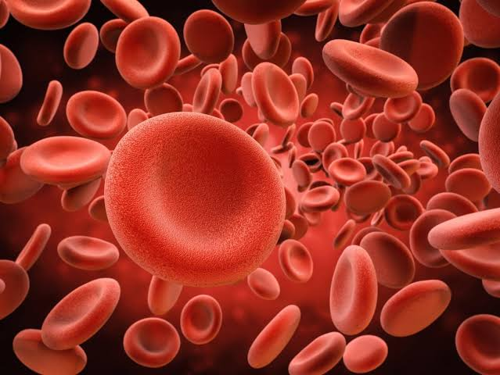

BLOOD COMPOSITION
Liquid part of blood :
PLASMA
92% water
Mineral ions
Glucose and nutrients
Hormones
CO2
Proteins
RBCs
Biconcave in shape
Diameter = 7.8 micrometer
Thickness = 2.5 micrometer
52,00,000/cubic millimeter of blood in males
47,00,000 in females
WBCs
7000 per microliter of blood – 6 types of WBC
Polymorphonuclear neutrophills 62% Polymorphonuclear eosinophills 2.3% Polumorphonuclear basophills 0.4% Monocytes 5.3% Lymphocytes 30%
PLATELETS
300,000 per microliter of blood

Blood is the only fluid tissue in the body. It appears to be a thick,
homogeneous liquid, but the microscope reveals that blood has
both cellular and liquid components. Blood is a specialized type
of connective tissue in which living blood cells, called the
formed elements, are suspended in a nonliving fluid matrix
called plasma (plaz-
mah). The collagen and elastic fibers typical
of other connective tissues are absent from blood, but dissolved
fibrous proteins become visible as fibrin strands during blood
clotting.
Blood consists of
- Liquid Plasma ( volume 55-60% )
- Formed elements ( volume 40-45% )
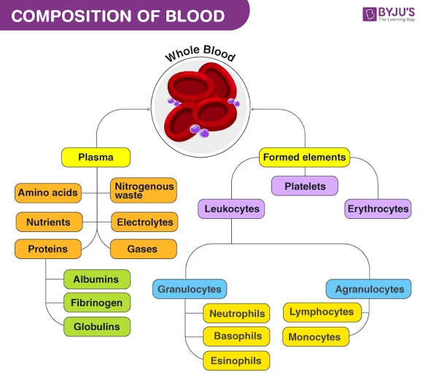

FUNCTIONS OF BLOOD

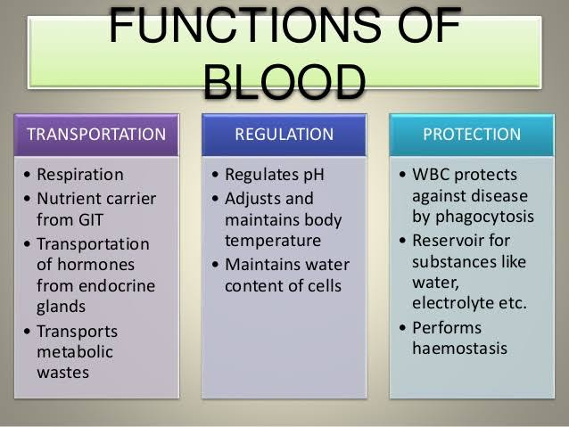
Blood has three main functions
- Transportation
- Protection
- Regulation
TRANSPORT
Blood transports following substances
- Gases, namely Oxygen (O₂) and Carbon dioxide (CO₂) between the lungs and rest of the body.
- Nutrients from the digestive tract and storage sites to the rest of the body.
- Waste products to be detoxified by the liver and kidneys.
- Hormones from the glands in which they are produced to their target cells.
- Heat to the skin so as to help regulate body temperature.
PROTECTION
Blood has several roles in inflammation.
- White blood cells ( Leukocytes ) destroy invading microorganisms and cancer cells.
- Antibodies and other proteins destroy pathogenic substances
- Platelet factors initiate blood clotting and help minimise blood loss.
REGULATION
Blood helps regulate
- Ph by interacting with acids and bases
- Water balance by transferring water to and from tissues

Q2: What is Erythrocyte , Erythropoiesis , Erythrocytosis and Erythropenia.
Ans:

ERYTHROCYTES
A cell that contains hemoglobin and can carry oxygen to the body. Also called a red blood cell (RBC). The reddish color is due to the hemoglobin. Erythrocytes are biconcave in shape, which increases the cell's surface area and facilitates the diffusion of oxygen and carbon dioxide.
Approximately 2.4 million new Erythrocytes produced per second.
A typical human Erythrocyte has a disk diameter of approximately 6.2-8.2 μm
The average taken by human red blood cells is 28 seconds to complete one cycle of circulation.
Major function is transportation of haemoglobin
RBCs contains carbonic anhydrase which catalysis reaction between carbon dioxide and water and perform function of transporting carbon dioxide frim tissues to lungs.
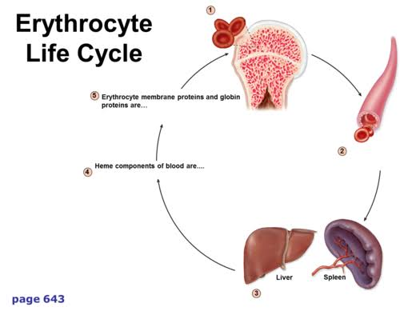

ERYTHROPOIESIS
Process of Formation of RBCs is called Erythropoiesis
Erythropoiesis is the process which produces red blood cells, which is the development from erythropoietic stem cell to mature red blood cell.
It is stimulated by decreased O₂ in circulation, which is detected by the kidneys, which then secrete the hormone erythropoietin. This hormone stimulates proliferation and differentiation of red cell precursors, which activates increased erythropoiesis in the hemopoietic tissues, ultimately producing red blood cells (erythrocytes). In postnatal birds and mammals (including humans), this usually occurs within the red bone marrow. In the early fetus, erythropoiesis takes place in the mesodermal cells of the yolk sac. By the third or fourth month, erythropoiesis moves to the liver. After seven months, erythropoiesis occurs in the bone marrow. Increased level of physical activity can cause an increase in erythropoiesis. However, in humans with certain diseases and in some animals, erythropoiesis also occurs outside the bone marrow, within the spleen or liver.
Erythropoiesis takes place in the bone marrow, where hemopoietic stem cells differentiate and eventually shed their nuclei to become reticulocytes.
Erythropoiesis, the development of red blood cells, is a tightly regulated process for maintaining sufficient oxygen delivery to tissue.
In addition to erythropoietin, the erythropoietic machinery requires a constant supply of iron, vitamin B12, and folic acid.
Erythropoietin is the principal hormone that regulates erythropoiesis and its transcription is mediated by hypoxia inducible factor-1 (HIF-1)
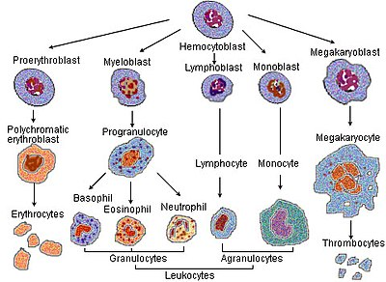
Causes:
Erythropoietin is produced in the kidney and liver in response to low oxygen levels. In addition, erythropoietin is bound by circulating red blood cells; low circulating numbers lead to a relatively high level of unbound erythropoietin, which stimulates production in the bone marrow.
Treatment:
Erythropoiesis-stimulating agents (ESAs) continue to have an important role in the treatment of anemia in patients with CKD. ESA use in this group of patients has been shown to raise hemoglobin (Hgb) levels, decrease blood transfusion requirements, and improve the quality of life and symptoms related to anemia.

ERYTHROCYTOSIS
Increase in Red Blood Cell Mass
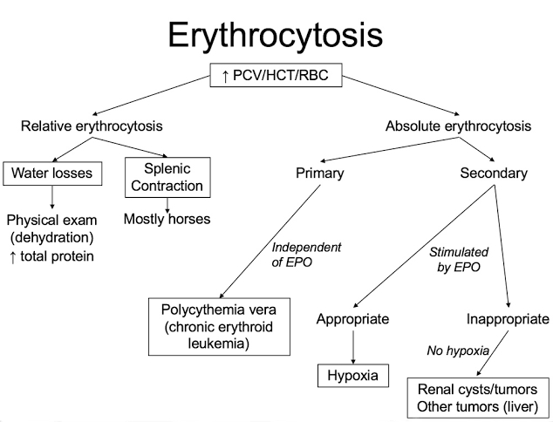
Erythrocytosis is defined as an increase in red blood cell (RBC) mass, usually absolute, erythrocytosis and is also associated with an increased hematocrit (HCT) and hemoglobin concentration. Although some use the term polycythemia interchangeably with erythrocytosis, the two are not synonymous.
Relative erythrocytosis occurs due to dehydration or endotoxemia (hemoconcentration) or excitement/exercise (splenic contraction). ... Appropriate secondary erythrocytosis occurs in response to increased erythropoietin (EPO) levels resulting from sustained hypoxia.
Secondary is erythrocytosis that develops secondary to disorders that cause tissue hypoxia, inappropriately increase erythropoietin production, or increase sensitivity to erythropoietin. ... Any elevation of hemoglobin or hematocrit above normal values for age and sex is considered erythrocytosis.
Causes:
Smoking, a lack of oxygen, such as from lung diseases or being in high altitudes.
Treatment:
Any underlying disorder that is causing the oxygen deprivation and secondary erythrocytosis is treated as effectively as possible. In some people, phlebotomy (in which some of the person's blood is removed) is used to lower the number of red blood cells. It is rare that phlebotomy is needed in secondary erythrocytosis.

ERYTHROPENIA
A decrease in the number of erythrocytes, associated with anemia
Or
Deficiency of Red Blood Cells
It is caused by a mutation in genes that control how many RBCs your bone marrow makes. When one of these genes is mutated, your bone marrow will produce extra RBCs, even when your body doesn't need them.
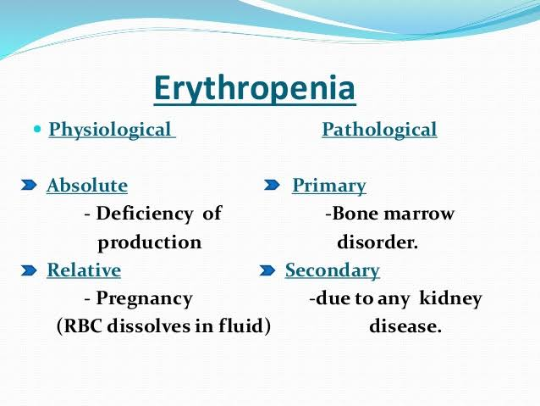
Causes: smoking.
a lack of oxygen, such as from lung diseases or being in high altitudes.
tumors.
medications such as steroids and diuretics.
Treatment
Any underlying disorder that is causing the oxygen deprivation and secondary erythrocytosis is treated as effectively as possible. In some people, phlebotomy (in which some of the person's blood is removed) is used to lower the number of red blood cells. It is rare that phlebotomy is needed in secondary erythrocytosis.

Q3: What is Platelets? and write about clotting mechanism and its all steps.
Ans:

PLATELETS
Platelets are tiny blood cells that help your body form clots to stop bleeding. If one of your blood vessels gets damaged, it sends out signals to the platelets. The platelets then rush to the site of damage. they form a plug (clot) to fix the damage.
Platelets are made in your bone marrow along with your white and red blood cells. Your bone marrow is the spongy center inside your bones. Another name for platelets is THROMBOCYTES Healthcare providers usually call a clot a thrombus. Once platelets are made and circulated into your bloodstream, they live for 8 to 10 days.
Under a microscope, a platelet looks like a tiny plate. Your healthcare provider may do a blood test called a complete blood count to find out if your bone marrow is making the right number of platelets:
A normal platelet count is 150,000 to 450,000 platelets per microliter of blood.
Your risk for bleeding develops if a platelet count falls below 10,000 to 20,000. When the platelet count is less than 50,000, bleeding is likely to be more serious if you're cut or bruised.
Some people make too many platelets. They can have platelet counts from 500,000 to more than 1 million.

MECHANISM
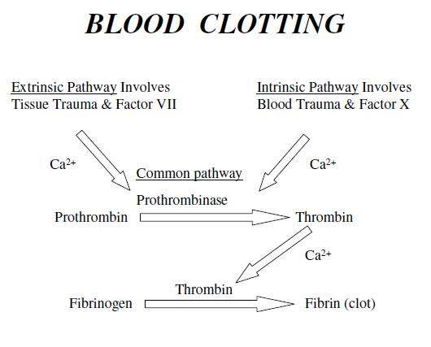
Clotting Mechanism is broken into 2 Stages:
Primary Hemostasis:
Formation of a weak Platelet plug
Secondary Hemostasis :
Stabilizing the weak Platelet plug into a clot by the fibrin network.
The mechanism of coagulation involves activation, adhesion and aggregation of platelets, as well as deposition and maturation of fibrin. Platelets immediately form a plug at the site of injury; this is called primary hemostasis.
The second critical step in hemostasis, which follows vasoconstriction, is platelet plug formation.
There are three steps to platelet plug formation are:
adherence
activation
aggregation

Q4: Write a detail note on ABO System?
Ans:

ABO System
ABO blood group system, the classification of human blood based on the inherited properties of red blood cells (erythrocytes) as determined by the presence or absence of the antigens A and B, which are carried on the surface of the red cells. Persons may thus have type A, type B, type O, or type AB blood.
NOMENCLATURE
Number of ABO Blood group antigens are 4
ISBT Symbol: ABO
ISBT number: 001
Gene Symbol: ABO
Gene name: ABO blood group ( A transferase, α1,3-N-acetylgalactosaminyltransferase;B transferase, α1,3-galactosyltransferase ).
ABO SYSTEM
BY DR. KARL LANDSTEINER 1900
Received Nobel prize in Physiology or Medicine in 1930 for this discovery.
- He concluded that it is inherited from Parents.
- Based on A and B Antigens-Agglutinogems
- It may have
Neither of them
One of them
Both of them
The ABO blood group system is used to denote the presence of one, both, or neither of the A and B antigens on erythrocytes. In human blood transfusions it is the most important of the 36 different blood type (or group) classification systems currently recognized. A mismatch (very rare in modern medicine) in this, or any other serotype, can cause a potentially fatal adverse reaction after a transfusion, or an unwanted immune response to an organ transplant. The associated anti-A and anti-B antibodies are usually IgM antibodies, produced in the first years of life by sensitization to environmental substances such as food, bacteria, and viruses.
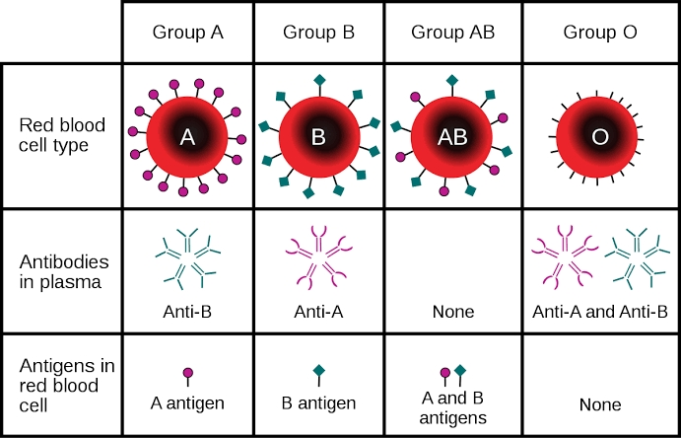

ABO phenotypes
The four basic ABO phenotypes are O, A, B, and AB. After it was found that blood group A RBCs reacted differently to a particular antibody (later called anti-A1), the blood group was divided into two phenotypes, A₁ and A₂. RBCs with the A₁ phenotype react with anti-A1 and make up about 80% of blood type A. RBCs with the A₂ phenotype do not react with anti-A1 and they make up about 20% of blood type A. A₁ red cells express about 5 times more A antigen than A₂ red cells, but both types of red cell react with anti-A, and as far as transfusion purposes are concerned, the A₁ and A₂ blood groups are interchangeable.
There are many other subgroups of blood group A in which RBCs tend to weakly express the A antigen, whereas weak variants of the blood group B phenotype are rare.
The immune system forms antibodies against whichever ABO blood group antigens are not found on the individual's RBCs. Thus, a group A individual will have anti-B antibodies and a group B individual will have anti-A antibodies. Blood group O is common, and individuals with this blood type will have both anti-A and anti-B in their serum. Blood group AB is the least common, and these individuals will have neither anti-A nor anti-B in their serum.
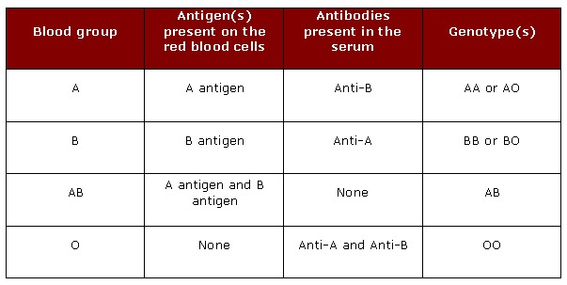
ABO antibodies in the serum are formed naturally. Their production is stimulated when the immune system encounters the "missing" ABO blood group antigens in foods or in micro-organisms. This happens at an early age because sugars that are identical to, or very similar to, the ABO blood group antigens are found throughout nature.
The ABO locus has three main alleleic forms: A, B, and O. The A allele encodes a glycosyltransferase that produces the A antigen (N-acetylgalactosamine is its immunodominant sugar), and the B allele encodes a glycosyltransferase that creates the B antigen (D-galactose is its immunodominant sugar).
Function of the A and B antigens
functions of the ABO blood group antigens are not known. Individuals who lack the A and B antigens are healthy, suggesting that any function the antigens have is not important, at least not in modern times.
Diseases associated with ABO blood group antigens
No diseases are known to result from the lack of expression of ABO blood group antigens, but the susceptibility to a number of diseases has been linked with a person's ABO phenotype. Such correlations remain controversial and include the observation that gastric cancer appears to be more common in group A individuals ,whereas gastric and duodenal ulcers occur more often in group O individuals.
Clinical Significance of ABO Antibodies
ABO Antibodies are of major clinical significance for two reasons:
They are naturally occurring and are found universally
They are highly reactive

Indications for ABO grouping:
ABO grouping is required for all of the following individuals:
Blood Donors
since it can be life threatening to give the wrong ABO group to the patient.
Transfusion recipients
since we need to know the donor blood is ABO compatible.
Transplant Candidates and Donors
ABO antigens are found in other tissues as well. Therefore the transplant candidates and donors must be compatible.
Prenatal Patients
To determine whether the mothers may have babies who are suffering from ABO-HDN. It is also beneficial to know the ABO group should she start hemorrhaging.
Newborns
(sometimes) If the baby is demonstrating symptoms of Hemolytic Disease of the Newborn, the ABO group needs to be determined along with Rh and others.
Paternity testing
Since the inheritance of the ABO Blood Group System is very specific, this serves as one of the first methods to determine the likelihood that the accused father is the father or not.

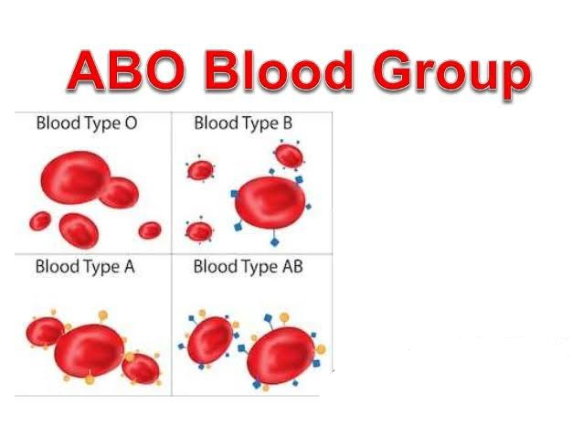
Q5:
- A person fell down from a tree and become unconscious, with bleeding from head, what will you do as a first aid?
Ans: First of all I’ll check that i and the casualty aren't in any danger, and, if possible, make the situation safe i’ll sanitize my hands and then wear surgical gloves to reduce the risk of any infection being passed on. Then i will apply piodine on the affected part nd then i will apply bandage. if bleeding continues through the pad, I’ll apply pressure to the wound until the bleeding stops and then apply another pad over the top and bandage it in place. I will not remove the original pad or dressing, but continuously i will check that the bleeding has stopped or not.
- You have to meet with your friend and you came to know he’s covid positive , what precautionary measures will you take?
Ans: First of all i will advise him to be isolated separately in his home. Because now adays hospitals are not safe. They are killing corona patients. And I’ll advise him to take fresh juices , fruits , hot water , fresh vegetables and panadol. And I’ll also quarantine myself. Because I interacted with covid patient.
Everyone should follow following precautionary measures
Clean your hands often. Use soap and water, or an alcohol-based hand rub.
Maintain a safe distance from anyone who is coughing or sneezing.
Don’t touch your eyes, nose or mouth.
Cover your nose and mouth with your bent elbow or a tissue when you cough or sneeze.
Stay home if you feel unwell.
If you have a fever, cough and difficulty breathing, seek medical attention. Call in advance.
Follow the directions of your local health authority.

THE END

