Subject: Anatomy-IV
Submitted by: Sidra (15057)
DPT 4th Semester
Midterm Assignment, spring 2020.

Select the best possible answer.
1. Sub arachnoid hemorrhage is caused by the rupture of which vessel?
a. Middle meningeal artery
b. middle meningeal vein
c. cerebral artery
d. cerebral vein

2. The superior sagittal sinus is located between the?
a. inner table of the skull and the endosteal (parietal) layer of the Dura
b. Endosteal (parietal) and the meningeal (visceral) layers of the Dura
c. meningeal (visceral) layer of the Dura and the arachnoid layer
d. arachnoid layer and the pie mater

3. How many poles does a cerebrum has?
a. 3 lobes
b. 4 lobes
c. 3 poles
d. 4 poles

4. What type of cells is present in the fifth layer of cerebral cortex?
a. large pyramidal cells
b. giant pyramidal cells
c. Betz cells
d. Both b & c

5. A fetal origin posterior communicating artery arises from the?
a. basilar artery
b. middle cerebral artery
c. internal carotid artery
d. vertebral artery

6. Regarding sympathetic and parasympathetic nervous system, which of the following is true?
a. Long preganglionic fibers and short postganglionic fibers in SNS.
b. Long preganglionic fibers and short postganglionic fibers in PSNS.
c. Short preganglionic fibers and short postganglionic fibers in SNS.
d. Short preganglionic fibers and long postganglionic fibers in PSNS
e. both b & c.
f. both a & d.

7. Sensory information enters the CNS via the dorsal portion, Motor commands exit the CNS via the ventral portion.
a. True
b. False

8. Which of the following regarding taste area is true?
a. Bradman’s area 43
b. situated in lower end of post central gyrus in superior wall of lateral sulcus near the insula.
c. both a & b.
d. none of them are true.

Questions 9-11 are related to the figure 1, given below. Question number 9, 10 carries 1 mark each. Question number 11 carries 5 marks.

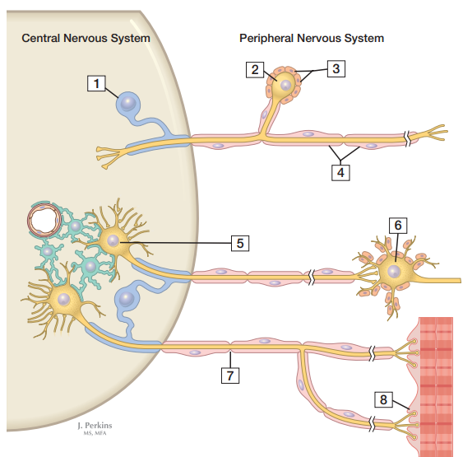
Figure 1

9. Given in the figure below, area labeled as 5 is?
a. Postganglionic autonomic neuron
b. Preganglionic autonomic neuron
c. Motor end plate (neuromuscular junction)
d. Primary sensory (ganglion) cell body

10. Given in the figure below, area labeled as 6 is?
a. Postganglionic autonomic neuron
b. Preganglionic autonomic neuron
c. Motor end plate (neuromuscular junction)
d. Primary sensory (ganglion) cell body

11. In the figure 1 shown above, label the following numbers;

2 Synaptic button
3 Effector Organ muscles
4 Schwan’s cell mylean sheath
7 Node of Ranvier
8 Exon terminal

Answer the following questions. Add diagrams/ pictures if needed.
Each question carries 5 marks.

- Osman, a 23 years old boy suffered a traumatic brain injury on the right sided orbital lobe. Which side and which half of the retinal field's sensory input would be lost? Reason why?

ANSWER:-
Osman 23 year old boy suffered a traumatic brain injury on the right sided orbital lob
So in this case right side was injured so left side of both eyes visual ability was lost
Reason:-
Homonymous hemianopia (or homonymous hemianopia) is hemianopic visual field loss on the same side of both eyes. Homonymous hemianopia occurs because the right half of the brain has visual pathways for the left hemi field of both eyes, and the left half of the brain has visual pathways for the right hemi field of both eyes. When one of these pathways is damaged, the corresponding visual field is lost.

- What are the differences between spinal nerves and cranial nerves?

ANSWER:-
Ans. Different between cranial and spinal nerve:-
CRANIAL NERVE:
- Nerve that are originated from brain or brain stem.
- There are 12 different nerve.
- These 12 cranial nerve are in paired form and present outside the body.
- Rely information to / from various part of the body to the brain.
- There are to different types of neurons which are given below.
- Afferent (carry sensory information to the central nerves system).
- Efferent (carry motor signal away from the central nerves system towards muscle).
- EXAMPLES:-
- Involve vision, sensation of smell, sensation hearing, and sensation of taste and eye movement.
SPINAL NERVES:-
- Consist of 31 pair nerves which carry motor, sensory and autonomic between the spinal card and body.
- According to vertebral the spinal nerves are classified into five groups
- 8- Cranial nerves
- 12- Thoracic nerves
- 5- Lumber
- 5- Sacral
- 1-Coccygeal

- The dorsal and ventral root of spinal card are connected to form spinal nerves
- Dorsal root consist of sensory nerve and form dorsal ramus which control (skin, muscle of posterior body wall and head and neck)
- Ventral root consists of motor nerves and also form ventral ramus which control (skin, muscles of Anterior and lateral body wall)

- What do you know about the reticular formation of spinal cord?
ANSWER
RETICULAR FORMATION OF SPINAL CARD:-
Reticular formation run from the top of spinal card to the brain stem into the thalamus is called reticular formation
The reticular formation is made up network of nerve fibers and nerve cell

The reticular formation consists of three type of neurons that have various function
- SHORT INTERNEURONS
- INTERNEURONS
- LONG PROJECTION NEURONS

- SHORT INTERNEURON : short inter neurons are present in the spinal card and brain it is necessary for facial expression , eating , breathing and for eye movement
- INTERNEURONS:-Interneuron are present in the thalamus and hypothalamus which is necessary for sensory perception
- LONG PROJECTION NEURONS: long projection neuron are present in the brain stem and hypothalamus and there exon ascending to the forebrain or descending to the spinal card.
ROLE OF RETICULAR FORMATION
The role of reticular formation are an involment in pain sensation, alertness, fatigue, sleep and motivation also related character traits such as introversion and extroversion

Damage of Reticular Formation

Damage to the reticular formation can lead to coma or dead reticular formation multi system are damage such as muscles contraction, skin trophic, pain, sleep apnoea .

