Course Title: Biochemistry I
Micro 2nd Lab Assignment
Student Name: ZAINAB ALI
Student ID: 16004

Note: Avoid copy paste material as it may deduct your marks.

Q1. Discuss the Watson and Crick Model of DNA.
WATSON AND CRICK MODEL OF DNA:-
Wilkins , Rasolind Franklin , James Watson and Francis circk made major Contribution to developing and understanding the structure of DNA . In 1953 James watson and Francis deducted the following four points about DNA.
- DNA molecules consist of tow individual polynucleotide strand that wind around a common axis to create a double helix structure. These two strand of DNA run in a parallel but in opposite direction
- The backbone DNA molecules run along the exterior of DNA while the nitrogen base run on the inside.
- The bases are nearly perpendicular to the common axis and firm pairs. Each base pair is separated form by a distance of 3.4 angstroms. A single helical turn of the DNA stretch aver a distance of 34 angstroms, which mean that there are 10 base pairs in a single turn. Since the DNA turn represents 360 degree and there are 10 base pairs in a single turn that mean each base pair turns the DNA helix by 36 degrees.
- The DNA molecules has a diameter of 20 angstroms. In addition, Watson and Crick also uncovered that the purine base always pair up with pyrimidine as to insure that the DNA.

The following points explain the models of DNA as proposed by Watson and Crick.
- DNA is made up of double helix made up of polynucleotide chains that are coiled with each other in a right handed fashion.
- The two strands are anti parallel to each other. One strand runs in 5'-3' polarity and other run into 3'-5' polarity.
- The deoxyribose sugar and the phosphate group attached to it form the backbone of the polynucleotide strand.
- The nitrogenouse base attached with deoxyribose sugar through glycosidic bonds form the inner core.
- The nitrogenouse base of the two strand form hydrogen bonds as per their complimentary such that Adenine form H-bond with Thymine and Guanine form three H-bonds with cytosine.
- The diameter of the DNA is 20nm and the bases are at 0.34nm. There are 10 base pairs per turn and length of the turn is 3.4nm.
- The helix show a minor groove and major groove.
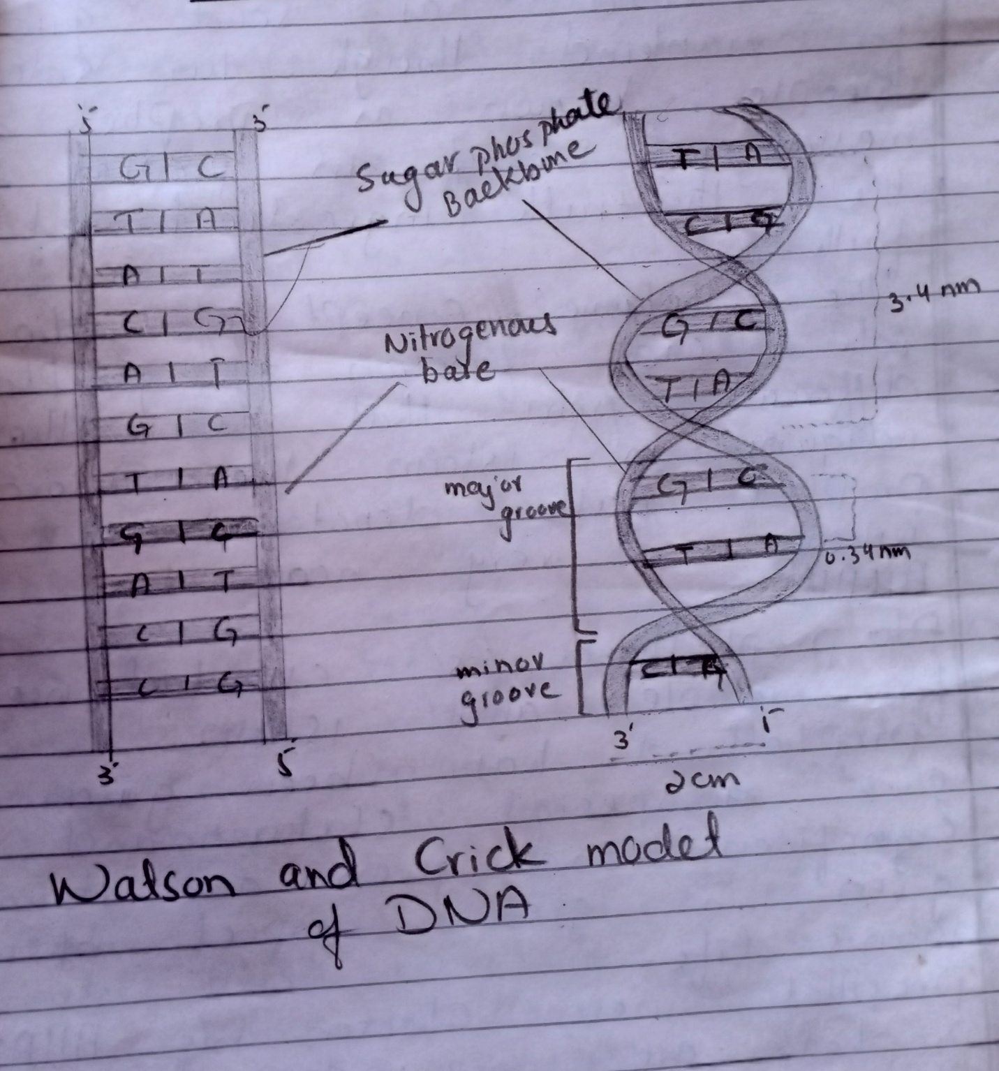
Q2. Draw the structure of following saccharides:
  - Fructose
  - Fructose, or fruit sugar, is a simple ketonic monosaccharide found in many plants, where it is often bonded to glucose to form the disaccharide sucrose. It is one of the three dietary monosaccharides, along with glucose and galactose, that are absorbed directly into blood during digestion.
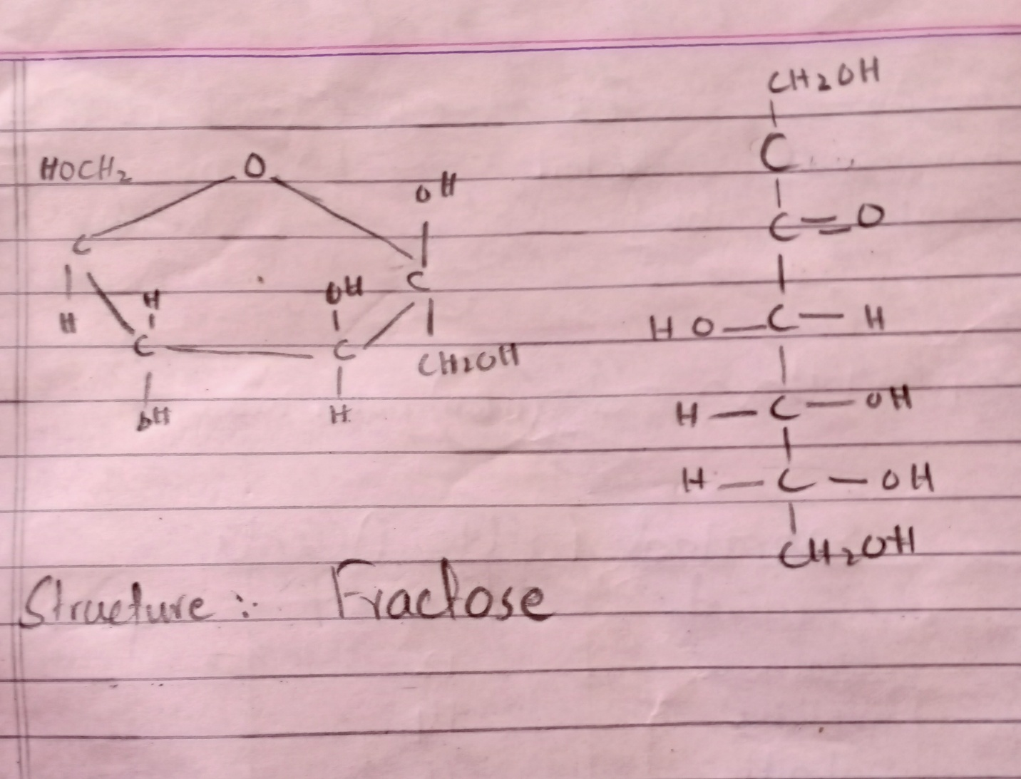
  - Maltose
Maltose consists of two molecules of glucose that are linked by an α-(1,4') glycosidic bond. Maltose results from the enzymatic hydrolysis of amylose, a homopolysaccharide (Section 28.9), by the enzyme amylase. Maltose is converted to two molecules of glucose by the enzyme maltase, which hydrolyzes the glycosidic bond.
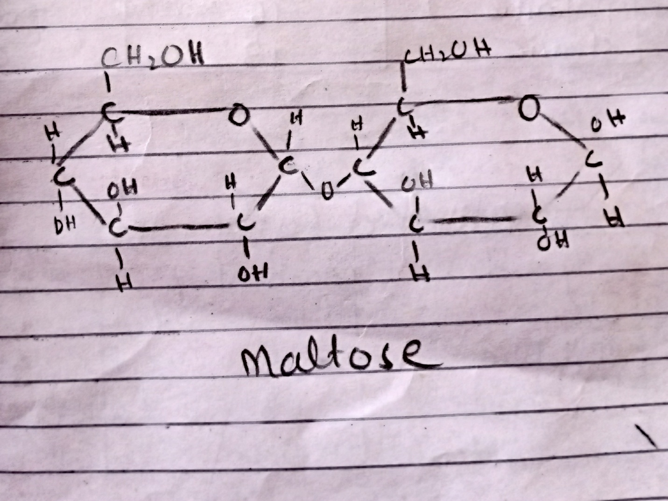

  - Table sugar
  - Table sugar is the common name for a sugar known as sucrose. It is a type of disaccharide made from the combination of the monosaccharides glucose and fructose. The chemical or molecular formula for sucrose is C₁₂H₂₂O₁₁, which means each molecule of sugar contains 12 carbon atoms, 22 hydrogen atoms and 11 oxygen atoms.
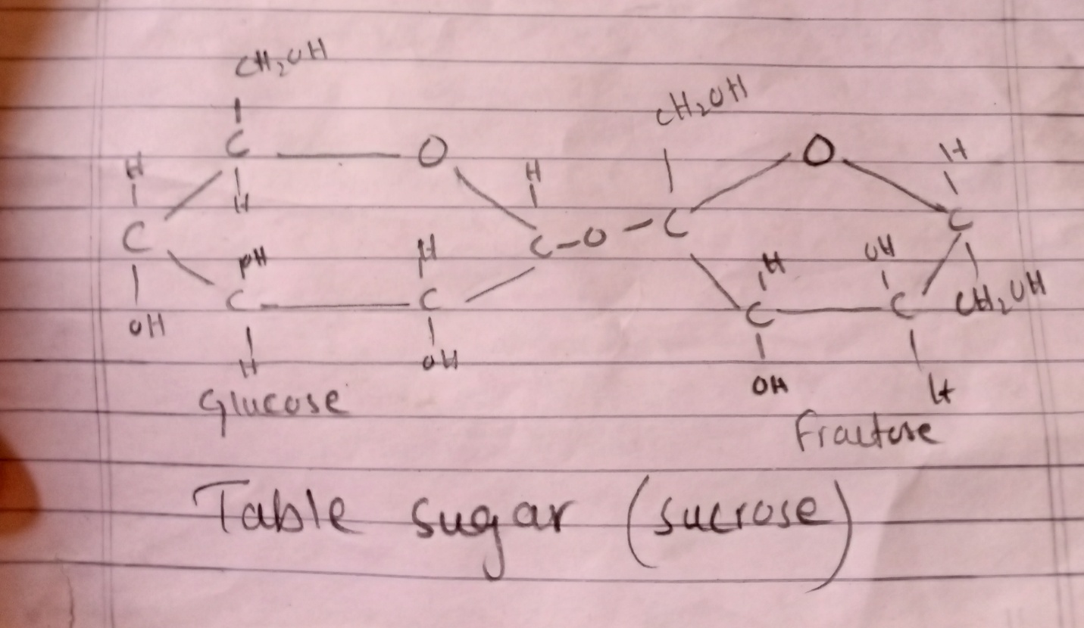

  - Stachyose
Stachyose is a tetrasaccharide consisting of two D-galactose units, one D-glucose unit, and one D-fructose unit sequentially linked. Stachyose is a normal human metabolite present in human milk and is naturally found in many vegetables (e. g. green beans, soybeans and other beans) and plants.
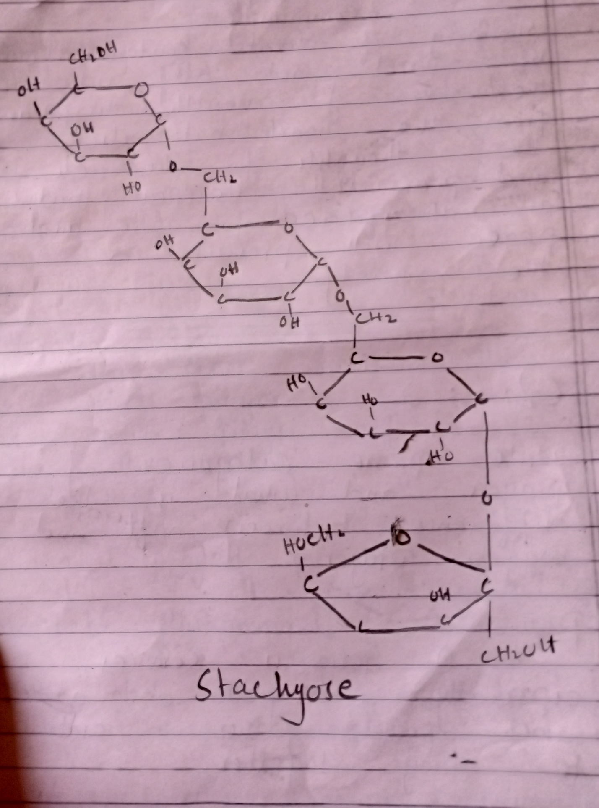

  - Milk sugar
Lactose is a disaccharide. It is a sugar composed of galactose and glucose subunits and has the molecular formula C₁₂H₂₂O₁₁. Lactose makes up around 2–8% of milk (by weight). The name comes from lac (gen
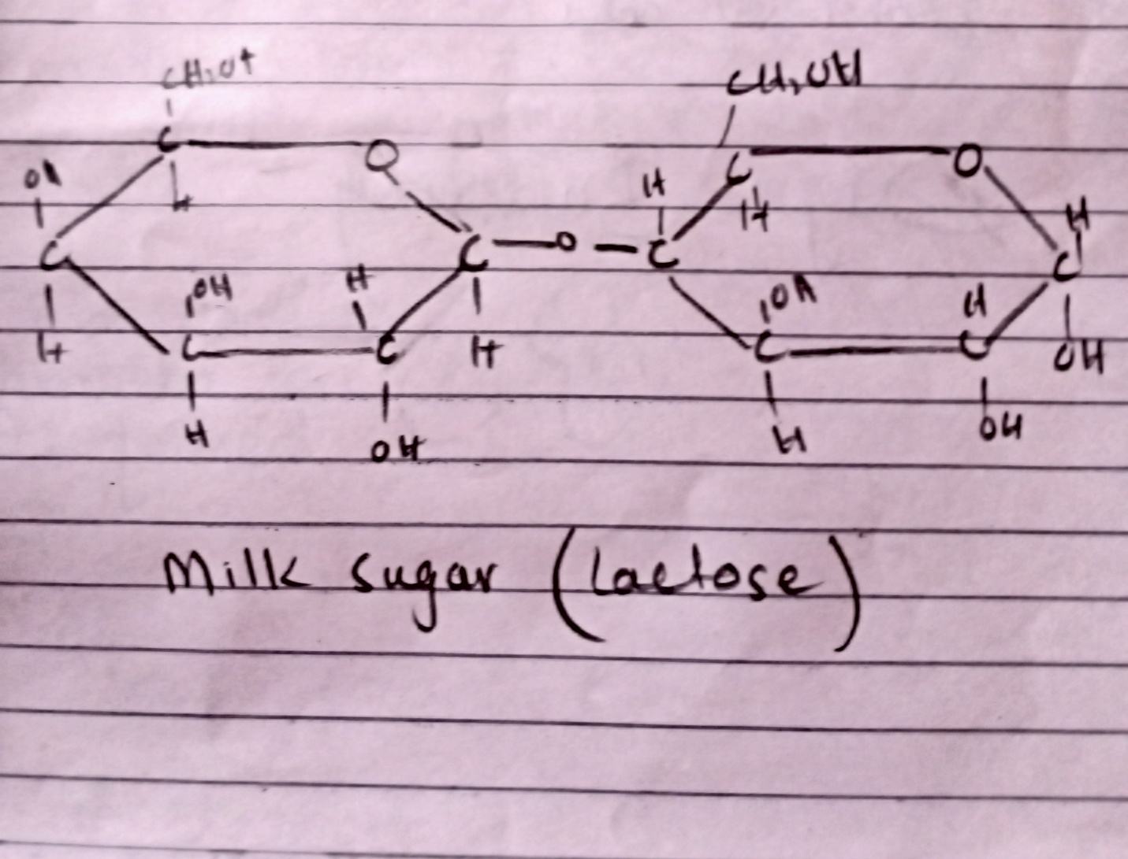
.
  - Glyceraldehyde
Glyceraldehyde is a triose monosaccharide with chemical formula C3H6O3. It is the simplest of all common aldoses. It is a sweet, colourless crystalline solid that is an intermediate compound in carbohydrate metabolism. ... Glyceraldehyde is an aldotriose comprising propanal having hydroxy groups at the 2- and 3-positions
