Name :Sahil
I.D : 14615
DPT 4th Semester
Paper : Pathology and Microbiology
Submitted to : Dr Imran
Q 1 : What are hemodynamic disorder explain any three (3)?

HEMODYNAMIC DISORDERS
Introduction
The health and well-being of cells & tissues depend not only on an intact
circulation to deliver nutrients but also on normal fluid hemostasis. This chapter
reviews the major disturbances involving the hemodynamic system.
Edema
Definition:
Edema is increased fluid in the interstitial tissue spaces or it is a fluid
accumulation in the body cavities in excessive amount. Depending on the site,
fluid accumulation in body cavities can be variously designated as:

Clinical classification of edema:
One can also clinically classify edema into localized & generalized types.
A) Localized
a) Hydrothorax – fluid accumulation in pleural cavity in a pathologic amount.
b) Hydropericardium – pathologic amount of fluid accumulated in the pericardial
cavity.
c) Hydroperitoneum (ascites) – fluid accumulation in peritoneal cavity.
d) hydrocephalus fluid accumulation in brain .
ex of disease cause localized edema
1) Deep venous thrombosis
2) Pulmonary edema
3) Brain edema
4) Lymphatic edema
B) Generalized
Generalized edema (anasarca) : is a sever & generalized edema of the body with
profound subcutaneous swelling. occurs due to :
a. Reduction of albumin due to excessive loss or reduced synthesis as is caused
by:
1) Protein loosing glomerulopathies like nephrotic syndrome
2) Liver cirrhosis
3) Malnutrition
4) Protein-losing enteropathy stage

b. Increased volume of blood secondary to sodium retention caused by congestive
heart failure

Excess of diseases cause generalized edema
1) Nephrotic syndrome
2) Liver cirrhosis
3) Malnutrition
4) Heart failure
5) Renal failure
Mechanism of edema formation:
Approximately 60% of the lean body weight is water, two-thirds of which is
intracellular with the remainder in the extracellular compartment.
The capillary endothelium acts as a semipermeable membrane and highly
permeable to water & to almost all solutes in plasma with an exception of
proteins. Proteins in plasma and interstial fluid are especially important in
controlling plasma & interstitial fluid volume. Normally, any outflow of fluid into
the interstitium from the arteriolar end of the microcirculation is nearly balanced
by inflow at the venular end. Therefore, normally, there is very little fluid in the
interstitium.
Edema formation is determined by the following factors:
1) Hydrostatic pressure
2) Oncotic pressure
3) Vascular permeability
4) Lymphatic channels
5) Sodium and water retention
We will discuss each of the above sequentially.

1) Hydrostatic and oncotic pressures:
The passage of fluid across the wall of small blood vessels is determined by the
balance between hydrostatic & oncotic pressures. There are primary forces that
determine fluid movement across the capillary membrane. Any defect in these
force lead to escape of the fluid in to interstitium .
2) Vascular permeability:
Increased vascular permeability usually occurs due to acute inflammation. In
inflammation, chemical mediators are produced. Some of these mediators cause
increased vascular permeability which leads to loss of fluid & high molecular
weight albumin and globulin into the interstitium. Such edema (i.e. that caused by
increased vascular permeability) is called inflammatory edema. Inflammatory
edema differs from non-inflammatory edema by the following features
a) Inflammatory edema (exudate)
b) Non-inflammatory edema (transudate)
Due to inflammation-induced
increased permeability and leakage of
plasma proteins.
A type of edema occurring in hemodynamic
derangement (i.e. increased plasma hydrostatic
pressure & decreased plasma oncotic pressure
[protein rich
[protein poor]
Specific gravity > 1.012

Specific gravity < 1.012
Leukocyte and clotting fibrin is high
Odors putrefactive
Oder less
pH acidic
pH alkaline
Associated with inflammatory reaction
No inflammatory reaction
Causes of non-inflammatory transudate:
1- Hypoproteinemia (T.B, chronic fascilosis, starvation ,hepatitis , malnutrition).
2- Increase in capillary blood pressure (obstruction of vein ,obstruction of lymphatic
vessels ,pressure on vein ).
3- Water and Na retention

3) Lymphatic channels:
Also important is the lymphatic system which returns to the circulation the small
amount of proteinaceous fluid that does leak from the blood into the interstial
spaces. Therefore, obstruction of lymphatic channels due to various causes leads
to the accumulation of the proteinaceous fluid normally drained by the lymphatic
channels. Such kind of edema is called lymphatic edema.
Lymphatic edema occurs in the following conditions:
1) Parasitic infection. E.g filariasis which causes massive lymphatic and inguinal
fibrosis
2) Lymphatic obstruction secondary to neoplastic infiltration. E.g. breast cancer
3) post surgical or post irradiation, i.e surgical resection of lymphatic channels or
scarring after irradiation
4) Sodium and water retention:
Sodium & subsequently water retention occurs in various clinical conditions such
as congetive heart failure & renal failure. In these conditions, the retained sodium
& water result in increased capillary hydrostatic pressure which leads to the edema
seen in these diseases.
Morphology of edema
Gross appearance:
1- Pale white fluid fill the body cavities .
2- Swelling of edematous organ .
3- Clearing & separation of extracellular matrix.
Microscopy
(non inflammatory edema )
1- Present of fluid faint pink in color between cells and body cavities.
2- Few amount of fibrin and albumin homogenous .
3- Contain few amount of RBCs ,WBCs.

Hyperemia and Congestion
Definition:
Both of them can be defined as a local increase in volume of blood in
a particular tissue.
Hypermia (active)
Is an active process resulting from an increased inflow of blood into a tissue
because of arteriolar vasodilation. commonly occurs in exercising skeletal muscle
or acute inflammation. Affected tissue becomes red as there is engorgement with
oxygenated blood.
Congestion (passive)
Is a passive process resulting from impaired outflow of blood from a tissue occurs
systemically as in cardiac failure or locally as in isolated venous obstruction.
Affected tissue appears blue-red due to accumulation of deoxygenated blood. It
may be acute or chronic.
- In long-standing congestion (also called chronic passive congestion states),
poorly oxygenated blood causes hypoxia → results in parenchymal cell
degeneration or cell death. 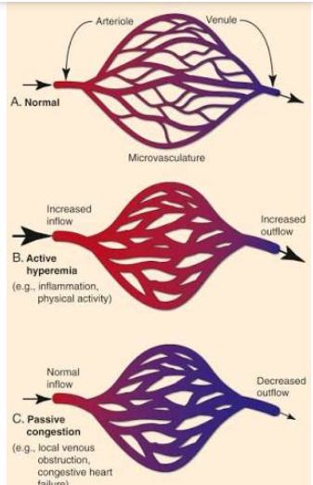
Ex:
a) Pulmonary congestion
Cut surface: hemorrhagic & wet.
1. Acute pulmonary congestion:
Alveolar capillaries engorged with blood
septal edema
2. Chronic pulmonary congestion:
- Thickened & fibrotic septa
- Alveolar spaces contain hemosiderin-laden macrophages resulting in an
appearance termed brown indurations.
- Can result in pulmonary hypertension.
b) Hepatic congestion
1) Acute hepatic congestion:
- Central vein & sinusoids are distended
- There may be even central hepatocyte degeneration.
- Peripheral hepatocytes better oxygenated & develop only fatty changes.

2) Chronic passive congestion of liver:
- Central lobules grossly depressed because of loss of cells and take white pale
color whereas the surrounding hepatic tissue appear red brown this give picture
of (nutmeg liver).
Hemorrhage
Definition: Hemorrhage is extravasation of blood outside the blood vessel.
Causes:
• Physical trauma – Stabbing
-Atherosclerosis
-Vasculitis
- Gunshot
- Motor vehicle accident
• Inadequacies in blood clotting which can be due to:
A. Too few or poorly functioning platelets (i.e. qualitative & quantitative defect
of platelets)
B. Missing or low amount of clotting factors
E.g. Low levels of prothrombin, fibrinogen & other precursors.
Inadequate vitamin K leads to clotting factor deficiency because this vitamin is
important in the synthesis of the clotting factors by the liver. 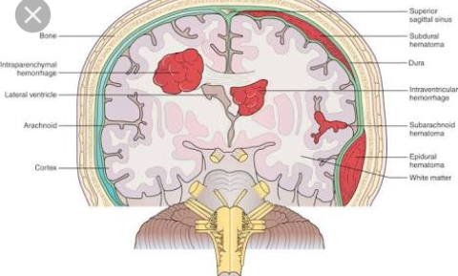
Type of hemorrhage.
A. External hemorrhage
Escape of blood outside the body .
- 1 Epistaxis: Bleeding from the nose .
3- Hemoptysis: Coughing of blood .
3- Hematemesis: Vomiting of blood .
4- Melena: Presence of dark digested blood in stools.
5- Bleeding per rectum: passage of red blood with stool
6- Hematuria: Blood in urine.
7- Menorrhagia: Excessive or prolonged menstrual bleeding
8- Metrorrhagia: Irregular uterine bleeding unrelated to menses
9- Bleeding from skin. stage 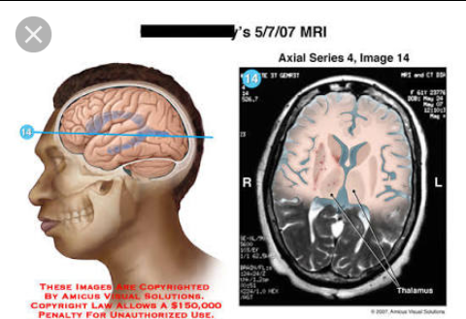

B. Internal hemorrhage
Bleeding into body cavities.
1- Hemothorax: Hemorrhage into the pleural sac.
2- Hemopericardium: Hemorrhage . into pericardial sac.
3- Hemoperitoneum: Hemorrhage . into peritoneal sac.
4- Hematocele: Hemorrhage . into tunica vaginalis sac.
5- Hemoarthrosis: Hemorrhage . into a joint cavity.
C. Interstitial hemorrhage
1) Hematoma: Hemorrhage enclosed within a tissue or a cavity .
2) Petechial: Minute 1-2 mm hemorrhages occurring in the skin, mucosal
membrane, or serosal surface .
3) purpura: Slightly > 3mm hemorrhage occurring in the skin .
4) Ecchymosis: Larger than 1-2cm subcutaneous hematoma (bruises). It is typical
after trauma.
Effects of haemorrhage: depend on the rate and amount of blood loss:
• If > 20% the total blood volume is rapidly lost from the body, it may lead to
hypovolemic shock & death. Chronic loss of blood leads to anemia.
Hemostasis and Blood Coagulation
Hemostasis
Definition:
Hemostasis is the maintenance of the clot-free state of blood & the
prevention of blood loss via the formation of hemostatic plug.
Hemostasis depends on three general components:
a) Vascular wall
b) Platelets
c) Coagulation pathways
Whenever a vessel is ruptured or severed, hemostasis is achieved by several
mechanisms:
A. Vascular rupture

C. Formation blood clot as a result of blood coagulation
D. Eventual growth of fibrous tissue in to the blood clot to close the hole in the
vessel permanently.
Steps of heamostasis :
The mechanism of heomostasis can be divided into four stages
- Constriction of blood vessels
- Formation of temporary platlets
- Activation of coagulation cascade
- Formation of fibrin plug
Purpose of hemostasis
It facilitates a series of enzymatic activation that lead to a formation of clot with platlets and fibrin clots .This clot seals toinjured area controls and prevents further bleeding while tissue regeneration process takes place

Repair
Defination:
It is a healing outcome in which tissue donot return to their normal architecture and function .
Repair typically results in the formation of scar tissue
Repair process
- Removal of Debris
  - begins early and initiated by liquefaction and removal of dead cells and other debris
- Formation of Granulation Tissues
  - connective tissue consisting of capillaries and fibroblasts that fills the tissue defect created by removal of debris
- Scarring
  - fibroblasts produce collagen until granulation tissue becomes less vascular and less cellular
  - progessive contraction of the wound occurs, resulting in deformity of original structure
- Retention of debris or foreign body
- Impaired circulation
- Persistent infection
- Metabolic disorders
  - diabetes
- Dietary deficiency
  - ascorbic acid
  - protein
most often consist of a combination of regeneration and scar formation by deposition of collegen
scar formation is the predominant healing process that occurs when the extracellular matrix framework is damaged by severe injury .
chronic inflammation that accompanies persistent injury also stimulate scar formation because of local production of growth factors and cytokines that promote fibroblast proliferation and collegen synthesis
The term fibrosis is used to describe the extensive deposition of collegen that occurs under these situation
ECM components are essential for wound healing, because they provide the framework for cell migration, maintain the correct cell polarity for the re- assembly of multilayer structures, and participate in the formation of new blood vessels (angiogenesis).
cells in the ECM (fibroblasts, macrophages, and other cell types) produce growth factors, cytokines, and chemokines that are critical for regeneration and repair. Although repair is a healing process, it may itself cause tissue dysfunction, as, for instance, in the development of atherosclerosis. Control of Normal Cell Proliferation and Tissue Growth
In adult tissues the size of cell populations is determined by the rates of cell proliferation, differentiation, and death by apoptosis (Fig. 3-3), and increased cell numbers may result from either increased proliferation or decreased cell death.
Differentiated cells incapable of replication are referred to as terminally differentiated cells.
The impact of differentiation depends on the tissue under which it occurs: in some tissues differentiated cells are not replaced, while in others they die but are continuously replaced by new cells generated from stem cells.

Healing :
Defination
Healing is the body response to injury in an attempt to restore normal structure and function
Process of healing:
The process of healing involves 2 distinct processes :
- Regeneration
- Repair
Regeneration :
Is when healing takes place by proliferation of parenchymal cell and usually results in complete restoration of original tissue
The goal of all surgical procedure should be regeneration which return the tissue to their normal microstructure and function .

Healing
- Fibroplasia is a response to
  - Damaged connective tissue
  - Parenchymal damage exceeds regenerative capacity
- Hyperplasia of connective tissue
- Neovascularization
- Granulation
  - coordinated proliferation of fibroblasts with a rich bed of capillaries
stages of wound healing :

stage of inflammation
stage of granulation tissue formation and organization
stage of epithelialisation
stage of scar formation
stage of mutation
Phases of wound healing
For soft tissue wound healing
1 inflammatory phase :
It can be broken down into further
- clot formation
- early inflammation
- Late inflammation
2 proliferative phase
3 Mutation phase
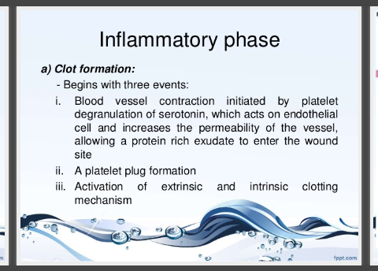
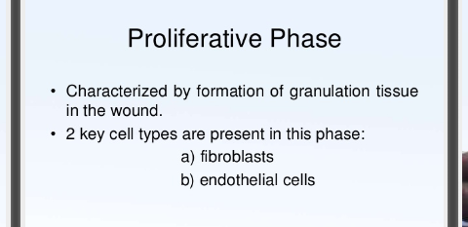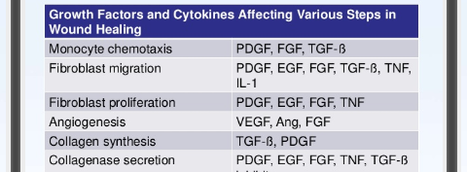

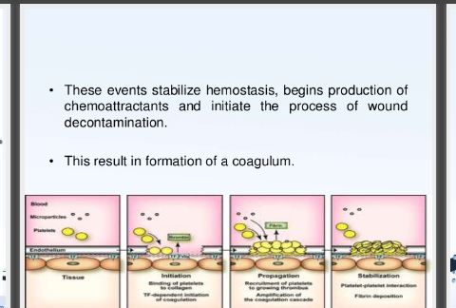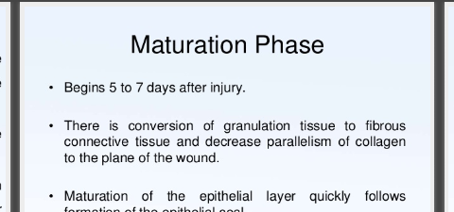

- intensely hyperemic with a roughened or granular,
- Mechanisum of wound healing:
Healing by first intention
- clean surgical incision or other clean narrow cut
- Focal disruption of epithelial basement membrane with little cell damage
- Regeneration dominates fibrosis
- Scabbing with fibrin-clotted blood
- Neutrophils migrate to edges
- Epidermis becomes mitotic and deposits ECM
- Macrophages replace neutrophils
- Vascularization and collagen deposition fills gap
- Contraction of collagen minimizes epidermal regeneration
Healing by second intention
Larger area of tissue injury such as abcess, ulcer, infarction that destroys ECM
- Large clot or scab with fibrin and fibronectin fills gap
- Larger volume of necrotic debris must be removed by more neutrophils and macrophages
  - Opportunity for collateral damage by phagocytes
- Scar tissue formed from vascular cells, fibroblasts, and myofibroblasts
- Contraction of myofibroblasts distorts tissue
More prone tinf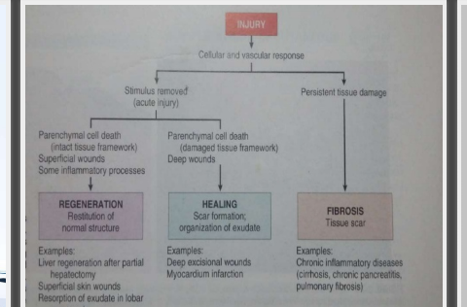
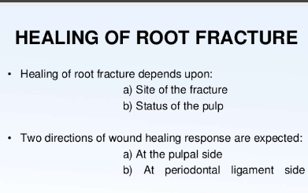

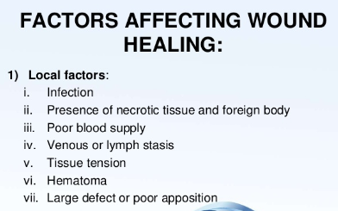
A3 Renewal and regeneration:
Cell or tissue renewal and regeneration are the two main developmental requirements of adult organisms. Both processes have as starting point a population of stem cells, normally located in a specific environment called the “niche” [1], which provides them the required signals to maintain the stemness properties, or to differentiate to the required different cell types.
Cell renewal:
Cell Renewal. (cell biology) it is the replacement of cells, for example those in the skin, by the proliferative activity of basal stem cells.
Fast renewal tissues can be recognized by a higher mitotic activity. Conversely, slow renewal tissues contain less mitosis, and may not be easily recognized from non-renewing areas which may also present some mitosis . The fate decisions of stem cells during proliferation directly influence tissue renewal and homeostasis.
Cell renewal cycle of skin cells:
Our skin has its cell renewal own cycle during which the epithelial cells regenerate from the epidermis deepest layer to replace those that form skin surface.

As we age, cell renewal slows down more and more, causing a significant change in the epidermis structure, the skinmost superficial part.

Indeed, with each passing day our skin replaces the older epithelial cells, now become inefficient, with new cells that allow an epithelial tissue renovation.

Cellular renewal: process time
At a young age, cell renewal process is completed in about 28 days.

There is an optimal production of collagen and elastin; i.e. production of proteins that help to support dermis structure, making the skin smooth, toned and compact.

After turning 30, however, this process tends to slow down, requiring more and more days to complete cell replacement path, with a natural consequence of skin aging.

And after turning 40:

The collagen and elastin production decreases further, going to undermine the skin structure with three main effects:

- loss of tone and firmness of the skin,
- gradual skin thickening,
- a more pronounced expression of wrinkles and skin lines.

Regeneration:
- Regeneration replaces lost structures.
- Regeneration in human is the regrowth of loss tissues or organs in response to injury.
- This is constant to wound healing, or partial regulation, which involves closing up the injury site with some gradation of scar tissue. Some tissues such as skin, the vas defence and large organs including the liver can regrow quite readily.
- Skin tissue can be regenerate in vivo and in vitro. Other organs and body parts have been procured to regenerate, include: penis, fats and a scalad down human heart.
Regeneration in cell:
- Regeneration in the processes of renewal, restoration and growth that make genomes, cells, organisms, and ecosystem resilient to natural function or cause disturbance or damage, their cells become activated and restore the organs back to their pre-existing state.
What tissue can generate:
- Skeletal muscles have ability to regenerate and form new muscle tissue, while cardiac muscle cells do not regenerate. Cardiac stem cells may be coaxed in to regenerating cardiac muscle with new medical strategies .Smooth muscle cells have the greatest ability to regenerate.
Examples:

- Liver regeneration after partial hepatectomy.
- Superficial skin wounds.
- Resorption of exudate in lobar pneumonia.
Q4. Write a detailed note on staphylococcus and streptococcus (15)
A4. Staphylococcus:
Staphylococcus is a genus of Gram-positive bacteria in the family Staphylococcaceae from the order Bacillales. Under the microscope, they appear spherical (cocci), and form in grape-like clusters. Staphylococcus species are facultative anaerobic organisms (capable of growth both aerobically and anaerobically).
Scientific name:Staphylococcus
Class: Bacilli
Higher classification: Staphylococcaceae
Phylum: Firmicutes
Rank: Genus
Order: Bacillales
Lower classifications: Staphylococcus epidermidis, MRSA Super bug
Structure:
Staphylococci are Gram-positive cocci about 0.5-1.0 micrometer in diameter.they grow in cluster, pairs and occasionally is short chains. The clusters arise because staphylococcus divide in two planes.
The configuration of the cocci help to distinguish micrococci and staphylococci from streptococci, which usually grow in chains.
Natural habitat:
S aures colonizes the nasal passage and axillae. S epidermis isa a common human skin commensal.
Other species of staphylococci are infrequent human commensals. Some are commensals of other animals.
Pathogenesis:
S aureus expresses many potential virulence factors.
- Surface proteins that promote colonization of host tissues.
- Factors that probably inhibit phagocytosis (capsule, immunoglobulin binding protein).
- Toxins that damage host tissues and cause disease symptoms

Host defenses:

Phagocytosis is the major mechanism for combatting staphylococcal infection.
Antibodies are produced which neutralize toxins and promote opsonization.
The capsule and protein A any interfere with phagocytosis.

Treatment:

Infections acquired outside hospital can usually be treated with Penicilinase-resistant beta-lactams.
Hospital acquired infection is often caused by antibiotic resistant stains and can only be treated withvancomycin.

Diagnosis:

Diagnosis is based on performing tests with colonies. Tests for clumping factor, coagulase, hemolysis and thermostable deoxyribonuclease are rotinely used to identify S aureus.
Commercial latex agglutination tests are available. Identification of S epidermis is confirmed by commercial bio typing kits.
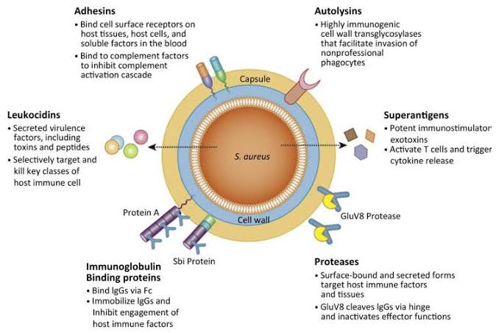

Streptococcus:

Streptococcus is a genus of gram-positive coccus or spherical bacteria that belongs to the family Streptococcaceae, within the order Lactobacillales, in the phylum Firmicutes. Cell division in streptococci occurs along a single axis, so as they grow, they tend to form pairs or chains that may appear bent or twisted.

Scientific name:Streptococcus

Class: Bacilli

Phylum: Firmicutes

Rank: Genus

Higher classification:Streptococcaceae

Order:Lactobacillales

Lower classifications: Group A streptococcus, Streptococcus agalactiae,

Classification of streptococci:

Three different types of streptococci are initially differentiated by their appearance when they are grown on sheep blood agar:
- Beta-hemolytic streptococci produce zones of clear hemolysis around each colony.
- Alpha-hemolytic streptococci (commonly called viridian streptococci) are surrounded by green discoloration resulting from incomplete hemolysis.
- Gamma-hemolytic streptococci are nonhemolytic.

Structure:

Structure. Streptococci are Gram-positive, nonmotile, nonsporeforming, catalase-negative cocci that occur in pairs or chains. Older cultures may lose their Gram-positive character. Most streptococci are facultative anaerobes, and some are obligate (strict) anaerobes.

Virulence factors:

Many streptococci elaborate virulence factors, including streptolysins, DNSases, and hyaluronidase, which contribute to tissue destruction and spread of infection.

Diseases caused by streptococci:

The most significant streptococcal pathogen is S. pyogenes, which is beta-hemolytic and in Lancefield group A and in thus denoted as group A beta-hemolytic streptococci (GABHS).
The most common acute diseases due to GABHS are:
- Pharyngitis
- Skin infections
- In addition, delayed, nonsuppurativecomplications (rheumatic fever,acuteglomerulonephriris) sometimes occur > 2 weeks after infection.

Diagnosis:

- Culture
- Sometimes rapid antigen tests or antibody titers
- Streptococci are readily identified by culture on a sheep blood agar plate.

Treatment:

Penicillin is a drug of choice for pharyngeal GABHS infections. No isolate of GABHShas shown penicillin resistance clinically.
However some streptococcal strains appear to have in vitro tolerance to penicillin(i.e, significantly decreased bacterial effect of penicillin); the clinical significance of such strains is nuclear

