Page1

NAME:ALAMZEB
ID:14481
DEP:COMPUTER SCIENCE
PROGRAM:SOFTWARE ENGNIEERING
SECTION:BS(SE-4)(A)

Page2

Q1:
ANS
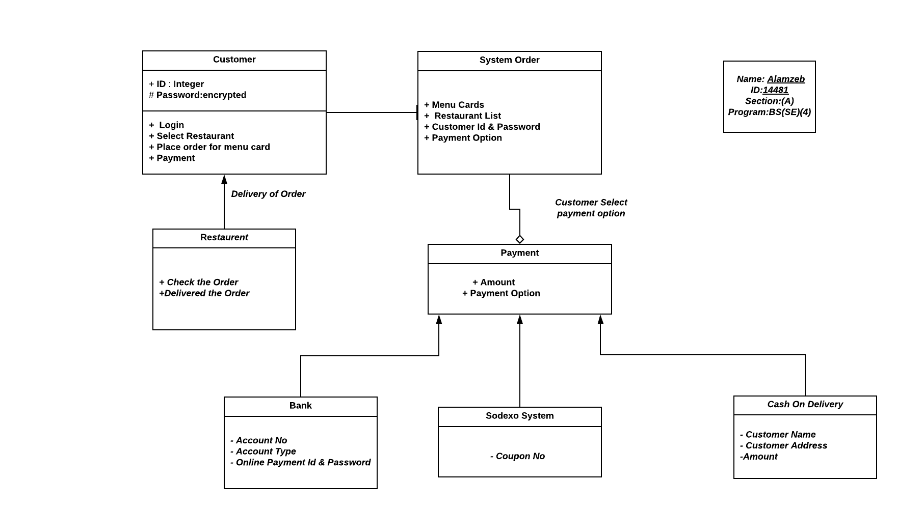

Page3

Q2: Suggest how an engineer responsible for drawing up a system requirements specification might keep track of the relationships between functional and non-functional requirements.
Ans: FUNCTIONAL:
- The functional requirements describe what the system should do while.
- Statements of services the system should provide, how the system should react to particular inputs and how the system should behave in particular situations
NON-FUNCTIONAL:
- The non-functional requirements describe how the system works.
- Often apply to the system as a whole rather than individual features or services.
In Software Engineering, the software requirements focus on the needs that should be solved by the software.
- The requirements needed to design meets the requirements such as compatibility, portability etc.
- Design the system so that it ensures the safety and security.
- Implementing the system in an efficient manner.
- The cost and time required for the development should not affect the design and implementation of the system.
The functional requirement defines the use of the developer knowledge. It does not conflict with each other.
The first step is to make the systems requirements document.
It is engineer responsible to prepare documents to each functional and non-functional requirement.

The engineer needs to prepare the document depending on this: Non-functional requirments need the natural language and functional requirements need the structured language to understand better.
- It gives the matrix that shows each requirement related to each other.
- It is very difficult to manage because the functional and non-functional requirements put efforts with each other on track of relationships.
- Non-functional requirements linked with functional requirements to list identify the system levels that have related each other
- The engineer needs to prepare the way to link the functional to non-functional to implement it.
- The functional requirements enforce the non-functional requirements that shall be recorded and tracked.
- For example :
if a system involved user logins and sessions, the engineer might draw a line between the functional requirement “A user shall be able to login to the system by entering his/her username and password” and the non-functional requirements “A particular user session should not last more than five hours” and “User password should be reset every 150 days to ensure security,” to indicate that the two system requirements will have a direct effect on the user requirement.

Q3:
ANSWER:
It is difficult to introduce agile methods into large companies for a number of reasons
- Project managers who don’t have experience of agile methods may be reluctant to accept the risk of a new approach, as they do not know how this will affect their particular projects
- Project managers who don’t have experience of agile methods may be reluctant to accept the risk of a new approach, as they do not know how this will affect their particular projects
- Agile methods seem to work best when team members have a relatively high skill level. However within large organizations there are likely to be a wide range of skills and abilities. And people with lower skill levels may not be effective team members in agile processes.
Example :
If the company decided to close down a number of offices that were specialized in using agile methods they may face a multitude of difficulties. When a company is driven by a close team and is divided they will be unable to have daily meetings, which can cause issues with communication, programming in pairs would not be possible, a communication gab would be created, productivity will slow down due to communication issues, and detecting errors would be quite difficult. These problems can be avoided by creating merging offices together so pair programming and daily communication can be established. If that is not possible, a communication platform consisting of webcams, desktop viewing software, and microphones should be created to allow better communication.

Q4:
ANSWER:
An automated ticket-issuing system sell rail tickets .User select their destination and inputs a credit card and personal identification number . The rail ticket is issued and their credit card account charged . When the user presses the start button , a menu display of potential destination is activated , along with a message to the user to select a destination . Once a destination has been selected , users are requested to input their credit card . Its validity is checked and the user is when requested to input a personal identifier . When the credit transaction has been validated , the ticket is issued.
AMBIGUITIES AND OMISSION INCLUDE:
- Is it to select multiple destination same time?
- Ticket needs to book either single person or multiple people on same time to the destination?
- Destination selected is wrong then is it possible to cancel or go back?
- Supposed an invalid credit card is used then what will happen?
- Is it to swipe or insert the credit card?
- Is it manually entering the number?
- Is it there rooms or train?
- If an incorrect personal identification number is entered then what happen?
- Ticket prices are varying for Adults/child?
- In this first if the person have no credit card. Then what? Whats the process of cash.
- What if the person choose the wrong destination? So can he go back in options?
- Is there a cancel option to change the destination?
- Is there voice for blind who can’t read?

Q5
ANSWER:

1. The customer goes up to the ATM and inserts card into the reader. Typically, the ATM offers a set of quick actions the customer can take but they all require a PIN to be entered .Upon entering the pin, the customer can then deposit cash or checks (up to 50 bills), withdraw cash, and/or view their balance.
2. The customer has 5 chances to enter their pin successfully, otherwise the account gets locked for possible fraud or theft – the bank gets notified of these actions. Even though these actions may be fraudulent, the ATM is designed to return the card. It displays an error and states that the customer should go to the physical location (bank) or call customer service.

