NAME : HASEEB ULLAH KHAN

ID NO : 16081

SUBJECT : ARCHITECTURE

DEPARTMENT : CIVIL ENGINEERING

SEMISTER : FALL 2020

QNO1:

ANS NO 1:

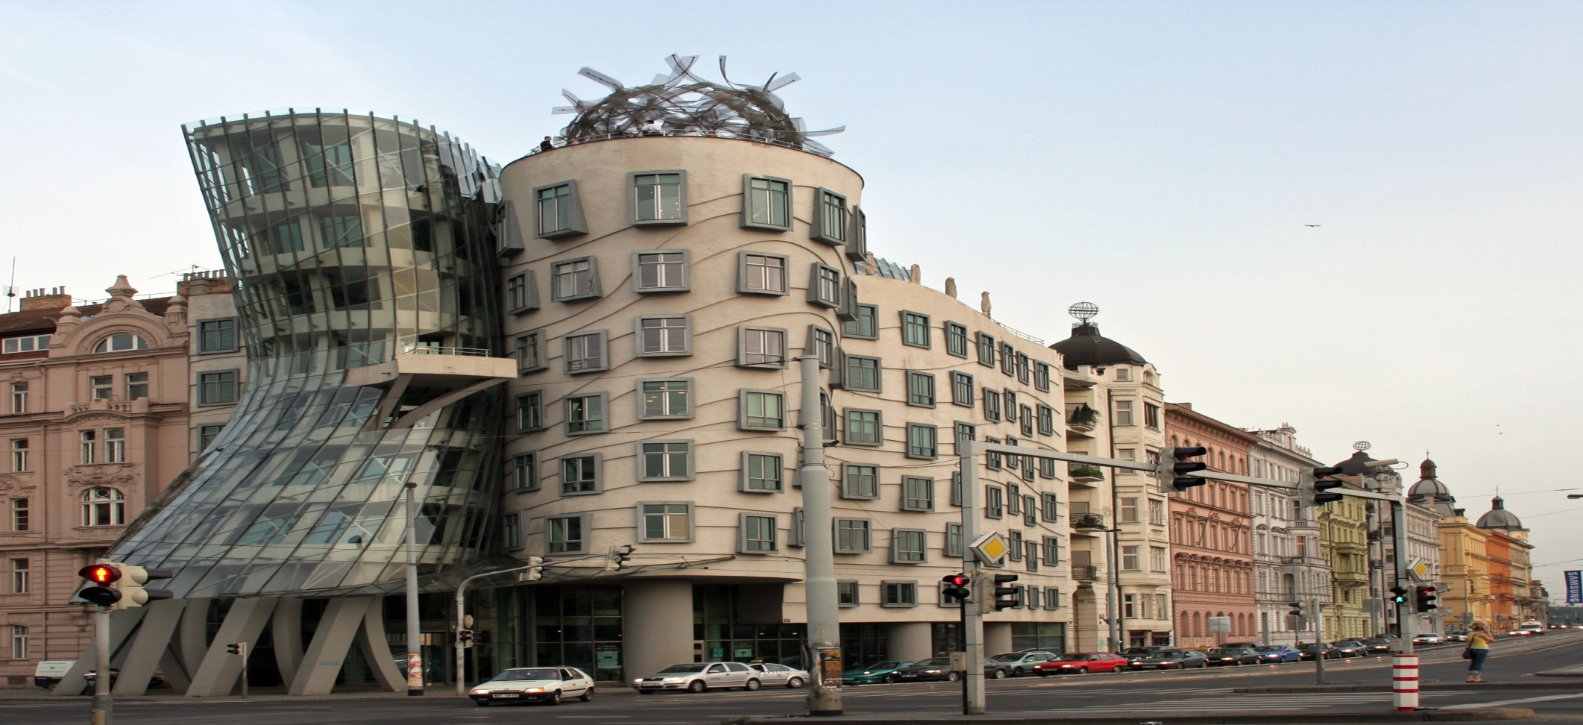

History: The antithesis of da vinci’s unity but still balance of opposition. The contemporary architects frank Gehry and vlado milunic designed the raisin building (1992-96) in prague, Czech republic as statement of harmony between the old and new world culture. Built in 15th century and that was destroyed in world war II.

Principal of design: To organizing formal element (line, space, light, color, texture, pattern, time, motion) into the whole composition.

Nick name: The building’s nick name are “Dancing house” and Fred and Ginger” because the two sides twist and whirl.

Positive points: The building is a playful celeb of modern engineering to look like brink of catastrophe but it’s structurally sound.

Negative points: We sense a of collapse the forms are twisted distorted and the foundation appears to be faulty.

Attraction: We can do nothing because it is so attractive for its designing.

QNO2:

ANS NO 2:

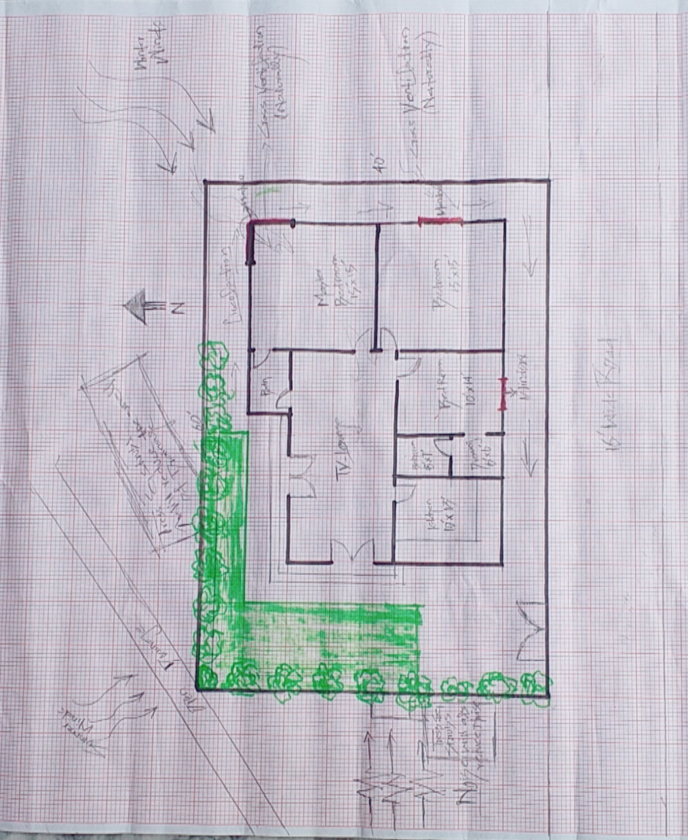

QNO 3:

ANS NO 3:

