Name: Sayed Abaseen
ID: 12534
Subject: operation management
Submitted to: Sir Dr Liaqat Ali
Mid-term Assignment
Date 4/18/2020
IQRA NATIONAL UNIVERSITY, KPK, PESHAWAR, PAKISTAN

Assignment Note: Attempt all questions. Submission in the form of MS word is compulsory. Operation Management:
Question No.1
i. Farming, mining, construction are examples of
(a) Good producing (b) Service producing (c) Good and Services both (d) None of them
Ans : (a) Goods producing
ii. ------------results from a mismatch between supply and demand
(a)Inventory (b) Capacity (c) Supply (e) none of them
Ans: (a) inventory
iii. In contrast to the demand function, the quantity which suppliers are willing to supply usually varies ----------- with the market price
(a) Inversely (b) Directly (c) Both (a) and (b) (d) None of them
Ans: (c) Both (a) & (b)

iv. The demand and supply functions are
(a) Quadratic (b) Linear (c) Nonlinear (d) None of them
Ans: (b) linear
v. -------is the process of comparing the actual with the standard and taking corrective action.
(a) Controlling (b) Planning (c) Co-ordination (d) Management (e) None of them
Ans: (a) Controlling
vi. The term ________ implies the foregone profit due to inability of company to produce.
(a) Opportunity cost (b) Marginal cost (c) Overhead cost (d) All of the above
Ans: (a) Opportunity cost
Vii. Which of the following is not the characteristic of Project Production?
(a) Continuous flow of material (b) Highly mechanized material handling, (c) Virtually zero manufacturing cycle time (d) All of the above
Ans: (d) All of the above
viii. Inadequate production capacity ultimately leads to
(a) Poor quality (b) Poor Customer Service (c) Poor inventory control (d) All of the above
Ans: (b) Poor Customer Service

ix. Which of the following statements regarding the Production Order Quantity model is true?
(a) It applies only to items produced in the firm's own production departments.
(b) It relaxes the assumption that the demand rate is constant.
(c) It minimizes the total production costs.
(d) It relaxes the assumption that all the order quantity is received at one time.
(e) It minimizes inventory.
Ans: (d) It relaxes the assumption that all the order quantity is received at one time.
x. The purpose of the transportation approach for location analysis is to minimize
(a) Total costs (b) total shipping costs
(c) Total variable costs (d) total fixed costs (e) the number of shipmen
Ans: b) total shipping costs

Question No.2
Discuss the OM’s Organization roles. What are the characteristics of Goods and Services?
Answer: Discuss the OM’s Organization roles
The role of operation management is to transforms inputs into outputs. Operation management is the main and important function of every organization and its also related to the management function so the role of operation management is to manage the production of an organization and also to have control over planning, organizing, leading.
Managing the human resource, equipment and technology other information for the production of good and service. In inputs we involved human, raw-material, and money.
Goods and services will be our outputs
What are the characteristics of Goods and Services?
Goods:
Are tangible, it can be touch seen and move from one place to other.
Goods can be owned from one person to other person.
It can be use for more than on time.
It can produce in factory

Services:
Services are intangible they are only exist can’t be seen or touch.
Services are generally customized, the quality and performance.
Services can be use only once.
Services can’t be own.
Its cant be kept in stock
Services are an activity and its is a performance

Question No.3
Suppose demand and supply functions have been estimated for two competing products.
qd₁ =2q₁-3q₂-3 (demand, product 1) , qd₂ =q₁+4q₂-8 (demand, product 2)
, qs₁ =q₁-3 ( supply, product 1), qs₂ = 4q₂-2 (supply , product 2 )
Determine the price for which the market equilibrium would exist.

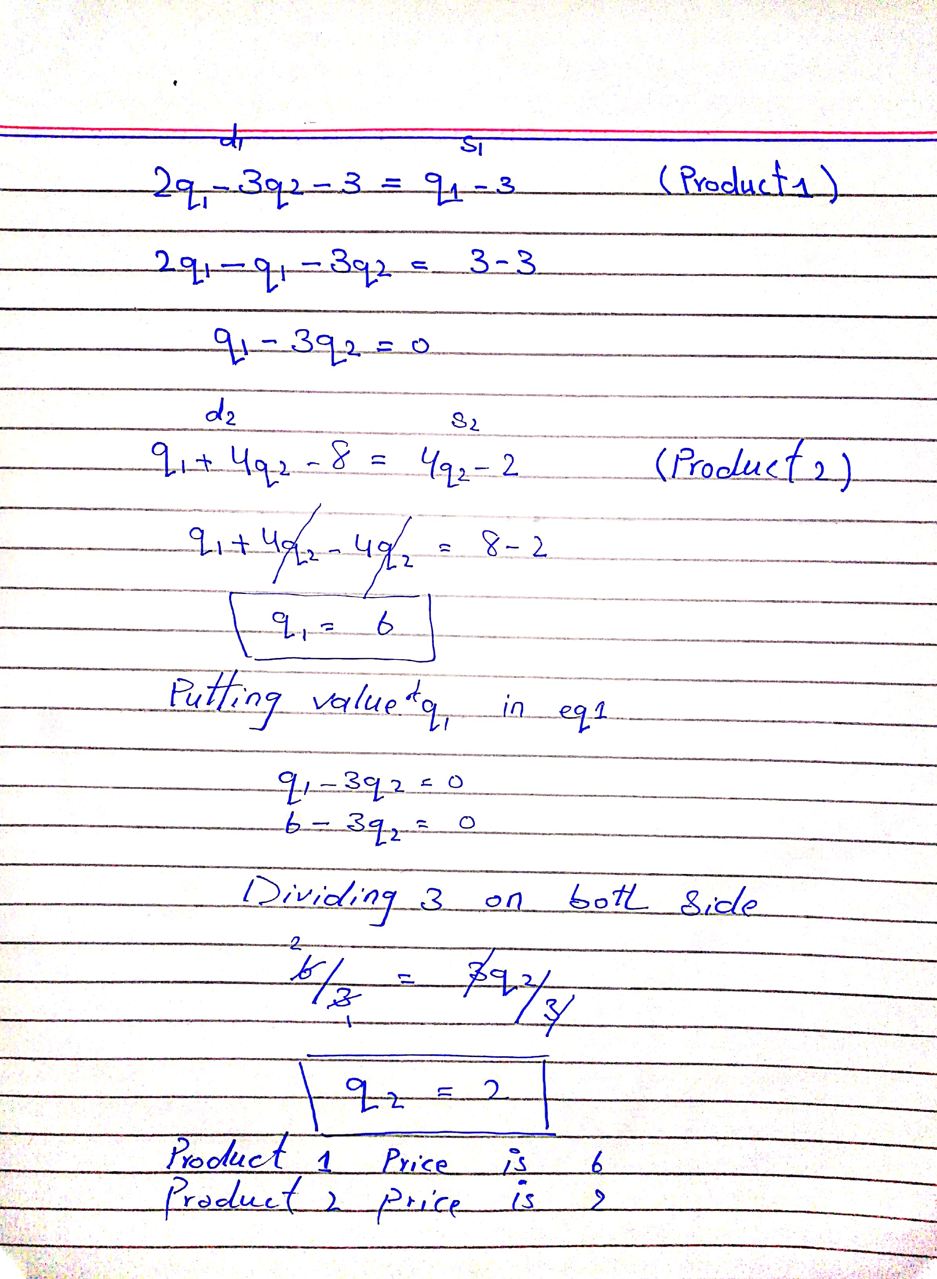Question No.4:
What is Operational Manager also discuss the role of operational manager?
Ans: Operational Manager:
The operation manager is person who supervises everything everyday like all the activities of organization and controls the operations which meet to the actual strategy of organization. Making plans to develop the performance of organization and achieve organization goals.
Operation manager is to minimize the risk and cost and maximize the profit to organization.
Role of operational manager:
Operation manager make sure that the actual performance is matching to the standard performance.
Creating strategic decisions with the help of planning, designing of operation.
The role of operation manager is to control the flow of good from manufacturing to warehouses and from that point to the sales.
To control of product production insure about the quality of production operation manager checking on servicing machines, repairing, of necessary device, building infrastructure.

Question No.5:
How Organizations can gain Competitive advantages.
Ans:
Organization can gain competitive advantages by look at the organization terms and value of three functions.
- Marketing
- Finance
- Operation
Competitive advantages by marketing base strategy:
Organization identifies the customer’s needs and wants and their demands. By having good pricing strategy organization can attract more customers toward it self.
Have good skill and idea about advertising and promotion and making good image of the organization in market is also one of the reasons of gaining competitive advantages.
Competitive advantages by finance base strategy:
A company should identify how to and where to us their money.
And company should acquisition of long term assets which profit more than one time periods.
An organization should also know their equity and debt and identify capital structure.
Competitive advantages by operation base strategy:
The company should make proper goods and services design by creating of that product and service make favorable to customers.
Organizations kept their price low and make it as economical
The quality should be related to the price and services.
An organization should always be an active in any situation and make a quick response to any problem.
An organization should be flexible with the changes of situation and environment organization should change itself as well.
Organization should keep controlling on the stock and also maintain the production process and focus on the supply chain management that how to deliver their product from factory to market for sale.
And organization should always keep in mind that the customers issue is that organization issue

