FINAL TERM ASSIGNMENT
ANATOMY
MOIEEZ TARIQ

ANSWER NO 1:
SUPERFICIAL POSTERIOR COMPARTMENT OF LEG
MUSCLES | BLOOD SUPPLY | ACTIONS
Gastrocnemius | Tibial nerve S1 S2 | Plantarflexes ankle when knee is extended; raises heel during walking; flexes leg at knee joint
plantaris | Tibial nerve S1 S2 | Weakly assists gastrocnemius in plantarflexing ankle
soleus | Tibial nerve S1 S2 | Plantarflexes ankle independent of position of knee; steadies leg on foot

DEEP POSTERIOR COMPARTMENT OF LEG
MUCLES | Blood supply | Actions
Flexor Halluces longus muscle | Tibial nerve S1 S2 | Flexes big toe at all joints; weakly plantarflexes ankle; supports medial longitudinal arch of foot
Tibialis posterior muscle | Tibial nerve  (L4, L5) | Plantarflexes ankle; inverts foot
Flexor digitorium longus muscle | Tibial nerve  (S1, S2) | Flexes lateral four digits; plantarflexes ankle; supports longitudinal arches of foot
Popliteus muscle | Tibial nerve  (L4, L5, S1 | Weakly flexes knee and unlocks it by rotating femur 5 deg on fixed tibia; medially rotates tibia of unplanted limb

ANSWER NO 2:
FOOT DROP:
Foot drop is a gait abnormality in which the dropping of the forefoot happens due to weakness, irritation or damage to the common fibular nerve including the sciatic nerve, or paralysis of the muscles in the anterior portion of the lower leg. It is usually a symptom of a greater problem, not a disease in itself.
CAUSES
- Foot drop is caused by weakness or paralysis of the muscles involved in lifting the front part of the foot.
- Causes of foot drop might include: Nerve injury.
- The most common cause of foot drop is compression of a nerve in your leg that controls the muscles involved in lifting the foot (peroneal nerve).

SIGNS AND SYMPTOPMS
- Inability to hold footwear. A feeling of loosening of the footwear may cause discomfort and dragging of the affected foot while walking. ...
- Tripping. ...
- Falls. ...
- High steppage gait. ...
- Circumduction gait. ...
- Limp foot. ...
- Numbness. ...
- Often unilateral

TREATMENT
Treatment for foot drop might include: Braces or splints. A brace on your ankle and foot or splint that fits into your shoe can help hold your foot in a normal position

b. DEEP VENOUS THROMBOSIS:
Deep vein thrombosis (DVT) is a serious condition that occurs when a blood clot forms in a vein located deep inside your body. A blood clot is a clump of blood that's turned to a solid state. Deep vein blood clots typically form in your thigh or lower leg, but they can also develop in other areas of your body.
CAUSES
DVT is caused by a blood clot. The clot blocks a vein, preventing blood from properly circulating in your body. Clotting may occur for several reasons. These include:
- Injury. Damage to a blood vessel’s wall can narrow or block blood flow. A blood clot may form as a result.
- Surgery. Blood vessels can be damaged during surgery, which can lead to the development of a blood clot. Bed rest with little to no movement after surgery may also increase your risk for developing a blood clot.
- Reduced mobility or inactivity. When you sit frequently, blood can collect in your legs, especially the lower parts. If you’re unable to move for extended periods of time, the blood flow in your legs can slow down. This can cause a clot to develop.
- Certain medications. Some medications increase the chances your blood will form a clot.

SIGN AND SYMPTOMS
- swelling in your foot, ankle, or leg, usually on one side
- cramping pain in your affected leg that usually begins in your calf
- severe, unexplained pain in your foot and ankle
- an area of skin that feels warmer than the skin on the surrounding areas
- skin over the affected area turning pale or a reddish or bluish color
People with an upper extremity DVT, or a blood clot in the arm, may also not experience symptoms. If they do, common symptoms include:
- neck pain
- shoulder pain
- swelling in the arm or hand
- blue-tinted skin color
- pain that moves from the arm to the forearm
- weakness in the hand
TREATMENT
DVT treatments focus on keeping the clot from growing. In addition, treatment may help prevent a pulmonary embolism and lower your risk of having more clots.

ANSWER NO 4
SCIATIC NERVE
ANATOMICAL COURSE
The sciatic nerve is derived from the lumbosacral plexus. After its formation, it leaves the pelvis and enters the gluteal region via greater sciatic foramen. It emerges inferiorly to the piriformis muscle and descends in an inferolateral direction.
As the nerve moves through the gluteal region, it crosses the posterior surface of the superior gemellus, obturator internus, inferior gemellus and quadratus femoris muscles. It then enters the posterior thigh by passing deep to the long head of the biceps femoris.
Within the posterior thigh, the nerve gives rise to branches to the hamstring muscles and adductor magnus. When the sciatic nerve reaches the apex of the popliteal fossa, it terminates by bifurcating into the tibial and common fibular nerves.

SENSORY FUNCTIONS
The sciatic nerve does not have any direct cutaneous functions. It does provide indirect sensory innervation via its terminal branches:
- Tibial nerve – supplies the skin of the posterolateral leg, lateral foot and the sole of the foot.
- Common fibular nerve – supplies the skin of the lateral leg and the dorsum of the foot.
MOTOR FUNCTION
Innervates the muscles of the posterior thigh (biceps femoris, semimembranosus and semitendinosus) and the hamstring portion of the adductor magnus (remaining portion of which is supplied by the obturator nerve). Indirectly innervates (via its terminal branches) all the muscles of the leg and foot.

ANSWER NO 5
The muscles in the medial compartment of the thigh are collectively known as the hip adductors. There are five muscles in this group; gracilis, obturator externus, adductor brevis, adductor longus and adductor magnus.
All the medial thigh muscles are innervated by the obturator nerve, which arises from the lumbar plexus. Arterial supply is via the obturator artery.
MEDIAL COMPARTMENT OF THIGH MUSCLES

MUSCLES | ACTIONS
Aductor magnus | They both adduct the thigh. The adductor component also flexes the thigh, with the hamstring portion extending the thigh
Adductor longus | Adduction of the thigh.
Adductor brevis | Adduction of the thigh
Obturator externus | Adduction and lateral rotation of the thigh.
gracilis | Adduction of the thigh at the hip, and flexion of the leg at the knee.

B. TARSAL TUNNEL SYNDROME
Tarsal tunnel syndrome is a compression, or squeezing, on the posterior tibial nerve that produces symptoms anywhere along the path of the nerve running from the inside of the ankle into the foot. Tarsal tunnel syndrome is similar to carpal tunnel syndrome, which occurs in the wrist.
CAUSES
Tarsal tunnel syndrome results from compression of the tibial nerve, and it’s often caused by other conditions.
Causes can include:
- severely flat feet, because flattened feet can stretch the tibial nerve
- benign bony growths in the tarsal tunnel
- varicose vein in the membrane surrounding the tibial nerve, which cause compression on the nerve
- inflammation from arthritis
- lesions and masses like tumors or lipomas near the tibial nerve
- injuries or trauma, like an ankle sprain or fracture — inflammation and swelling from which lead to tarsal tunnel syndrome
- diabetes, which makes the nerve more vulnerable to compression
SYMPTOMS
- sharp, shooting pains
- pins and needles
- an electric shock
- a burning sensation
TREATMENT

At-home treatments
You can take anti-inflammatory medications (including nonsteroidal anti-inflammatory drugs) to reduce inflammation, which may alleviate compression of the nerve. Resting, icing, compression, and elevation, known as the RICE treatment, may also help reduce swelling and inflammation.

Doctor-prescribed treatments
Steroid injections may also be applied to the affected area to reduce swelling. In some cases, braces and splits may be used to immobilize the foot and limit movement that could compress the nerve. If you have naturally flat feet, you may want to have custom shoes made that support the arches of your feet.

ANSWER NO 3:

Introduction
The arterial blood supply of the thigh comes directly from the external iliac artery. The external iliac artery becomes the femoral artery after it passes beneath the inguinal ligament and enters the femoral triangle.

Femoral Triangle
The femoral triangle is a useful anatomical landmark. This triangular depression is located inferiorly to the inguinal ligament. It is bounded by the adductor longus muscle medially and the Sartorius muscle laterally. Three important structures run through the femoral triangle – femoral nerve, femoral artery and femoral vein (from most lateral to medial). At the apex of the femoral triangle, the femoral artery and vein enter the adductor canal.

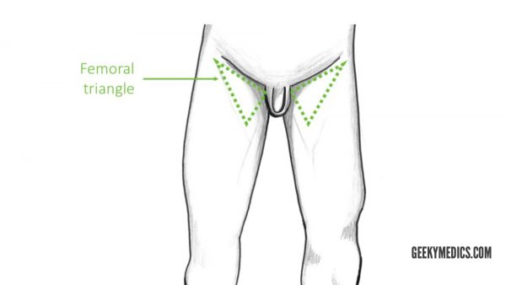Femoral triangle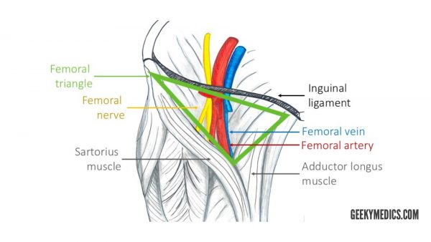Arteries of the Thigh
The femoral artery runs in the middle of the femoral triangle. It supplies the anterior and anteromedial aspects of the thigh.
The profunda femoris artery is the largest branch of the femoral artery. This vessel is also known as the deep artery of the thigh and has three main branches:
- Medial circumflex femoral artery (MCFA)
- Lateral circumflex femoral artery (LCFA)
- Perforating branches – three to four arteries supplying the posterior and anterolateral muscles of the thigh (adductor magnus, hamstrings, vastus lateralis). They run laterally across the muscles.
the profunda femoris artery never leaves the thigh.

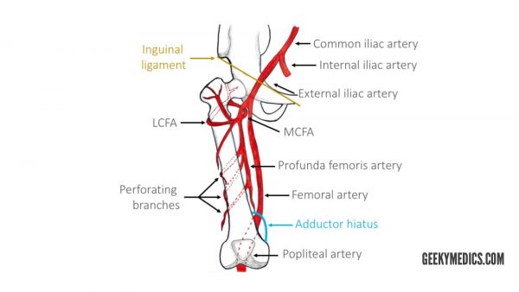

The femoral artery then enters the adductor canal, which terminates at the adductor hiatus. The adductor hiatus is a gap between the adductor and hamstring heads of the adductor magnus muscle. This is where the femoral artery becomes the popliteal artery.

Arteries of the Hip
The hip joint is supplied mainly by the medial and lateral circumflex femoral arteries arising from the profunda femoris artery.
The ascending and transverse branches of LCFA and MCFA anastomose wrapping around the proximal part of the femur. The retinacular branches arise from that anastomosis, supplying the neck. There is a small contribution from the superior and inferior gluteal arteries.
The head of the femur is additionally supplied by the foveal artery, which originates from the obturator artery. The foveal artery runs in the ligamentum teres of the acetabulum.

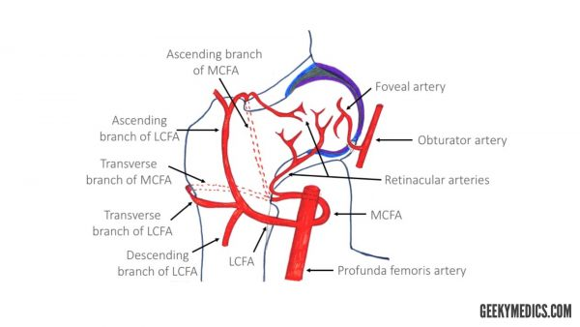Arteries of the gluteal region
The main arteries of the gluteal region are the superior gluteal and inferior gluteal arteries. They arise from the internal iliac artery.
The superior gluteal artery is the largest branch of the internal iliac artery and arises from its posterior division. It has superficial and deep branches which supply the gluteus maximus, gluteus medius, gluteus minimus and tensor fasciae latae muscles.
The inferior gluteal artery originates from the anterior division of the internal iliac artery. This artery supplies blood to the gluteus maximus, piriformis, internal obturator, gemellus superior and inferior and quadratus femoris muscles. It also gives off a branch to the sciatic nerve.
