Mid Term
Conventional radiological procedure and clinical practice Paper,
Solved By: Waqas Khan.
ID: 15091.
Program: BS Radiology.
Semester: 4th.
Iqra National University Peshawar
Ans No.1:
Barium swallow:
Barium swallow is the best for analysis, if a patient has variation from the norm/trouble in gulping.
STANDARD PROTOCOL:
- Guarantees persistent security.
- Licenses normalization of Exam.
- Permits correlation of exhibitions additional time, Treatment.
- Permits correlation with others tolerant, Groups, Normals.
- Permits Better correspondence between clinicians.
- Lip conclusion.
- Hold position.
- Bolus arrangement.
- Oral buildup.
- Delicate sense of taste rise.
- Tongue based.
- Withdrawal PES opening.
- Front hyoid mo.
---------------------------------------------------------------------------------------

Ans No.2:
Barium supper is utilized for the anomaly of duodenum and stomach study.

- Spots films of stomach lying:
RAO (Right Anterior Oblique):
In here we lie the patient in inclined position and marginally RAO.

SUPINE:
WE lie the patient at prostrate situation at pressure cushion, because of it we show the antrum and body.
LAO (Left Anterior Oblique):
In this condition we lie the patient in left side at a slant. Accordingly, we exhibit lesser bend on face.
Left lateral Tilted:
In this condition we put the head up degree edge. because of it we show the fundus. Thus gas can gather in fundus and we see it plainly.
(2) Spots films of duodenal loop lying:
PRONE:
In here the patient lies in inclined situation on pressure cushion.
SUPINE:
In this condition we lie the patient in recumbent position.
LAO (lateral Anterior oblique):
In this condition we lie the patient in left foremost angled.
The main perspective on fundus in an erect position taken in this stage.
Spots film of esophagus:
It is taken when barium is gulped to show total examination.it exhibit the throat spot film.

ANS No.3: General classification of contrast:
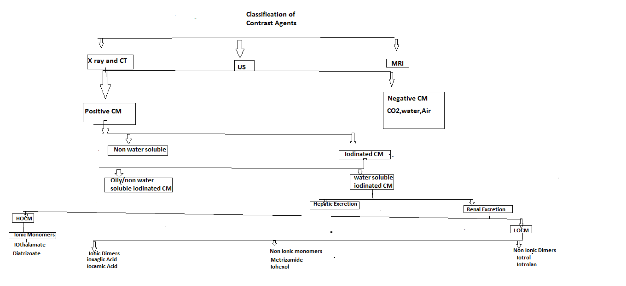
FURTHERS CLASSIFICATION:
POSITIVE CONTRAST MEDIA:
its radio hazy.
its white on film.
It is high nuclear number.
USE:
Its ordinarily use for GI track contemplates.

Iodine compounds:
USE:
Angiography:
Differentiate concentrate for vessels.
NEGATIVE CONTRAST MEDIA:
Its radio lucent.
It is low nuclear n.
BARIUM SULPHATE:
Barium is valuable and essential difference specialists in Radiology division.
Its exceptionally radio dark.
Its nuclear number is 56
It manages just orally and rectally.
Uses:
It’s used in barium swallow, barium meal, barium enema
ADVANTAGES OF BARIUM SULPHATE:
Principle advantage is dissolvable difference operators. It has fantastic coating.it permits the see typical and unusual strong example.
IODINE CONTRAST MEDIA:
Its water solvent. We oversee it just in IV B/C it is water dissolvable. Its nuclear weight is 127 and nuclear number is 53. Its normally delegated ionic and nonionic. because of their generally destructive connection with our body dissolvability.
USE:
Angiography, venography and so forth.

Iodine is preferred because:
Radiologist favored in light of high differentiation thickness, due its high nuclear numbers.

3: OILY/ Non water-soluble iodinated CM:
It is insoluble in water. It is white on radiograph.
Examples:
Myodil:
investigation of spinal line.
Ethiodol:
Both are slick differentiation, its complexity investigation of lymphatic vessels.
Complication:
Fat metabolism.
Use:
Sialography, hysterosalpingography, its more commonly in oily CM. Decry cystography, galactography, Bronchography, and Myelography.
4: WATER SOLUBLE IODINATED CM:
It is utilized for analyze of gastrointestinal ailment. It changes their adequacy in diagnosing gastrointestinal deterrent with security. In puncturing it enter the stomach hole as much as quickly.
HIGH OSMOLAR CONSTRAST MEDIA:
It's the most seasoned operators .it are moderately in costly. it is monomers that ionize in solution.it osmolality extend is 1,300 to 2,140/kg. it is around multiple times above to human blood.

LOW OSMOLAR CONTRAST MEDIA:
it is 2 multiple times over the osmolality of blood.it oversee intravascular and intrathecal. it's not constantly nonionic monomers.
Use:
iodamide, ioxilan, loperamide, ioversol, iohexol.
The LOCM additionally incorporate iso molar differentiation media. The main LOCM is as of now use in Nonionic dimer, iodixanol impact.

Thank You.

