Name : Haider Ali ID: 6916

Question no 1:
Answer: The two main functions of the data link layer are data link control and media
access control. Data link control deals with the design and procedures for commu-
nication between two adjacent nodes: node-to-node communication. Media access
control deals with procedures for sharing the link.
The two main functions of the data link layer are data link control and media
access control. Data link control deals with the design and procedures for commu-
nication between two adjacent nodes: node-to-node communication. Media access
control deals with procedures for sharing the link.
The two main functions of the data link layer are data link control and media access control. Data link control deals with the design and procedures for communication between two adjacent nodes: node-to-node communication. Media access control deals with procedures for sharing the link.

Question no 2:
Byte oriented and bit oriented protocols:
In a byte-oriented protocol, data to be carried are 8-bit characters from a coding
system. Character-oriented protocols were popular when only text was exchanged
by the data link layers. In a bit-oriented protocol, the data section of a frame is a
sequence of bits. Bit-oriented protocols are more popular today because we need to
send text, graphic, audio, and video which can be better represented by a bit pat-
tern than a sequence of characters
In a byte-oriented protocol, data to be carried are 8-bit characters from a coding system. Character-oriented protocols were popular when only text was exchanged by the data link layers. In a bit-oriented protocol, the data section of a frame is a sequence of bits. Bit-oriented protocols are more popular today because we need to send text, graphic, audio, and video which can be better represented by a bit pat-tern than a sequence of characters
Byte stuffing and bit stuffing:
Character oriented protocols use byte stuffing to be able to carry an 8 bit pattern that is the same as the flag. Bit stuffing to be able to carry pattern similar to the flag. Bit stuffing adds an extra bit to the data section of the frame whenever a sequence of bits is similar to the flag.
Flow control and error control:
Flow control refers to a set of procedures used to restrict the amount of data that
the sender can send before waiting for acknowledgment. Error control refers to a
set of procedures used to detect and correct errors.
Flow control refers to a set of procedures used to restrict the amount of data that the sender can send before waiting for acknowledgment. Error control refers to a set of procedures used to detect and correct errors.
Go-Back-N ARQ protocol and selective-repeat-ARQ protocol:
In the Go-Back-N ARQ Protocol, we can send several frames before receiving acknowledgments. If a frame is lost or damaged, all outstanding frames sent before that frame are resent. In the Selective- Repeat ARQ protocol we avoid unnecessary transmission by sending only the frames that are corrupted or missing. Both Go-Back-N and Selective-Repeat Protocols use sliding windows. In Go-Back-N ARQ, if m is the number of bits for the sequence number, then the size of the send window must be at most 2m−1; the size of the receiver window is always 1. In Selective-Repeat ARQ, the size of the sender and receiver window must be at most 2m−1
HDLC AND PPP:
HDLC is a bit oriented protocol for communication over point to point and multi point links. PPP is used to improve the efficiency of bidirectional transmission.

Space division and time division switches:
In a space-division switch, the path from one device to another is spatially separate
from other paths. The inputs and the outputs are connected using a grid of elec-
tronic microswitches. In a time-division switch, the inputs are divided in time
using TDM. A control unit sends the input to the correct output device
In a space-division switch, the path from one device to another is spatially separate from other paths. The inputs and the outputs are connected using a grid of electronic micro switches. In a time-division switch, the inputs are divided in time using TDM. A control unit sends the input to the correct output device.
In the Go-Back-N ARQ Protocol, we can send several frames before receiving
acknowledgments. If a frame is lost or damaged, all outstanding frames sent before
that frame are resent. In the Selective- Repeat ARQ protocol we avoid unnecessary
transmission by sending only the frames that are corrupted or missing. Both Go-
Back-N and Selective-Repeat Protocols use
sliding windows. In Go-Back-N ARQ,
if m is the number of bits for the sequence number, then the size of the send win-
dow must be at most 2
m
−1; the size of the receiver window is always 1. In Selec-
tive-Repeat ARQ, the size of the sender and receiver window must be at most 2
m−1

Question no 3:

For noiseless channel:
- Simplest protocol
- Stop and wait protocol

Simplest protocol:
it is a unidirectional protocol in which data frames are traveling in only one direction-from the sender to receiver. We assume that the receiver can immediately handle any frame it receives with a processing time that is small enough to be negligible. The data link layer ofthe receiver immediately removes the header from the frame and hands the data packet to its network layer, which can also accept the packet immediately. In other words, the receiver can never be overwhelmed with incoming frames.

Stop and wait protocol:
If data frames arrive at the receiver site faster than they can be processed, the frames must be stored until their use. Normally, the receiver does not have enough storage space, especially if it is receiving data from many sources. This may result in either the discarding of frames or denial of service. To prevent the receiver from becoming overwhelmed with frames, we somehow need to tell the sender to slow down. There must be feedback from the receiver to the sender. The protocol we discuss now is called the Stop-and-Wait Protocol because the sender sends one frame, stops until it receives confirmation from the receiver (okay to go ahead), and then sends the next frame. We still have unidirectional communication for data frames, but auxiliary ACK frames (simple tokens of acknowledgment) travel from the other direction. We add flow control to our previous protocol.

Protocols for noisy channel:
- Stop and wait ARQ
- Go-Hack-N ARQ
- Selective repeat ARQ

Stop and wait ARQ:
It adds a simple error control mechanism to the Stop-and-Wait Protocol. Let us see how this protocol detects and corrects errors. To detect and correct corrupted frames, we need to add redundancy bits to our data frame (see Chapter 10). When the frame arrives at the receiver site, it is checked and if it is corrupted, it is silently discarded. The detection of errors in this protocol is manifested by the silence of the receiver. Lost frames are more difficult to handle than corrupted ones. In our previous protocols, there was no way to identify a frame. The received frame could be the correct one, or a duplicate, or a frame out of order. The solution is to number the frames. When the receiver receives a data frame that is out of order, this means that frames were either lost or duplicated.

Go-Hack-N ARQ:
To improve the efficiency of transmission (filling the pipe), multiple frames must be in transition while waiting for acknowledgment. In other words, we need to let more than one frame be outstanding to keep the channel busy while the sender is waiting for acknowledgment. In this section, we discuss one protocol that can achieve this goal; in the next section, we discuss a second. The first is called Go-Back-N Automatic Repeat Request (the rationale for the name will become clear later). In this protocol we can send several frames before receiving acknowledgments; we keep a copy of these frames until the acknowledgments arrive.

Selective repeat ARQ:
Go-Back-N ARQ simplifies the process at the receiver site. The receiver keeps track of only one variable, and there is no need to buffer out-of-order frames; they are simply discarded. However, this protocol is very inefficient for a noisy link. In a noisy link a frame has a higher probability of damage, which means the resending of multiple frames. This resending uses up the bandwidth and slows down the transmission. For noisy links, there is another mechanism that does not resend N frames when just one frame is damaged; only the damaged frame is resent. This mechanism is called Selective Repeat ARQ. It is more efficient for noisy links, but the processing at the receiver is more complex.

Question no 4:
A technique called piggybacking is used to improve the efficiency of the bidirectional protocols. When a frame is carrying data from A to B, it can also carry control information about arrived (or lost) frames from B; when a frame is carrying data from B to A, it can also carry control information about the arrived (or lost) frames from A. High-level Data Link Control (HDLC) is a bit-oriented protocol for communication over point-to-point and multipoint links. It implements the ARQ mechanisms. To provide the flexibility necessary to support all the options possible in the modes and configurations just described, HDLC defines three types’ off rams: information frames (I-frames), supervisory frames (S-frames), and unnumbered frames (V-frames). Each type of frame serves as an envelope for the transmission of a different type of message. I-frames are used to transport user data and control information relating to user data (piggybacking).

Question no 5:
In a single-stage switch, blocking does not occur because every combination of input and output has its own cross point; there is always a path. (Cases in which two inputs are trying to contact the same output do not count. That path is not blocked; the output is merely busy.) In the multistage switch however, only 4 of the first 20 inputs can use the switch at a time, only 4 of the second 20 inputs can use the switch at a time, and so on. The small number of crossbars at the middle stage creates blocking. In large systems, such as those having 10,000 inputs and outputs, the number of stages can be increased to cut down on the number of cross points required. As the number of stages increases, however, possible blocking increases as well. Many people have experienced blocking on public telephone systems in the wake of a natural disaster when the calls being made to check on or reassure relatives far outnumber the regular load of the system.

Question no 7:

The three different techniques are describes in the chapter are
- Line coding
- Block coding
- Scrambling

Question no 8:
The data rate defines the number of data elements (bits) sent in 1s. The unit is bits
per second (bps). The signal rate is the number of signal elements sent in 1s. The
unit is the baud
The data rate defines the number of data elements (bits) sent in 1s. The unit is bits
per second (bps). The signal rate is the number of signal elements sent in 1s. The
unit is the baud
The data rate defines the number of data elements (bits) sent in 1s. The unit is bits per second (bps). The signal rate is the number of signal elements sent in 1s. The unit is the baud.

Question no 9:
The data rate defines the number of data elements (bits) sent in 1s. The unit is bits
per second (bps). The signal rate is the number of signal elements sent in 1s. The
unit is the baud.
A data element is the smallest entity that can represent a piece of information. A signal element is the shortest unit of a digital signal. Data elements are what we need to send; signal elements are what we can send. Data elements are being carried; signal elements are the carriers.

Question no 10:
Solution:
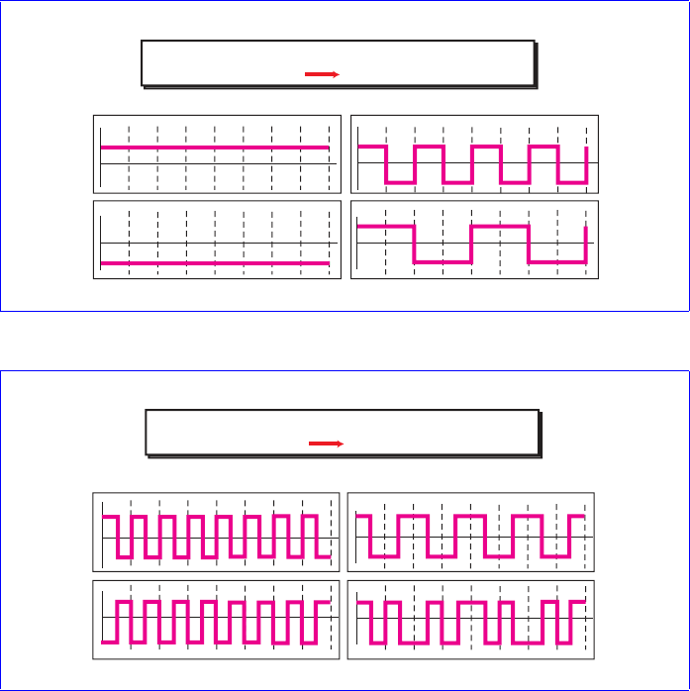

Question no 11:
Answer: An IPv4 address is 32 bits long. An IPv6 address is 128 bits long.

Question no 12:
Answer:
Classful addressing assigns an organization a Class A, Class B, or Class C block
of addresses.
Classless addressing assigns an organization a block of contiguous
addresses based on its needs.
Classful addressing assigns an organization a Class A, Class B, or Class C block of addresses. Classless addressing assigns an organization a block of contiguous addresses based on its needs.

Question no 13:
Answer: classes A, B and C are used for unicast communication. Class D is for multicast communication and class E addresses are reserved for special purposes.

Question no 14:
Answer: A mask is classful addressing is used to find the first address in the block when one of the addresses is given. The default mask refers to the mask when there is no sub netting or super netting.

Question no 15:
Answer: The network address in a block of addresses is the first address. The mask can be
ANDed with any address in the block to find the network address.
The network address in a block of addresses is the first address. The mask can be ANDed with any address in the block to find the network address.

Question no 16:
Answer: home users and small businesses may have created small networks with several hosts and need an ip addresses for each host. With the shortage of addresses, this is a serious problem. A quick solution to this problem is called network address translation. NAT enables a user to have a large set of addresses internally and one address, or a small set of addresses, externally. The traffic inside can use the large set; the traffic outside, the small set.

Question no 17:
The address space in 16 bit addresses is
2
16
=
65536
$$2^{16}=65536$$

Question no 18:

$2^{x}=1024$
$x=\log_{2}{1024}$
$x=10$

Question no 19:
Binary notation of 129.14.6.8:
1000001 00001110 00000110 00001000
Binary notation of 208.34.54.12:
11010000 00100010 00110110 00001100

Question no 20:
Dotted decimal notation for 01111111 11110000 01100111 01111101:
127.240.103.125
Dotted decimal notation for 10101111 11000000 11111000 00011101:
175.192.240.29

Question no 21:

With the information given, the first address is found by ANDing the host address
with the mask 255.255.0.0 (/16).
The last address can be found by ORing the host address with the mask comple-
ment 0.0.255.255.
However, we need to mention that this is the largest possible block with 2
16
addresses. We can have many small blocks as long as the number of addresses
divides this number.
With the information given, the first address is found by ANDing the host address with the mask 255.255.0.0 (/16).
Host Address: 25
.
34
.
12
.
56
Mask (ANDed): 255
.
255
.
0
.
0
Network Address (First):
25 . 34 . 0 . 0
Host Address: 25.34.12.56
Mask (ANDed): 255.255.0.0
Network Address (First): 25.34.0.0
The last address can be found by ORing the host address with the mask complement 0.0.255.255.
Host Address : 25.34.12.56
Mask complement (ORed) : 0.0. 255.255
Last address : 25.34.255.255
However, we need to mention that this is the largest possible block with $2^{16}$addresses. We can have many small blocks as long as the number of addresses divides this number.

