Subject: Anatomy II Total Marks 50
Final Term Assignment.
NAME HIRA AHAD
ID 16235

Semester: DPT 2nd.

Q:1 Enumerate muscles in the posterior compartment of the lower leg with clinical significances also write action and innervation of each posterior compartment muscle.

Q:2Explain the following
- Foot drop
- Deep venous thrombosis

Q:3Explain blood supply of thigh and gluteal region with the help of diagram.

Q 4: Describe anatomical course, motor and sensory function of Sciatic Nerve

Q 5: Enumerate Muscles of the medial compartment of thigh, what is tarsal tunnel syndrome?

ANS 1:MUSCLE OF THE POSTERIOR COMPARTMENT OF THE LOWER LEG:
The posterior compartment of the leg contains seven muscles, organized into two layers – superfecial and deep.
Two layers superficial and deep separate by a band of fascia.
The posterior leg is largest of three compartment.
It invert foot.
They are inervated by the tibial nerve, a terminal branch of the sciatic nerve.
SUPERFICIAL MUSCLES:
1.GASTROCNEMIUS:
The gastrocnemiu is the most superficial of all the muscles in the posterior leg.it has two heads medial and lateral, wtich converge to form a single muscle belly.
ACTION:
It plantarflexe at the ankle joint and because it crosses the knee, it is a flexor three.
INNERVATION:
Tibial nerve
2. PLANTARIS:
the plantaris is a small muscle with a long tendon, which can be mistaken foe a nerve is it descends down the leg. It is absent in 10% of people.
ACTION:
Its flexor there
Not vital muscle for these movement
INNERVATION:
Tibial nerve
3. SOLEUS:
It soleus is located deep to the gastrocnemius. It is large and flat, named soleus due to its resemblance of a sole – a flat fish.
ACTION:
Plantarflexe the foot it ankle joint
INNERVATION:
Tibial nerve
DEEP MUSCLE:
1. P0PLITEUS:
ACTION
Leterally rotates the femur on the tibia
Unlocking the knee joint
Flexion
2. TIBIALIS POSTERIOR:
ACTION
Invert the planter flexes the foot
Maintain medial arch of foot
INNERVATION:
Tibial nerve
3. FLEXOR HALLUCIS LONGOUS:
ACTION
Flexes the great toe
INNERVATION:
Tibial nerve
CLINICAL SIGNIFICANCE
When calcaneal tendon rupture indicate complete tear of tendon
Calcaneal tendinitis chronic inflimation of tendon
Injury occur during force full plantarflexion of foot
Treatment are not surgical.

ANS 2.
DEEP VEIN THROMBOSIS:
Formation of blood clots ina deep vein
Comman in leg or pelvic
SYMPTEMS:
Swelling
Redness
Enlarged vein
TREATMENT:
Anticoagulation
2. FOOT DROP:
Foot drop is a gait abnormallity in which the dropping of the forefoot happens due to weakness, irritation or demage to the common fibular nerve including the sciatic nerve, or paralysis of the muscles in the anterior portion of the lower leg
ANS 3.
BLOOD SUPPLY OF THIGH:
Comes from external iliac artery
When it pass beneath the inguinal legment and enters to femoral triangle it become femoral artery
ARTERIES OF THE THIGH:
MCFA and LCFA and perforating beaches
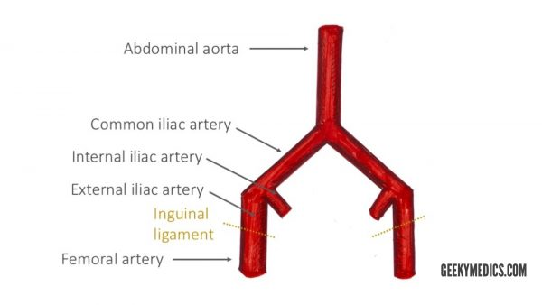

2.GLUTEAL REGEN
Main artery are superior gluteal and inferor gluteal
Arise from internal iliac artery
Super gluteal is largest branch of the internal iliac artery

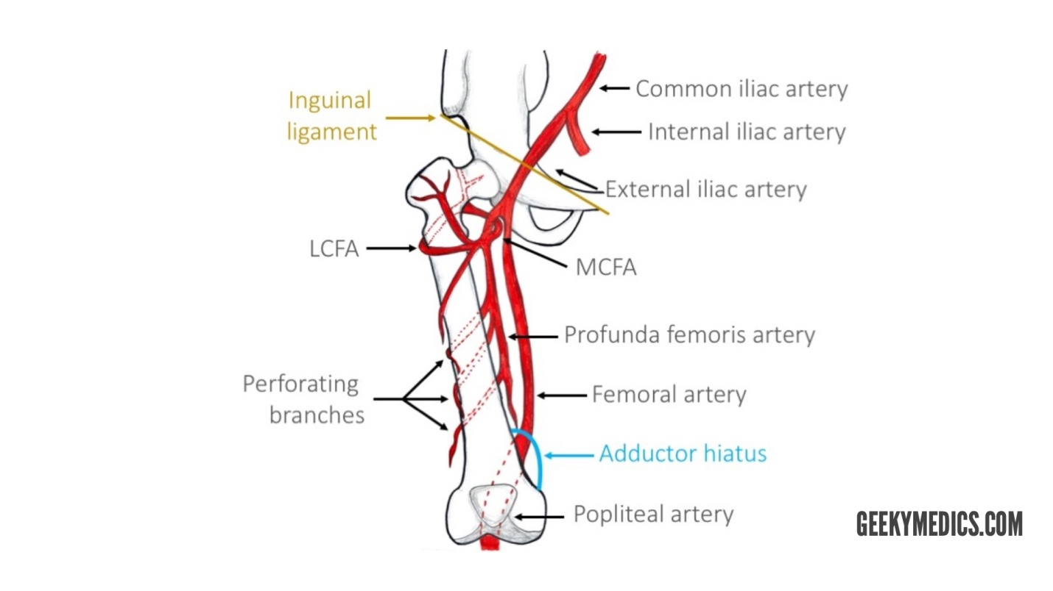

ANS.4
SCIATIC NERVE:
The sciatic nerve is a major nerve of the lower limb. It is a thick flate band, approximately 2cm wide-the largest nerve in the body
MOTOR FUNCTIONS:
Innervats the muscles of the posterior thigh (biceps femoris, semimembranosus and semit endinosus) and the hmstring portion of the adductor magnus (remaing poriton of which is supplied by the obturator nerve )
SENSORY FUNCTIONS:
No direct senory functions in thigh regon (indirectly innervats (via its terminal branches )the skin of the lateral leg, heel,and both the dorsal and plantar surface of the foot)
MOTOR FUNCTIONS:
All though the sciatic nerve passes through the gluteat region, it does not inervate any muscles their.
However,the sciatic nerve does not directly inervate the muscles in the posterior compatment of the thigh and the hamsstring portion of the adductor magnus
The sciatic nerve also indirectly innervate several other muscles, via its two terminal braches.tibial nerve the muscle of the posterior leg and some of the intrinsic foot muscles common febural nerve the musles of the interior leg, leteral leg ,and the remaing intrinsic foot muscles.the sciatic nerve inervats the muscles of the posterior thigh, entire foot and entire leg .

ANS.5
MUSCLES OF MEDIAL COMPARTMENT OF THE THIGH:
The muscles in the medial compartment of the thigh or collectively known is the hip adductors. There are five muscles in this group
Adductor brevis
Adductor longus
Obturator
Adductor mangnus
Gracilis
All the medial thigh muscles are innervated by the obturator nerve,which arries from the lumbar pleus. Artial supply is via the obturator artrey
TARSAL TANNAL SYNDROME:
Tarsal tannal syndrome occurs due to and entrapment of posterior tiabial nerve
Pain and paresthesia in the tiabial nerve
Night pain
CAUSES:
Tendon sheath cyst
Post traumatic fibrosis
Thickened flexor retinaculum
Ill flittimg foot vare
In these innervations are succes full, the flexor retinaculum can be cut surgically, which releses the pressure.

