IQRA NATIONAL UNIVERSITY

Assigment
REINFORCED CONCRETE DESIGN
Submitted by: MUHAMMAD SALEEM
ID: 15345
Submitted to: Engr. FAWAD AHMAD

Raft Foundation
A foundation is a lower portion of building structure that transfers its gravity loads to the earth. Foundations are generally broken into two categories: shallow foundations and deep foundations. A tall building must have a strong foundation if it is to stand for a long time. To make a foundation, we normally dig a trench in the ground, digging deeper and deeper until we come to subsoil, which is more solid than the topsoil that is used to grow plants and crops. When the trench is deep enough, we fill it with any strong, hard material we can find. Sometimes we pour in concrete into the trench, which we strengthen even more by first putting long thin round pieces of steel into the trench. When the concrete dries, the steel acts like the bones in our body to tie the foundation together. We call this reinforced concrete. Once the foundation has been packed down tightly, or dried hard, we can begin to build the building superstructure.
Multi-Storey Buildings:
The tallness of a building is relative and cannot be defined in absolute terms either in relation to height or the number of stories. But, from a structural engineer's point of view the tall building or multi-storied building can be defined as one that, by virtue of its height, is affected by lateral forces due to wind or earthquake or both to an extent that they play an important role in the structural design. Tall structures have fascinated mankind from the beginning of civilization. The Egyptian Pyramids, one among the seven wonders of world, constructed in 2600 B.C. are among such ancient tall structures Such structures were constructed for defense and to show pride of the population in their civilization. The growth in modern multi-storied building construction, which began in late nineteenth century, is intended largely for commercial and residential purposes. The development of the high-rise building has followed the growth of the city closely. The process of urbanization, that started with the age of industrialization, is still in progress in developing Chapter one Introduction Full hand calculation, analysis and design of multi story building 5 countries. Industrialization causes migration of people to urban centers where job opportunities are significant. The land available for buildings to accommodate this migration is becoming scarce, resulting in rapid increase in the cost of land.
Design Bases:
The single most important characteristic of any structural member is its actual strength, which must be large enough to resist, with some margin to spare, all foreseeable loads that may act on it during the life of the structure, without failure or other distress. It Chapter one Introduction Full hand calculation, analysis and design of multi story building 4 is logical, therefore, to proportion members, i.e., to select concrete dimensions and reinforcement, so that member strengths are adequate to resist forces resulting from certain hypothetical overload stages, significantly above loads expected actually to occur in service. This design concept is known as strength design. For reinforced concrete structures at loads close to and at failure, one or both of the materials, concrete and steel, are invariably in their nonlinear inelastic range. That is, concrete in a structural member reaches its maximum strength and subsequent fracture at stresses and strains far beyond the initial elastic range in which stresses and strains are fairly proportional. Similarly, steel close to and at failure of the member is usually stressed beyond its elastic domain into and even beyond the yield region. Consequently, the nominal strength of a member must be calculated based on this inelastic behavior of the materials. A member designed by the strength method must also perform in a satisfactory way under normal service loading. For example, beam deflections must be limited to acceptable values, and the number and width of flexural cracks at service loads must be controlled. Serviceability limit conditions are an important part of the total design, although attention is focused initially on strength. 1-6 Multi-Storey Building.
Reinforced concrete (RC):
Is a composite material in which concrete's relatively low tensile strenght and ductility are counteracted by the inclusion of reinforcement having higher tensile strength and/or ductility. The reinforcement is usually, though not necessarily, steel reinforcing bars (rebar) and is usually embedded passively in the concrete before the concrete sets. Reinforcing schemes are generally designed to resist tensile stresses in particular regions of the concrete that might cause unacceptable cracking and/or structural failure. Modern reinforced concrete can contain varied reinforcing materials made of steel, polymers or alternate composite material in conjunction with rebar or not. Reinforced concrete may also be permanently stressed (in compression), so as to improve the behavior of the final structure under working loads. In the United States, the most common methods of doing this are known as pre-tensioning and post-tensioning. For a strong, ductile and durable construction the reinforcement needs to have the following properties at least: • High relative strength, High toleration of tensile strain Chapter one Introduction Full hand calculation, analysis and design of multi story building 6 • Good bond to the concrete, irrespective of pH, moisture, and similar factors • Thermal compatibility, not causing unacceptable stresses in response to changing temperatures, Durability in the concrete environment
- The soil removed down to correct depth.
- The foundation bed is then compacted by ramming.
- Lay reinforcement on spacers over the foundation bed.
- Pour the concrete over the reinforcemen

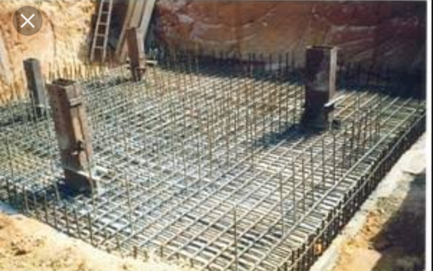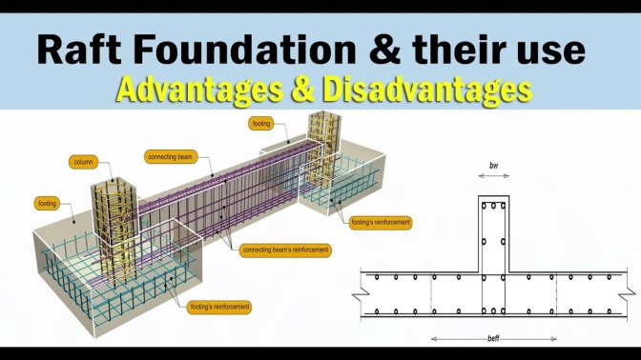
Raft Foundation

Types of Load:
Dead loads are static forces that are relatively constant for an extended time. They can be in tension or compression. The term can refer to a laboratory test method or to the normal usage of a material or structure. Live loads are usually unstable or moving loads. These dynamic loads may involve considerations such as impact, momentum, vibration, slosh dynamics of fluids, etc. An impact load is one whose time of application on a material is less than one-third of the natural period of vibration of that material. Cyclic loads on a structure can lead to fatigue damage, cumulative damage, or failure. These loads can be repeated loadings on a structure or can be due to vibration.
Loads on architectural and civil engineering structure:
Building codes require that structures be designed and built to safely resist all actions that they are likely to face during their service life, while remaining fit for use. Minimum loads or actions are specified in these building codes for types of structures, geographic locations, usage and materials of construction. Structural loads are split into categories by their originating cause. In terms of the actual load on a structure, there is no difference between dead or live loading, but the split occurs for use in safety calculations or ease of analysis on complex models. To meet the requirement that design strength be higher than maximum loads, building codes prescribe that, for structural design, loads are increased by load factors. These load factors are, roughly, a ratio of the theoretical design strength to the maximum load expected in service. They are developed to help achieve the desired level of reliability of a structure based on probabilistic studies that take into account the load's originating cause, recurrence, distribution, and static or dynamic nature.
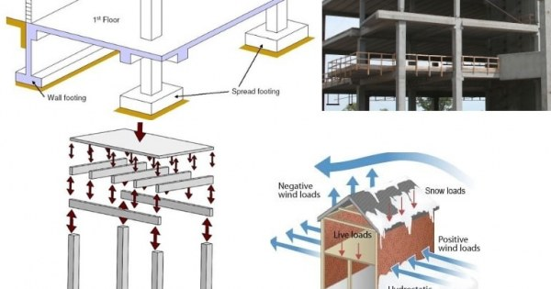
Loads on Archetecture design

Imposed Loads:
Imposed load is produced by the intended use or occupancy of building including the weight of movable partitions distributed and concentrated loads, load due to impact and vibration and dust load, imposed do not include due to wind, seismic activity, snow, and loads imposed due to temperature changes to which the structure will be subjected to creep and shrinkage of the structure, the differential settlements to which the structure may undergo. Live loads, or imposed loads, are temporary, of short duration, or a moving load. These dynamic loads may involve considerations such as impact, momentum, vibration, slosh dynamics of fluids and material fatigue. Live loads, sometimes also referred to as probabilistic loads, include all the forces that are variable within the object's normal operation cycle not including construction or environmental loads. Roof and floor live loads are produced during maintenance by Chapter Two Load Type Full hand calculation, analysis and design of multi story building 18 workers, equipment and materials, and during the life of the structure by movable objects, such as planters and people. Bridge live loads are produced by vehicles traveling over the deck of the bridge.
Dead Loads:
Dead loads are permanent or stationary loads which are transferred to structure throughout the life span. Dead load is primarily due to self weight of structural members, permanent partition walls, fixed permanent equipments and weight of different materials. The dead load includes loads that are relatively constant over time, including the weight of the structure itself, and immovable fixtures such as walls, plasterboard or carpet. The roof is also a dead load. Dead loads are also known as permanent or static loads.
Live Loads:
Live loads are either movable or moving loads with out any acceleration or impact. There are assumed to be produced by the intended use or occupancy of the building including weights of movable partitions or furniture etc. The floor slabs have to be designed to carry either uniformly distributed loads or concentrated loads whichever produce greater stresses in the part under consideration. Since it is unlikely that any one particular time all floors will not be simultaneously carrying maximum loading, the code permits some reduction in imposed loads in designing columns, load bearing walls, piers supports and foundations. Live loads include any temporary or transient forces that act on a building or structural element. Typically, they include people, furniture, vehicles, and almost everything else that can be moved throughout a building. Live loads can be prescribed to any structural element (floors, columns, beams, even roofs) and will ultimately be factored into a calculation of gravity loads, which we'll explain below We measure uniform live loads as KN/m2 . The acceptable live load will vary considerably based on the occupancy and expected use of a structure or structural element For example, the live load for a school, and colleges 4-5 KN/m2 Stadiums 5 KN/m2 and houses 2 KN/m2 . Chapter Two Load Type Full hand calculation, analysis and design of multi story building.
Other Loads:
Engineers must also be aware of other actions that may affect a structure, such as: Foundation settlement or displacement
• Fire
• Corrosion
• Explosion
• Creep or shrinkage
• Impact from vehicles or machinery vibration
• Construction loads
Load Combinations:
A load combination results when more than one load type acts on the structure. Building codes usually specify a variety of load combinations together with load factors (weightings) for each load type in order to ensure the safety of the structure under different maximum expected loading scenarios. For example, in designing a staircase, a dead load factor may be 1.2 times the weight of the structure, and a live load factor may be 1.6 times the maximum expected live load. These two "factored loads" are combined (added) to determine the "required strength" of the staircase. The reason for the disparity between factors for dead load and live load, and thus the reason the loads are initially categorized as dead or live is because while it is not unreasonable to expect a large number of people ascending the staircase at once, it is less likely that the structure will experience much change in its permanent load.

