Dated: 23/9/2020.

Name: Maaz Fida.
ID: 14647.
Subject: Ecnomics.
Teacher: Sir Zohaib.
Remarks: ………………………………………………………………………………………………………………………………………………………………………………………………………………………………………………………………………………………………………………………………………………………………………………………………………………………………………………………………………………………………………………………………………………………………………………………………………………………………………………

Teacher sign: ……………
Economics

Q: (a) What factors affect buyers demand for goods?
Ans:
- Buyer:

- A buyer is a person which pays the price for the services or goods that he utilizes for self-satisfaction. A buyer is also known as consumer.

- The consumer goods include a wide range of products such as food and clothing to luxury items such as jewelry and electronics.
- The overall demand for food may not likely to fluctuate wildly but up to some extent.
- The specific foods consumers purchase can vary significantly under different economic conditions.
- The level of consumer spending on more optional purchases, such as automobiles and electronics, varies greatly depending on a number of economic factors.

- Factors:

- The economic factors that most affect the demand for consumer goods are:

- Employment,
- Wages,
- Prices/inflation,
- Interest rates, and
- Consumer confidence.

……………………………………………………………………………………..

(b) What factors affect seller’s supply of goods?

Ans:

- Seller:

- A seller is a person which provides the services or goods for the buyers or consumers to fulfil their desire of satisfaction. In return seller is paid in form of money or cross services or even goods.

Or

- Supply refers to the quantity of a good that the producer plans to sell in the market.

- Supply Curve:
- The supply depends on the stock and market price of the product.
- Stock of a product refers to quantity of a product available in the market for sale within a specified point of time.

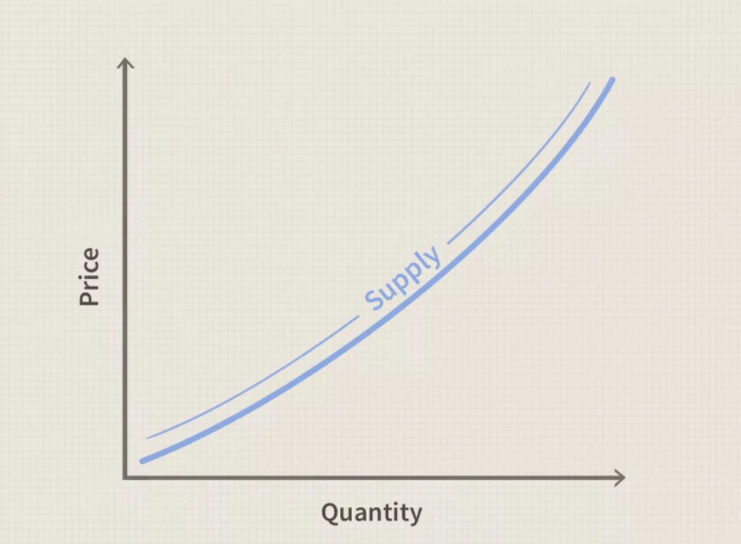

- Both stock and market price of a product affect its supply to a greater extent.
- If the market price is more than the cost price, the seller would increase the supply of a product in the market.
- However, the decrease in market price as compared to cost price would reduce the supply of product in the market.

- Factors:
- Supply can be influenced by a number of factors that are termed as determinants of supply and they are:
- Price.
- Cost of production.
- Natural conditions.
- Technology.
- Transport conditions.
- Government policies.
- Prices of related goods.

………………………………………………………………………………………….

Q2. Discuss in detail any of the five principles of economics?
Ans:

Principle 1: People face trade-offs:

- To get one thing that we like we usually have to give up another thing that we also like. Making decisions requires trading off one goal against another.
- When people are grouped into societies, they face different kinds of trade-offs.
- One trade-off society faces is between efficiency and equity.
- Efficiency means that society is getting the most it can from its scare resources.
- Equity means that the benefits of those resources are disturbed fairly among society’s members.
- Life’s trade-offs is important because people are likely to make good decisions only if they understand the options that they have available.

Principle 2: The cost of something is what you give up to get it:

- Because people face trade-offs, making decisions requires comparing the costs and benefits of alternative courses of action.
- In many cases, the cost of some action is not as obvious as it might first appear.
- The opportunity cost of an item is what you give up to get that item.
- When making any decision, decision makers should be aware of the opportunity cost that accompanies each possible action. In fact, they usually are.

Principle 3: Rational People think at the Margin:

- Decisions in life are rarely black and white.
- Economists use the term marginal changes to describe small incremental adjustments to an existing plan of action.
- Keep in mind that margin means edge, so marginal changes are adjustments around the edges of what you are doing.
- In many situations, people make the best decisions by thinking at the margin.
- A rational decision maker takes an action if and only if the marginal benefit of the action exceeds the marginal costs.

Principle 4: People Respond to Incentives:

- Because people make decisions by comparing costs and benefits, their behavior may change, when the costs of benefits change. That is, people, respond to incentives.
- Public policy makers should never forget about incentives, because many policies change the costs of benefits that people face and, therefore, alter behavior.
- When policy makers fail to consider how their policies affect incentives, they often end up with results they did not intend.
- Policies can have effects that are not obvious in advance.
- When analyzing any policy, we must consider not only the direct effects but also the indirect effects that work through incentives.
- If the policy changes incentives, it will cause people to alter their behavior.

Principle 5: Trade can make everyone better off:

- The Americans and the Japanese are often mentioned in the news as being competitors to Europeans in the world economy.
- In some ways this is true, because American and Japanese firms do produce many of the same goods as European firms.
- Trade between Europe and the United States or Japan is not like a sports contest, where one side wins and the other side loses. In fact, the opposite is true: trade between two economies can make each economy better off.
- Trade allows each person to specialize in the activities he or she does best.
- By trading with others, people can buy a greater variety of goods and services at lower cost.
- So Japanese and Americans are as much our partners in the world economy as they are our competitors.

………………………………………………………………………………………………

Q3. Explain the following:
- Seasonal unemployment.
- Fictional unemployment.
- Structural unemployment.
- Cyclical unemployment.

Ans:
- The following topics are discussed as below:

- Seasonal unemployment:
- Seasonal unemployment occurs when people are unemployed at particular times of the year.
- It is that time when demand for labor is lower than usual.
- For example: A hotel at Kumrat valley Upper Dir will be closed in winters due to too much cold and snow, also the people travel less to such place off season. So the labor demand will be low and there will be seasonal based unemployment.

- Fictional unemployment:
- The frictional nature of the unemployment relates to the time lag between workers moving from one job to the next.
- It is the time that a person spends free when either quitting a job or searching for new one.
- Examples of frictional unemployment include: Quitting, a voluntary form of frictional unemployment. Termination, an involuntary form of frictional unemployment.

- Structural unemployment:
- Structural unemployment refers to a mismatch between the jobs available and the skill levels of the unemployed. Unlike cyclical unemployment, it’s caused by forces other than the business cycle.
- Structural unemployment is long-lasting unemployment that comes about due to shifts in an economy.
- This type of unemployment happens because though jobs are available, there’s a mismatch between what companies need and what available workers offer.
- Structural unemployment can last for decades and usually requires a radical change to reverse.
- Technology tends to exacerbate structural unemployment, marginalizing certain workers and rendering particular jobs, such as manufacturing, obsolete.
- By looking into the U.S. unemployment rate by years, one can track the health of the country’s economy and get a clearer picture of how structural unemployment can occur. The chart below tracks the U.S. structural unemployment from 2002 to 2015.

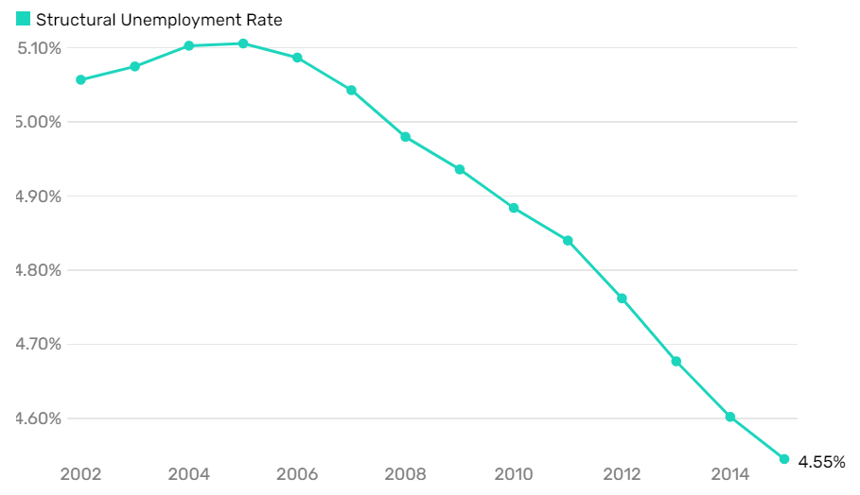

- Cyclical unemployment:
- Cyclical unemployment is the impact of economic recession or expansion on the total unemployment rate.
- Cyclical unemployment generally rises during recessions and falls during economic expansions and is a major focus of economic policy.
- Cyclical unemployment is one factor among many that contribute to total unemployment, including seasonal, structural, frictional, and institutional factors.
- One concrete example of cyclical unemployment is when an automobile worker is laid off during a recession to cut labor costs. During this downturn, people are buying fewer vehicles, so the manufacturer doesn't need as many workers to meet the demand.
- High or low cyclical unemployment is only temporary.

……………………………………………………………………………………………..

Q5: (a) Discuss the factors that can shift the labor demand curve?

Ans:

- Factors:
- Factors that can shift the demand curve for labor include:

- Change in the quantity demanded of the product that the labor produces.
- Change in the production process that uses more or less labor, and
- Change in government policy that affects the quantity of labor that firms wish to hire at a given wage.
- The number of people employed at each wage level can change and in the next diagram we see an outward shift of the labor demand curve. The curve shifts when there is a change in the conditions of demand in the jobs market.
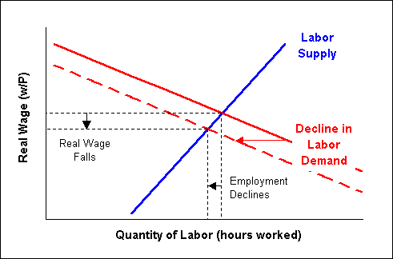

………………………………………………………………………………………………….

Q (b) Explain the following:

- Productive efficiency.
- Allocative efficiency.

Ans:

- Productive efficiency:
- Productive efficiency is concerned with producing goods and services with the optimal combination of inputs to produce maximum output for the minimum cost.
- To be productively efficient means the economy must be producing on its production possibility frontier.
- That is it is impossible to produce more of one good without producing less of another.
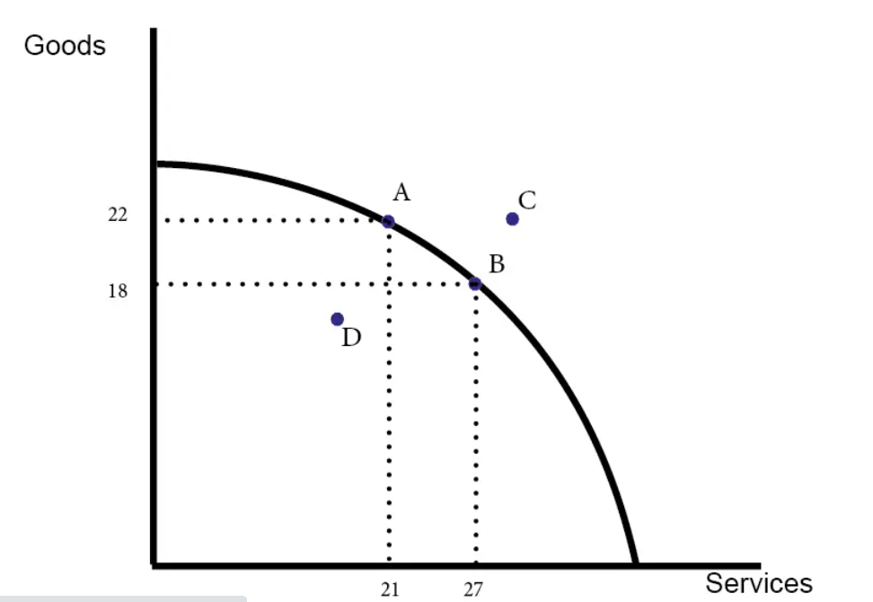

- Points A and B are productively efficient.
- Point D is inefficient because you could produce more goods or services with no opportunity cost.
- Point C is currently impossible.

………………………………………………………………………………………….
- Allocative efficiency:
- Allocative efficiency is the level of output where marginal cost is as close as possible to the marginal benefits.
- This means that the price of the product or service is close to the marginal benefit that one gets from using that product or service.
- Allocative efficiency occurs when market data is freely accessible to all market participants. It allows them to make informed decisions on what to purchase or produce and in what quantities.
- Allocative efficiency is a property of an efficient market whereby all goods and services are optimally distributed among buyers in an economy.
- In economics, the point of allocation efficiency for a product or service occurs at the price and quantity defined by the intersection of the supply curve and the demand curve.
- Allocation efficiency only holds if markets themselves are efficient in general informationally.

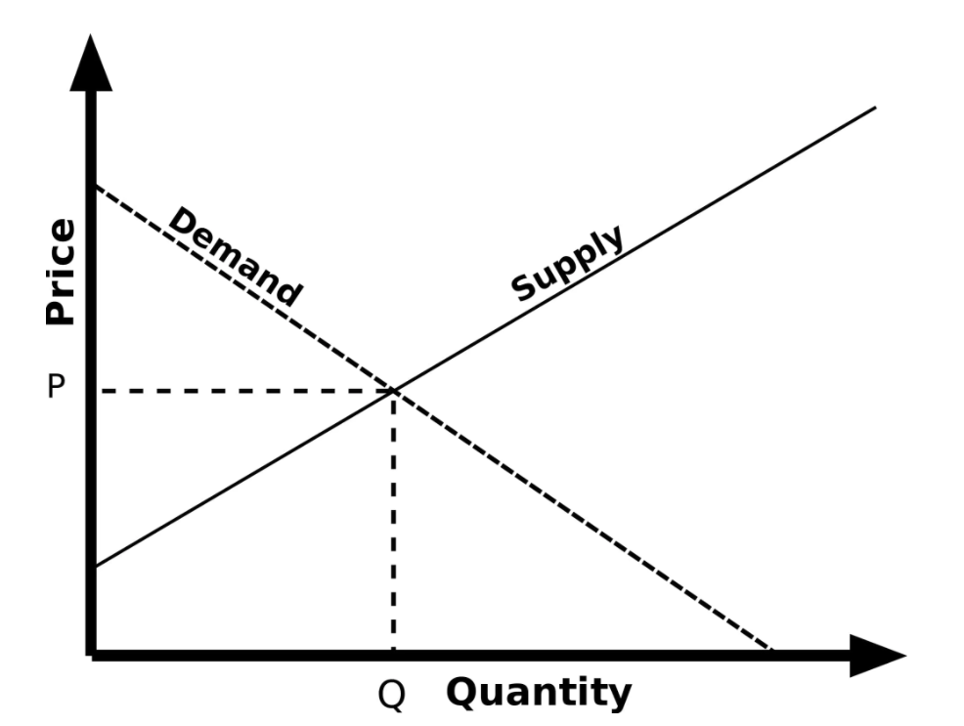

…………………………………………………………………………………………………

Q4. Show graphically the effect of tax and explain it accordingly?
Ans:
- The impact of taxation:
Taxation on goods, income or wealth influence economic behavior and the distribution of resources.
- For example, higher taxes on carbon emissions will increase cost for producers, reduce demand and shift demand towards alternatives.

- Higher income tax can enable a redistribution of income within society, but may have an impact on reducing the incentives to work and supply labor.

  - Taxation can have an impact on many aspects of the economy, including:
- Labor supply
- Labor productivity
- Economic growth
- Inflation
- Production and consumption of goods
- Saving rates/consumption
- Income distribution
- Resource distribution
- Levels of government spending

Impact of direct taxation – income tax

- Raise revenue for the government.
- The main purpose of tax is to raise income for the government which can lead to higher spending on health care and education.
- The impact depends on what government spends the money on.
- Less discretionary income.
- Those paying income tax will be left with less discretionary income to spend after income tax has been deducted.
- This is likely to lead to lower levels of household spending and lower levels of household saving. However, if the government spends the tax revenue overall aggregate demand (AD) will not be affected.

- Incentive effect:

Higher income tax reduces the take-home pay and can reduce the incentive to work. Either workers chose not to do overtime or even leave the labor market altogether. However, there are two conflicting effects of higher tax.

- Substitution effect:

Higher tax leads to lower wages – and work becomes relatively less attractive than leisure. The substitution effect of a higher tax is that workers will want to work less.

- Income effect:

However, if higher tax leads to lower wages, then a worker may feel the need to work longer hours to maintain his target level of income. Therefore, the income effect means that higher tax may mean some workers feel the need to work longer.

- This means there is no guarantee of the impact of higher tax – it depends whether the substitution effect is greater than the income effect.

- Laffer curve:

The Laffer curve is an analysis which suggests at some tax rates, higher income tax will reduce incentives to work and actually leads to lower tax revenue.

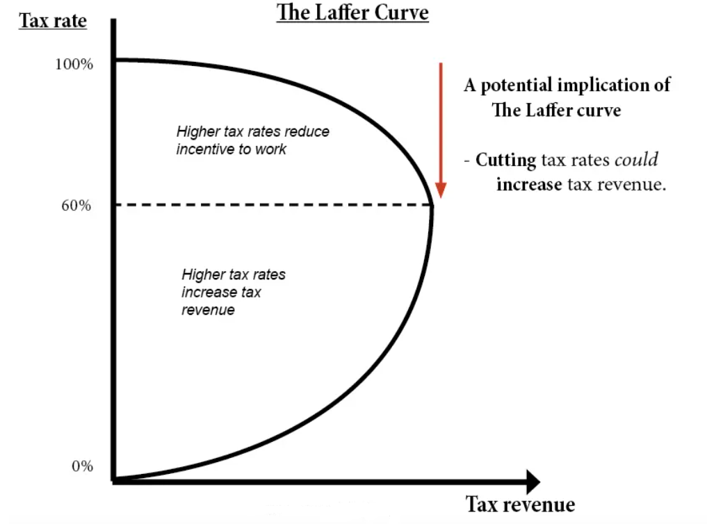
- Impact on the distribution of income:

Income tax is a progressive tax. In the UK, there is a tax threshold of £10,000, with a higher rate of income tax of 40%. As income rises, the percentage of income paid in tax increases. 16% of all income tax revenue is paid for by the top 1% earners. Income tax has a role in redistributing income and offsetting more regressive taxes, such as excise duty and indirect tax.

Impact of a higher tax burden:
What is the effect of an increase in the overall tax burden? This is the % of GDP that is collected in tax. This can vary between countries. Generally, less developed economies have a lower tax burden, more developed economies have a higher tax burden.
For less developed economies, the tax burden tends to be lower because of difficulties in collecting taxes and less developed economic and political institutions.
To some extent, a rise in the tax burden shows a relationship with economic development. However, there are still variations – Sweden and the US have similar levels of GDP per capita, but the tax burden in Sweden (45%) is nearly double the US (25%). This reflects the more extensive welfare state (free health care, education) in Sweden than the US.
Some argue that the high levels of tax in Nordic countries can act as a disincentive to growth and investment. On the other hand, the stability of a welfare state, health care and education reduce uncertainty and problems such as health bankruptcy. There is no clear correlation between the tax burden and the rate of economic growth in the long term.
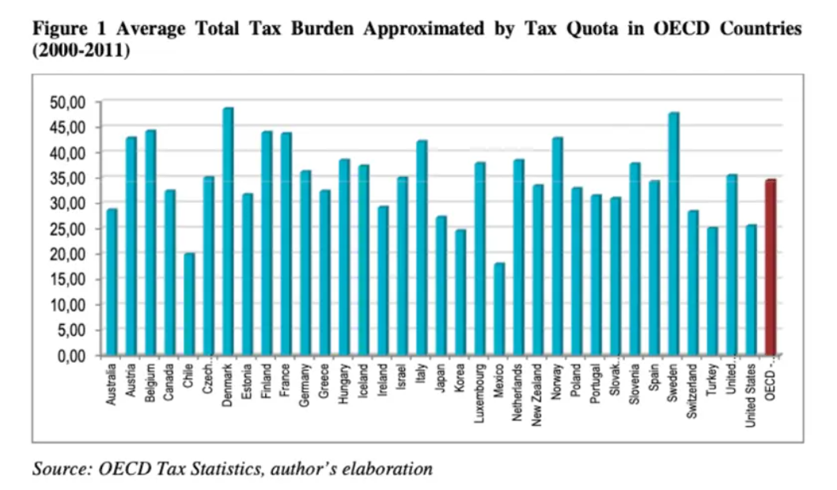

Impact of indirect tax:

The impact of indirect tax is more of a microeconomic issue.

A higher tax on a good, shifts supply to the left causing higher price and less demand.

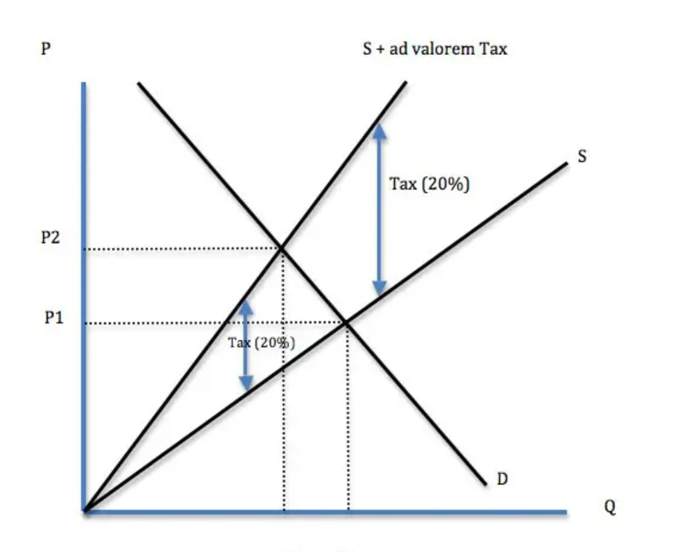

This graph is showing the impact of an ad valorem tax (20%) on a good.

- The impact of an indirect tax will depend on the elasticity of demand:

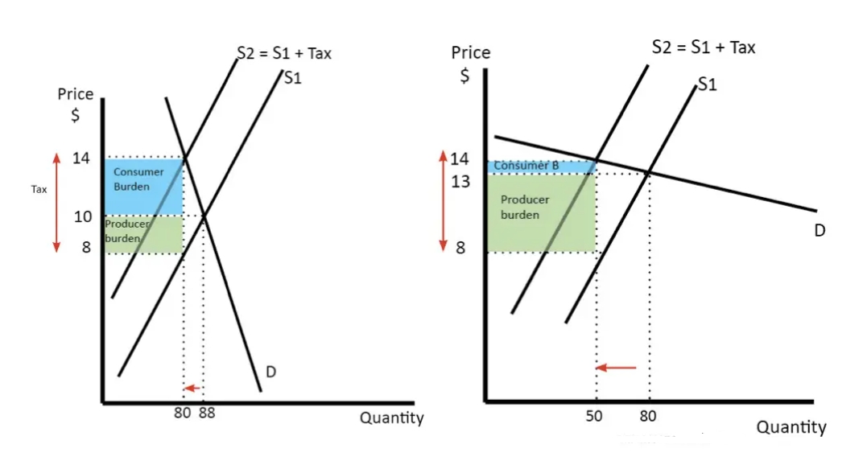

Where demand is price inelastic (left), the tax leads to a rise in price from £10 to £14. The consumer burden is £4 x 80. The producer receives £2 less so the producer burden is £3 x 80.

However, where demand is price elastic (right) the tax leads to only a small rise in price from £13 to £14. The consumer burden is relatively smaller.

Taxes and inflation:

A rise in excise duty or VAT can lead to one-off price increases. Therefore, it tends to cause cost-push inflation. However, the inflationary impact of the tax increase will only last one year (unless it changes expectations of inflation).
Higher taxes during a time of stagnant wages can lead to a decline in real incomes.

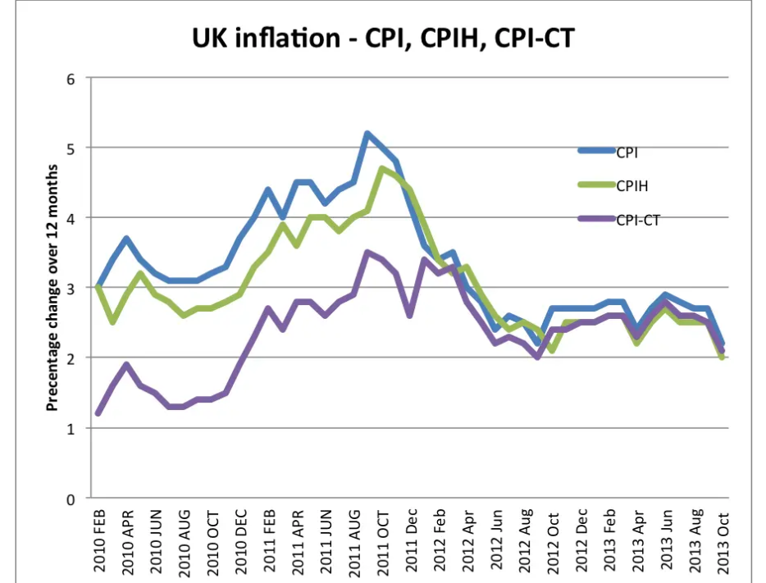

This shows the inflation rate in the UK. In 2011, CPI was over 5%. However, the inflation measure CPI-CT (which excludes taxes was lower at just 3%)

Tax and social efficiency:
The logic of taxes on demerit goods and goods with negative externalities is to make consumers pay the social cost of the good and internalize the externality.

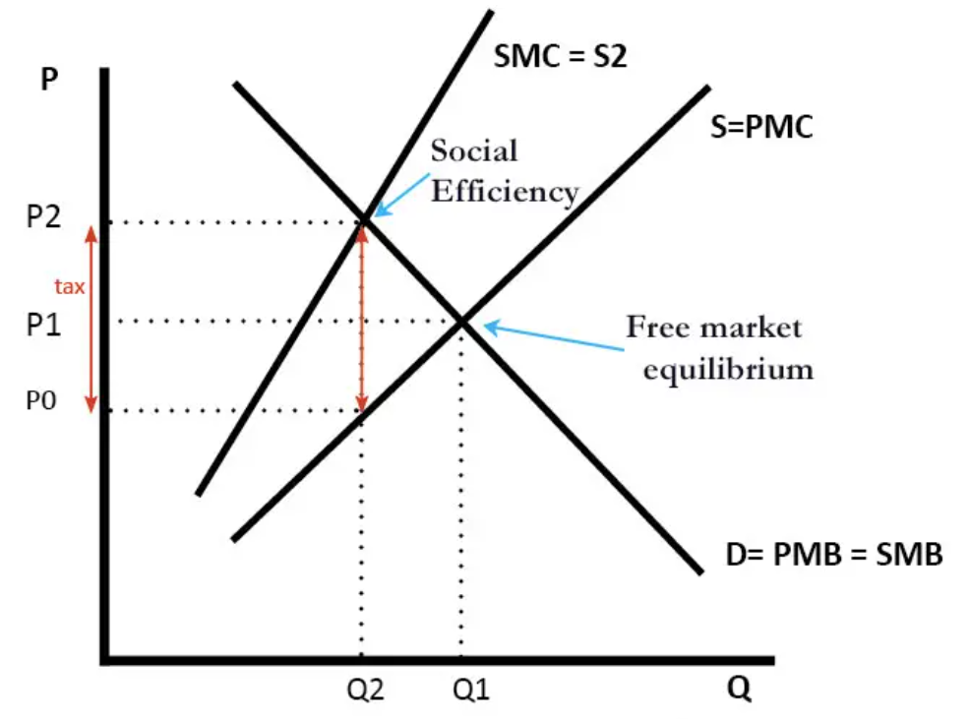
Without the tax, the market price of producing chemicals may be less than the social cost. The tax can increase the price to reflect the greater social marginal cost. In the above diagram, the tax of P2-P0 increases the price to P2 and reduces demand from Q1 to Q2.
- Key Points:
- Imposing a tax on the supplier or the buyer has the same effect on prices and quantity.
- The effect of the tax on the supply-demand equilibrium is to shift the quantity toward a point where the before-tax demand minus the before-tax supply is the amount of the tax.
- A tax increases the price a buyer pays by less than the tax. Similarly, the price the seller obtains falls, but by less than the tax. The relative effect on buyers and sellers is known as the incidence of the tax.
- There are two main economic effects of a tax: a fall in the quantity traded and a diversion of revenue to the government.
- A tax causes consumer surplus and producer surplus (profit) to fall.. Some of those losses are captured in the tax, but there is a loss captured by no party—the value of the units that would have been exchanged was there no tax. These lost gains from trade are known as a deadweight loss.
- The deadweight loss is the buyer’s values minus the seller’s costs of units that are not economic to trade only because of a tax (or other interference in the market efficiency).
- The deadweight loss is important because it represents a loss to society much the same as if resources were simply thrown away or lost.
- Small taxes have an almost zero deadweight loss per dollar of revenue raised, and the overhead of taxation, as a percentage of the taxes raised, grows when the tax level is increased.

…………………………………………………………………………………………………….

